Contents
Part 9 Development codes, 5
9.1 Preliminary 5
9.2 Development that cannot be made assessable in accordance with schedule 6 of the Planning Regulation 2017 6
9.2.1 Community residence requirements 6
9.2.2 Requirements for cropping involving forestry for wood production code for accepted development 7
9.2.3 Reconfiguring a lot (subdividing one lot into two lots) and associated operational works code 9
9.2.3.1 Purpose 9
9.3 Use codes 12
9.3.1 Centre Activities Code 12
9.3.1.1 Application 12
9.3.1.2 Purpose 12
9.3.1.3 Assessment benchmarks for assessable development 13
9.3.2 Community and Recreation Uses Code 21
9.3.2.1 Application 21
9.3.2.2 Purpose 21
9.3.2.3 Assessment benchmarks for assessable development 22
9.3.3 Extractive Industry Code 24
9.3.3.1 Application 24
9.3.3.2 Purpose 24
9.3.3.3 Assessment Benchmarks for assessable development 24
9.3.4 Home Based Business Use Code 27
9.3.4.1 Application 27
9.3.4.2 Purpose 27
9.3.4.3 Requirements for accepted development and assessment benchmarks for assessable development 27
9.3.5 Industry Uses Code 31
9.3.5.1 Application 31
9.3.5.2 Purpose 31
9.3.5.3 Assessment benchmarks for assessable development 31
9.3.6 Markets Code 36
9.3.6.1 Application 36
9.3.6.2 Purpose 36
9.3.6.3 Requirements for accepted development and assessment benchmarks for assessable development 36
9.3.7 Medium Density Residential Code, 41
9.3.7.1 Application 41
9.3.7.2 Purpose 41
9.3.7.3 Requirements for accepted development and assessment benchmarks for assessable development 43
9.3.8 Rural Uses Code 98
9.3.8.1 Application 98
9.3.8.2 Purpose 98
9.3.8.3 Assessment benchmarks for assessable development 98
9.3.9 Sales Office Code 100
9.3.9.1 Application 100
9.3.9.2 Purpose 100
9.3.9.3 Requirements for accepted development and assessment benchmarks for assessable development 100
9.3.10 Small Lot Housing Design Code 101
9.3.10.1 Application 101
9.3.10.2 Purpose 101
9.3.10.3 Requirements for accepted development and assessment benchmarks for assessable development 102
9.3.11 Telecommunications Facility Code 120
9.3.11.1 Application 120
9.3.11.2 Purpose 120
9.3.11.3 Requirements for accepted development and assessment benchmarks for assessable development 121
9.4 Other development codes 123
9.4.1 Advertising Devices Code 123
9.4.1.1 Application 123
9.4.1.2 Purpose 123
9.4.1.3 Requirements for accepted development and assessment benchmarks for assessable development 124
9.4.2 Environmental Standards Code 142
9.4.2.1 Application 142
9.4.2.2 Purpose 142
9.4.2.3 Assessment benchmarks for assessable development 142
9.4.3 Integrated Water Cycle Management Code 156
9.4.3.1 Application 156
9.4.3.2 Purpose 156
9.4.3.3 Assessment benchmarks for assessable development 156
9.4.4 Landscaping Code 159
9.4.4.1 Application 159
9.4.4.2 Purpose 159
9.4.4.3 Assessment benchmarks for assessable development 159
9.4.5 Reconfiguring a Lot Code 164
9.4.5.1 Application 164
9.4.5.2 Purpose 164
9.4.5.3 Requirements for accepted development and assessment benchmarks for assessable development 165
9.4.6 Transport, Access and Parking Code 192
9.4.6.1 Application 192
9.4.6.2 Purpose 192
9.4.6.3 Assessment benchmarks for assessable development 193
9.4.7 Works and Services Code 207
9.4.7.1 Application 207
9.4.7.2 Purpose 207
9.4.7.3 Requirements for accepted development and assessment benchmarks for assessable development 207

Development codes,

Preliminary

Development codes are the assessment benchmarks assessment where identified as an applicable code in Part 5.

The following codes and requirements apply to development under schedule 6 of the Regulation and are relevant for the planning scheme.

The following are the codes and requirements under the Regulation for development in the planning scheme area:

Community residence code requirements applying to development that may not be made assessable development under the planning scheme

Cropping (involving forestry for wood production) code applying to development that may not be made assessable development under the planning scheme

Reconfiguring a lot (subdividing one lot into two lots) and associated operational works code applying to development for which code assessment is required under Schedule 10, part 12 and schedule 10, part 14, division 2 of the Regulation.

The following are the use codes for the planning scheme:

Centre Activities Code.

Community and Recreation Uses Code.

Extractive Industry Code.

Home Based Business Use Code.

Industry Uses Code.

Markets Code.

Medium Density Residential Code.

Rural Uses Code.

Sales Office Code.

Telecommunications Facility Code.

The following are the other development codes for the planning scheme:

Advertising Devices Code.

Environmental Standards Code.

Integrated Water Cycle Management Code.

Landscaping Code.

Reconfiguring a Lot Code.

Transport, Access and Parking Code.

Works and Services Code.
Editor’s note—The following schedules of the Regulation are relevant to the Toowoomba Regional Planning Scheme
- Schedule 6, Part 2, 6 of the Regulation, Material change of use for community residence
- Schedule 13 of the Regulation, Requirements for cropping involving forestry for wood production
- Schedule 12 of the Regulation, Particular reconfiguring a lot requiring code assessment.

Development that cannot be made assessable in accordance with schedule 6 of the Planning Regulation 2017

Community residence requirements
- Development for a community residence that complies with all of the requirements in Table 5.4.1 is accepted development .
Table 9.2.1:1 – Community residence for accepted development only
1. | The premises are in a residential zone or rural residential zone.
2. | No more than seven (7) support workers attend the residence in a 24-hour period.
3. | At least two (2) car parks are provided on the premises for use by residents and visitors.
4. | At least one (1) of the car parks stated in (3) is suitable for persons with disabilities.
5. | At least one (1) car park is provided on the premises for use by support workers.
Editor’s note—Schedule 6, Part 2, (6) of the Regulation states the developmentthe planning scheme is prohibited from making assessable development for a material change of use for community residence.

Requirements for cropping involving forestry for wood production code for accepted development
Table 9.2.2:1 –Requirements for accepted development that is a material change of use for cropping involving forestry for wood production or operational work for harvesting trees for wood production
Requirements
Setbacks
1 | The use or work is at a distance of at least the separation distance stated in Table 9.2.2:2 – Separation distances.  Refer to Table 9.2.2:2 - Separation distances below
2 | Seedlings within the separation distance stated in requirement (1) are removed if the seedlings—  - are the same species as the trees to be harvested; and  - are not native to the local area.
3 | For land with a slope of more than 10% but less than 25% - the development uses only—  - mechanical strip cultivation on the contour; or  - spot cultivation; or  - manual cultivation.
4 | For land with a slope of 25% or more— the development uses only—  - spot cultivation; or  - manual cultivation.
5 | The construction, operation or maintenance of a track or road for the development does not adversely affect—  - a natural drainage feature on the land; or  - land that is subject to erosion or landslide.
6 | A track or road for the development—  - is appropriately drained; and  - has a stable surface.
7 | Drainage structures for a track or road for the development are regularly maintained.
8 | Drainage water from a track or road for the development is directed away from exposed soils and onto undisturbed ground or other areas with a stable surface.
9 | For development involving a forest for wood production that is less than 40ha— a fire break that is at least 7m wide, measured from the base of the outermost tree in the forest to be harvested, is established and maintained.
10 | For development involving a forest for wood production that is at least 40ha, but less than 100ha—a fire break that is at least 10m wide, measured from the base of the outermost tree in the forest to be harvested, is established and maintained.
11 | For development involving a forest for wood production that is 100ha or more—  - a fire break that is at least 20m wide, measured from the base of the outermost tree in the forest to be harvested, is established and maintained; or  - both of the following things are established and maintained—  - a fire break that is at least 10m wide, measured from the base of the outermost tree in the forest to be harvested;  - a fuel reduction area immediately behind the fire break that is at least 10m wide.
12 | Trees to be harvested in the fuel reduction area are pruned to a minimum height of 5m when the trees reach a height of 10m.
13 | Fire breaks are kept clear of flammable material with a height of more than 1m.
14 | Fire access tracks and roads that are at least 4m wide are established and maintained on the premises.
15 | Each part of the forest for wood production is within 250m of a fire access track or road.
16 | Despite requirement (1), the following works may be carried out within the separation distance mentioned in Table 9.2.2:2 - Separation distances—  - the construction of roads and tracks for the development;  - maintenance works for the development.

Table 9.2.2:2 - Separation distances
Column 1  Structure or thing | Column 2  Separation distance
1 A watercourse shown on the regulated vegetation management map (1:100,000) and classified as stream order 1 to 2 under the Strahler stream order classification system |  | 5m from the defining bank of the watercourse
2 A watercourse shown on the regulated vegetation management map (1:100,000) and classified as a stream order 3 to 5 under the Strahler stream order classification system |  | 10m from the defining bank of the watercourse.
3 A watercourse shown on the regulated vegetation management map (1:100,000) and classified as a stream order 6 under the Strahler stream order classification system |  | 20m from the defining bank of the watercourse.
4 A State-owned protected area or forest reserve under the Nature Conservation Act 1992 |  | 10m from the boundary of the protected area or forest reserve
5 A category A area, category B area, category C area or category R area |  | 10m from the boundary of the area
6 A dwelling |  | 100m from the dwelling, or another distance that complies with the Building Code and AS 3959-2009 Construction of buildings in bushfire prone areas
7 A machinery shed |  | A distance that is the greater of the following—  - 25m from the machinery shed; or  - A distance from the structure that equals 1.5 times the maximum height of the trees to be harvested
8 A transmission grid, supply network or above-ground pipeline, that services more than 1 premises and is not the subject of an easement. |  | A distance that is the longer of the following—  - 25m from the structure;  - A distance from the structure that equals 1.5 times the maximum height of the trees to be harvested

Reconfiguring a lot (subdividing one lot into two lots) and associated operational works code

Purpose

The purpose of the reconfiguring a lot (subdividing one lot into two lots) and associated operational works code is for assessing application for development for reconfiguring a lot that requires assessment as regulated in Part 5, section 5.4 under Table 5.4:2—Regulated categories of development: reconfiguring a lot.

Editor’s note—Schedule 12 (3) of the Regulation sets out the assessment benchmarks for the reconfiguring a lot.
Table 9.2.3:1 – Reconfiguring a lot (subdividing one lot into two lots) and associated operational works code requiring code assessment
This code applies to a reconfiguring of a lot if –
- The lot is in an industrial zone or residential zone (other than a park residential zone or rural residential zone); and
- the reconfiguration is the subdivision of one (1) lot, other than a rear lot, into two (2) lots (each a created lot); and
- each created lot is at least the minimum lot size for the relevant zone stated in a local instrument; and
- the reconfiguration is consistent with the purpose statement for the relevant zone stated in a local instrument.

However, this code does not apply if –
- all or part of the premises, are in an erosion prone area or any of the following areas under a local instrument
  - a flood hazard area;
  - a bushfire hazard area;
  - a landslide hazard area;
  - a storm tide inundation area; or
- an overlay in a local instrument applies to all or part of the premises, or any part of the premises.

For this section –
Industrial zone means area (however described) designated in a local categorising instrument as industrial.
Relevant zone means the zone applying to premises under a local instrument.

A reference to a local instrument is a reference to a local instrument applying to the premises.

1 | The frontage of each created lot complies with the minimum frontage requirements for the relevant zone stated in a local instrument.
2 | The building envelope of each created lot complies with the building envelope requirements for the relevant zone stated in a local instrument.
3 | The reconfiguration involved the creation of a rear lot only if the local instrument states that a rear lot is consistent with the relevant zone.
4 | The number of lots, including rear lots, adjoining each created lot complies with the maximum number of adjoining lots of the relevant zone stated in a local instrument.
5 | If the reconfiguration creates a rear lot—  - An access strip for the rear lot does not adjoin the access strip of more than one (1) other rear lot; and  - No more than two (2) rear lots are accessed from the head of a single cul-de-sac
6 | If a local instrument states minimum setback distances for the relevant zone—the distance of a building or structure from a boundary of a created lot complies with the minimum distances stated in the local instrument.
7 | If the reconfiguration is in a residential zone and a local instrument does not state minimum setback distances for the zone— the distance of an existing building or structure from a boundary of a created lot complies with the minimum setback distances stated in the Queensland Development Code, parts 1.1 to 1.3
8 | A new building or structure on the premises—  - will comply with the Queensland Development Code, part 1.4; and  - will be outside of an existing or planning infrastructure easement.
9 | - Each created lot has access to the road network through—direct road frontage; or  - an access strip; or  - an access easement, if a local instrument states that an access easement is consistent with the relevant zone.
10 | Access from each created lot to the road network is-  - lawful, safe and practical; and  - designed and built in accordance with requirements for the relevant zone stated in a local instrument, including requirements about width, length or gradient.
11 | If a local instrument does not state a minimum width requirement for an access strip or access easement in the relevant zone – an access strip or access easement for a created lot has a minimum width of –  - for reconfiguring a lot in a residential zone—5m; or  - for reconfiguring a lot in an industrial zone— 8m.
12 | If a local instrument does not state a maximum length requirement for an access strip or access easement in the relevant zone – an access strip or access easement for a created lot has a maximum length of 50m.
13 | If the premises are in a reticulated water area – each created lot is connected to the reticulated water supply system.
14 | If the premises are not in a reticulated water area – each created lot has an alternative potable water supply source that complies with the minimum storage capacity requirements for the relevant zone stated in a local instrument.
15 | If the premises are in an area with a sewerage service – each created lot is connected to the sewerage service.
16 | If the premises are not in an area with a sewerage service – each created lot has an effluent treatment and disposal system designed and built in accordance with the requirements stated in a local instrument.
17 | Each lot is connected to a supply network and telecommunication network, if required under a local instrument.
18 | Any other infrastructure necessary to service the lots will be provided, designed and built in accordance with the requirements stated in a local instrument.
19 | The release of sediment from the premises, including from erosion and sediment-laden stormwater runoff-  - is minimised during and after construction; and  - complies with the requirements stated in a local instrument.
20 | Filling and excavation on the premises –  - does not cause a vertical change to the natural ground level of more than 1 metre; and  - does not result in ponding on the premises or adjoining land; and  - complies with the requirements stated in a local instrument.

Use codes

Centre Activities Code

Application

This code applies to assessable development identified as requiring assessment against the Centres Activities Code by the categories of development and assessment tables in Part 5 – Tables of Assessment.

Purpose

The purpose of the Centre Activities Code is to guide the development of the following uses to manage business activities, whether within or outside a designated centre, to ensure that adverse impacts on surrounding areas are appropriately managed:

Adult Store.

Agricultural Supplies Store.

Bar.

Car Park.

Food and Drink Outlet.

Function Facility.

Garden Centre.

Funeral Parlour.

Hardware and Trade Supplies.

Health Care Services.

Hotel.

Nightclub Entertainment Facility.

Office.

Outdoor Sales.

Parking Station.

Service Industries.

Service Station.

Shop.

Shopping Centre.

Showroom.

Theatre.

Tourist Attraction.

Veterinary Services.

The purpose of the Centres Activities Code will be achieved through the following overall outcomes:

development facilitates a high level of safety for users and the wider community;

development facilitates the creation of integrated, attractive places that optimise opportunities for community interaction;

built form is oriented to the street and public places rather than internalising major activity spines and nodes;

development is consistent with the existing or desired character of the locality in which it is located, enhances the existing streetscape and does not adversely impact on the amenity of that locality;

pedestrian and cyclist permeability and accessibility is enhanced as a priority over cars and the efficiency and safety of the transport network generally is protected;

built form is responsive to climatic conditions and is energy and water efficient; and

the functionality and viability of all centres in the network is protected and out-of-centre development of business activities is avoided other than where servicing a particular local need.

Assessment benchmarks for assessable development
Table 9.3.1:1 – Centre Activities Code – Assessment benchmarks for assessable development
Performance outcomes | Acceptable outcomes
The following apply to all applicable development in any location.
Built Form
PO₁ Buildings are finished with high quality materials, selected for their durability and the contribution they make to the character of the area in which the site is located. | No acceptable outcome is nominated.
PO₂ Buildings are designed with flexible layouts to enable occupancy by different land uses over time. | AO_{2.1} Buildings have floor to ceiling heights that are in accordance with the following:  ground level: 3.3m minimum to allow for commercial and/or retail uses; and  all other floors: 2.7m minimum.
PO₃ Development includes fenestration and sun shading devices which:  shade buildings;  reduce glare;  assist in maintaining comfortable indoor temperatures;  minimise heating loads;  conserve energy; and  provide texture to building facades. | No acceptable outcome is nominated.
PO₄ Public spaces have adequate access to direct sunlight . | AO_{4.1} The development does not cast additional shadows on public parks, gardens or squares between the hours of 11:00 am and 2:00 pm on 22 September (equinox).
PO₅ Development including accommodation activities provides residents of the site with a high level of safety and security. | AO_{5.1} Entries to residential uses are prominent when viewed from the street, clearly defined, signposted and well lit.  AO_{5.2} Separate entrances are provided to residential uses and non-residential uses on the same site.
PO₆ Any loading/unloading areas and outdoor storage areas are located and designed to be unobtrusive from neighbouring residential premises and public places. | AO_{6.1} Loading/unloading areas are located in a building or enclosure or otherwise screened from neighbouring residential premises or public view.
PO₇ Development is oriented to the streets and pedestrian places it fronts and provides a strong relationship between internal and external spaces with frontage treatments that add to the attractiveness of the place for pedestrians. | No acceptable outcome is nominated.
PO₈ The architectural treatment of facades avoids large blank walls, and enhances the existing streetscape character through the use of design elements such as:  variations in plan shape, such as curves, steps, recesses, projections or splays;  variations in the treatment and patterning of windows, sun protection devices, or other elements of a façade;  elements of a finer scale than the main structural framing;  planting at any or all levels, including on podiums or roof decks; and  murals and artworks. | No acceptable outcome is nominated.
PO₉ Roof forms and spaces are designed as an integral part of the design and function of the building, contributing to the architectural quality and articulation of the skyline, the overall composition of the building form and the use of the building. For all buildings:  plant or lift equipment, vents and other technical equipment including solar or water collectors are integrated into the overall design of the building so that they do not disrupt the roof profile;  the design of the roof profile provides articulation and considers the view from the street, surrounding higher buildings and distant views; and  where practicable, building design provides for:  activation of the roof spaces for recreation and amenity space through the incorporation of features such as windows, skylights, roof terraces etc. which take advantage of the access to sunlight and distant views; and  the incorporation of rainwater and solar energy collection within the roof profile. | No acceptable outcome is nominated.
PO₁₀ Development responds to the topography of the centre in a way that promotes integration and connectivity between individual development sites, with ground level changes addressed by measures including:  incorporation of changes in ground level within the design of buildings to minimise the extent of external retaining walls;  use of external stairs, ramps, landings to provide for pedestrian movement between locations with different ground levels; and  seating, landscape treatments and the like to enhance the appearance of external retaining walls. | No acceptable outcome is nominated.
PO₁₁ Universal access is provided from the site to the pedestrian paths along the road frontage’s to the site and adjoining sites and public areas. | AO_{11.1} Changes of level at the site boundary allow access from the road, pedestrian paths and to adjoining sites to comply with AS1428—Design for Access and Mobility.
PO₁₂ Development contributes towards a comfortable and safe public realm by providing:  pedestrian-friendly and attractive facades;  comfortable, safe and sheltered pedestrian pathways; and  outdoor spaces which encourage regular and casual usage and which can accommodate street furniture, landscaping and shelter. | AO_{12.1} Main entrances front the street, pedestrian pathway or public space to which the building has frontage.  AO_{12.2} Where buildings are located on a corner site, the main entrance to the building faces the primary road frontage or the corner.  AO_{12.3} Development provides clear windows at ground level and where provided, grille or translucent security screens are used rather than solid shutters, screens or roller-doors.  AO_{12.4} New buildings incorporate footpath awnings such that:  the awning fully covers the pedestrian pathways along the front of the building which lie within the development site;  if the building abuts the street frontage, the awning covers the full width of the footpath but does not exceed past a vertical plane 1.5m inside the kerbline to enable street trees to be planted and grow or 0.6m inside the kerbline where trees are established;  the awning is aligned to provide continuity with shelter on adjoining sites; and  the awning is cantilevered from the main building with any posts within the footpath being non-load bearing.  AO_{12.5} If development does not provide awnings as outlined in AO_{12.4}, pedestrian shelter is provided as a free standing structure (such as an umbrella), and:  is provided and maintained by the building owner on their premises;  does not interrupt the normal flow of pedestrians;  is a minimum 2.5m above pavement height;  does not extend past a vertical plane 0.6m inside the kerbline;  minimises the number of posts; and  is constructed in lightweight materials.  AO_{12.6} Where constructing an awning or other device over a footpath, a lighting system is provided according to AS4282 – Control of the Obtrusive Effects of Outdoor Lighting, while still being a minimum of 20 lux at footpath level.
PO₁₃ Appropriate and adequate bicycle parking facilities are provided to service the staff, services and visitors to the development. | AO_{13.1} Bicycle parking facilities are provided in accordance with the Austroads Guide to Traffic Management – Part 11: Parking (Section 7.8.5), and are designed to meet AS 2890.3-1993.
PO₁₄ Development provides street furniture and landscape works which contributes to the desired character and landscaping theme of the centre in which the site is located. | AO_{14.1} The development provides seating, drinking fountains, shade structures and shelters, litter bins, bicycle parking facilities, signs, bollards and lighting.
PO₁₅ The development incorporates:  opportunities for casual surveillance and sightlines to public spaces, car parking and other potentially vulnerable locations;  exterior building designs which promote safety by maximising windows or active uses and avoiding concealed spaces or potential entrapment spaces;  adequate definition of private, semi private and public space;  adequate lighting especially of potential entrapment locations; and  appropriate way-finding mechanisms. | No acceptable outcome is nominated.
PO₁₆ Car parks and service areas are located and designed:  to be discrete with respect to their size, location and impact on the street frontage;  to minimise the impact on any adjoining residential premises;  to ensure that car parking does not dominate the frontage of the site;  to facilitate clear and safe pedestrian access to the entrance of the building; and  for landscaping and shade trees to soften the impact of car parking and service areas where contained at the front of the site. | AO_{16.1} Car parking and service areas are concealed within, under or behind buildings.  AO_{16.2} No vehicular access point is closer than 3m to the boundary with accommodation activities or residential zones.
PO₁₇ Structures, buildings and fences do not obstruct pedestrian and cyclist sightlines especially at vehicle access points. | No acceptable outcome is nominated.
Managing Impacts
PO₁₈ The privacy of on-site residents and residents of adjacent properties is adequately protected from visual intrusion. | AO_{18.1} Habitable room windows of a dwelling unit are separated a minimum of 9m from a habitable room window or private open space of another dwelling unit.  OR  AO_{18.2} Outlook from windows, balconies, and terraces of a dwelling unit is screened where a direct view within 9m is available into a habitable room or private open space of another dwelling unit.  OR  AO_{18.3} Windows have translucent glazing or sill heights of at least 1.5m where within 9m of a habitable room or private open space of a dwelling unit.  AO_{18.4} Where screening is used, it is:  a solid translucent screen or perforated panels or trellises which have a maximum of 50% openings; and  permanent and fixed, and designed to complement the development.
PO₁₉ Noise, vibrations and odour are adequately attenuated and managed so they do not cause environmental harm or nuisance, nor unreasonably affect the amenity of nearby sensitive land uses. | No acceptable outcome is nominated.
PO₂₀ Plant such as air-conditioning and refrigeration units are located and treated so as not to be visually obtrusive or create noise impacts on adjoining or nearby uses. | No acceptable outcome is nominated.
PO₂₁ Lighting is designed in a manner to ensure ongoing amenity and safety whilst ensuring surrounding areas are protected from undue glare or lighting overspill. | AO_{21.1} Lighting does not exceed 8.0 lux at 1.5m from beyond the site boundary.  AO_{21.2} Light is not directed towards land used for existing or future accommodation activities and is directed downward and shielded at its source.  AO_{21.3} Technical parameters, design, installation, operation and maintenance of outdoor lighting comply with the requirements of AS4282 – Control of the Obtrusive Effects of Outdoor Lighting.
Landscaping
PO₂₂ Street trees and landscaping positively contribute to the character and amenity of the centre, particularly through the treatment of pedestrian routes and nodes and car parks. | No acceptable outcome is nominated.
Movement Networks
PO₂₃ On sites greater than 1,500m² or where involving multiple adjoining sites or where the site adjoins land included in the centre zone, development maintains or provides continuous, attractive, direct, convenient, safe and effectively signed routes through sites for pedestrians and cyclists, providing for:  access to public transport facilities;  links to car parking areas; and  improved permeability and accessibility within a centre and/or between attractors such as (but not limited to) Educational Establishments, Child Care Centres, Community Uses, Hospitals and Shopping Centres. | AO_{23.1} Pedestrian connections:  are properly illuminated at all times;  are lined with active frontages such as display windows, shops, food and drink outlets;  are a minimum 3m wide; and  include a separate bikeway if appropriate
PO₂₄ Pedestrian pathways to public transport stops are clear and direct, and have a high degree of visibility, activity and surveillance along their entire length. | No acceptable outcome is nominated.
The following apply to all applicable development when located inside of a
Community Facilities Zone, Low-medium Density Residential Zone, Low Density Residential Zone, Rural Zone, Rural Residential Zone and Township Zone
PO₂₅ Development does not undermine the role and function of any of the centre zones. | No acceptable outcome is nominated.
PO₂₆ The amenity of the locality is not unreasonably affected as a result of the activity. | AO_{26.1} Hours of operation are limited to 7:00 am to 6:00 pm Monday to Saturday where in a zone other than a centre zone.
PO₂₇ Parking and vehicular access is located to minimise the impact on any adjoining land used for residential purposes. | AO_{27.1} Car parking areas do not adjoin any residential premises.  AO_{27.2} No vehicular access point is located closer than 10m to a boundary that adjoins a residential premises.
The following apply to specific uses.
Where a Service Station
PO₂₈ The site has sufficient area and dimensions to accommodate the required:  buildings and structure;  vehicle accesses;  vehicle parking, manoeuvring and loading/unloading areas; and  landscaping and buffers. | AO_{28.1} The site has a:  minimum area of 1,500m²; and  frontage of not less than 40m.
PO₂₉ The development is located and designed so that:  the visual impact of the buildings or structures is minimised; and  an adequate buffer can be provided to any adjoining residential use or zone. | AO_{29.1} The following minimum setbacks are provided:  building, structure or fixture:  front boundary setback, 15m; and  other boundary setbacks, 6m to accommodation activities and residential zones, 2m otherwise.  fuel pump:  front boundary setback,10m; and  other boundary setbacks, 10m to land in a residential zone.  car washing:  front boundary setback,15m; and  other boundary setbacks, 6m to land in a residential zone.  air hose facility:  front boundary setback, 3m; and  other boundary setbacks; 3m to land in a residential zone.
PO₃₀ The development and use does not cause environmental harm or nuisance to nearby noise sensitive land uses. | AO_{30.1} Car wash facilities are enclosed where adjoining accommodation activities and/or residential zones.  AO_{30.2} All plant and machinery is located, enclosed and/or otherwise attenuated to achieve the noise generation levels set out in the Environmental Protection (Noise) Policy 1997, and under that policy are not ‘unreasonable’.
PO₃₁ The development achieves acceptable levels of risk and institutes effective emergency measures. | AO_{31.1} The design and layout of the Service Station complies with Australian Standard AS1940 – 1993 – Storage and Handling of Flammable and Combustible Liquids.  AO_{31.2} The design and layout of the Service Station complies with Australian Standard AS1596 – 1997 – Storage and Handling of Liquid Petroleum (LP) Gas if LP Gas is supplied on site.
PO₃₂ Vehicular access to the site:  is adequate and safe;  does not detrimentally impact upon the safety, capacity or efficiency of the road or street system; and  does not cause the intrusion of non-residential traffic onto local residential streets. | AO_{32.1} Vehicular access satisfies the following requirements:  not less than two vehicle crossings are provided to the site;  vehicle access is provided to or from a trunk collector road or higher in the road hierarchy;  every driveway crossover:  has a width of not less than 7.5m but not greater than 10m; and
is situated so that, at the kerb line, no part is closer than:
(A) 10m to any part of any other crossing provided to the same site; and
(B) 12m to any part of a road intersection or traffic signal.
a deceleration lane is provided including, where necessary, the dedication of land as road to accommodate the deceleration lane and verge; and
the design, formation, grading and construction of any deceleration lane, and of the roadway on the truncated area, satisfy the requirements of Queensland Transport or Schedule 6 PSP No. 2 Engineering Standards - Roads and Drainage Infrastructure.
PO₃₃ Vehicles using, waiting to use or servicing the development do not interfere with road users, including pedestrians and cyclists. | AO_{33.1} Fill points are located so that tankers can stand wholly on-site when unloading fuel.  AO_{33.2} Minimum on-site queuing space, clear of any other access or manoeuvring path, is provided for three (3) vehicles on the entry side of any car wash bay and the first bay of any line of petrol bowsers.  AO_{33.3} Vehicles loading, unloading or filling, or being washed, dried, or otherwise using the facility, stand wholly on-site.
PO₃₄ Adequate and safe car parking and loading/unloading facilities are provided on-site. | AO_{34.1} Standing areas for the finishing of vehicles are provided on the exit side of the car washing bay(s) so that they do not interfere with any other access or manoeuvring paths.  AO_{34.2} Where a shop is provided as part of the service station development, at least 60% of the required customer parking spaces required are provided on the exit side of the fuel pumps.
PO₃₅ The development is landscaped to:  present an attractive appearance to the street; and  minimise visual impact of the development on adjoining accommodation activities. | AO_{35.1} A minimum 3m wide landscape strip is provided along the frontage(s) of the site, except for that part of any frontage where vehicle crossings are provided.  AO_{35.2} A minimum 3m wide densely planted landscape strip is provided along any common boundary with an accommodation activity or land in a residential zone.  AO_{35.3} A minimum 1.8m high acoustic screen fence is provided along any common boundary with an accommodation activity or other noise sensitive land use or with land in a residential zone.
PO₃₆ Development provides for an adequate, safe and reliable supply of potable and general use water, including (where available) connection to an approved reticulated system. | AO_{36.1} Development is connected to the Council’s reticulated water supply system.
PO₃₇ Provision is made for the treatment and disposal of wastewater so that acceptable public health and environmental standards are maintained. | AO_{37.1} Where in a sewered area, the development is connected to the Council’s reticulated wastewater system.

Community and Recreation Uses Code

Application

This code applies to assessable development identified as requiring assessment against the Community and Recreation Uses Code by the categories of development and assessment tables in Part 5 – Tables of Assessment.

Purpose

The purpose of the Community and Recreation Uses Code is to guide the development of the following uses to facilitate their establishment in a manner that minimises impacts on other surrounding uses:

Cemetery.

Child Care Centre.

Club.

Community Care Centre.

Community Use.

Educational Establishment.

Emergency services.

Hospital.

Indoor Sport and Recreation.

Major Sport, Recreation and Entertainment Facility.

Motor Sport Facility.

Outdoor Sport and Recreation.

Park.

Place of Worship.

The purpose of the Community and Recreation Uses Code will be achieved through the following overall outcomes:

new community and recreation uses and the expansion or redevelopment of existing community and recreation uses are designed to:

operate safely and efficiently;

enhance community identity and character;

create high quality public realm, where appropriate; and

discourage crime and anti-social behaviour.

community facilities and public spaces to be safe, accessible, conveniently located and include linkages to the adjacent pedestrian and cycleway networks;

community and recreation uses do not unduly impact on the amenity of the surrounding area;

community and recreation uses are established in appropriate locations that will best serve the community through accessibility, safety and co-location and integration with other community uses and facilities.

Assessment benchmarks for assessable development
Table 9.3.2:1 Community and Recreation Uses Code – Assessment benchmarks for assessable development
Performance outcomes | Acceptable outcomes
Character
PO₁ Development positively contributes to a pleasant streetscape and complements the character of the locality, having regard to:  avoidance of large blank walls through variations in plan shape, such as curves, steps, recesses, projections or splays; and  variations in the treatment and patterning of windows, sun protection devices, or other elements of a facade; | No acceptable outcome is nominated.
use of elements of a finer scale than the main structural framing;
planting at any or all levels, including on podiums or roof decks; and
use of murals and artworks.
PO₂ Development has a high quality appearance and makes a positive contribution to the streetscape having regard to orientation of buildings to the street and incorporation of way-finding elements. | AO_{2.1} The unarticulated length of external walls along a road frontage does not exceed 15m.  AO_{2.2} Pedestrian entries:  are visible from the street and visitor car parking areas and are separate to vehicle access points;  incorporate sun and rain shelter, such as overhangs or awnings, that are a minimum of 900mm wide from the external building face to the outermost projection; and  are defined by human scale design elements (such as, doors, windows, awnings, a portico, landscaping, etc).
PO₃ A variety of building materials, textures and colours, building elements, articulation and landscaping are used to provide visual interest. | No acceptable outcome is nominated.
PO₄ Landscaping is provided to enhance the appearance of the development and unsightly components are screened. | AO_{4.1} Where a front setback is provided, landscaping is provided along all road frontages of the site.  AO_{4.2} Outdoor work, storage (including bin storage) and servicing areas are:  not located adjacent to any road frontage; and  screened from public view by either:  a 1.8m high solid wall or fence, constructed in materials and colours compatible with the main building on site; or  mature landscaping that has the same effect as a 1.8m high wall.  AO_{4.3} A minimum of 5% of the site is used to provide landscaping.
PO₅ Building design and site layout, optimise accessibility and convenience for users, particularly pedestrians. | No acceptable outcome is nominated.
Amenity
PO₆ Development is compatible with the amenity of surrounding land, having regard to:  the location and type of vehicular access;  hours of operation;  traffic;  the location of car parking areas;  waste storage and collection, and litter management;  signage;  visual amenity;  privacy; and  noise, odour and dust emissions. | No acceptable outcome is nominated.
Child Care Centre
PO₇ The location and site design of the child care centre is highly accessible and is co-located with, or located close to, centres or other community or recreation uses. | No acceptable outcome is nominated.
PO₈ The site is located to minimise the:  hazards of heavy traffic; and  introduction of non-local traffic into minor, residential streets. | AO_{8.1} The site is not located on:  arterial routes; or  local access roads.
PO₉ Outdoor activity and storage areas are screened from adjoining properties and from the street. | No acceptable outcome is nominated.
PO₁₀ Buildings and activities are located and designed to discourage potentially hazardous vehicular or pedestrian movements and minimise on-site conflict between children’s activities and car parking. | AO_{10.1} Parking spaces are located so that children are not required to cross the driveway or vehicular access way to reach the building.

Extractive Industry Code

Application

This code applies to assessable development identified as requiring assessment against the Extractive Industry Code by the categories of development and assessment tables in Part 5 – Tables of Assessment.

Purpose

The purpose of the Extractive Industry Code is to facilitate optimal use of extractive resources, the safe and efficient operation of extractive industries, to ensure adverse amenity and environmental impacts are managed and ensure sites are satisfactorily rehabilitated over the life of the development.

The purpose of the code will be achieved through the following overall outcomes:

the design and layout of extractive industries adequately address the impacts of the development on the environment and avoid impacts on sensitive land uses;

extractive industry operations are managed so that significant impacts are contained within the site itself, or are managed and mitigated in the separation areas;

protection of environmental values is balanced with the operation of extractive industries;

haulage routes for extractive industries are safe for all road users, particularly pedestrians and cyclists, operate efficiently, and do not unduly impact on sensitive land uses; and

land disturbed by extractive industry operations is restored and rehabilitated to achieve a stable landform and a suitable land use.

Assessment Benchmarks for assessable development
Table 9.3.3:1 – Extractive Industry Code – Assessment benchmarks for assessable development
Performance outcomes | Acceptable outcomes
Design, Layout and Site Planning
PO₁ Extractive industries are separated from accommodation activities (other than caretaker’s accommodation) and other sensitive land uses to avoid potential for nuisance or complaint. | AO_{1.1} The resource/processing area is surrounded by a separation area from accommodation activities (other than caretaker’s accommodation) and other sensitive land uses having the following minimum distances:  1,000m where extractive industry involves blasting or crushing (namely rock); and  200m for any other extractive industry; and  where a Key Resource Area (KRA), the separation area shown in the State Planning Policy.
PO₂ To the extent practical, development is screened from roads, public vantage points and neighbouring properties, having regard to:  the characteristics of the site and surrounding area;  the resource being extracted; and  the desired visual character of the locality. | AO_{2.1} A densely vegetated buffer, having a minimum width of 30m, is provided to all boundaries of the site.
Management of Operations
PO₃ On-site drainage is designed, constructed and maintained to:  prevent ponding in excavated areas;  avoid erosion;  prevent pollution of groundwater and surface water; and  provide opportunities to conserve and reuse water on the site. | AO_{3.1} Banks and channels are constructed to divert stormwater runoff away from excavated areas.  AO_{3.2} Sediment basins are provided as required to detain stormwater runoff from disturbed areas such that there is no off-site discharge likely to cause environmental harm.  AO_{3.3} Bunding, treatment and disposal of wastes is carried out such that no environmental harm is caused.  AO_{3.4} Lining or other suitable treatment of erosion prone areas is established and maintained at discharge points.
PO₄ The development (including haulage route) is designed and operated to minimise noise impacts on the surrounding area and so that noise levels are not increased to an unacceptable level at any sensitive receiving environment. | No acceptable outcome is nominated.
PO₅ Vibration from the development is managed to acceptable levels. | AO_{5.1} Vibration levels do not exceed the Acoustic Quality Objectives contained in the Environmental Protection (Noise) Policy 2008.
PO₆ The development minimises potential air pollution impacts to acceptable levels. | AO_{6.1} Air pollution levels do not exceed the Air Quality Objectives contained in the Environmental Protection (Air) Policy 2008.
PO₇ Use of the site does not result in unacceptable impacts on the natural environment or adversely affect the ecology of the locality. | AO_{7.1} No vegetation is cleared outside the resource/processing area or haulage route.  AO_{7.2} Development is:  not performed in a manner to interfere with the flow, turbidity or quality of a waterway; and  to ensure that no residue, silt or washings from the site operations enter a waterway.
PO₈ Operations minimise lighting impacts on roads and other properties. | No acceptable outcome is nominated.
PO₉ Public access to the site is prevented. | AO_{9.1} Safety fencing to prevent unauthorised access, and having a minimum height of 1.8m, is erected and maintained around the full length of the perimeter of the site.
PO₁₀ Development is designed and managed so that it provides appropriate protection for community safety and health, and avoids unacceptable risk to life and property. | No acceptable outcome is nominated.
Rehabilitation
PO₁₁ Rehabilitation of the site, over the life of the project and on its completion, provides for:  progressive/staged rehabilitation works;  appropriate clean-up works (taking particular account of areas of possible soil or water contamination);  usable final landform and soil profiles;  suitable revegetation; and  establishment phase requirements. | No acceptable outcome is nominated.
PO₁₂ Rehabilitation allows for suitable use of any water bodies created through the extraction process, having regard to water quality, hydraulic conditions, land form and vegetation. | AO_{12.1} Any water bodies created through the extraction process have appropriate depth and batter slopes, which can support aquatic vegetation.  AO_{12.2} Rehabilitation is carried out to provide water quality of a standard which can support aquatic vertebrates and invertebrates.  AO_{12.3} Fringes of water bodies planted with wetland species such that a sustainable aquatic plant community is established.

Home Based Business Use Code

Application

This code applies to assessable development identified as requiring assessment against the Home Based Business Use Code by the categories of development and assessment tables in Part 5 – Tables of Assessment

Purpose

The purpose of the Home Based Business Use Code is to allow for business activities to be integrated within a dwelling house, whilst ensuring the primary use of the land remains residential and the amenity of the residential neighbourhood is maintained.

The purpose of the code will be achieved through the following overall outcomes:

a home based business is a domestic scale business that is subordinate to the primary residential or rural use of the site;

a home based business in a residential zone is not distinguishable from other dwellings in terms of visual appearance, noise emissions and traffic generation; and

a home based business does not adversely affect the character, amenity or function of the surrounding area.

Requirements for accepted development and assessment benchmarks for assessable development
Table 9.3.4:1 – Home Based Business Use Code – Requirements for accepted development and assessment benchmarks for assessable development
Performance outcomes | Acceptable outcomes
Domestic Scale and Intensity
PO₁ The use is limited to a small scale operation and:  is located wholly or mainly within a dwelling and associated outbuildings;  is conducted by a resident or residents of the dwelling; and  maintains a domestic scale and character. | AO_{1.1} The use is conducted entirely within the dwelling and/or any associated outbuilding on the site.  AO_{1.2} The use is carried out by residents of the dwelling.  AO_{1.3} The use involves no more than one (1) non-resident employee on site at any one time.
Amenity
PO₂ The use is visually integrated with the residential use, the streetscape and adjacent premises. | AO_{2.1} Equipment, goods and materials associated with the use are stored inside the dwelling or outbuilding.  AO_{2.2} The use does not involve the display of goods or materials, whether or not generated by the use, to be visible from outside the dwelling or outbuilding.
PO₃ Hours of operation are suited to a residential environment. | AO_{3.1} Home based business activities generating visitors or audible noises outside the dwelling or outbuilding (other than for a bed and breakfast) are not conducted outside the hours of 7:00 am to 7:00 pm, Monday to Saturday and 8:00 am to 7:00 pm Sunday and public holidays.
PO₄ The use does not impact adversely on the amenity of the surrounding area through the production of excess noise, vibration, odour or lighting. | AO_{4.1} Noise levels generated by the use do not exceed 5dB(A) above ambient background levels at the property boundary at anytime.  AO_{4.2} No source of power other than one or more single phase motors of not more than 0.4kW power is used provided that the total power drawn by all motors does not exceed 1.5kW.  AO_{4.3} Any odour emissions do not exceed one (1) odour unit beyond the site boundaries.  AO_{4.4} The use ensures that illumination levels 1.5m outside the site do not exceed 8 lux.
PO₅ The operation of the use is safe for the occupants of the dwelling, the employees, visitors and neighbours. | AO_{5.1} The amount of stored chemicals, gases or other hazardous materials is no more than the limits normally associated with a residential dwelling.  AO_{5.2} The use complies with the Australian Standard, The Storage and Handling of Flammable and Combustible Liquids AS 1940, including standards for minor storage in a residential building of any type.
PO₆ Use of motor vehicles associated with the home business must not impact adversely on residential amenity. | AO_{6.1} The business does not include any type of vehicle service or repair on the site.
Traffic
PO₇ The use does not generate traffic more than that reasonably expected for the surrounding area. | Where not in the Rural Zone:  AO_{7.1} The use does not involve more than one (1) business related motor vehicle being parked on the site or in the street/s the site has frontage to, at any time (excluding business related vehicle/s of the permanent resident/s and one non–resident employee’s vehicle).  AO_{7.2} The use involves no more than one (1) visit per day of a delivery vehicle with a Gross Vehicle Mass (GVM) of 4.5 tonnes or less.  AO_{7.3} The use does not involve or require the use of or visit by a vehicle with a Gross Vehicle Mass (GVM) of 4.5 tonnes or more.  Where in the Rural Zone:  AO_{7.4} The use does not involve more than one (1) business related motor vehicle up to B-double in size per employee being parked within 100m of any site boundary.  AO_{7.5} The use involves no more than one (1) visit per day of a delivery vehicle with a capacity not exceeding a B-double classification.  AO_{7.6} The use does not involve or require the use of or visit by a vehicle with a capacity exceeding a B-double classification.  In all zones:  AO_{7.7} Loading or unloading activities are undertaken within the site.  AO_{7.8} The use does not generate more than 10 vehicle trips per day where one (1) vehicle trip equates to arriving and departing the site.
PO₈ Where access is from a state-controlled road, on-site parking areas provide sufficient clearance from accesses to ensure vehicles do not block through-traffic lanes when negotiating entry to the site. | AO_{8.1} On sites with access from a state-controlled road an access strip/driveway of at least 3m in length is provided between the frontage of the site and the first car parking bay.
Bed and Breakfast and Farm Stay
PO₉ The function and scale of the visitor accommodation is subordinate to the primary use of the dwelling as a private permanent residence. | AO_{9.1} The operator(s) of the use reside in the dwelling within which the bed and breakfast is established or, where a farm stay, the operator(s) of the use reside on the same site.  AO_{9.2} The maximum capacity is:  AO_{9.3} Meals are not served for gain, other than to paying, overnight guests of the establishment.
   | Maximum number of rooms in a bed and breakfast or accommodation units in a farm stay | Maximum number of paying guests
  Where a bed and breakfast or farm stay in the Rural Zone | Six (6) | No specific limit
  Otherwise | Three (3) | Six (6)
PO₁₀ The bed and breakfast is provided on a site having sufficient area to allow for guest accommodation and car parking. | AO_{10.1} In addition to providing car parking for permanent residents and a non-resident employee (where applicable), the bed and breakfast provides one (1) car parking space on site for each room that can be occupied by a paying guest.
PO₁₁ The bed and breakfast provides reasonable levels of privacy and convenience for both residents and guests. | AO_{11.1} Guests are provided with a bedroom capable of being enclosed to prevent visual or other intrusion by permanent residents of the dwelling house.  AO_{11.2} The bedrooms for guests are in the same building as the bathroom and toilet facilities provided for exclusive use by guests.
Dog Day Care
PO₁₂ Where the use involves a dog day care business, the facility must not adversely impact on the amenity of neighbouring properties. | AO_{12.1} The maximum number of dogs cared for on site does not exceed two (2) at any given time.  AO_{12.2} The use does not involve the overnight boarding of dogs.

Industry Uses Code

Application

This code applies to assessable development identified as requiring assessment against the Industry Uses Code by the categories of development and assessment tables in Part 5 – Tables of Assessment

Purpose

The purpose of the Industry Uses Code is to guide the development of industry and industry related uses to facilitate the efficient operation of industrial activities in which adverse impacts on sensitive receptors are avoided and environmental values are protected and a safe and attractive working environment.

The purpose of the code will be achieved through the following overall outcomes:

industrial premises create a safe work environment with a high standard of amenity;

industrial premises are designed to be attractive, energy efficient, consistent with the desired character of the zone and achieve a functional layout;

development adequately minimises any potential adverse off-site environmental impacts;

development is compatible with nearby sensitive land uses and areas; and

risk of land contamination is avoided.

Assessment benchmarks for assessable development
Table 9.3.5:1 – Industry Uses Code – Assessment benchmarks for assessable development
Performance outcomes | Acceptable outcomes
Location
PO₁ Industry activities are located where they are compatible with the local character and where the impacts from industries on sensitive land uses and other public places, community or recreational facilities can be appropriately managed. | No acceptable outcome is nominated.
Building Design and Site Layout
PO₂ Development has a high quality appearance having regard to orientation of buildings to the street and incorporation of way-finding elements. | AO_{2.1} The unarticulated length of external walls along a road frontage does not exceed 15m.  AO_{2.2} Where applicable, ancillary office space and sales area of each building is sited on and oriented towards the primary street frontage.
AO_{2.3} Pedestrian entries:
are visible from the street and visitor car parking areas and are separate to vehicle access points;
incorporate sun and rain shelter, such as overhangs or awnings, that are a minimum of 900mm wide from the external building face to the outermost projection; and
are defined by human scale design elements (such as, doors, windows, awnings, a portico, landscaping, etc).
PO₃ Landscaping is provided to enhance the appearance of the development and unsightly components are screened. | AO_{3.1} Unless a lesser setback is supported by a zone code or local plan, landscaping is provided along all road frontages of the site, for a minimum width of:  5m along any other regional arterial or sub-arterial roads; or  3m along any other road frontage.  AO_{3.2} Outdoor work, storage (including bin storage) and servicing areas are:  not located adjacent to any road frontage; and  screened from public view by either:  a 1.8m high solid wall or fence, constructed in materials and colours compatible with the main building on site; or  mature landscaping that has the same effect as a 1.8m high wall.  AO_{3.3} A minimum of 5% of the site is used to provide landscaping.
PO₄ A variety of building materials, textures and colours, building elements, articulation and landscaping are used to provide visual interest. Examples shown below. | No acceptable outcome is nominated.
Examples for PO₄
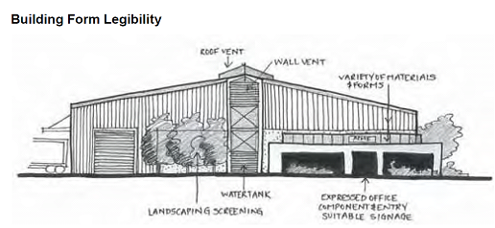

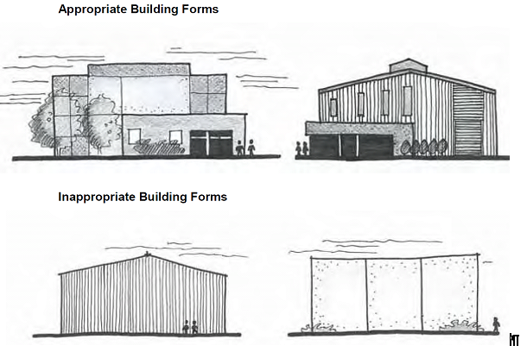

PO₅ Site layout facilitates the security of people and property having regard to:  opportunities for casual surveillance and sightlines;  exterior building designs which promote safety;  adequate definition of uses and ownership;  adequate lighting;  appropriate way-finding mechanisms (e.g. signage);  minimisation of entrapment locations; and  building entrances, loading and storage areas being well lit and lockable after hours. | No acceptable outcome is nominated.
PO₆ Development is designed to incorporate graffiti-prevention measures. | AO_{6.1} Building design and layout discourages graffiti and incorporates the following elements where practical:  designs with an absence of ‘natural ladders’;  minimal unbroken vertical surface areas; and  graffiti-deterrent surface treatments.
Amenity
PO₇ Development minimises potential conflicts with, or impacts on, other uses having regard to vibration, odour, dust or other emissions to air. | AO_{7.1} Development achieves the air quality design objectives set out in the Environmental Protection (Air) Policy 2008.  AO_{7.2} Any industry that involves the storage of materials on site that are capable of generating air contaminants either by wind or when disturbed are managed by:  being wholly enclosed in storage bins; or  a watering program so material cannot become airborne.
PO₈ Development prevents or minimises the generation of any noise so that:  nuisance is not caused to adjoining premises or other nearby sensitive land uses; and  desired ambient noise levels in residential areas are not exceeded. | AO_{8.1} Development achieves the noise generation levels set out in the Environmental Protection (Noise) Policy 2008.
PO₉ Outdoor lighting does not adversely affect the amenity of adjoining properties or create a traffic hazard on adjacent roads. | AO_{9.1} Light emanating from any source complies with Australian Standard AS4282 Control of the Obtrusive Effects of Outdoor Lighting.  AO_{9.2} Outdoor lighting is provided in accordance with Australian Standard AS 1158.1.1 – Road Lighting – Vehicular Traffic (Category V) Lighting – Performance and Installation Design Requirements.
PO₁₀ Development provides for the collection, treatment and disposal of liquid wastes or sources of contamination such that off-site releases of contaminants do not occur. | AO_{10.1} Areas where potentially contaminating substances are stored or used, are:  roofed and sealed with concrete, asphalt or similar impervious substance and bunded; and  located in a flood free area of a 1 in 100 year flood event.  AO_{10.2} Provision is made for spills to be bunded and retained on site for removal and disposal by an approved means.  AO_{10.3} Roof water is piped away from areas of potential contamination.
PO₁₁ Development is designed and managed so that it provides appropriate protection for community safety and health and avoids unacceptable risk to life and property. | No acceptable outcome is nominated.

Markets Code

Application

This code applies to assessable development identified as requiring assessment against the Markets Code by the categories of development and assessment tables in Part 5 – Tables of Assessment

Purpose

The purpose of the Markets Code is to ensure markets are operated so that adverse impacts on the amenity of the surrounding area are avoided or minimised.

The purpose of the code will be achieved through the following overall outcomes:

markets are appropriately located and managed to ensure there are no unacceptable impacts on traffic movement, safety, amenity, health or infrastructure; and

premises for a market are maintained in a presentable condition between periods of market operation.

Requirements for accepted development and assessment benchmarks for assessable development
Table 9.3.6:1 – Markets Code – Requirements for accepted development,
Performance outcomes | Acceptable outcomes
Amenity
PO₁ Where provided, outdoor lighting does not adversely affect the amenity of the locality or create a traffic hazard on adjacent roads. | AO_{1.1} Light emanating from any source complies with Australian Standard AS4282 Control of the Obtrusive Effects of Outdoor Lighting.  AO_{1.2} Outdoor lighting is provided in accordance with Australian Standard AS 1158.1.1 – Road Lighting – Vehicular Traffic (Category V) Lighting – Performance and Installation Design Requirements.
PO₂ Operation of the use is respectful of the character of the locality. | AO_{2.1} The market is not open to the public outside the hours of 7:00 am to 9:00 pm.  AO_{2.2} Setup and packup of the market does not occur outside the hours of 5.00am to 11:00 pm.  AO_{2.3} The site is used for a market no more than once a month.
PO₃ Development prevents or minimises the generation of any noise so that:  nuisance is not caused to adjoining premises or other nearby noise sensitive areas; and  desired ambient noise levels in residential areas are not exceeded. | AO_{3.1} Development achieves the noise generation levels set out in the Environmental Protection (Noise) Policy 2008.
PO₄ The ongoing operation of the use does not create nuisance beyond the site due to the emission of air borne contaminants. | AO_{4.1} No particulate matter or visible contaminant, including dust, smoke, fumes and aerosols likely to cause environmental harm or nuisance emanates beyond the boundaries of the Premises.
PO₅ Development provides for the disposal of wastes in a manner that protects public health and avoids environmental nuisance or harm. | AO_{5.1} Where not connected to Council’s reticulated wastewater system, all wastes are contained in an on-site disposal system for the duration of the development, and carried off-site for treatment and disposal.  AO_{5.2} No wastes are disposed of into a waterway or drain.  AO_{5.3} Solid wastes are collected and stored in an enclosed refuse container and carried off-site for treatment and disposal.
PO₆ Any animals involved in the use are managed to protect public health and safety, and avoid environmental nuisance or harm. | AO_{6.1} No animals remain on the site outside the general operating hours of the use.
PO₇ The use is operated safely and efficiently. | AO_{7.2} A person associated with the management of the use is on the property at all times, for the duration of the use.  AO_{7.3} The premises is cleaned and restored to its original condition on completion of the use.
PO₈ Contaminants and contaminated water are not directly or indirectly released from the premises unless directed to an appropriate disposal point. | AO_{8.1} Contaminants or contaminated water is not directly or indirectly released from the premises except for:  - Uncontaminated overland stormwater flow;  - Uncontaminated stormwater to the stormwater system;  - Contaminants released to sewer under and in accordance with a trade waste permit granted by the local government under the Water Supply (Safety and Reliability) Act 2008.
Layout of Markets
PO₉ Markets are designed to provide for:  convenient pedestrian access and movement;  legibility between stalls and existing surrounding uses;  pedestrian comfort and safety, including the provision of public convenience facilities;  waste disposal facilities appropriate to the type and scale of use; and  (e) the parking of stallholders vehicles. | AO_{9.1} Pedestrian access or pathways a minimum of 2m wide are provided between:  stall fronts; and  stalls and existing shop fronts.  AO_{9.2} Where the market is conducted on a footpath and the adjoining road remains open to vehicle use, a minimum 1.2m clearance from the kerb to any market structure or use area is provided.  AO_{9.3} The site layout of the stalls provides view corridors and pedestrian circulation access to adjacent businesses and advertising signs.  AO_{9.4} Waste containers are provided on the premises for the disposal of waste from stall holders (operators) and the public at a rate of:  one (1) container for each food stall operator (not including existing street bins); and  sufficient containers for waste generated from each other (non-food) stall (not including existing street bins).  AO_{9.5} Space is allocated on the site for the parking of stallholder vehicles either as part of or contiguous to each stall or within a separate part of the site specifically designated for this purpose.  AO_{9.6} Stallholder parking spaces and access lanes are dimensioned in accordance with AS 2890.1-1993 Parking Facilities - Off-street Car Parking.

Table 9.3.6:2 – Markets Code – assessment benchmarks for assessable development
Performance outcomes | Acceptable outcomes
Site Area
PO₁ Development, for the duration of the use, is on a site of sufficient size to accommodate:  the proposed activity; and  the expected number of visitors/users. | AO_{1.1} Development is carried out on a site with a minimum site area of 1,000m².  AO_{1.2} Car parking is provided in accordance with Table 9.4.6:3 in the Transport, Access and Parking Code.
Amenity
PO₂ Development provides adequate separation, buffering and screening from residential premises so that the privacy and amenity of such premises are not adversely affected. | AO_{2.1} Temporary structures, active outdoor use areas, site access and car parking, servicing or storage areas are set back from any boundary adjoining residential premises a minimum of 6m.
PO₃ Where provided, outdoor lighting does not adversely affect the amenity of the locality or create a traffic hazard on adjacent roads. | AO_{3.1} Light emanating from any source complies with Australian Standard AS4282 Control of the Obtrusive Effects of Outdoor Lighting.  AO_{3.2} Outdoor lighting is provided in accordance with Australian Standard AS 1158.1.1 – Road Lighting – Vehicular Traffic (Category V) Lighting – Performance and Installation Design Requirements.
PO₄ Operation of the use is respectful of the character of the locality. | AO_{4.1} The use is only operated and open to the public between the hours of 7:00 am to 6:00 pm Monday to Sunday.  AO_{4.2} Setup and packup of the market does not occur outside the hours of 5.00am to 7:00 pm.
PO₅ Development prevents or minimises the generation of any noise so that:  nuisance is not caused to adjoining premises or other nearby noise sensitive areas; and  desired ambient noise levels in residential areas are not exceeded. | AO_{5.1} Development achieves the noise generation levels set out in the Environmental Protection (Noise) Policy 2008.
PO₆ Development provides for the disposal of wastes in a manner that protects public health and avoids environmental nuisance or harm. | AO_{6.1} Where not connected to Council’s reticulated wastewater system, all wastes are contained in an on-site disposal system for the duration of the development, and carried off-site for treatment and disposal.  AO_{6.2} No wastes are disposed of into a waterway or drain.  AO_{6.3} Solid wastes are collected and stored in an enclosed refuse container and carried off-site for treatment and disposal.
PO₇ Any animals involved in the use are managed to protect public health and safety, and avoid environmental nuisance or harm. | AO_{7.1} No animals remain on the site outside the general operating hours of the use.  AO_{7.2} Any animals involved with a market are exercised only within the property boundaries.  AO_{7.3} Animal wastes are collected and disposed of daily.
PO₈ The use is operated safely and efficiently. | AO_{8.1} When appropriate, the following control measures are implemented:  crowd or pedestrian control measures;  traffic control measures; and  security measures.  AO_{8.2} A person associated with the management of the use is on the property at all times, for the duration of the use.  AO_{8.3} The premises is cleaned and restored to the original condition on completion of the use.
Layout of Markets
PO₉ Markets are designed to provide for:  convenient pedestrian access and movement;  legibility between stalls and existing surrounding uses;  pedestrian comfort and safety, including the provision of public convenience facilities; and  waste disposal facilities appropriate to the type and scale of use. | AO_{9.1} Pedestrian access or pathways a minimum of 2m wide are provided between:  stall fronts; and  stalls and existing shop fronts.  AO_{9.2} Where the market is conducted on a footpath and the adjoining road remains open to vehicle use, a minimum 1.2m clearance from the kerb to any market structure or use area is provided.  AO_{9.3} The site layout of the stalls provides view corridors and pedestrian circulation access to adjacent businesses and advertising signs.  AO_{9.4} Waste containers are provided on the premises for the disposal of waste from stall holders (operators) and the public at a rate of:  one (1) container for each food stall operator (not including existing street bins); and  sufficient containers for waste generated from each other (non-food) stall (not including existing street bins).
AO_{9.5} Public toilets are:
provided within the area of the market; or
located within 200m of the market.
AO_{9.6} Public signage is provided to identify the location of and the entry to public toilet facilities.
PO₁₀ Provision is made for emergency vehicle access to and within the market. | AO_{10.1} A clear movement path, at least 3m in width, is maintained through or around the market to allow emergency vehicle access.

Medium Density Residential Code,

Application

This code applies to assessable development identified as requiring assessment against the Medium Density Residential Code by the categories of development and assessment tables in Part 5 – Tables of Assessment

Purpose

The purpose of the Medium Density Residential Code is to guide the development of the following uses to ensure that medium density residential development creates pleasant, safe and attractive living environments while facilitating a range of housing types that sensitively blend with existing streetscapes and neighbourhoods and facilitate increased population within proximity to major centres:

Dual Occupancy

Dwelling House (where on a hatchet lot which is 450m² or greater)

Multiple Dwelling.

Nature-based Tourism.

Non-resident Workforce Accommodation.

Relocatable Home Park.

Residential Care Facility.

Retirement Facility.

Resort Complex.

Rooming Accommodation.

Short-Term Accommodation.

Tourist Park.

The purpose of the code will be achieved through the following overall outcomes:

the character, scale and density of development are commensurate with the purpose and overall outcomes of the zone and (where applicable) zone precinct in which the development is proposed;

Dual occupancy development is integrated within residential neighbourhoods in a dispersed manner, distributing density in a way that has regard to the existing /intended character of the neighbourhood and zone in which it is located;

The design and layout of the development:

enhances access to housing diversity, offering choice to different household types and individuals to suit residents through different life-cycle stages;

reflects and contributes to the qualities of the local streetscape and Toowoomba’s Garden City character;

responds to the site’s natural and built context, such as orientation, topography, vegetation and climate and nearby buildings’ aesthetic qualities such as their scale, form and materials;

has a density appropriate for a site and its context in keeping with existing or preferred transitional neighbourhood character;

provides design elements that reflect and enhance local character and identity and strengthens site features such as views, heritage values and significant vegetation;

provides an appropriate scale in terms of the bulk and height relative to the scale of the street and surrounding buildings (in keeping with existing or preferred transitional neighbourhood character);

maintains neighbourhood amenity and does not create unacceptable impacts on surrounding premises;

achieves an appropriate built form for a site and building in terms of building alignment and proportions;

provides safe and equitable access for pedestrians and vehicles;

facilitates a high level of residential amenity, including provision of adequate safety, privacy, access to sunlight and open space within the site and to adjacent properties; and

incorporates high-quality landscaping that contributes to the desired character of the area and recognises that landscape and buildings operate as an integrated and sustainable system.

Requirements for accepted development and assessment benchmarks for assessable development
Table 9.3.7:1 – Medium Density Residential Code – Requirements for accepted development and assessment benchmarks for assessable development
Performance outcomes | Acceptable outcomes
Where a Dual Occupancy
PO₁ Dual Occupancy development is dispersed within residential neighbourhoods, not clustering in groups of more than three adjoining or opposite sites, and does not become the dominant form of housing within a street by occupying more than 20 percent of properties within a street block. | AO_{1.1} In Greenfield Areas Dual Occupancy development occurs on designated Dual Occupancy lots.

 | Performance outcomes | Acceptable outcomes
 | PO₂ The development is designed in a manner that responds to the sites opportunities and constraints, including any existing building on the lot, and to the broader urban and streetscape contexts.  Note: Development should be designed and documented by a suitably qualified professional (i.e. architect or building designer). Details of professional qualifications should be noted on drawings submitted with any development application | AO_{2.1} The design of the development considers and responds to:  - Site specific qualities including:  - site topography and slope (contours at a minimum of 1m intervals);  - Views  - solar aspect and access;  - prevailing breezes  - existing buildings on the site;  - site access  - services  - identification of buildings to be demolished;  - existing vegetation (locations to be surveyed and the diameter of the trunk at 1m above ground level shown. On highly buttressed trees the extent of buttressed roots is to be shown);  - proposed position of new buildings overlaid  - Nearby features including:  - opportunities for on street visitor car parking;  - buildings on adjoining land  - important views from neighbouring properties  - features and character of adjoining land and buildings including doors & windows  - street fixtures;  - Local qualities and amenities including:  - available public transport;  - nearby amenities such as parks, shops  AO_{2.2} Site design retains all existing street trees.  Note: See Figure 1 below for examples of site analysis and nearby feature plans.
 | 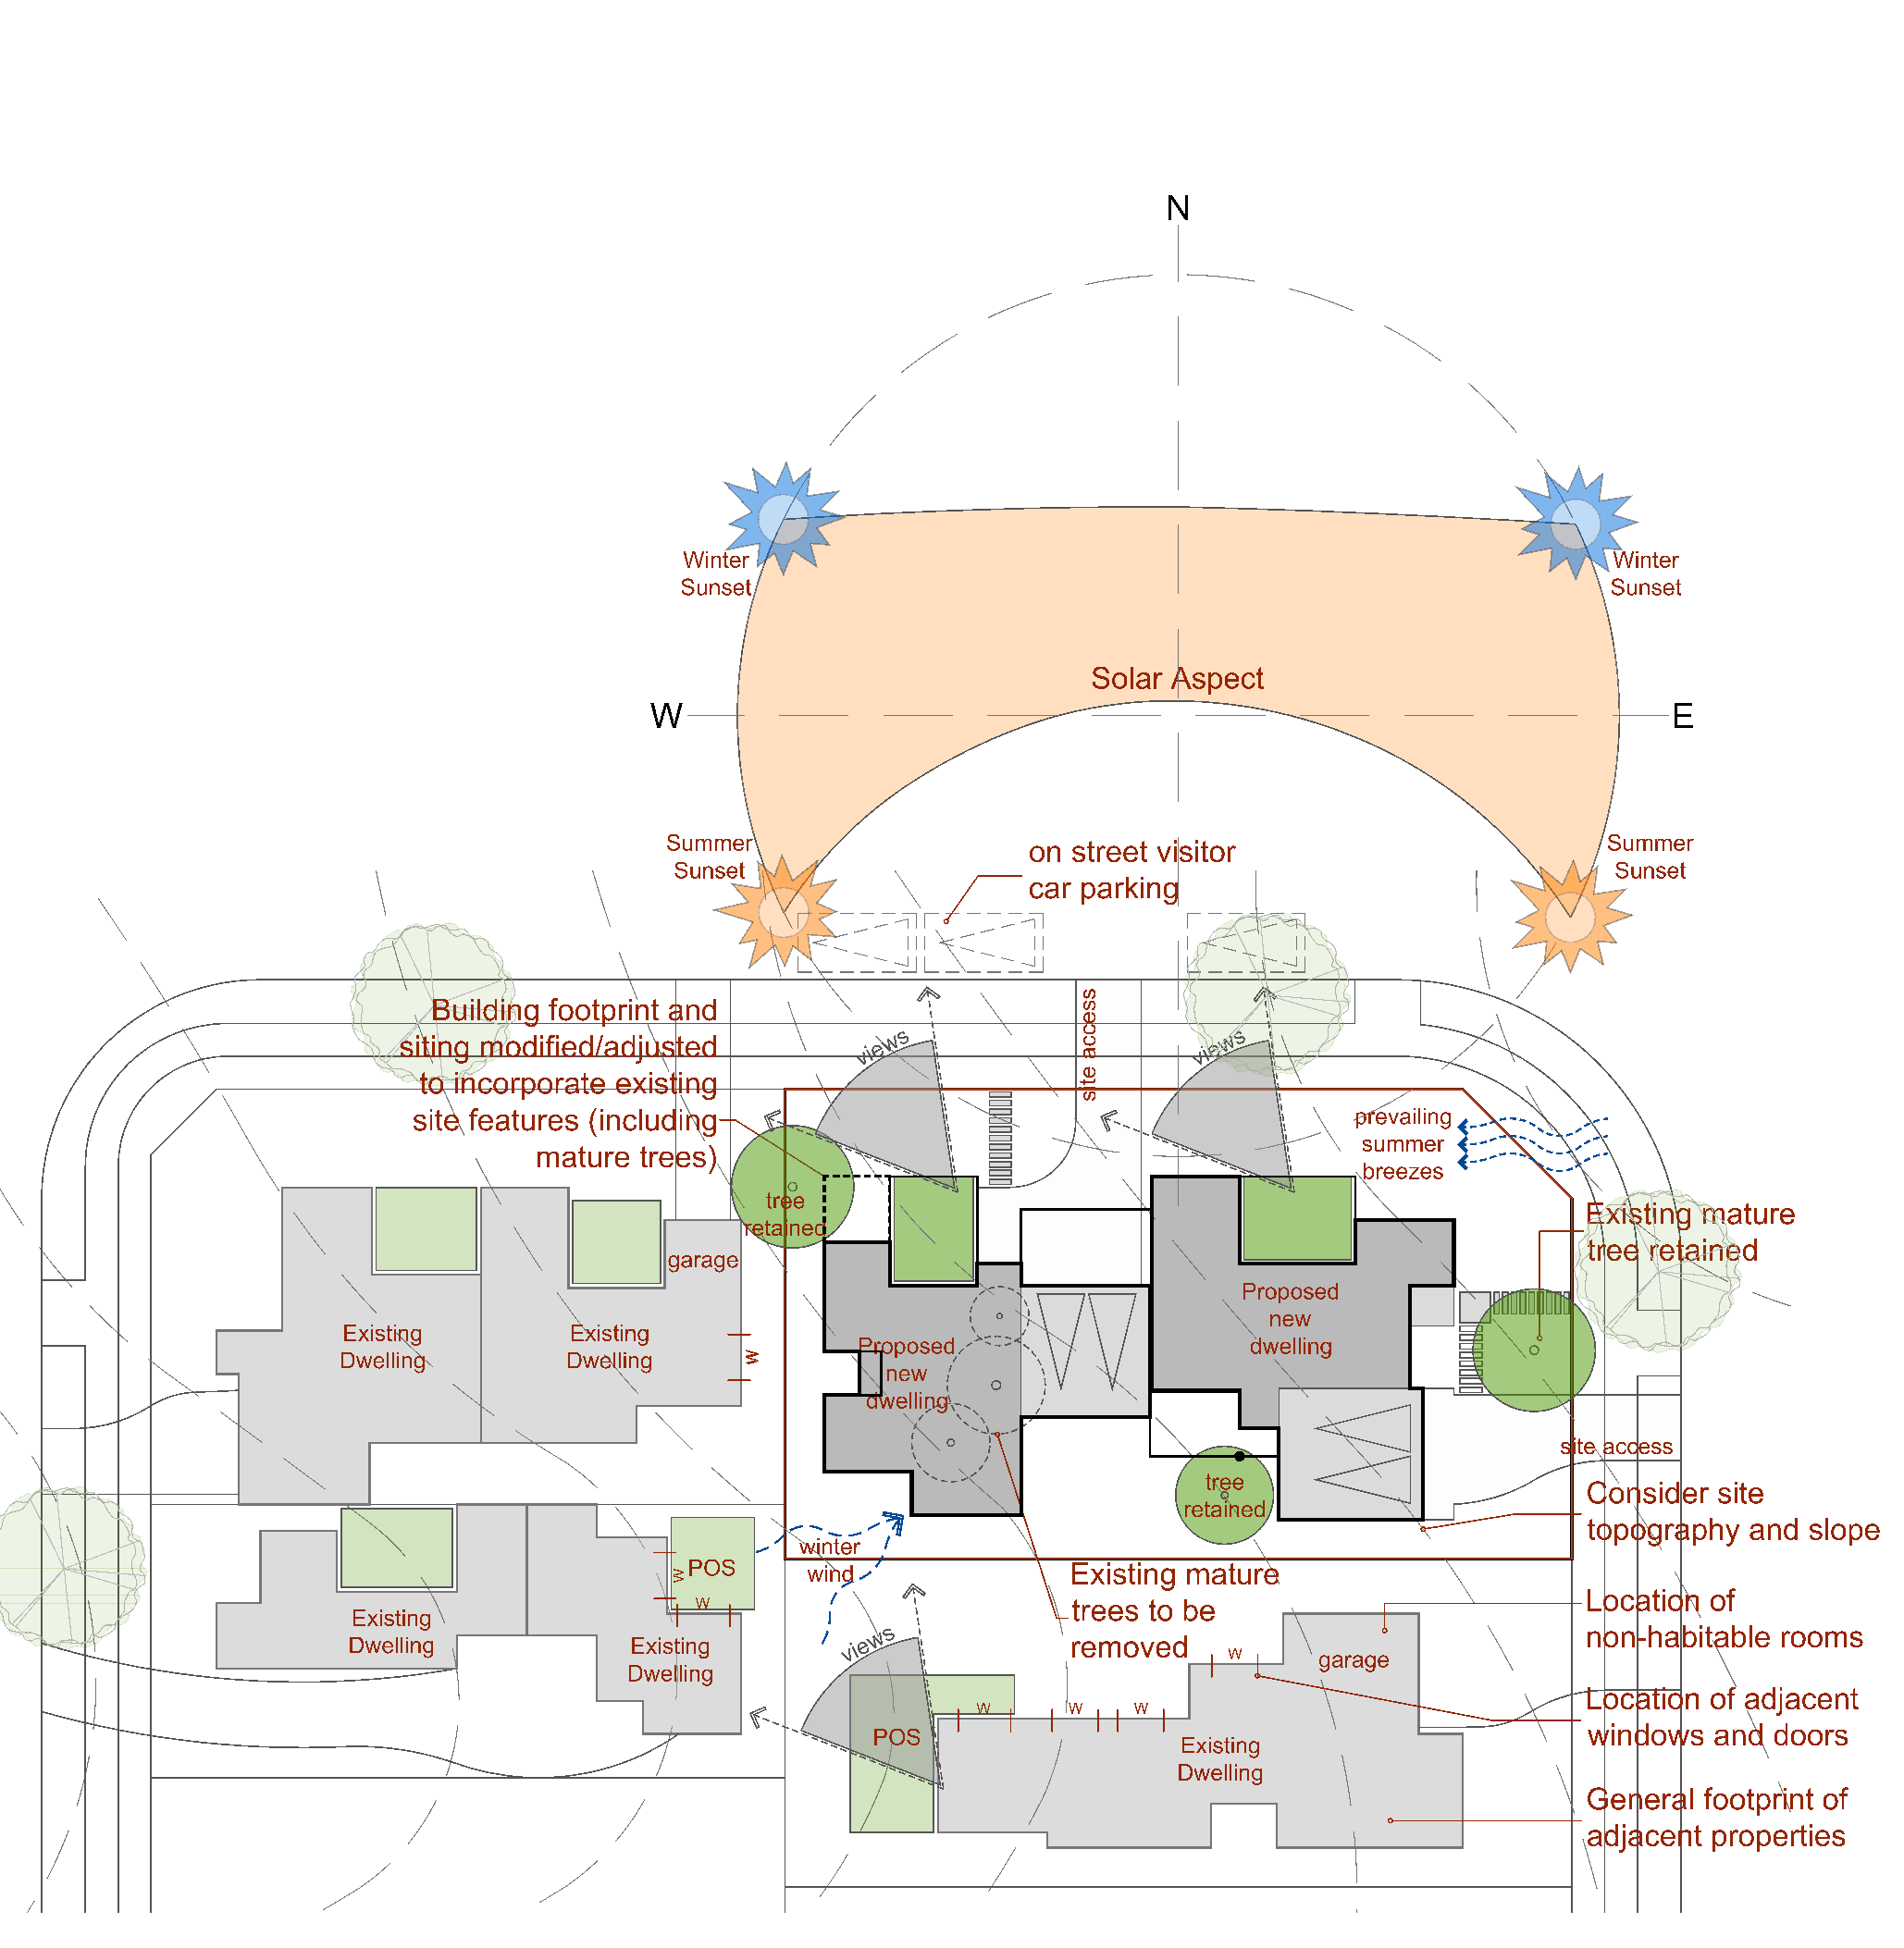 Figure 1
 | PO₃ Development responds to the slope of the land in the siting, design and form of buildings and structures to minimise requirements for cut and fill. | AO_{3.1} Cut and fill beyond natural ground level does not exceed a vertical distance of 1m, unless contained within building walls and in accordance with the requirements outlined in SC6.2 PSP No. 2 – Engineering Standards – Roads and Drainage Infrastructure.  Note: See Figure 2.  AO_{3.2} Batters and earth-retaining structures are constructed in accordance with SC6.2 PSP No. 2 – Engineering Standards – Roads and Drainage Infrastructure.
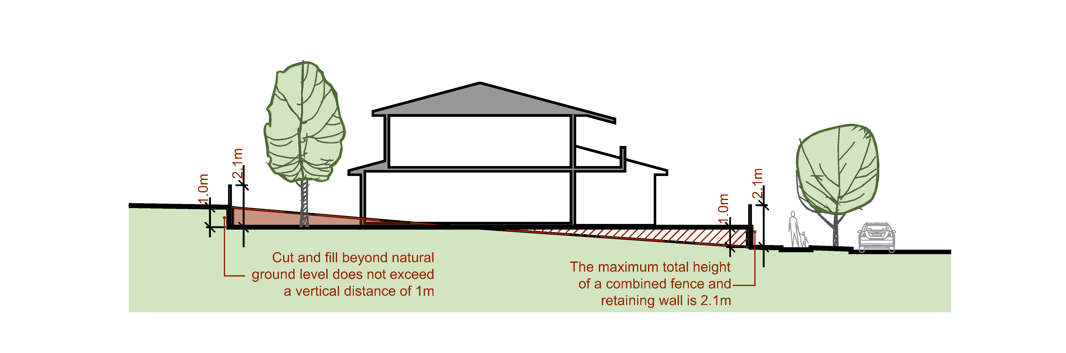
Figure 2
 | PO₄ Development is designed to facilitate the retention of any existing street tree adjacent to the site. | AO_{4.1} Development does not compromise or require the removal of any street tree.
 | PO₅ Development:  (a) provides for the on-site infiltration of stormwater and minimises the additional burden on drainage infrastructure;  (b) minimises the visual impact of hard surface areas; and  (c) respects the existing or preferred neighbourhood character and responds to the features of the site. | AO_{5.1} The impervious site cover does not exceed Table 1:  AO_{5.2} No more than 50% of the front setbacks area is impervious.  AO_{5.3} Site cover does not exceed rates specified in Table 2.  Note: See Figure 3.
  Table 1
  Average building height | Maximum impervious site cover
  If both of the proposed dwellings are 1 storey | 70%
  If one or both of the proposed dwellings is 2 storeys | 65%
  Table 2
  Dwelling Height | Maximum site cover
  If both of proposed dwellings are 1 storey | 50%
  If one of proposed dwellings is 2 storeys | 45%
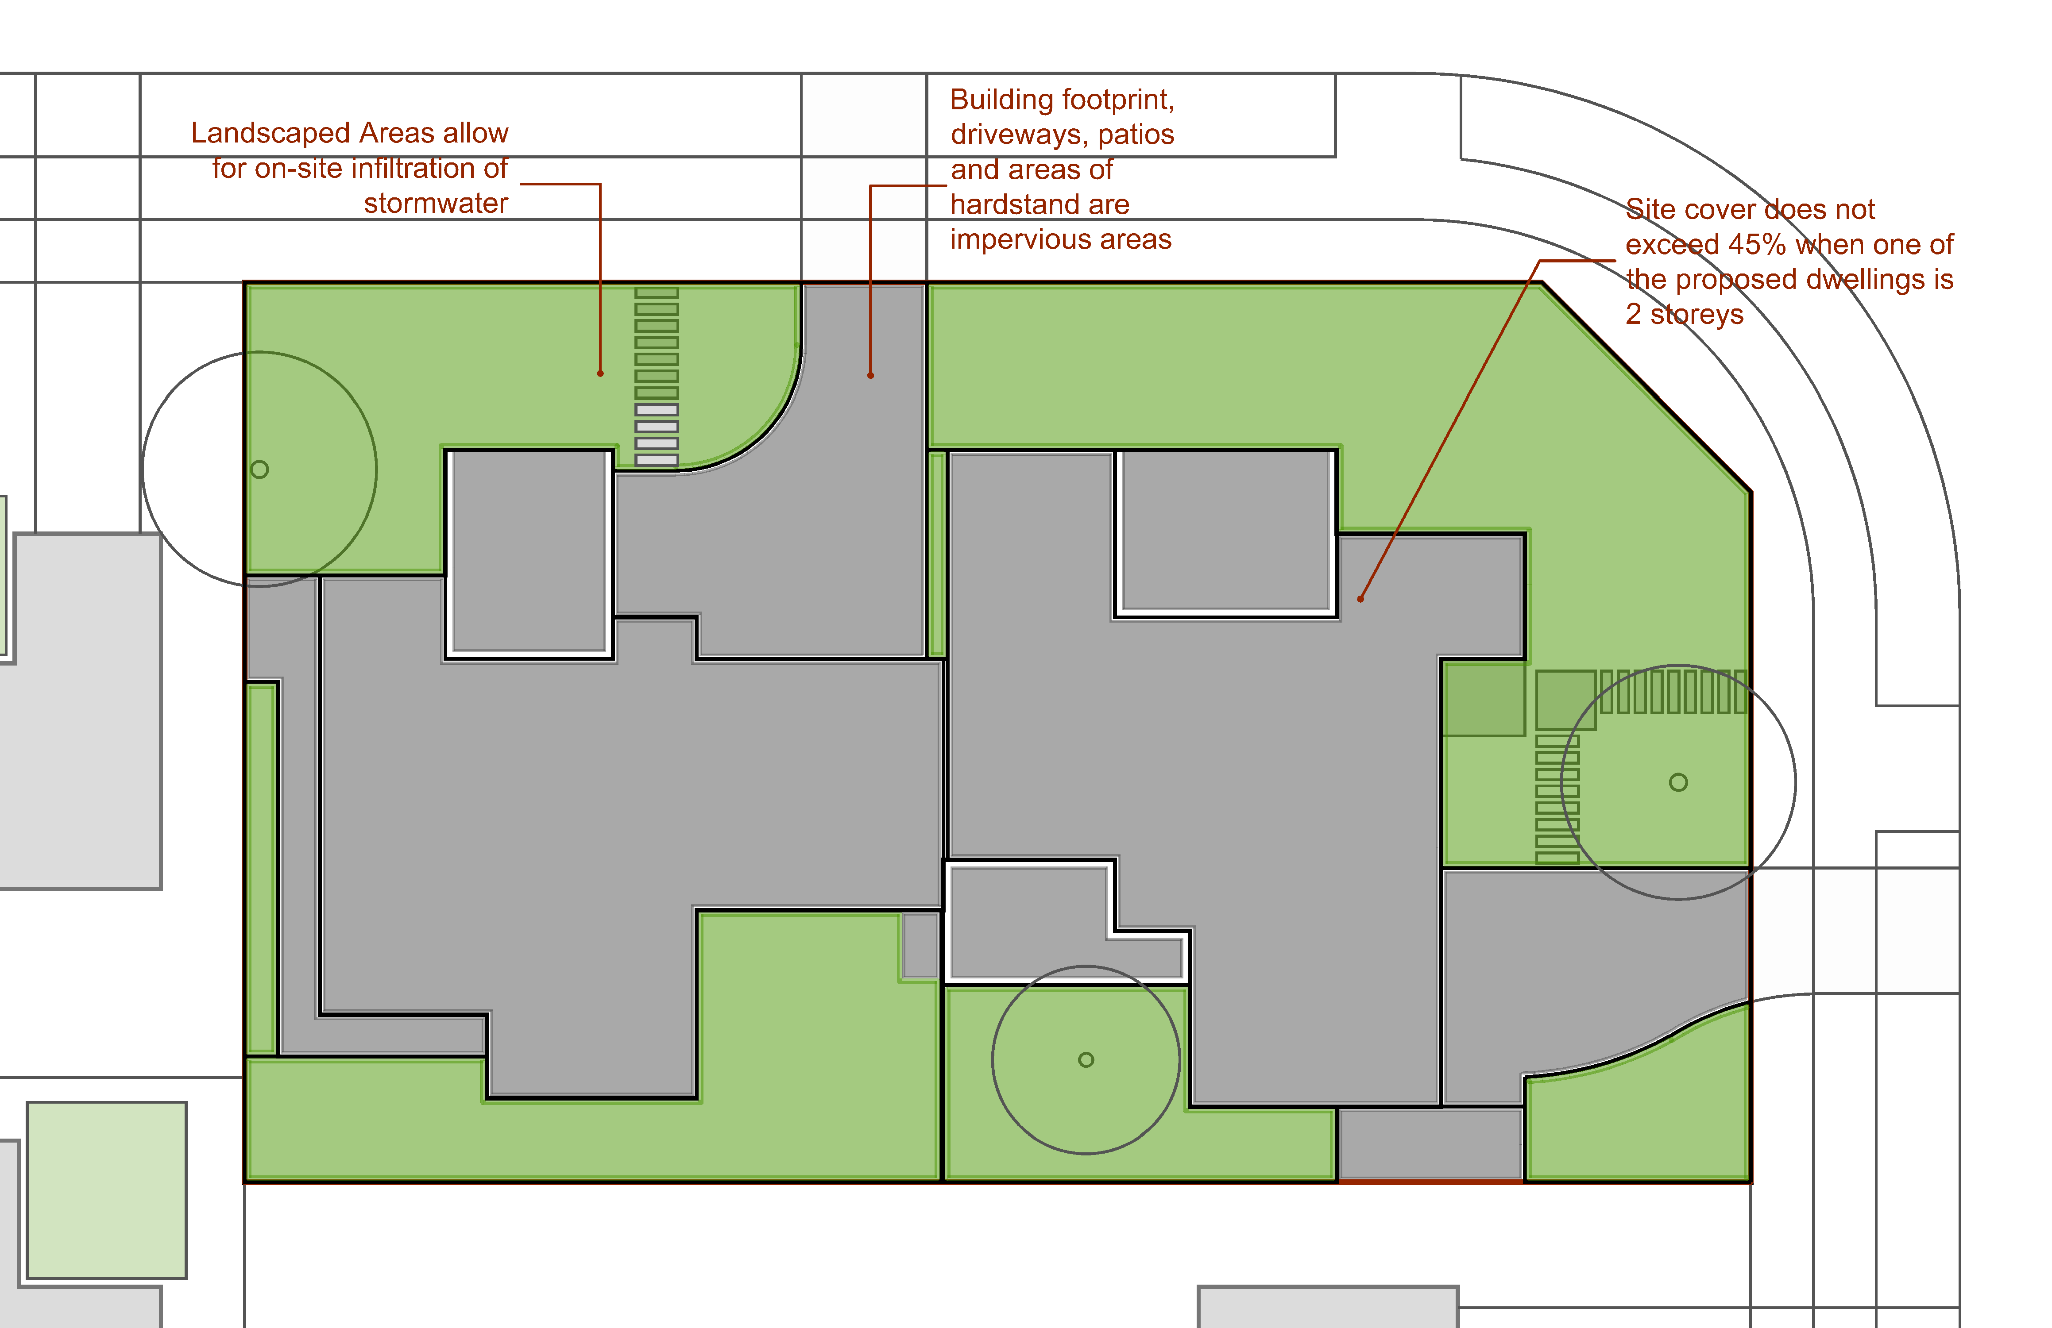
Figure 3
 | PO₆ Areas of hardstand required for parking and pathways:  are minimised,  incorporate generous landscaping:  to promote a garden streetscape character, and  to minimise visual impacts of views to hardstand areas for occupants and the public, particularly in the front garden. | AO_{6.1} Landscaped areas are provided in accordance with Table 3:  Note: Landscaped areas included in the calculations consist of garden beds and lawn areas throughout the site with a width of no less than 1.5m;  Excludes all paved and other impervious areas such as driveways, patios, terraces, car parking spaces and bin and other utility areas.  See Figure 4.
  Table 3
  Building height | Minimum landscaped area
  Building height | Where 80% or more of the front setback is landscaped area additional landscaping for the balance of the site must be a minimum of: | Where less than 80% of the front setback area is landscaped additional landscaping for the balance of the site must be a minimum of:
  1-2 storeys | 10% site area | 15% site area
  3 storeys | 12.5% site area | 17.5% site area
  4+ storeys | 15% site area | 20% site area
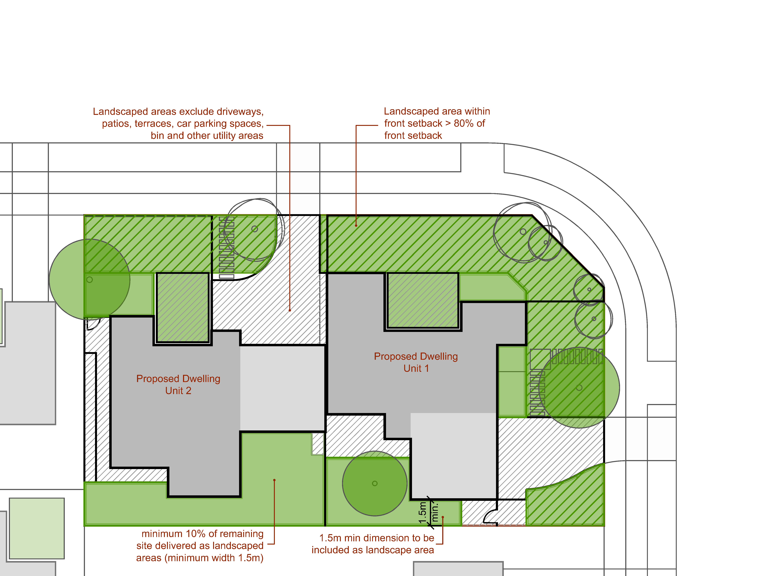
Figure 4
PO₇ The front building setback is consistent with the prevailing front setbacks of other residential buildings in the street.  Note: The prevailing setback of the street is determined by the setbacks of the residential buildings on any lot along the road within 100m of the site. |  |  | AO_{7.1} Buildings are setback from the road frontage:  - within 10% of the average front setback of existing residential buildings within 100m of the site; or  - where there is no adjoining buildings the front setback is provided in accordance with Table 4.  Note: See Figure 5.
  Table 4
  Building element | Minimum setback
  Solid building wall (other than a garage) | 4.0m
  Solid building wall (where for a garage) | 5.5m
  Permeable or non-enclosed elements (e.g. porch, verandah, balcony or carport) | 3.5m (or 3m where secondary road frontage)
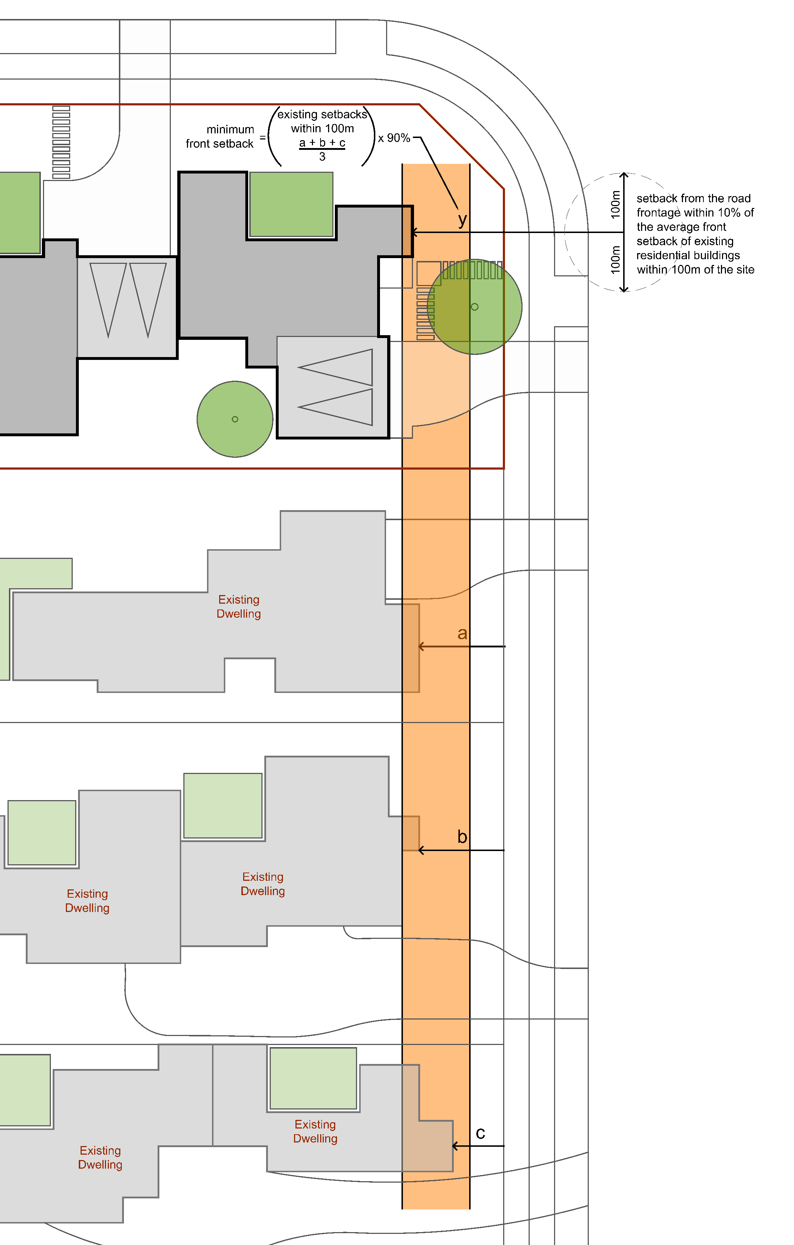
Figure 5
PO₈ Side and rear building setbacks:  (a) are appropriate to the scale of the development and the intended character of the zone and/or precinct and local plan in which the site is located;  (b) provide for adequate daylight for habitable rooms and open space areas on and adjoining the site; and  (c) are sufficient to minimise overshadowing and overlooking of adjoining premises. |  |  | AO_{8.1} Any part of a building built to a side boundary:  (a) must not exceed a maximum height of 3.5m;  (b) must not exceed a maximum length of 9m;  (c) must be a minimum distance of 2.4m from any other wall built to the side boundary (whether on the site or an adjoining site) or be joined to another built to boundary wall if on a adjoining site; and  (d) must not exceed a maximum total length of 50% of the side boundary.  OR  AO_{8.2} Buildings are set back from side boundaries in accordance with the following:  - For lots with frontages less than 20m:  - 1.2m for any part of the building up to 3.5m high; and  - 2m for any part of the building above 3.5m high.  - For lots with frontages greater than 20m:  - 1.8m for any part of the building up to 3.5m high; and  - 2.4m for any part of the building above 3.5m high.  AO_{8.3} Buildings are set back from the rear boundary a minimum of 3m.  AO_{8.4} Development ensures that solar access to habitable rooms and private open space of adjoining premises: -  - achieves a minimum of 3 hours of sunlight between 9am and 3pm on June 21; or  - is not further reduced where existing solar access is less than that specified in (a).  Note: See Figure 6.
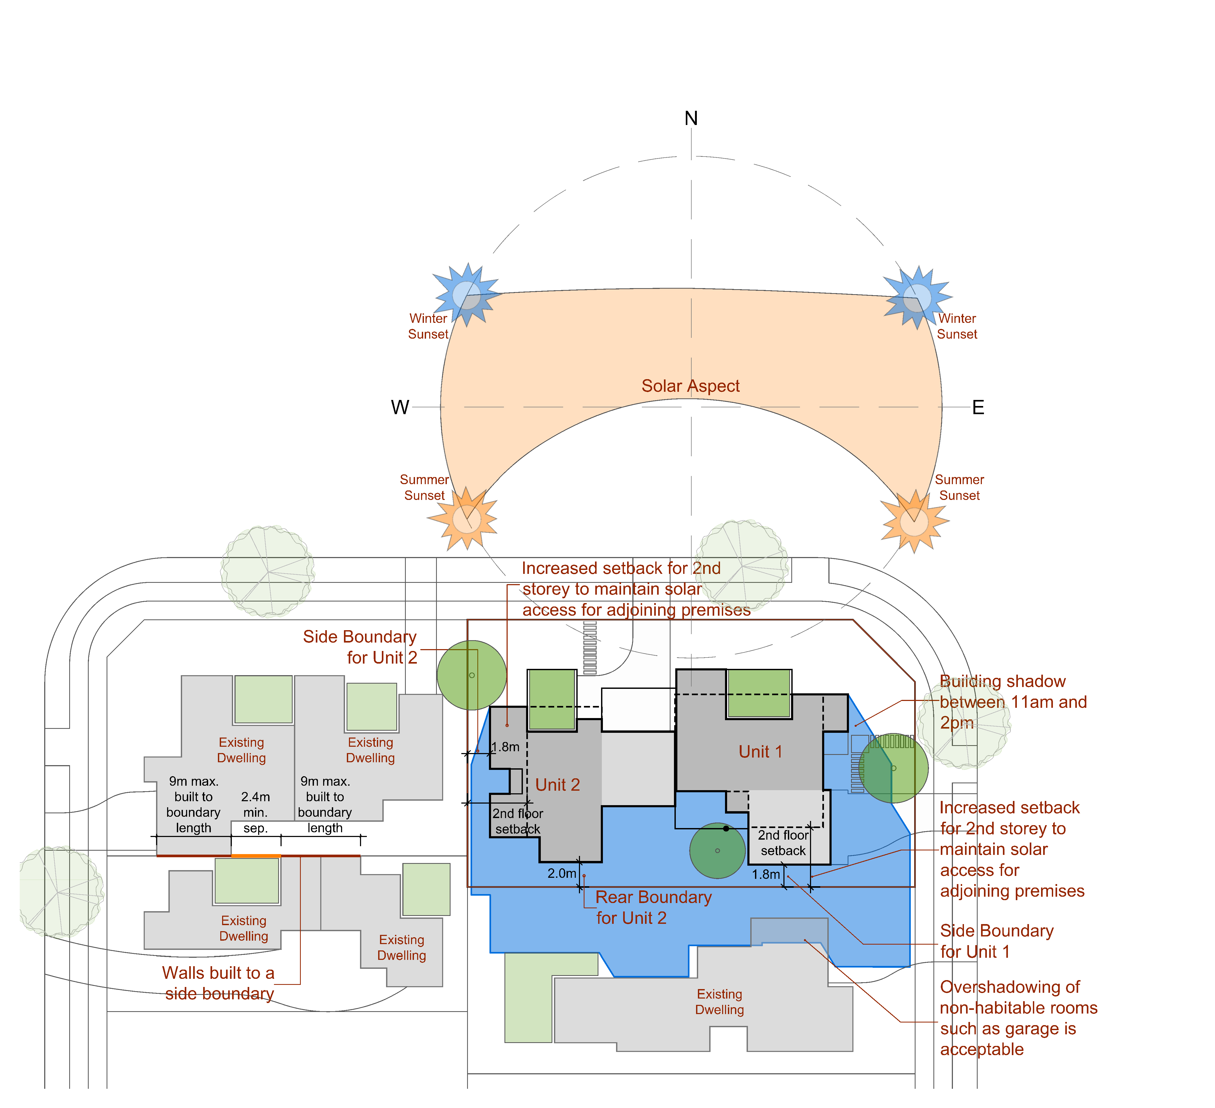
Figure 6

 |  | Performance outcomes |  | Acceptable outcomes
 |  | PO₉ Development provides adequate and suitable private open space to meet the needs of occupants for privacy, relaxation and entertainment and to accommodate visitors. |  | AO_{9.1} Private open space has a minimum area of 16m² and minimum dimensions of 4 metres by 4 metres.  AO_{9.2} Private open space is:  - is oriented to receive at least three hours of sun between 9am and 5pm on 21 June.  - directly accessible from a living area or kitchen;  - fenced or landscaped to achieve privacy for occupants;  - clear of bins, clothes lines, hot water systems, air conditioning units, above ground water tanks and associated infrastructure and other forms of ancillary equipment and  - not located within the front setback area.  Note: See Figure 7.
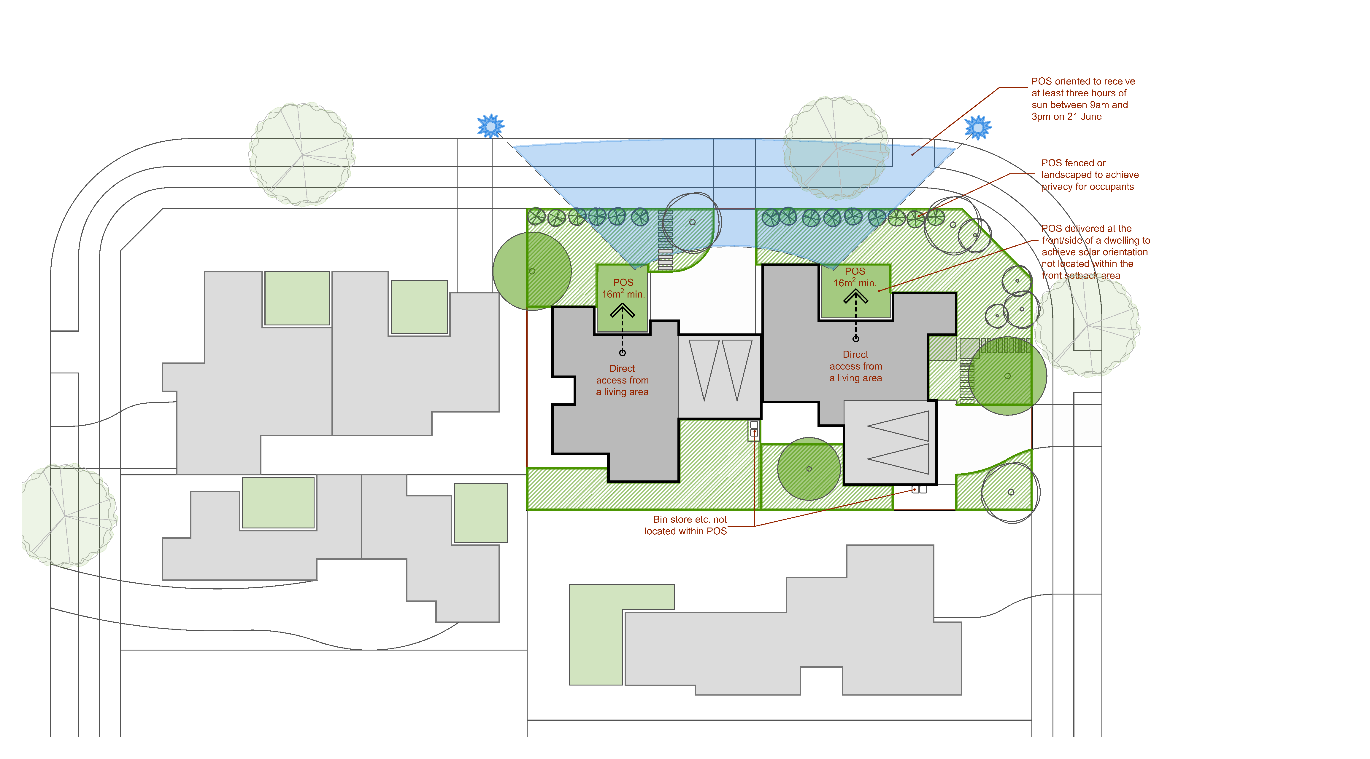
Figure 7
 |  | PO₁₀ All car parking is designed to accommodate a standard car (B85 vehicle) and incorporates adequate manoeuvring area to parking spaces (including carports and garages). | AO_{10.1} Design of the site layout must ensure a B85 vehicle (as defined in AS 2890.1:2004 Parking facilities - Off-street car parking) is able to enter an enclosed garage or visitor car park in a single forward manoeuvre and exit in a single reverse manoeuvre.
 |  | PO₁₁ Development provides resident and visitor car parking which is integrated into the site and building design and:  (a) does not negatively impact the amenity of the site, adjoining sites or streetscape;  (b) is not a prominent visual feature from the street or other public spaces; and  (c) contributes to the establishment of a garden setting by avoiding large areas of visible hardstand. | AO_{11.1} Parking is only provided within the front setback area where it is:  (a) located on the driveway directly in front of a carport or garage; and  (b) not covered.  Note: Where car parking is provided in accordance with AO11.1(a) the driveway should have a minimum length of 5 metres to avoid parked vehicles extending beyond the site boundary.  AO_{11.2} Where car parking is provided below ground:  (a) Access ramps are not located within 6m of the street boundary and do not exceed an opening width of 6m; and  (b) Entry to the site for pedestrians is provided separate from vehicle entries by way of a safe, well lit and clearly identifiable pathway or gatehouse;  AO_{11.3} All car parking is freely available for use by to the applicable occupants and visitors of the development.  Note: See Figure 8.
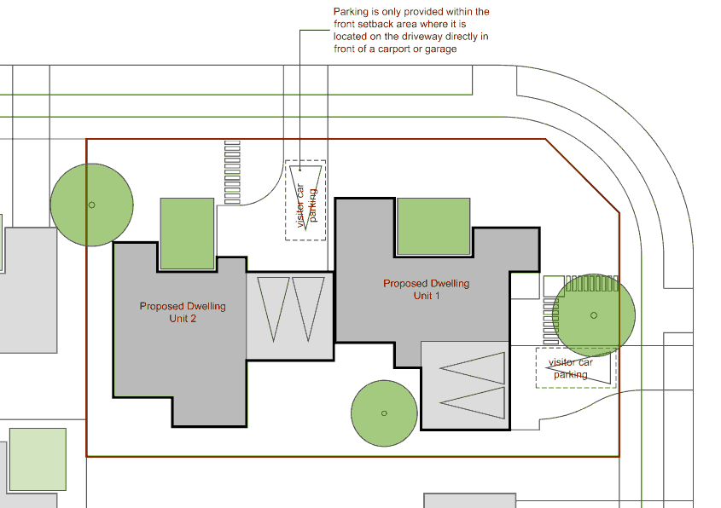
Figure 8
 |  | PO₁₂ Garages and carports (except those with frontage to a rear lane) do not dominate the street frontage. | AO_{12.1} Garages and/or carports facing a street make up no more than 30% of the width of the site.  AO_{12.2} Garages and/or carports facing a street are setback a minimum of 1 metre behind the main face of the dwelling.  Note: See Figures 9 and 10.
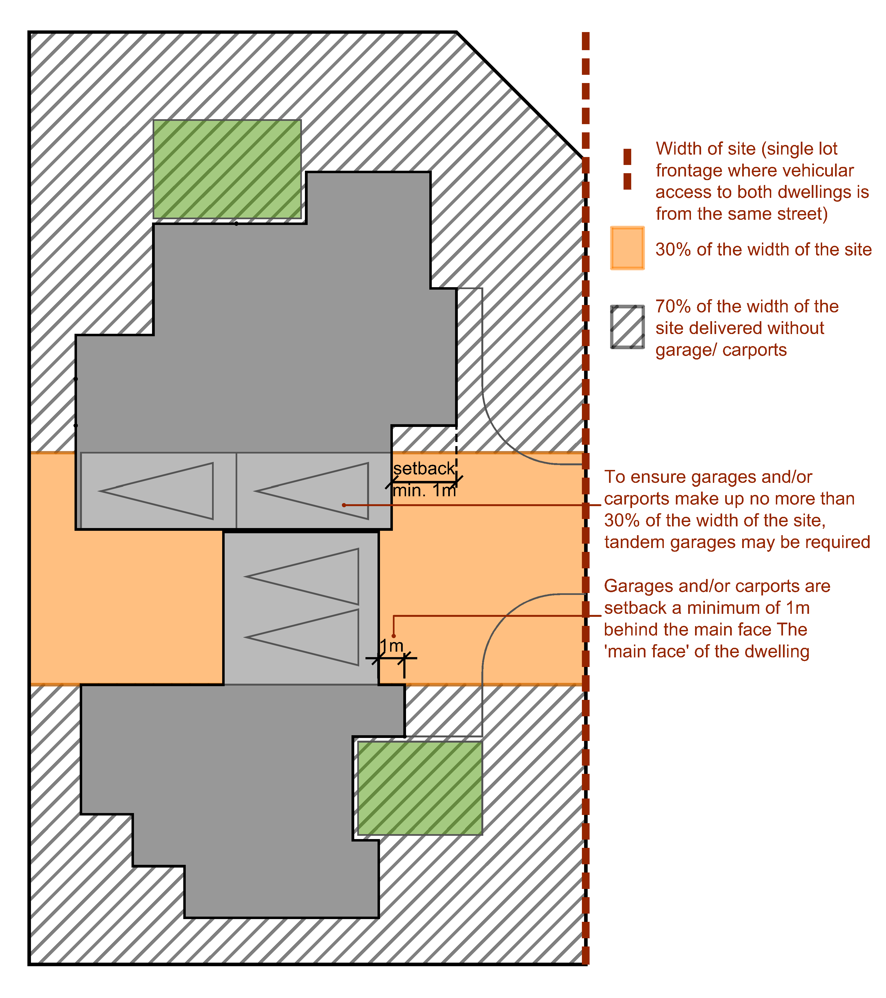
Figure 9
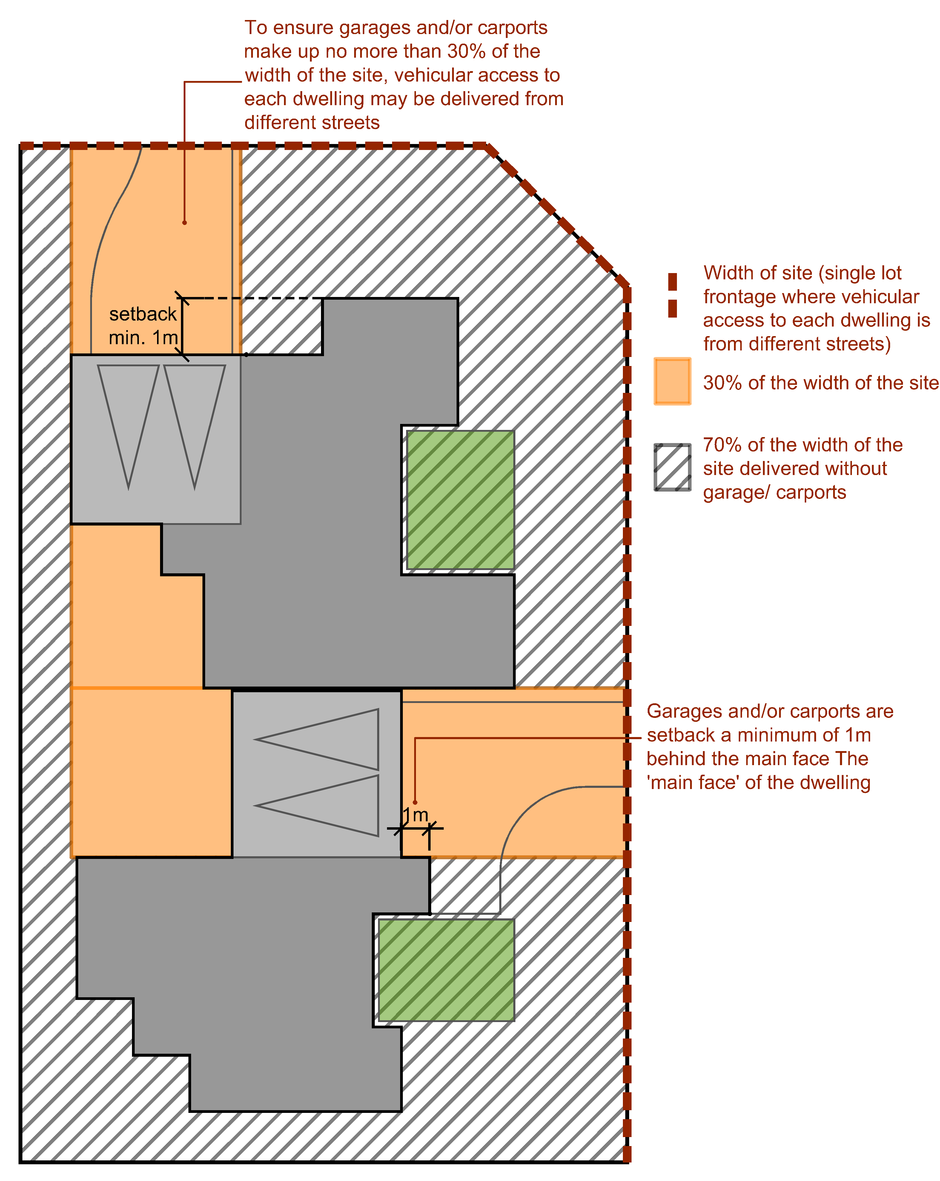
Figure 10
 | PO₁₃ Safe and equitable access for both pedestrians and vehicles is provided, to and from buildings and the street whilst minimising the extent and number of driveways. |  | AO_{13.1} Where vehicular access to both dwellings is from the same street the driveway is shared and has a maximum crossover width of 5m.  AO_{13.2} Where vehicular access to each dwelling is from different streets the driveway has a maximum crossover width of 3m.  AO_{13.3} Where the site abuts a lane vehicle access is provided from the lane.  AO_{13.4} Separate pedestrian access is provided to each dwelling, clearly distinguishable from the vehicle zone.  Note: See Figure 11.
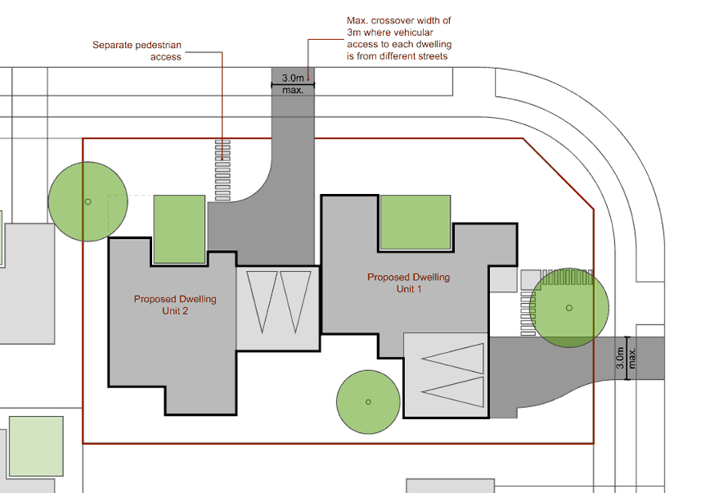
Figure 11
 | PO₁₄ The privacy of residents of the development or adjoining premises is protected when they are inside a dwelling or in a private open space area. |  | AO_{14.1} Habitable room windows of a dwelling are separated a minimum of 9m from a habitable room window or private open space of another dwelling on the same or an adjoining site.  OR  AO_{14.2} Where there is a direct view within 9m into a habitable room or private open space of another dwelling on the same or an adjoining site  - the elements with the view such as windows, balconies, or terraces of a dwelling must be screened in accordance with AO14.3; or  - the Windows have translucent glazing up to or sill heights of at least 1.5m from the internal floor level; or  - a solid fence or masonary wall with a minimum height of 1.5m is positioned between the elements with the view.  AO_{14.3} Where screening is used, it:  - is a solid translucent screen or a louvre perforated panel, trellis or the like that has a maximum of 50% open to solid ratio; and  - is a fixed, permanent element of a design that complements the style, detailing and materials of the development.  Note: See Figure 12.
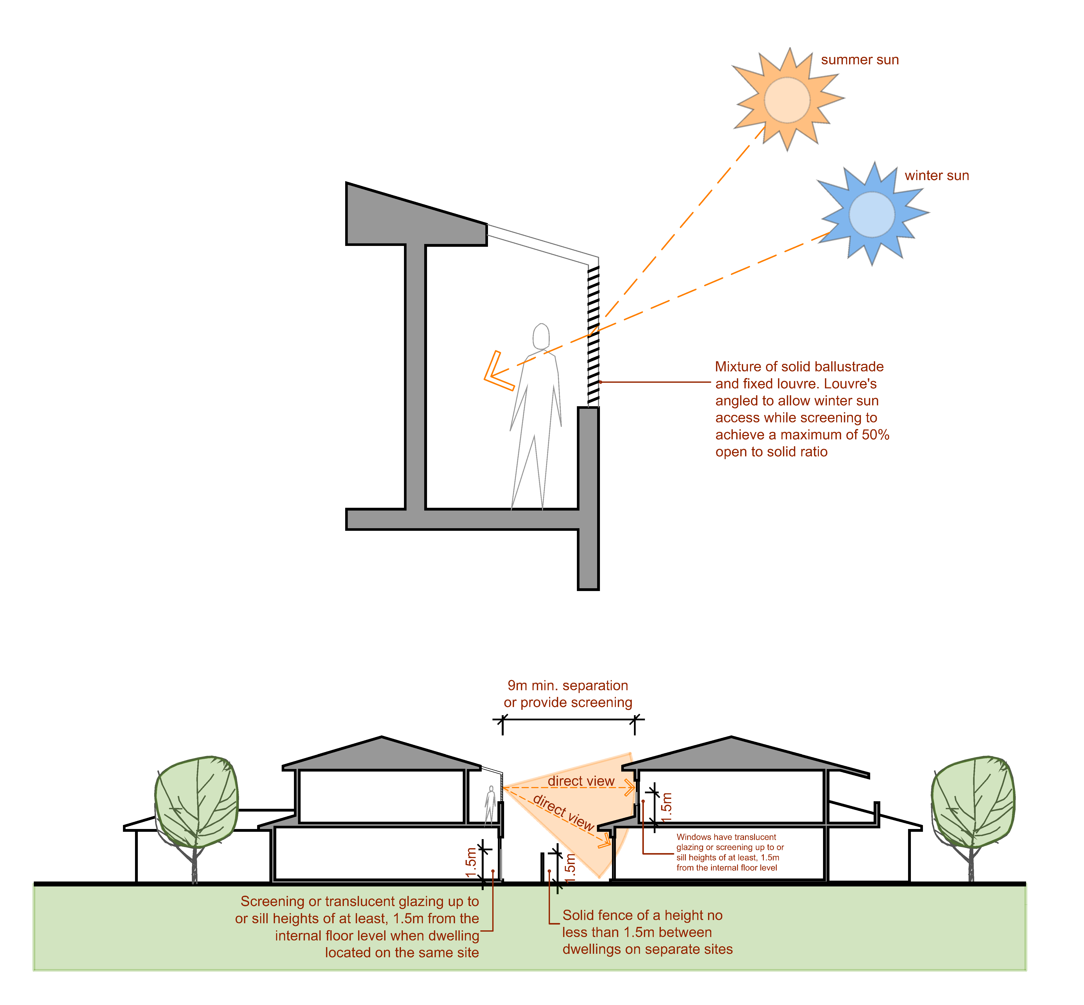
Figure 12
 | PO₁₅ The development is designed so that occupants are not adversely affected by adjoining non-residential uses. |  | AO_{15.1} A 1.8m high solid screen fence and 2m wide vegetated buffer is provided along any section of the site boundary that is common with vehicle movement and/or parking areas associated with a non-residential use on an adjoining site.
PO₁₆ Buildings are designed to a high aesthetic standard providing:  - prominent features towards the street frontage;  - detailing and finishes appropriate to the scale, quality and character of the street and to help differentiate between dwellings  - opportunities for informal surveillance of the street and other public spaces;  - clear and visible entries; and elements that complement or enhance the character of the local neighbourhood. |  |  | AO_{16.1} Buildings:  (a) are oriented to and address the street frontage;  (b) have front entries that provide full weather protection and where within 10m of any street, have clearly defined front entries that are visible from the street;  (c) where within 10m of any street; have one or more habitable rooms facing the street boundary that have windows or doors with a minimum area of clear glazing of 0.25m² for each linear metre of street frontage; and  (d) are designed to deliver depth in the façade facing the street or public space with a variation not less than 2m deep for a minimum 50% of the building width at ground level.  Note: Variation in building façade may be achieved through delivery of balconies, patios or building footprint articulation. The roofline over a balcony or patio may remain consistent with the dominant roof form.  Note: See Figure 13.
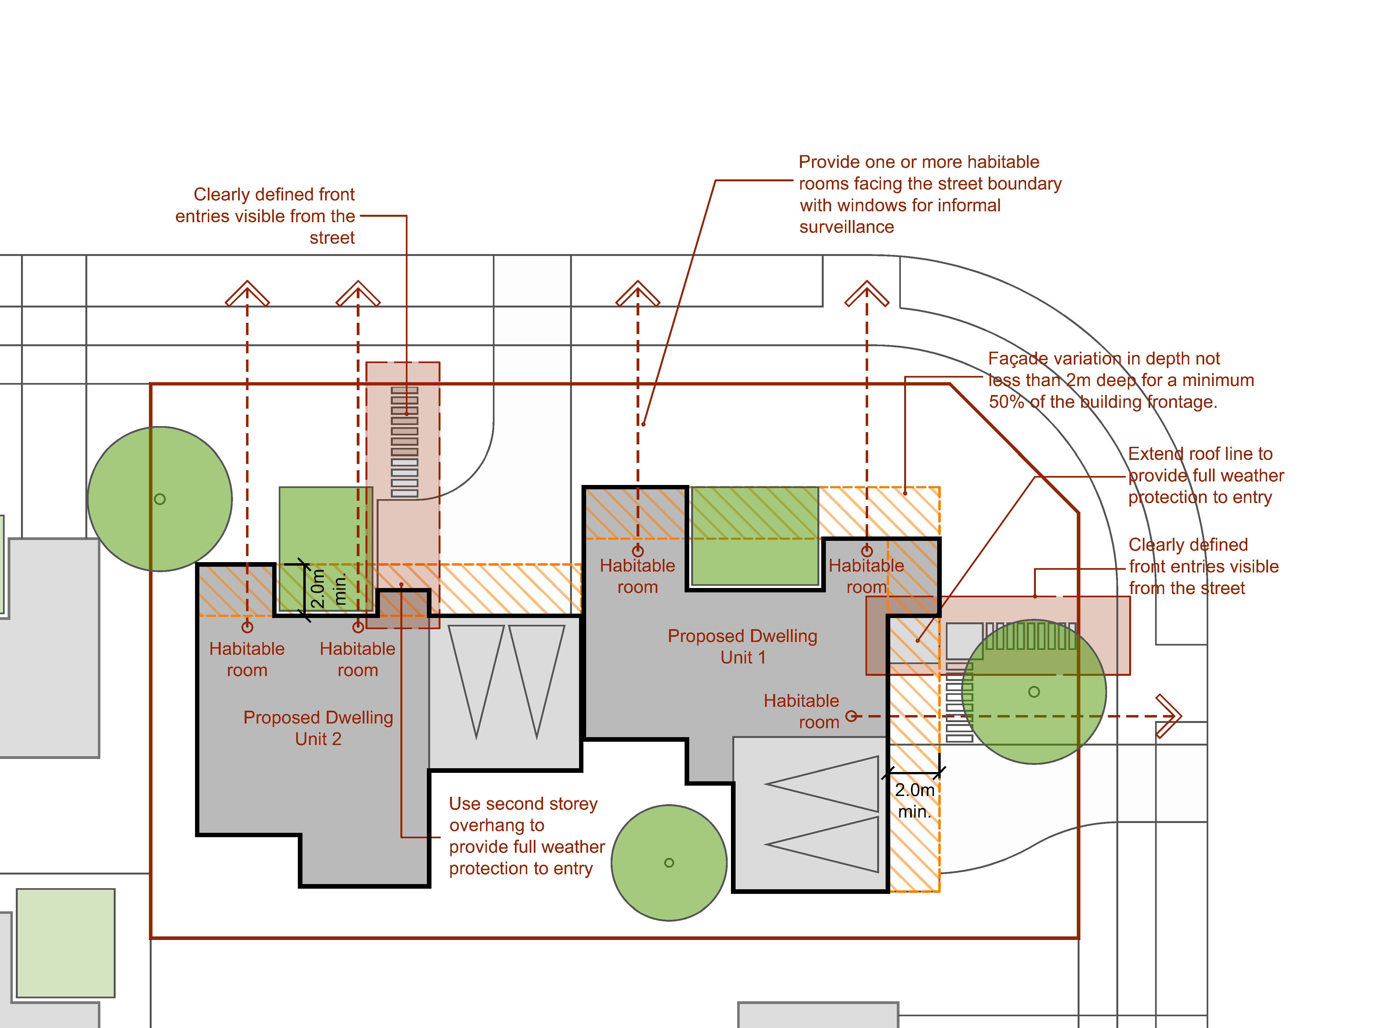
Figure 13
 | PO₁₇ Development incorporates typical domestic detailing to achieve a residential scale living environment with aesthetic standards and amenity for occupants similar to those of single dwellings in the neighbourhood. |  | AO_{17.1} The maximum single wall length of a building is 32m with offsets of 600mm minimum provided every 7.5m;  Note: Building walls separated by a distance of less than 10% of their combined length are considered as one wall.  AO _{17.2} Building bulk is minimised through articulation and other measures, including the provision of at least one (1) element from at least three (3) of the following element groups:  verandahs, porches, pergolas or balconies;  (b) roof overhangs (minimum 600mm deep);  (c) window hoods/screens;  (d) awning and shade structures; or  (e) 600mm vertical gutter offset to create roof articulation.  Note: See Figure 14.
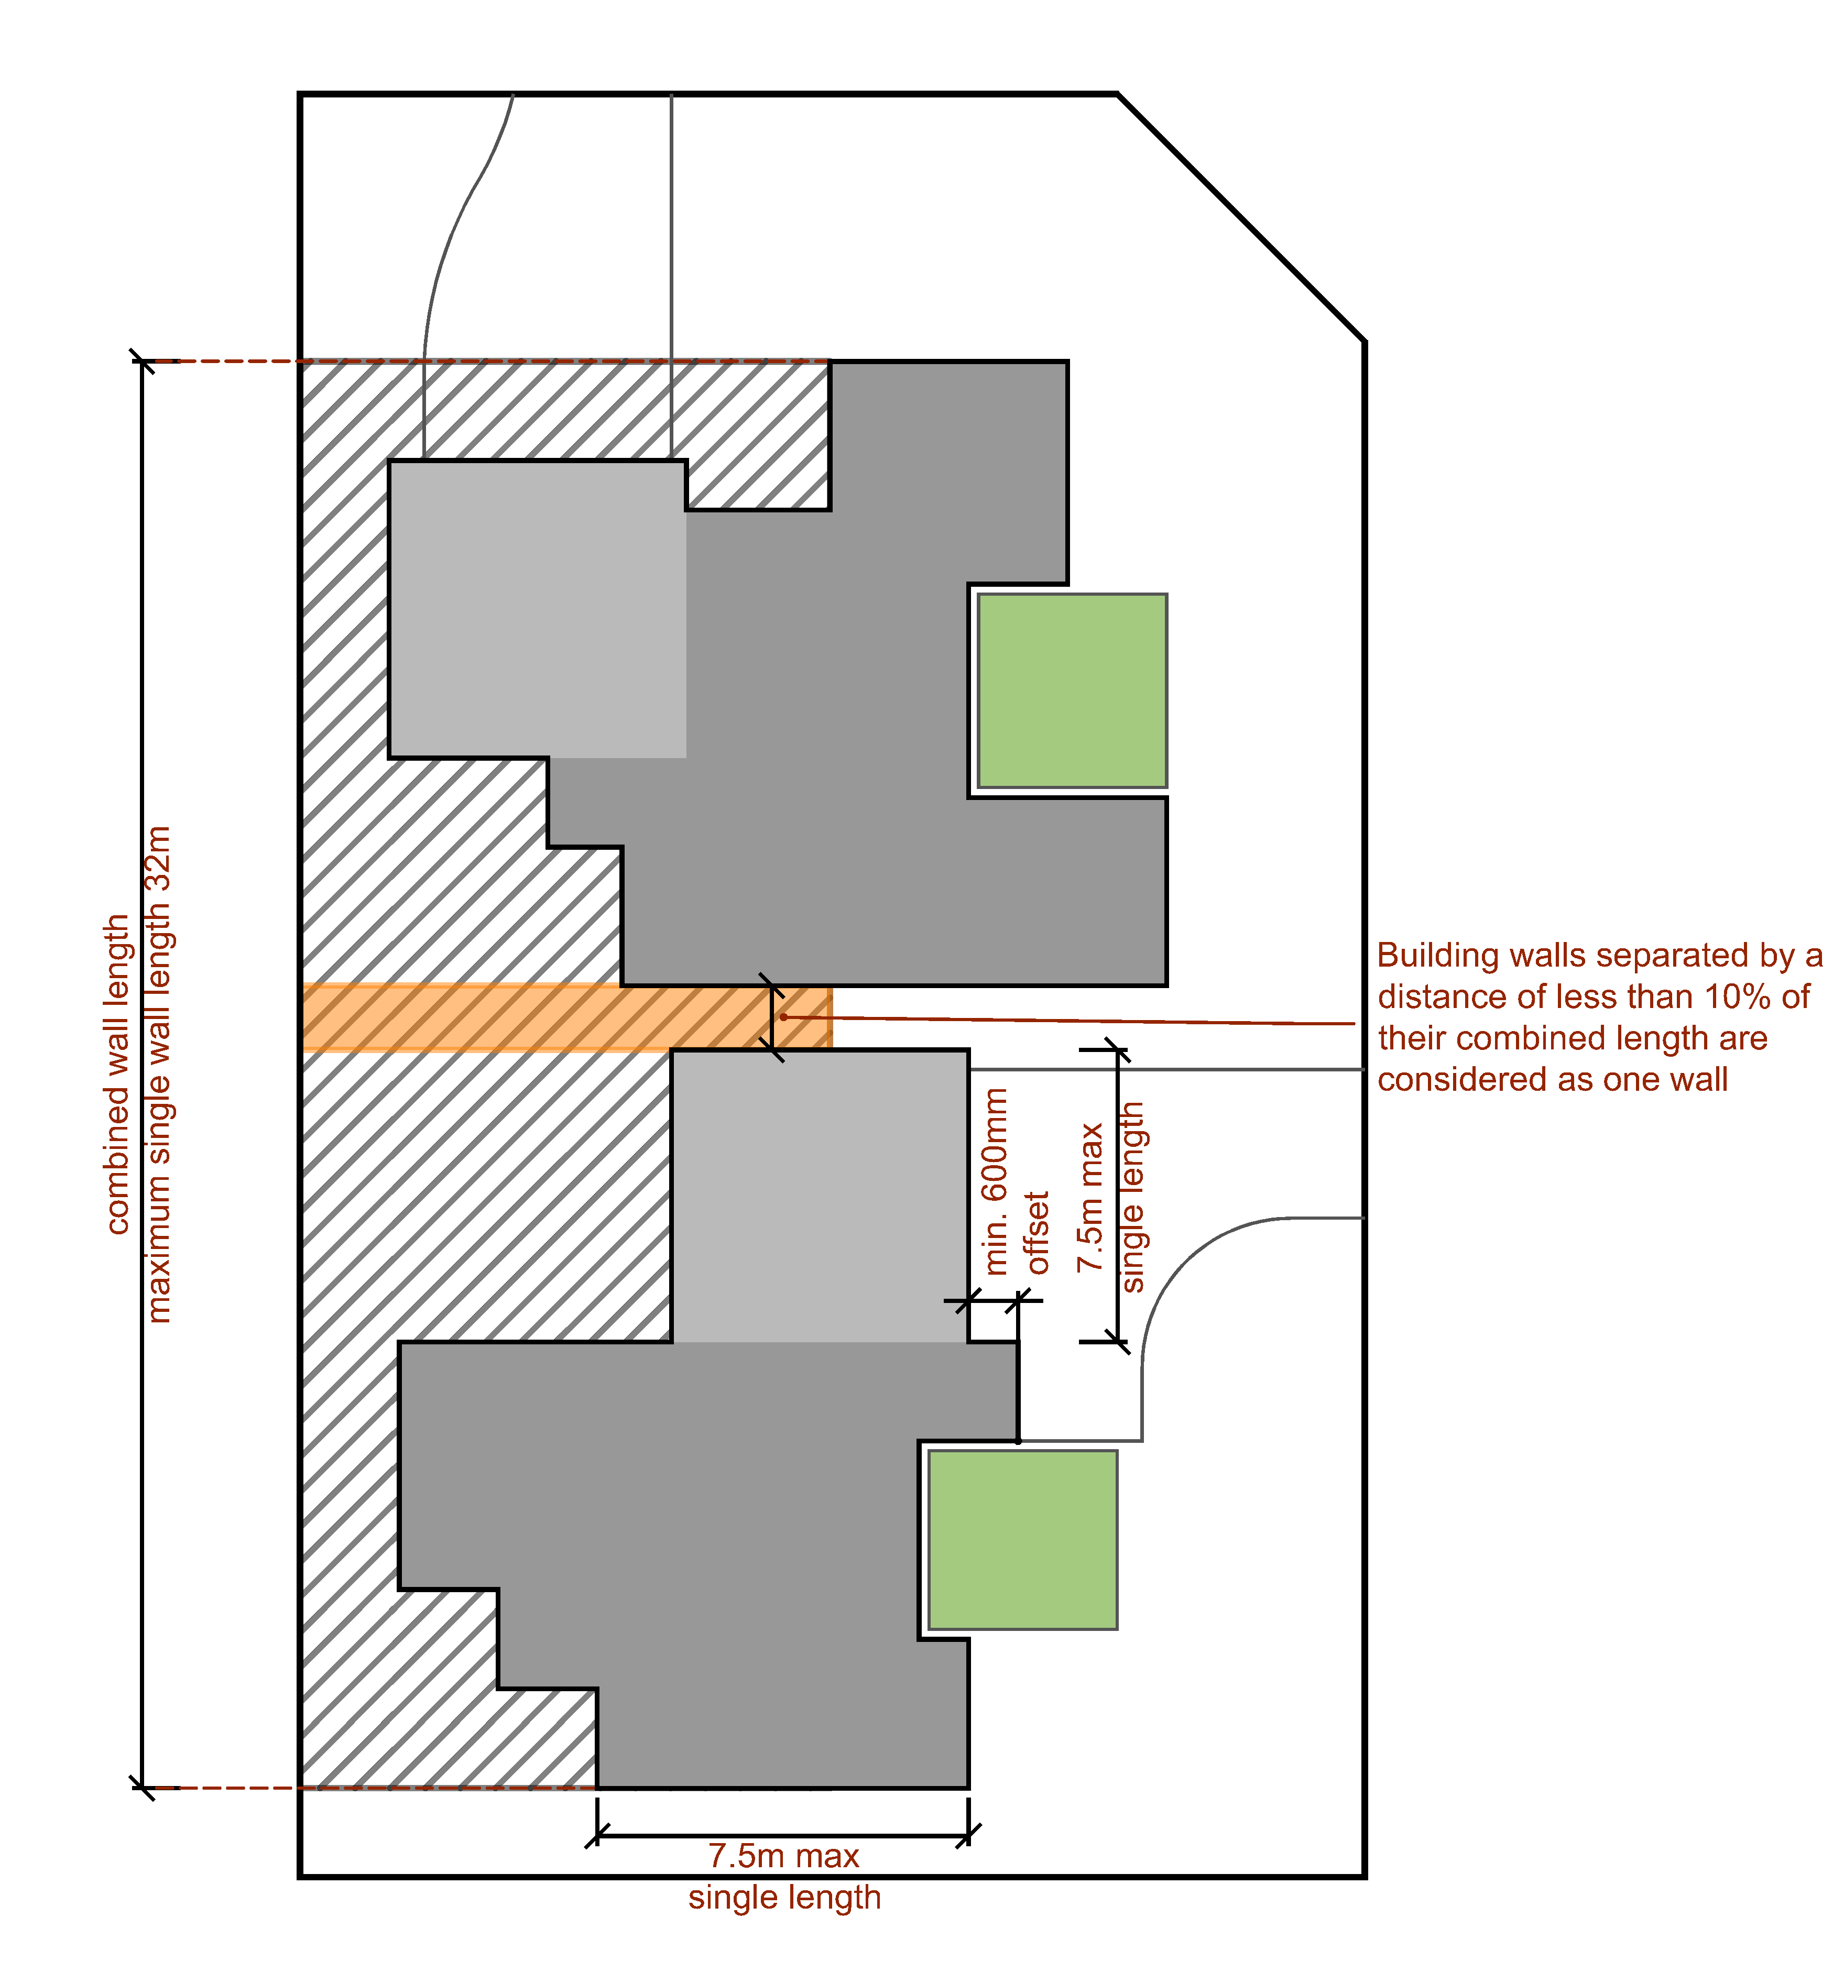
Figure 14
PO₁₈ Development provides landscaping that contributes to the landscape character, shade and the micro-climate of the neighbourhood and site through the retention or provision of at least one canopy tree. |  |  | AO_{18.1} One (1) tree capable of achieving a height of at least six (6) metres and canopy spread of at least five (5) metres at maturity is provided.
PO₁₉ The treatment of fencing and retaining walls in all situations reinforces the high quality, amenity and safety of the development. |  |  | AO_{19.1} The maximum total height of a combined fence and retaining wall is 2.1m, as measured from the base of the retaining wall to the top of the fence.  AO_{19.2} Where a combined fence and retaining wall is located on the front boundary, the fence has a minimum transparency of 30% when viewed from in front of the fence (at 90 degree angle to the fence).  AO_{19.3} Retaining walls and fences are constructed of high quality materials and contribute to residential amenity.  AO_{19.4} Any fence on the front boundary has a minimum 30% transparency when viewed from in front of the fence (at 90 degree angle to the fence).  Note: Where retaining walls are set off the property boundary by a minimum of 600mm, they are not considered to be combined with the fencing. (See Figure 15.)
Figure 15
PO₂₀ Front fencing contributes to privacy, screening, security, and street character while maintaining a visual relationship between dwellings and public spaces. |  |  | AO_{20.1} Fences located on a front property boundary or a common boundary with an adjacent park or within the front setback area:  - have a maximum height of 1.2 metres; or  - have a maximum height of 1.5 metres and a minimum transparency of 30% when viewed from in front of the fence (at 90 degree angle to the fence).  Note: In instances where the fence is located in conjunction with a retaining wall refer PO₁₉.
Performance outcomes |  |  |  | Acceptable outcomes
PO₂₁ Stormwater discharge from the site is to a lawful point of discharge as defined in the Queensland Urban Drainage Manual (QUDM), without the use of pumped or charged pipe systems, and not to private land other than to an easement for stormwater purposes befitting the site and allowing discharge to a lawful point of discharge in land over which Council has tenure or control. |  |  |  | AO_{21.1} The site:  (a) has a natural surface with an elevation that is higher than the abutting road and enables stormwater to drain gravitationally to the abutting road via subsurface pipes; or  (b) has a natural surface with an elevation that is higher than Council’s stormwater drainage network in the abutting road and enables stormwater to drain gravitationally to the stormwater drainage network in the abutting road via subsurface pipes; or  (c) has lawful access to an inter allotment drainage network with available capacity to meet the requirements of the development.
Where a Dwelling House on a Hatchet Lot
PO₂₂ The configuration and finish of the access strip/easement:  (a) enhances the streetscape qualities of the area and any adjoining premises;  (b) enhances the residential amenity of the area; and  (c) contributes to a high quality residential outcome for the site, by the incorporation of landscaping, provision for adequate setbacks and use of high quality materials. |  |  |  | AO_{22.1} Any area of hardstand, including the driveway, within the access strip / easement:  (a) has a maximum width of 3m; and  (b) is sealed with a rigid pavement.  AO_{22.2} The access strip/easement has a landscaped area/s with a combined minimum width of 2m for its full length.  AO_{22.3} The driveway landscaping must continue for the full length of the driveway for a minimum width of 0.5m.  AO_{22.4} Any fence on the inside boundary of the access strip / easement has a maximum height of one (1) metre for the first six (6) metres from the front boundary.
PO₂₃ The dwelling does not result in a reduction of amenity, privacy, or loss of solar access for any adjoining property. |  |  |  | AO_{23.1} The dwelling does not exceed a maximum height of 2 storeys or 8.5m above ground level.  AO_{23.2} The dwelling is setback a minimum of 2m from all boundaries.  AO_{23.3} North-facing windows to habitable rooms and/or the private outdoor space of an adjoining premises does not have sunlight reduced to less than 3 hours of solar gain between 9 a.m. and 3 p.m. on 21 June.
PO₂₄ Stormwater discharge from the site is to a lawful point of discharge as defined in the Queensland Urban Drainage Manual (QUDM), without the use of pumped or charged pipe systems, and not to private land other than to an easement for stormwater purposes befitting the site and allowing discharge to a lawful point of discharge in land over which Council has tenure or control.  Note: Land over which Council has tenure or control does not include Council’s open space network. |  |  |  | AO_{24.1} The site:  (a) has a natural surface with an elevation that is higher than the abutting road and enables stormwater to drain gravitationally to the abutting road via subsurface pipes; or  (b) has a natural surface with an elevation that is higher than Council’s stormwater drainage network in the abutting road and enables stormwater to drain gravitationally to the stormwater drainage network in the abutting road via subsurface pipes; or  (c) has lawful access to an inter allotment drainage network with available capacity to meet the requirements of the development.

Table 9.3.7:2 – Medium Density Residential Code – Assessment benchmarks for assessable development

 | Performance outcomes |  | Acceptable outcomes
 | PO₁ The development is designed in a manner that responds to the sites opportunities and constraints and to the broader urban and streetscape contexts.  Note: Development should be designed and documented by a suitably qualified professional (i.e. architect or building designer). Details of professional qualifications should be noted on drawings submitted with any development application |  | AO_{1.1} The design of the development considers and responds to:  - Site specific qualities including:  - site topography and slope (contours at a minimum of 1m intervals);  - Views  - solar aspect and access;  - prevailing breezes  - existing buildings on the site;  - site access  - services  - identification of buildings to be demolished;  - existing vegetation (locations to be surveyed and the diameter of the trunk at 1m above ground level shown. On highly buttressed trees the extent of buttressed roots is to be shown);  - proposed position of new buildings overlaid  - Nearby features including:  - opportunities for on street visitor car parking;  - buildings on adjoining land  - important views from neighbouring properties  - features and character of adjoining land and buildings including doors & windows  - street fixtures;  - Local qualities and amenities including:  - available public transport; and  - nearby amenities such as parks, shops.  AO_{1.2} Site design retains all existing street trees.  Note: See Figures 1 and 2.
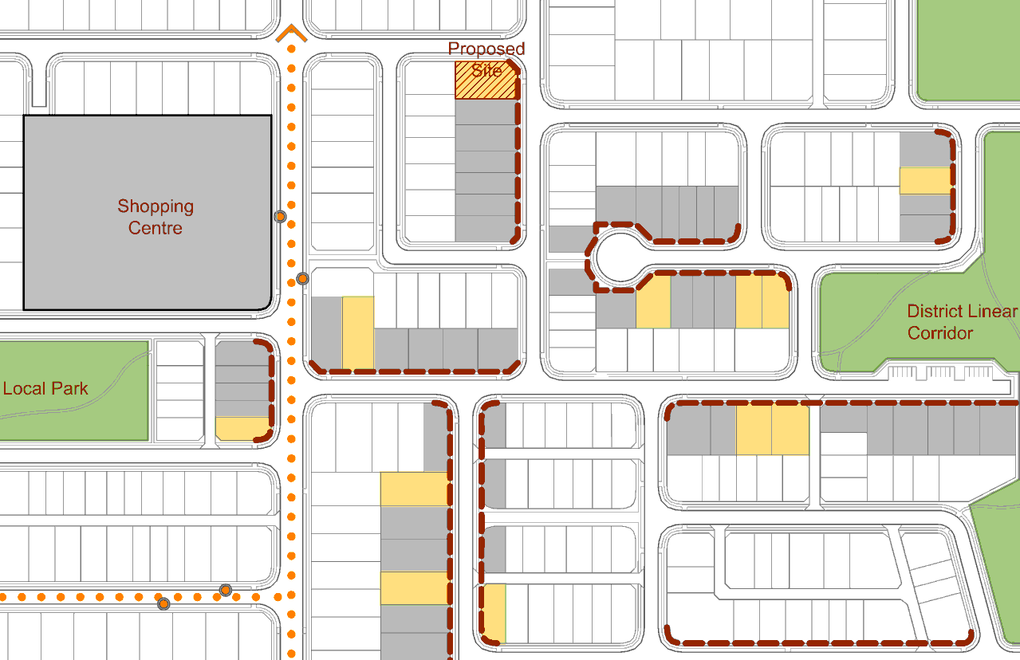
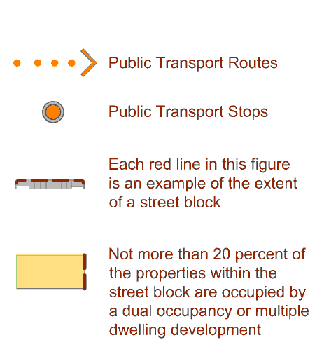
Figure 1
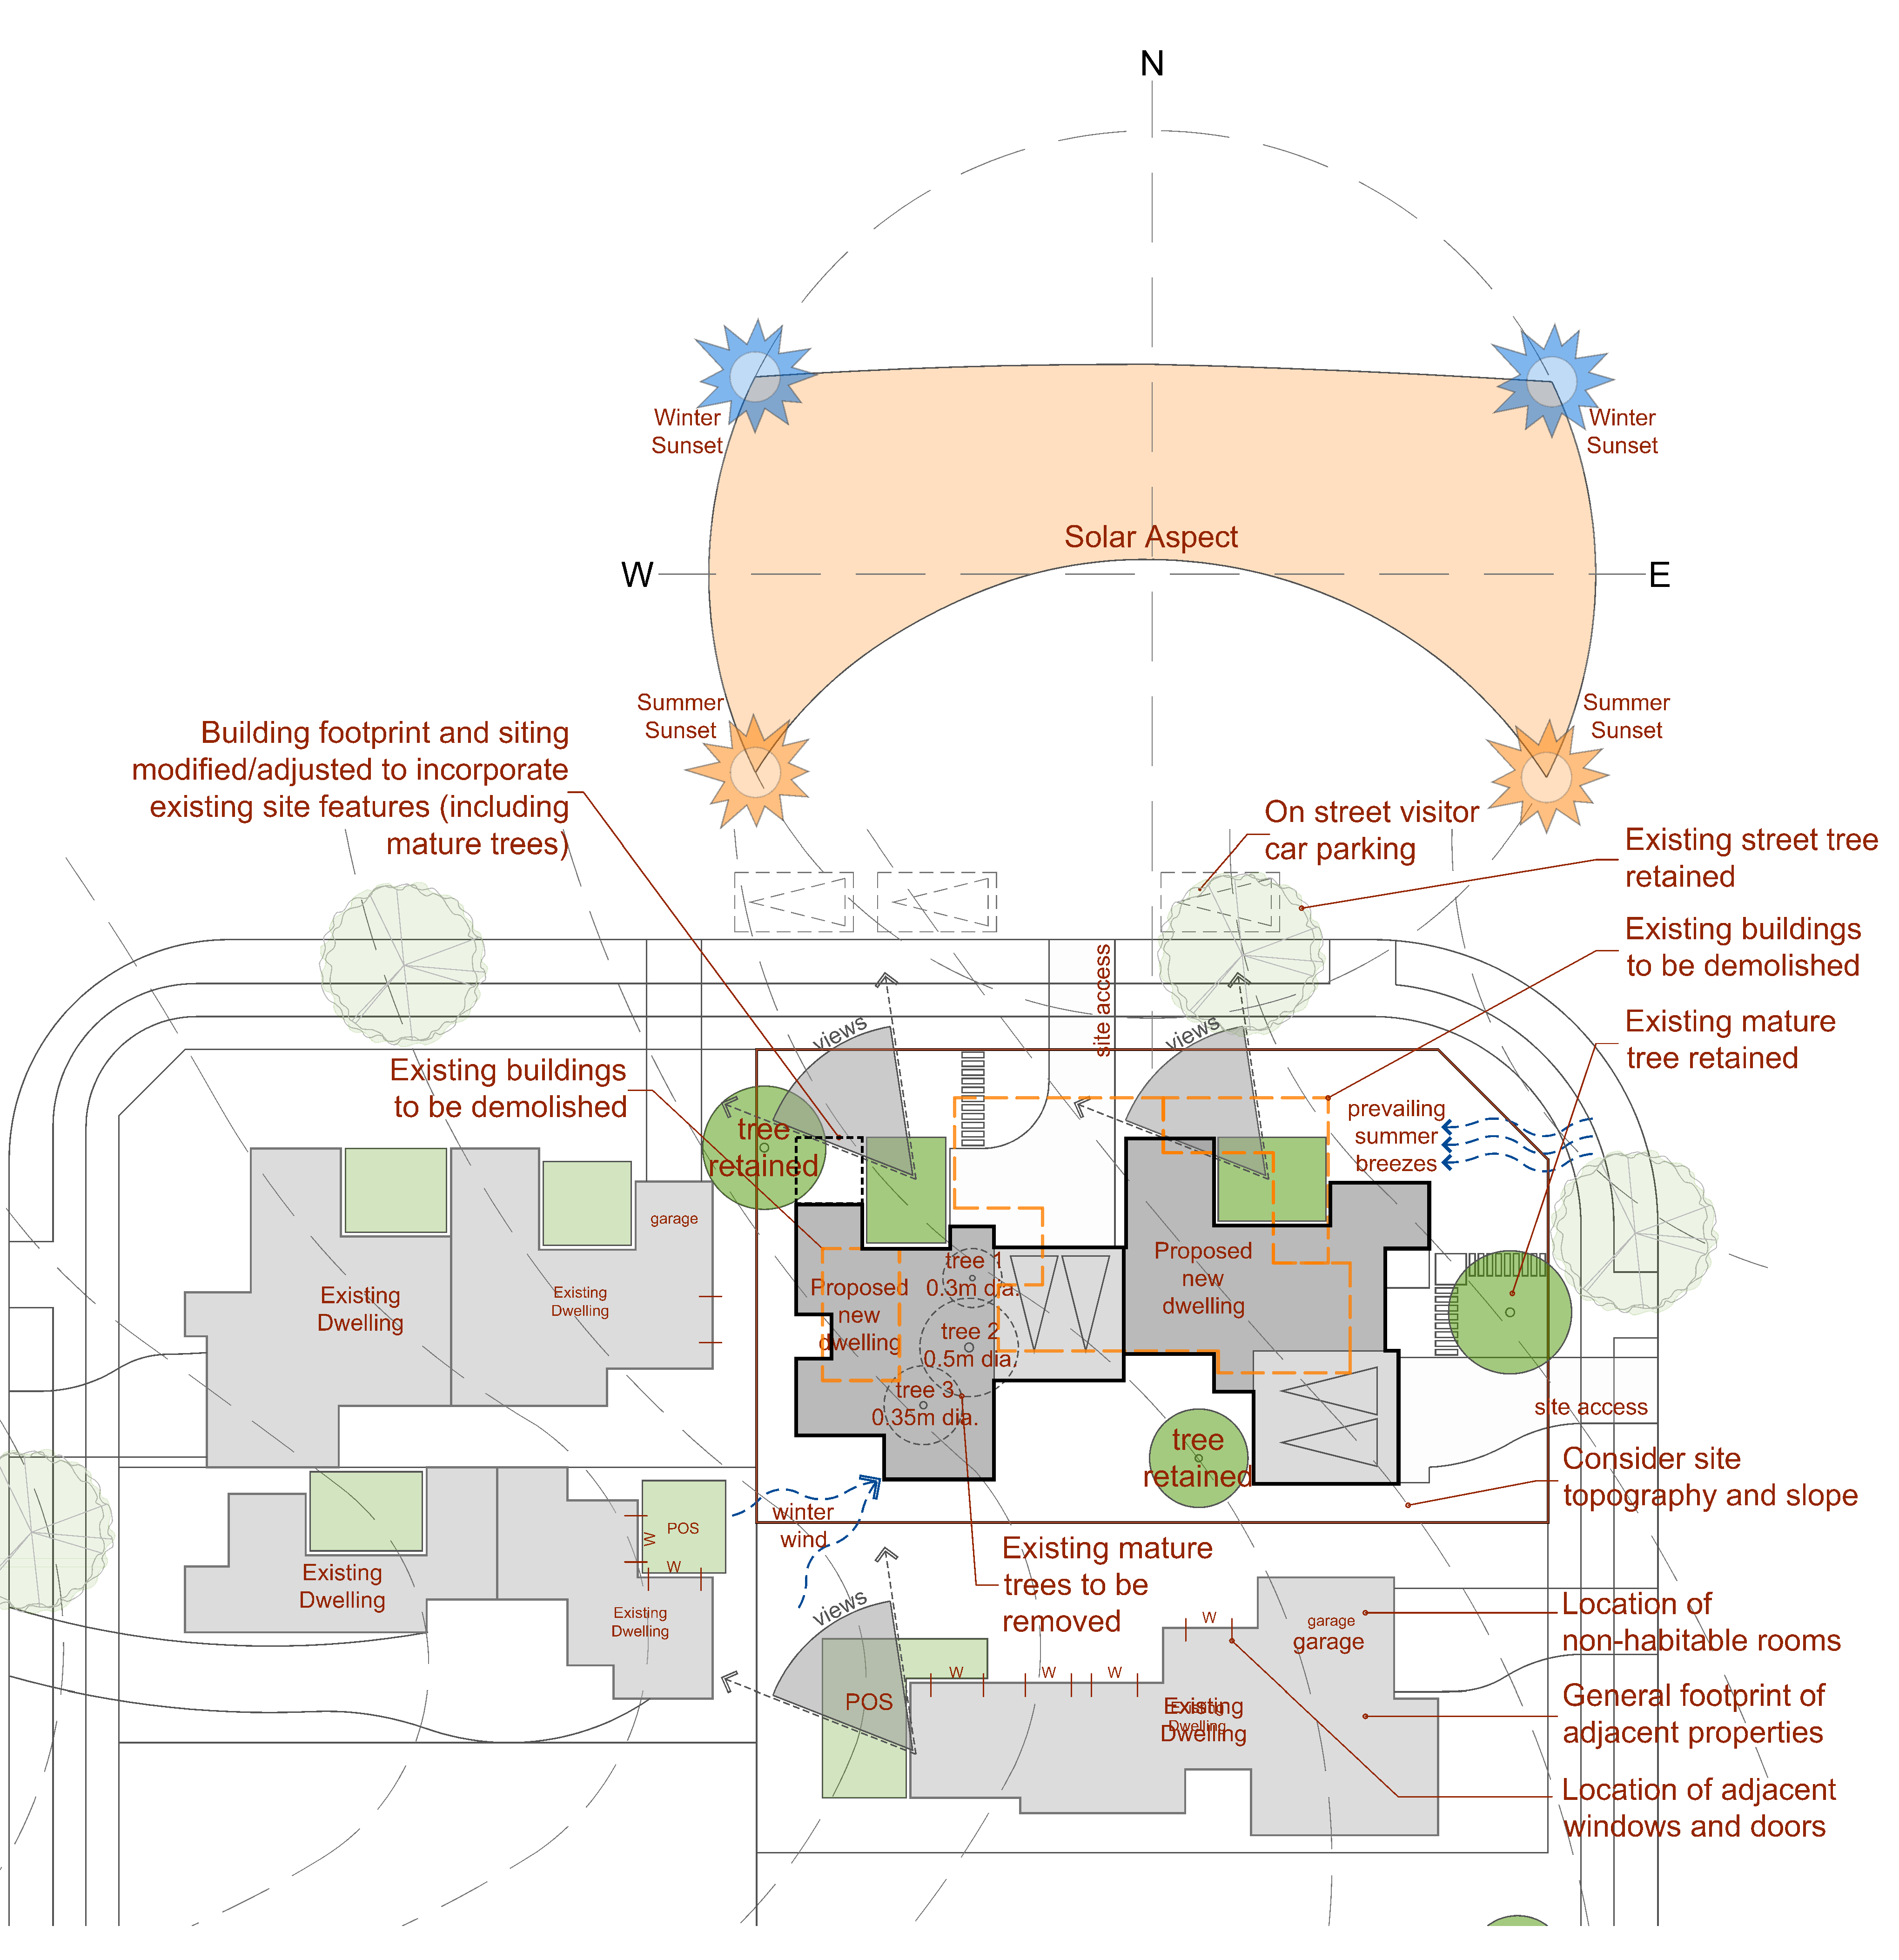
Figure 2
 | PO₂ Development responds to the slope of the land in the siting, design and form of buildings and structures to minimise requirements for cut and fill. |  | AO_{2.1} Cut and fill beyond natural ground level does not exceed a vertical distance of 1m, unless contained within building walls and in accordance with the requirements outlined in SC6.2 PSP No. 2 – Engineering Standards – Roads and Drainage Infrastructure. The extent of cut and fill must be shown on the proposed site plan and elevations.  AO_{2.2} Batters and earth-retaining structures are constructed in accordance with SC6.2 PSP No. 2 – Engineering Standards – Roads and Drainage Infrastructure.  Note: See Figure 3.
 | Figure 3
PO₃ Development is designed to facilitate the retention of any existing street tree adjacent to the site. |  | AO_{3.1} Development does not compromise or require the removal of any street tree.
 | PO₄ Development:  - provides for the on-site infiltration of stormwater and minimises the additional burden on drainage infrastructure;  - minimises the visual impact of hard surface areas; and  - respects the existing or preferred neighbourhood character and responds to the features of the site. |  | AO_{4.1} The impervious site cover does not exceed Table 1:  AO_{4.2} No more than 50% of the front setbacks area is impervious.  A0_{4.3} Site cover does not exceed rates specified in Table 2.  Note: See Figure 4.
  Table 1
  Average building height | Maximum impervious site cover
  If more than 50% of the proposed dwellings are 1 storey | 70%
  If more than 50% of the proposed dwellings are 2 storeys | 65%
  If more than 50% of the proposed dwellings are 3 or more storeys | 60%
  Table 2
  Dwelling Height | Maximum site cover
  If more than 50% of proposed dwellings are 1 storey | 50%
  If more than 50% of proposed dwellings are 2 storeys | 45%
  If more than 50% of proposed dwellings are 3 storeys | 40%
  If more than 50% of proposed dwellings are 4 storeys or more | 35%
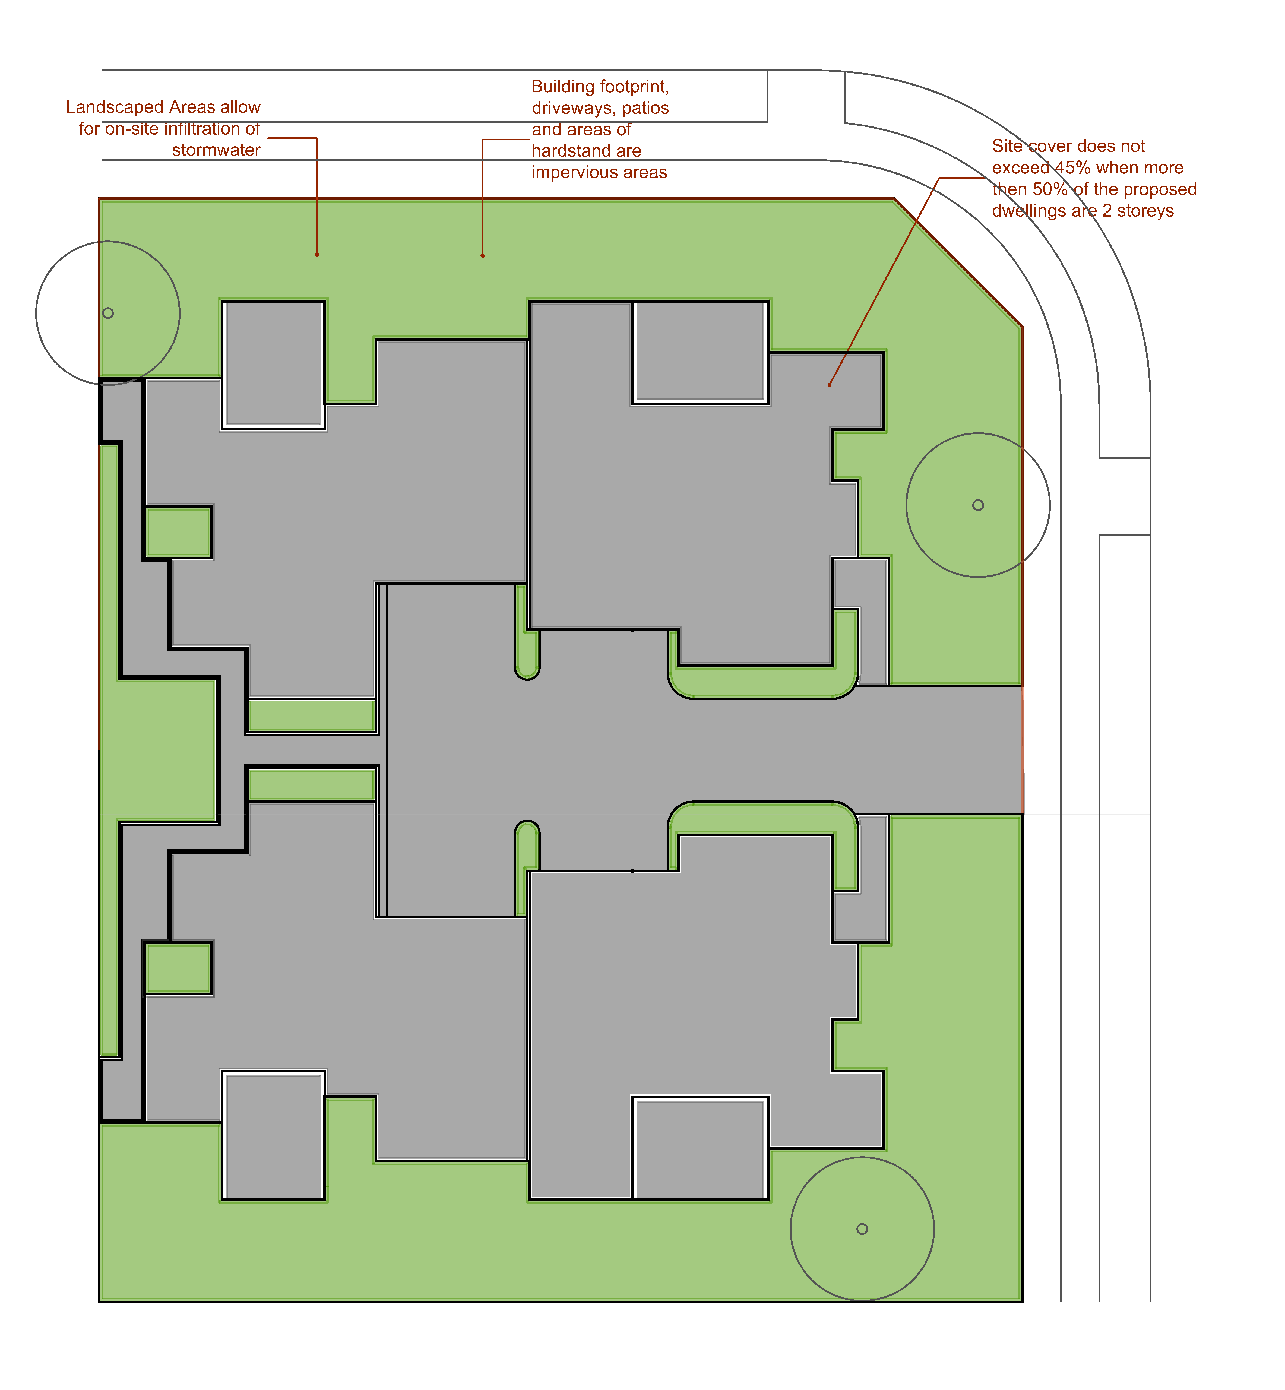
Figure 4
 | PO₅ Areas of hardstand required for parking and pathways:  are minimised,  Incorporate generous landscaping:  to promote a garden streetscape character, and  to minimise visual impacts of views to hardstand areas for occupants and the public, particularly in the front garden. |  | AO_{5.1} Landscaped areas are provided in accordance with Table 3:  Note: Landscaped areas included in the calculations consist of garden beds and lawn areas throughout the site with a width of no less than 1.5m;  Excludes all paved and other impervious areas such as driveways, patios, terraces, car parking spaces and bin and other utility areas.  See Figure 5.
  Table 3
  Building height | Minimum landscaped area
  Building height | Where 80% or more of the front setback is landscaped area additional landscaping for the balance of the site must be a minimum of: | Where less than 80% of the front setback area is landscaped additional landscaping for the balance of the site must be a minimum of:
  1-2 storeys | 10% site area | 15% site area
  3 storeys | 12.5% site area | 17.5% site area
  4+ storeys | 15% site area | 20% site area
 | Figure 5
 | PO₆ The front building setback is consistent with the prevailing front setbacks of other residential buildings in the street.  Note: The prevailing setback of the street is determined by the setbacks of the residential buildings on any lot along the road within 100m of the site. |  | AO_{6.1} Buildings are setback from the road frontage:  (a) within 10% of the average front setback of existing residential buildings within 100m of the site; or  (b) where there is no adjoining buildings the front setback is provided in accordance with Table 4.  Note: See Figure 6.
  Table 4
  Building element | Minimum setback
  Solid building wall (other than a garage) | 4.0m
  Solid building wall (where for a garage) | 5.5m
  Permeable or non-enclosed elements (e.g. porch, verandah, balcony or carport) | 3.5m (or 3m where secondary road frontage)
 | Figure 6
 | PO₇ Side and rear building setbacks:  (a) are appropriate to the scale of the development and the intended character of the zone and/or precinct or local plan in which the site is located;  (b) provide for adequate daylight for habitable rooms and open space areas for buildings on and adjoining the site; and  (c) are sufficient to minimise overshadowing and overlooking of adjoining premises. |  | In partial fulfilment of the performance outcome  AO_{7.1} Any part of a building built to a side boundary:  (a) must not exceed a maximum height of 3.5m  (b) must not exceed a maximum length of 9m;  (c) must be a minimum distance of 2.4m from any other wall built to the side boundary (whether on the site or an adjoining site) or be joined to another built to boundary wall if on an adjoining site; and  (d) must not exceed a maximum total length of 50% of the side boundary.  OR  AO_{7.2} Buildings are set back from side boundaries in accordance with the following:  - For lots with frontages less than 20m:  - 1.2m for any part of the building up to 3.5m high; and  - 2m for any part of the building above 3.5m high.  - For lots with frontages greater than 20m:  - 1.8m for any part of the building up to 3.5m high; and  - 2.4m for any part of the building above 3.5m high.  AO_{7.3} Buildings are set back from the rear boundary a minimum of 2m.  AO_{7.4} Development ensures that solar access to habitable rooms and private open space of adjoining premises: -  - achieves a minimum of 3 hours of sunlight between 9am and 3pm on June 21; or  - is not further reduced where existing solar access is less than that specified in (a).  Note: See figure 7.
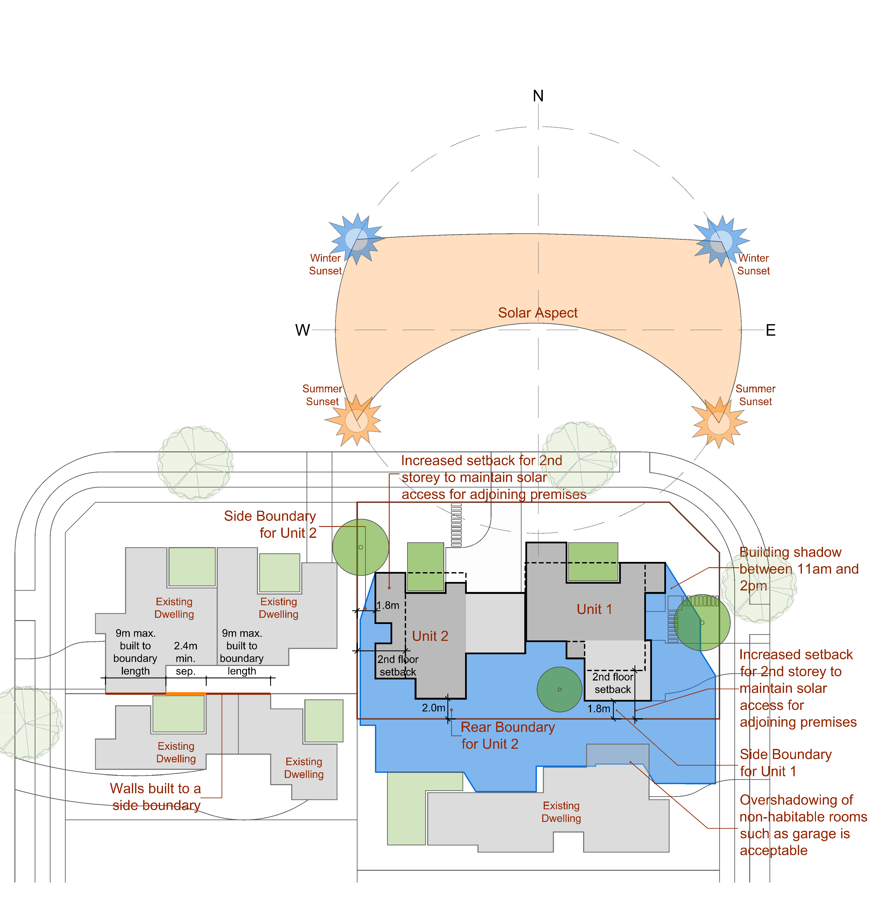
Figure 7
 | PO₈ Development provides adequate and suitable communal and private open space to meet the needs of occupants for privacy, relaxation and entertainment and accommodate visitors. |  | AO_{8.1} Development provides communal and private open space in accordance with Table 5.  AO_{8.2} Communal and private open space has a minimum dimension in accordance with Table 6.  *Min length required for both length and width.  AO_{8.3} Private open space is:  - is oriented to receive at least three hours of sun between 9am and 3pm on 21 June.  - directly accessible from a living area or kitchen;  - fenced or landscaped to achieve privacy for occupants;  - clear of bins, clothes lines, hot water systems, air conditioning units, above ground water tanks and associated infrastructure and other forms of ancillary equipment; and  - not located within the front setback area.  Note: See Figure 8.
  Table 5
  No. of Dwellings | Min. Communal Open Space per Dwelling | Min. Ground Floor Private Open Space per Dwelling | Min. Private Open Space above Ground Floor per Dwelling
  1-10 | 0m² | 16m² | 8m²
  11-15 | 20m² | 16m² | 8m²
  16+ | 25m² | 16m² | 8m²
  Table 6
  Type | Area | Minimum Dimension
  Private Open Space
  Ground Floor | 16m² | 4m*
  First Floor | 8m² | 2.7m*
  Communal Open Space
  All | <100m² | 5m
  All | 100m²+ | Length to breadth ratio of 2.5:1
 | Figure 8
 | PO₉ All car parking is designed to accommodate a standard car (B85 vehicle for occupant car parking and B99 vehicle for visitor car parking) and:  - is clearly identifiable and of adequate dimensions;  - incorporates adequate manoeuvring area to parking spaces (including carports and garages); and  - incorporates a clear, safe and effective circulation system.  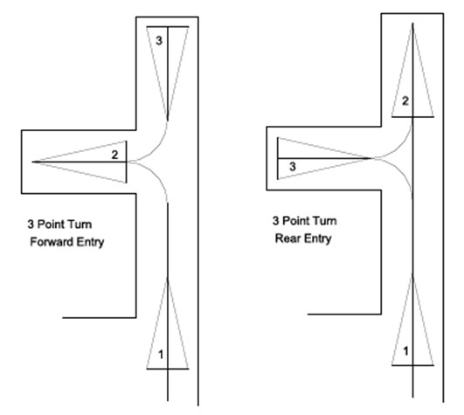  Figure 9 |  | AO_{9.1} Design of the site layout must ensure a B85 vehicle (as defined in AS 2890.1:2004 Parking facilities - Off-street car parking) is able to enter an enclosed garage or visitor car park in a single forward manoeuvre and exit in a single reverse manoeuvre prior to departing the site in a forward direction.  AO_{9.2} Design of the site layout must ensure a B99 vehicle (as defined in AS 2890.1:2004 Parking facilities - Off-street car parking) is able to enter a visitor car park in a single forward manoeuvre and exit in a single reverse manoeuvre prior to departing the site in a forward direction.  Note: See Figure 9.  AO_{9.3} Each parking space has minimum dimensions as per Table 7:
  Table 7
  Parking Space | Minimum Dimensions
  Single uncovered parking space  (with at least 400mm clearance between either side of the parking space and the nearest wall.) | 5.4 metres long by 2.6 metres wide
  Single uncovered parking space  (with less than 400mm clearance between either side of the parking space and the nearest wall.) | 5.4 metres long by 3 metres wide
  Single carport | 5.4 metres long by 3 metres wide
  Double carport | 5.4 metres long by 5.8 metres wide
  Single garage | 6.4 metres long by 3 metres wide internally
  Double garage | 6.4 metres by 6.4 metres wide internally
 | PO₁₀ Development provides resident and visitor car parking which is integrated into the site and building design and:  (a) Does not negatively impact the amenity of the site, adjoining sites or streetscape;  (b) Is not a prominent visual feature from the street or other public spaces; and  (c) Contributes to the establishment of a garden setting by avoiding large areas of visible hardstand. |  | AO_{10.1} Parking is only provided within the front setback area where it is:  (a) uncovered and located on a driveway directly in front of a carport or garage; or  (b) the front setback is a least 6m, and  (c) the car park surface is permeable;  (d) a minimum 2m wide densely planted landscape buffer is provided between the car park and the front boundary for the full length of the car park;  (e) the location of the car park does not compromise the ability of the dwelling to provide casual surveillance of the public realm; and  (f) at least 60% of the front setback area is landscaped area.  AO_{10.2} Where car parking is provided below ground:  (a) Access ramps are not located within 6m of the street boundary and do not exceed an opening width of 6m; and  (b) Entry to the site for pedestrians is provided separate from vehicle entries by way of a safe, well lit and clearly identifiable pathway or gatehouse;  AO_{10.3} All car parking:  is clearly signposted; and  is freely available for use by to the applicable occupants and visitors of the development.  Note: See Figures 10 and 11.
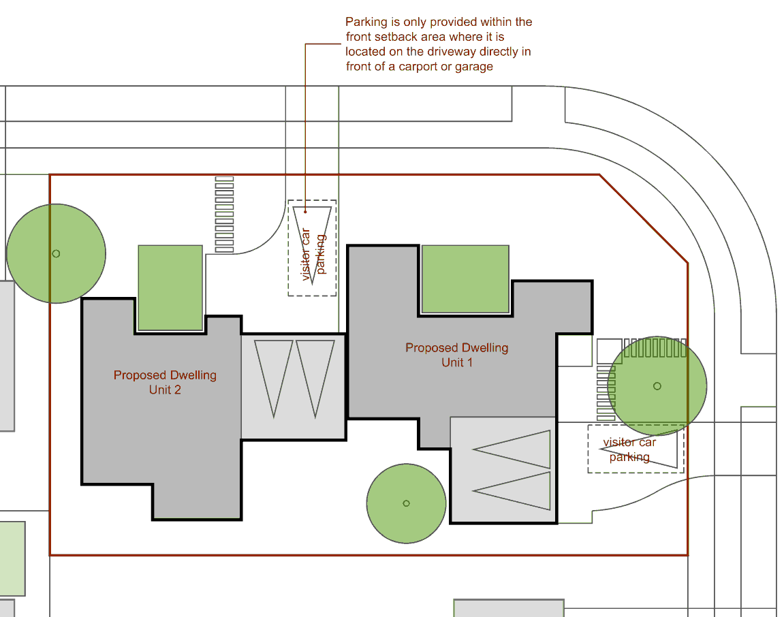
Figure 10
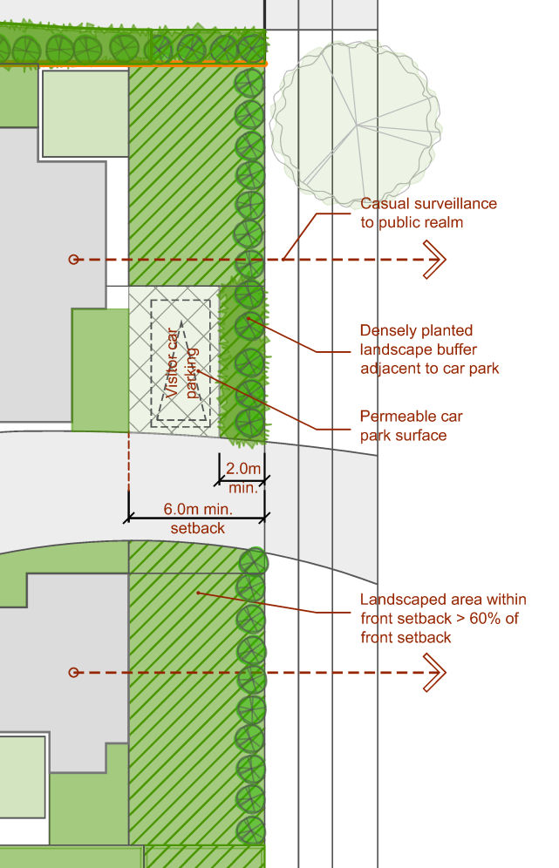
Figure 11
 | PO₁₁ Safe and equitable access for both pedestrians and vehicles is provided, to and from buildings and the street whilst minimising the extent and number of driveways. |  | In partial fulfilment of the performance outcome:  AO_{11.1} Vehicular access from the street is provided via a single shared driveway with a maximum crossover width of 5m.  AO_{11.2} Where the site abuts a lane vehicle access is provided from the lane.  Note: See Figure 12.
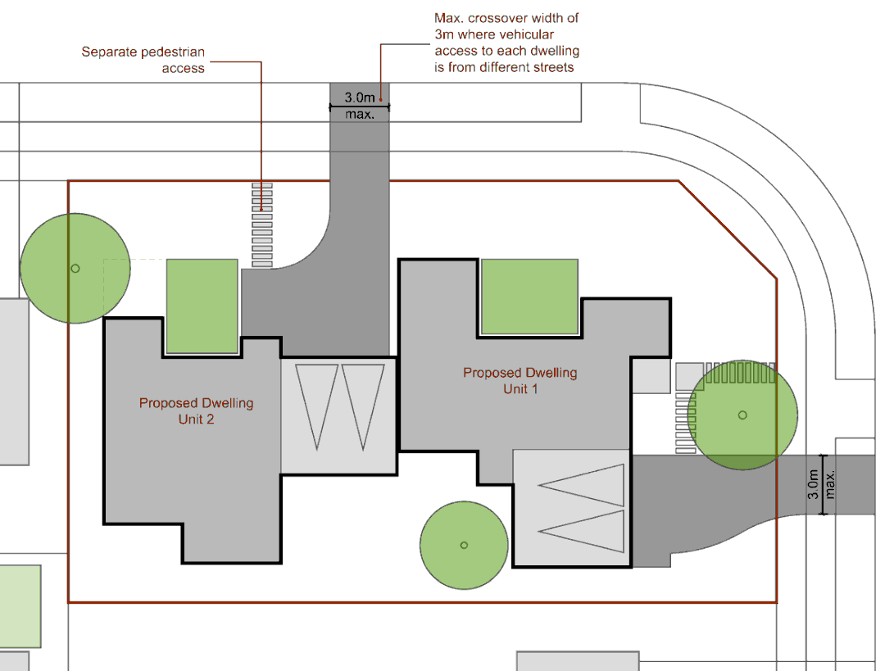
Figure 12
 | PO₁₂ The privacy of residents of the development or adjoining premises is protected when they are inside a dwelling or in a private open space area. |  | AO_{12.1} Habitable room windows of a dwelling are separated a minimum of 9m from a habitable room window or private open space of another dwelling on the same or an adjoining site.  OR  AO_{12.2} Where there is a direct view within 9m into a habitable room or private open space of another dwelling on the same or an adjoining site:  - The elements with the view such as windows, balconies, or terraces of a dwelling must be screened in accordance with AO13.3; or  - The Windows have translucent glazing up to or sill heights of at least, 1.5m from the internal floor level; or  - A solid fence or masonary wall with a minimum height of 1.5m is positioned between the elements with the view.  AND  AO_{12.3} Where screening is used, it:  - is a solid translucent screen or a louvre perforated panel, trellis or the like that has a maximum of 50% open to solid ratio; and  - is a fixed, permanent element of a design that complements the style, detailing and materials of the development.  Note: See Figure 13.
 | Figure 13
 | PO₁₃ The development is designed so that occupants are not adversely affected by adjoining non-residential uses. |  | In partial fulfilment of the performance outcome  AO_{13.1} A 1.8m high solid screen fence and 2m wide vegetated buffer is provided along any section of the site boundary that is common with vehicle movement and/or parking areas associated with a non-residential use on an adjoining site.
 | PO₁₄ Noise from the development does not unreasonably impact on existing or likely future dwellings on nearby land. |  | AO_{14.1} For developments of six (6) dwellings or more, vehicle movement areas are located a minimum of 3m from any adjoining dwellings.  AO_{14.2} Swimming pools, BBQs, dining areas and other recreational facilities located within communal open areas are located a minimum of 3m from adjoining dwellings.  OR  AO_{14.3} Provide acoustic screening in accordance with an acoustic engineer's design where vehicle movement or recreational areas are located closer than 3m to any adjoining dwellings.  Note: A minimum 1.5m vegetation buffer will be required with any acoustic fence to provide amenity. (See Figures 14 and 15.)
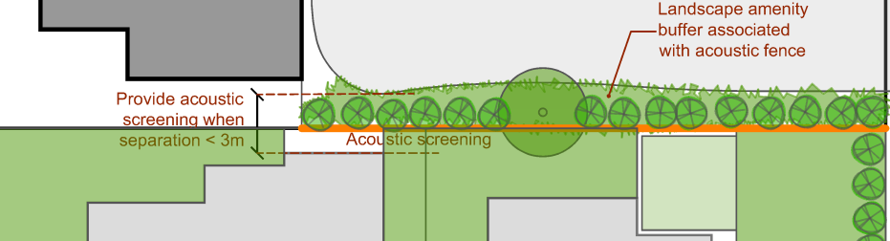
Figure 14
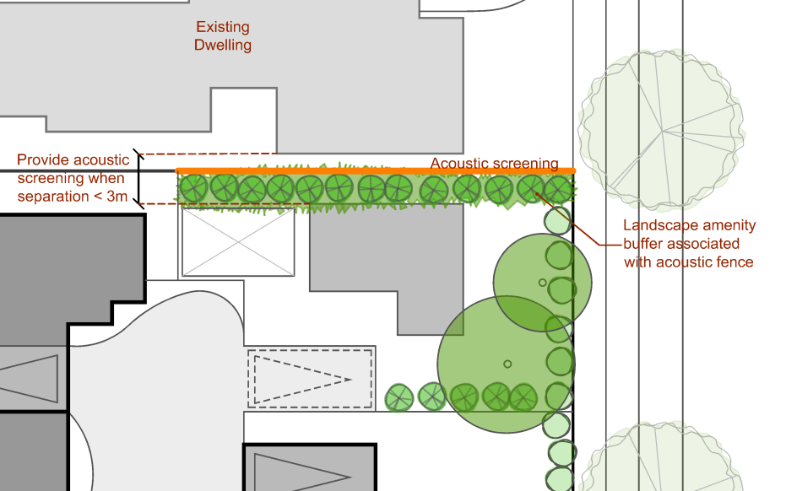
Figure 15
 | PO₁₅ Where communal open space is provided, it:  - is positioned on site to enjoy a good solar orientation;  - includes landscaping and screening for privacy to provide amenity;  - is easily accessible and conveniently located for the use of all occupants;  - is useable and safe;  - is designed and located to minimise internal and external impacts on the amenity of residents and neighbouring premises; and  - contributes positively to the streetscape where located in a frontage area. |  | AO_{15.1} Communal open space is oriented to receive at least three hours of sun between 9am and 5pm on 21 June.  AO_{15.2} Communal open space provided at the ground level, includes a balance of soft and hard landscape features with:  - a minimum 50% open to the sky, and  - a minimum 25% shaded by trees within 5 years.  AO_{15.3} The location and design of communal open space ensures that it is:  - able to be accessed by all residents from a common area within the site;  - subject to casual surveillance; and  - separated from private areas of the site.  AO_{15.4} Communal open spaces may include indoor recreation facilities.  Note: Communal open spaces do not contain:  - vehicle driveways, parking, manoeuvring or other associated hardstand areas; or  - structures such as rainwater tanks, bin storage areas, air conditioning plant, clothes hoists, etc. (See Figure 16.)
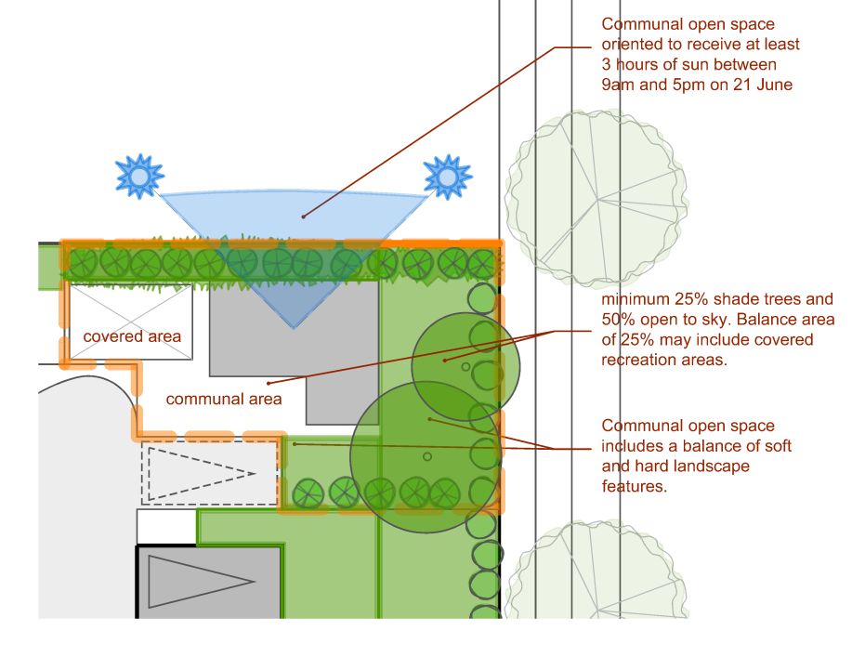
Figure 16
 | Performance outcomes |  | Acceptable outcomes
 | PO₁₆ Bin storage and access to the collection point is provided in a manner which is convenient, hygienic and will not result in an amenity impact on any use onsite or adjoining the premises. |  | AO_{16.1} Bin storage is:  - not located within the minimum private open space area required for the development;  - not located within 2m of any fresh air intake of any dwelling on the premises or adjoining premises; and  - if in an area which is accessible by more than one dwelling, is clearly identified as the storage area for the relevant unit/dwelling.  AO_{16.2} A path of access is provided between any bin storage area and the collection point which:  - is a minimum of 1.2m wide;  - is clear of any obstruction (i.e. retaining wall, landscaping, hot water tank);  - does not traverse through any habitable room (other than a garage);  - provides an at grade path of access (i.e. no steps); and  - is no longer than 30m.  Note: See Figure 17.
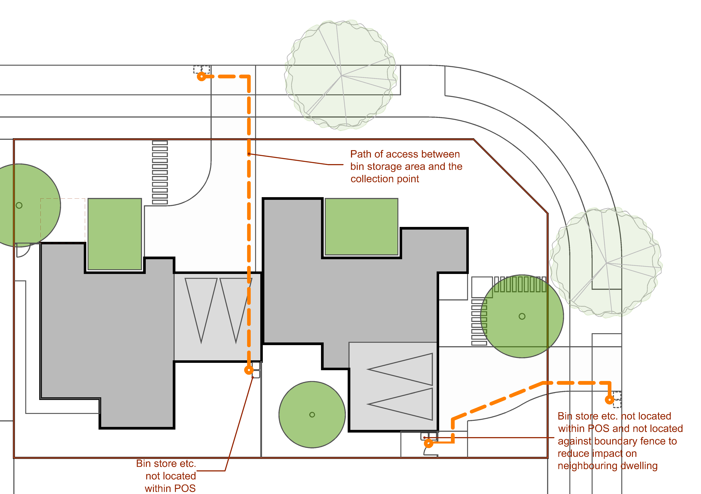
Figure 17
 | PO₁₇ Long, unvaried driveways to property boundaries are avoided and do not detract from the local streetscape. |  | AO_{17.1} Driveways are setback from side boundaries a minimum of 1.5m for the first 6m and 750mm thereafter incorporating a continuous densely planted landscape strip between the edge of the driveway and side boundary.  AO_{17.2} Driveways that exceed 40 metres in length must incorporate a change of alignment of a minimum of 1m.  Note: See Figure 18.
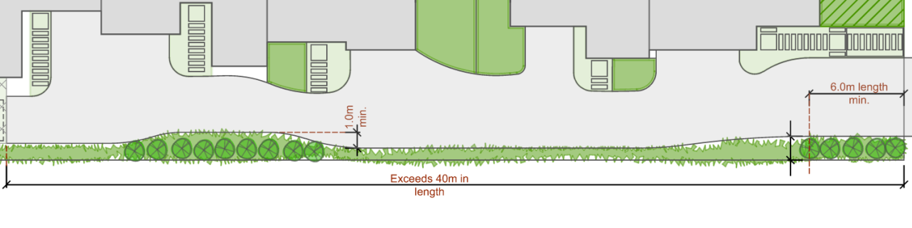
Figure 18
 | Performance outcomes |  | Acceptable outcomes
 | PO₁₈ Buildings are designed to a high aesthetic standard providing:  - prominent features towards the street frontage;  - detailing and finishes appropriate to the scale, quality and character of the street and to help differentiate between dwellings;  - opportunities for informal surveillance of the street and other public spaces;  - clear and visible entries; and  - elements that complement or enhance the character of the local neighbourhood. |  | In partial fulfilment of the performance outcome:  AO_{18.1} Buildings:  - where at the front of the site, are oriented to and address the street;  - have front entries that provide full weather protection and where within 10m of any street, have clearly defined front entries that are visible from the street;  - where within 10m of any street; have one or more habitable rooms facing the street boundary that have windows or doors with a minimum area of clear glazing of 0.25m2 for each linear metre of street frontage; and  - are designed to deliver depth in the façade facing the street or public space with a variation not less than 2m deep for a minimum 50% of the building width at ground level.  Note: See Figure 19.
 | Figure 19
 | PO19 Development incorporates typical domestic detailing to achieve a residential scale living environment with aesthetic standards and amenity for occupants similar to those of single dwellings in the neighbourhood. |  | In partial fulfilment of the performance outcome  AO_{19.1} The maximum single wall length of a building is 32m with offsets of 600mm minimum provided every 7.5m;  Note: Building walls separated by a distance of less than 10% of their combined length are considered as one wall. (See Figure 20.)  AO_{19.2} Building bulk is minimised through articulation and other measures, including the provision of at least one (1) element from at least three (3) of the following element groups:  verandahs, porches, pergolas or balconies;  (b) roof overhangs;  (c) window hoods/screens;  (d) awning and shade structures; or  (e) 600mm vertical gutter offset to create roof articulation.  AO_{19.3} Townhouses or attached dwellings have :  - no more than three (3) dwellings contained within a single building;  - a minimum of 4.5m separation between buildings.
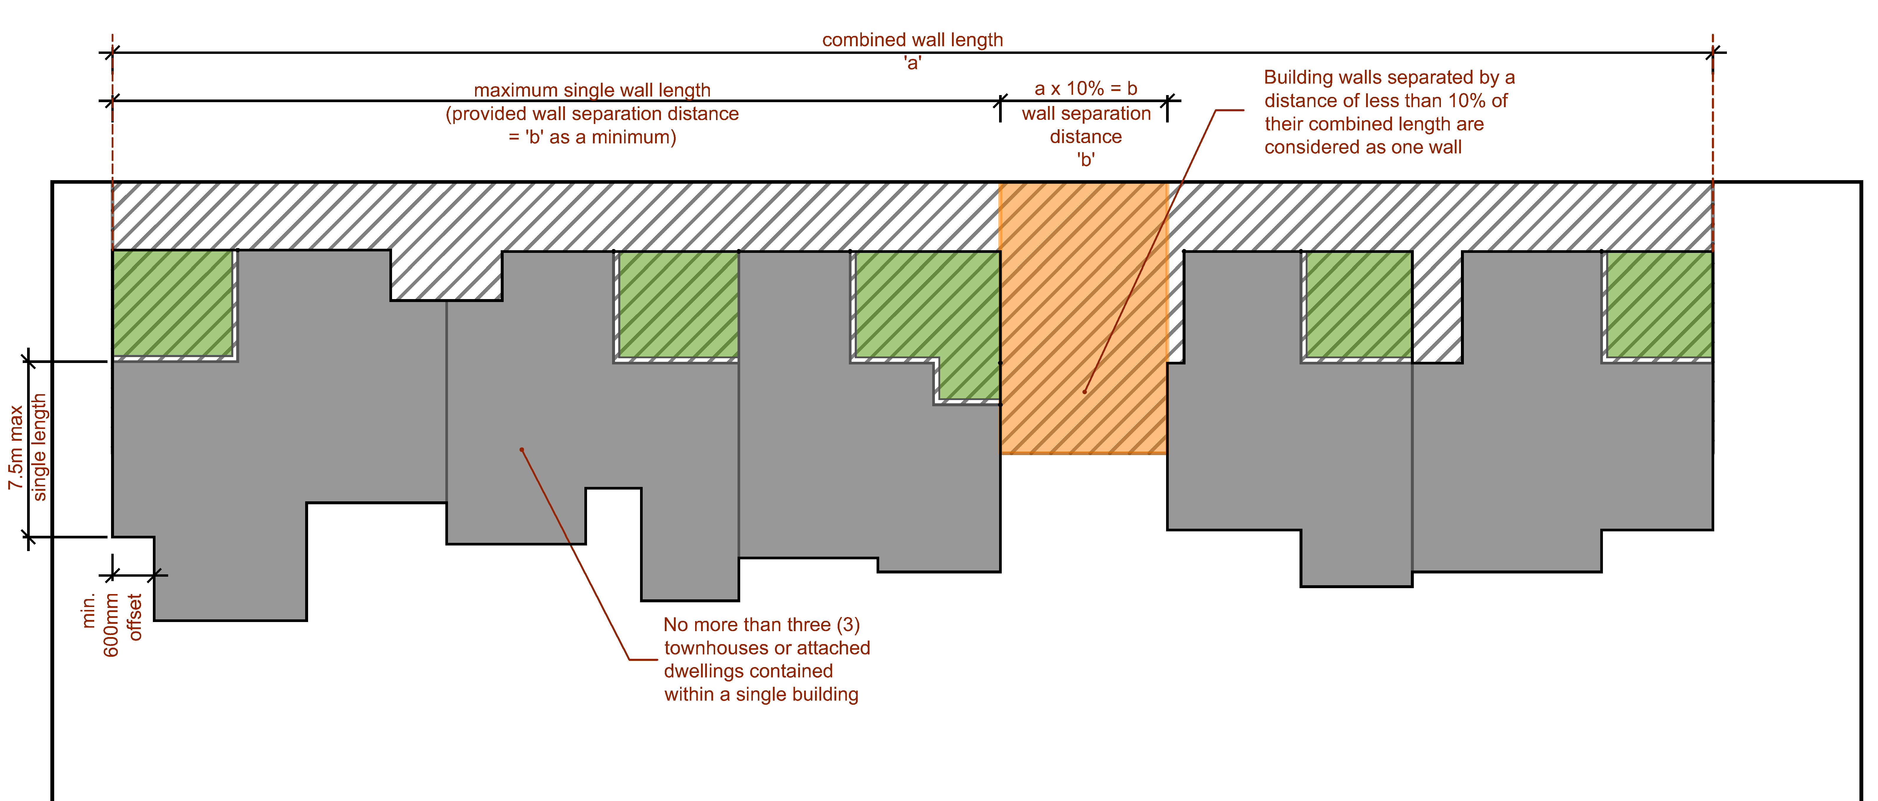
Figure 20
 | Performance outcomes |  | Acceptable outcomes
 | PO₂₀ Facades include a variety of colours, finishes and textures based on those found in houses within the surrounding streetscape and appropriate to the desired character of the area. |  | In partial fulfilment of the performance outcome:  AO_{20.1} Building facades incorporate:  - external elements and treatments that are of a high quality finish, durable and need minimal maintenance;  - at least three (3) distinct textures to finishes or surfaces not including roof, rainwater goods, glazing, joinery, doors, garage doors or soffits; and  - colours and textures that are similar with the colours and textures of adjoining buildings.
 | PO₂₁ Development provides landscaping that contributes to the landscape character, shade and the micro-climate of the neighbourhood and site through the retention of existing significant trees on the site. |  | In partial fulfilment of the performance outcome:  AO_{21.1} Landscape design plans for the subject site are prepared by a Registered Landscape Architect and lodged with the application for development approval.  AO_{21.2} Existing mature trees:  - are retained where assessed by a qualified arborist as healthy and sound and not a potential risk to people and property, and having a life expectancy greater than 10 years; and  - are integrated into the site design and protected from disturbance.  Note: An arborist report will be required to demonstrate assessment of mature trees and include advice for their protection from disturbance during construction.  Note: Retained mature trees are eligible to contribute to minimum tree provision requirements within AO22.3.  OR  AO_{21.3} New canopy trees capable of achieving a height of at least five (5) metres and canopy spread of at least six (6) metres at maturity are provided at the following rate:  - one (1) per site with a frontage of less than 25 metres; and  - two (2) per site with a frontage of 25m or more.  AO_{21.4} Plant species selection complements the local landscape character, is long lived, has non-invasive roots and suited to the site drainage, soil and climatic conditions.  Note: New street trees should be provided in accordance with Toowoomba Regional Council Street Tree Master Plan
 | PO₂₂ The treatment of fencing and retaining walls in all situations reinforces the high quality, amenity and safety of the development.  Note: Details demonstrating compliance with the performance outcome should be included in the landscape design drawings submitted with any development application. |  | AO_{22.1} The maximum total height of a combined fence and retaining wall is 2.1m, as measured from the finished surface level.  AO_{22.2} Where a combined fence and retaining wall is located on the front boundary, the fence has a minimum transparency of 30% when viewed from in front of the fence (at 90 degree angle to the fence).  AO_{22.3} Retaining walls and fences are constructed of high quality materials and contribute to residential amenity.  AO_{22.4} Any fence on the front boundary has a minimum 30% transparency when viewed from in front of the fence (at 90 degree angle to the fence).  Note: Where retaining walls are set off the property boundary by a minimum of 600mm, they are not considered to be combined with the fencing. (See Figure 21.)
 | Figure 21
 | PO₂₃ Front fencing contributes to privacy, screening, security, and street character while maintaining a visual relationship between dwellings and public spaces.  Note: Details demonstrating compliance with the performance outcome should be included in the landscape design drawings submitted with any development application. |  | AO_{23.1} Fences located on a front property boundary or a common boundary with an adjacent park or within the front setback area:  - have a maximum height of 1.2 metres; or  - have a maximum height of 1.5 metres and a minimum transparency of 30% when viewed from in front of the fence (at 90 degree angle to the fence).  Note: In instances where the fence is located in conjunction with a retaining wall refer PO23.
 | PO₂₄ Stormwater discharge from the site is to a lawful point of discharge as defined in the Queensland Urban Drainage Manual (QUDM), without the use of pumped or charged pipe systems, and not to private land other than to an easement for stormwater purposes befitting the site and allowing discharge to a lawful point of discharge in land over which Council has tenure or control.  Note: Land over which Council has tenure or control does not include Council’s open space network. |  | AO_{24.1} The site:  - has a natural surface with an elevation that is higher than the abutting road and enables stormwater to drain gravitationally to the abutting road via subsurface pipes; or  - has a natural surface with an elevation that is higher than Council’s stormwater drainage network in the abutting road and enables stormwater to drain gravitationally to the stormwater drainage network in the abutting road via subsurface pipes; or  - has lawful access to an inter allotment drainage network with available capacity to meet the requirements of the development.
 | PO₂₅ Where a Relocatable Home Park or Tourist Park the development site has an appropriate area and configuration to accommodate home or van sites, as well as adequate landscape and recreation areas, ancillary amenities and facilities, car parking and service areas. |  | No acceptable outcome is nominated.

Rural Uses Code

Application

This code applies to assessable development identified as requiring assessment against the Rural Uses Code by the categories of development and assessment tables in Part 5 – Tables of Assessment

Purpose

The purpose of the Rural Uses Code is to guide the development of the following uses to facilitate the appropriate development of a range of rural activities and to protect the productive capacity and natural resource values of rural land:

Animal Keeping.

Aquaculture.

Intensive Animal Industries.

Intensive Horticulture.

Permanent Plantations.

Rural Industry.

Wholesale Nursery.

Winery.

The purpose of the code will be achieved through the following overall outcomes:

development is located, designed and operated to avoid or appropriately minimise impacts on the amenity and character of the locality;

areas or values of environmental significance including biodiversity, waterways, wetlands, water quality and soil quality, are protected from the adverse impacts of development; and

development is provided with an appropriate standard of infrastructure that reflects the operational needs/capacity of the development and does not adversely impact on existing infrastructure or the carrying capacity of land in the locality.

Assessment benchmarks for assessable development
Table 9.3.8:1 – Rural Uses Code – Assessment benchmarks for assessable development
Performance outcomes | Acceptable outcomes
General
PO₁ Ecological values, habitat corridors and soil and water quality are protected, having regard to:  maximisation of vegetation retention and protection of vegetation from the impacts of development;  avoidance of potential for erosion and minimisation of earthworks;  retention and protection of natural drainage lines and hydrological regimes; and  avoidance of leeching by nutrients, pesticides or other contaminants, or potential for salinity. | No acceptable outcome is nominated.
PO₂ Development is designed and managed so that it provides appropriate protection for community safety and health, and avoids unacceptable risk to life and property. | No acceptable outcome is nominated.
PO₃ Effective separation distances are provided to minimise potential conflicts with or impacts on other uses having regard to vibration, odour, dust, spray drift and noise emissions. | No acceptable outcome is nominated.
PO₄ Provision is made for effluent treatment and disposal which ensures impacts on the natural environment are avoided and odour is minimised. | No acceptable outcome is nominated.
PO₅ An adequate water supply is available to the proposed use. | No acceptable outcome is nominated.
Intensive Animal Industries and Aquaculture
PO₆ Natural topography and vegetation effectively screen the development from nearby residences, community uses and any road or other public view point. | No acceptable outcome is nominated.
PO₇ Intensive animal industries or aquaculture are not located within a declared catchment area or a declared groundwater area. | No acceptable outcome is nominated.
PO₈ Sites used for intensive animal industries or aquaculture are large enough to contain all odour emissions within the boundaries of the site. | AO_{8.1} Potential odour sources are located the distances specified in Table 9.4.2:2 from the boundary of the site.
Animal Keeping being Kennels and Catteries
PO₉ Animal keeping (being kennels or catteries) is sited, constructed and managed such that:  animals are securely housed; and  the use does not cause a nuisance beyond the site boundaries. | AO_{9.1} The site is fenced to a minimum height of 1.8m designed to prevent escape of animals by climbing, jumping or digging.  AO_{9.2} Buildings are constructed with impervious reinforced concrete floors, gravity drained to the effluent collection/treatment point.  AO_{9.3} Exterior walls of buildings are constructed of sound absorbent material being brick, concrete, masonry or other similar material.  AO_{9.4} Animals are kept in enclosures, inside buildings at all times between the hours of 6:00 pm and 7:00 am.  AO_{9.5} A person who is responsible for the supervision of the operation of the development is accommodated on the premises at all times.

Sales Office Code

Application

This code applies to assessable development identified as requiring assessment against the Sales Office Code by the categories of development and assessment tables in Part 5 – Tables of Assessment

Purpose

The purpose of the Sales Office Code is to facilitate the temporary display or sale of land or buildings in a manner that does not adversely impact on the amenity of surrounding uses.

The purpose of the code will be achieved through the following overall outcomes:

the use has a limited duration of operation; and

the use maintains the character and amenity of the surrounding area.

Requirements for accepted development and assessment benchmarks for assessable development
Table 9.3.9:1 – Sales Office Code – Requirements for accepted development and assessment benchmarks for assessable development
Performance outcomes | Acceptable outcomes
Duration of Use
PO₁ The sales office is used for promotional purposes and operates for a limited duration as part of land and/or building sales or prize promotion. | AO_{1.1} The sales office is limited in its duration to a period not greater than:  two (2) years, where the use involves selling or displaying land or buildings (including a dwelling house, multiple dwelling, commercial or industrial buildings); and  six (6) months, in the case of land or buildings that can be won as a prize.
Location
PO₂ A sales office is appropriately located to service land or premises that is:  for sale;  on display; or  able to be won as a prize. | AO_{2.1} The sales office is only carried out on the same premises, or adjacent to the land or building(s), being displayed or sold.
Management of the Use
PO₃ The hours of operation of the sales office does not affect the amenity of adjoining land uses. | AO_{3.1} The sales office is not conducted outside the hours 7:00 am to 7:00 pm, Monday to Saturday and 8:00 am to 7:00 pm Sunday and public holidays.
Amenity
PO₄ Where provided, outdoor lighting does not adversely affect the amenity of the locality or create a traffic hazard on adjacent roads. | AO_{4.1} Light emanating from any source complies with Australian Standard AS4282 Control of the Obtrusive Effects of Outdoor Lighting.  AO_{4.2} Outdoor lighting is provided in accordance with Australian Standard AS 1158.1.1 – Road Lighting – Vehicular Traffic (Category V) Lighting – Performance and Installation Design Requirements.

Small Lot Housing Design Code

Application

This code applies to development identified as requiring assessment against the Small Lot Housing Design Code by the categories of development and assessment tables in Part 5 – Tables of Assessment.

Purpose

The purpose of the Small Lot Housing Design Code is to guide the development of dwelling houses located on lots with an area less than 450m² to enable a range of dwelling sizes and products to support housing diversity within the Toowoomba Region.

The purpose of the code will be achieved through the following overall outcomes:

Dwelling houses that complement or enhance the character of the neighbourhood and providing a high quality contribution to the local streetscape and Toowoomba’s ‘Garden City’ character;

Development enhances housing diversity, offering choice to different household types and individuals to suit residents through different life-cycle stages;

Dwelling houses are developed at a scale and height compatible with, and sympathetic to the adjoining existing residential parcels; and

Dwelling houses that provide appropriate levels of amenity and privacy, and adequate outdoor areas and car parking to meet varying household needs.

Requirements for accepted development and assessment benchmarks for assessable development
Table 9.3.10:1 – Small lot housing design code – Requirements for accepted development and assessment benchmarks for assessable development
Performance outcomes | Acceptable Outcomes
PO₁ Building siting, mass and form:  maximizes setbacks;  maximizes landscaping;  ensures adequate useable outdoor areas;  ensures adequate space for vehicle movement and parking areas;  ensures development maximizes on-site infiltration and minimizes the additional burden on drainage infrastructure;  reduces the impact of additional hardstand;  respects the existing or preferred neighbourhood character and responds to the features of the site;  allows for the provision of an appropriate supply of landscaping and open space; and  ensure accessible location for storage of rubbish bins and appropriate space for location of bins for ease of refuse collection. | For development up to two (2) storeys:  AO_{1.1} Site cover does not exceed 50% where the lot width is greater than 10m.  AO_{1.2} Site cover does not exceed 60% where the lot width is 10m or less.  Note: See Figure 1.  AO_{1.3} Impervious site cover does not exceed 70%.  Note: See Figure 2.  For development over two (2) storeys:  No acceptable outcome is nominated.  For all development:  AO_{1.4} Development ensures that solar access to habitable rooms and private open space on the development site and adjoining premises achieves minimum solar gain of 3 hours between 9am and 3pm July 21.  Note: See Figure 3.  AO_{1.5} Where the development abuts a rear lane refuse collection must be accommodated at the rear of the property  AO_{1.6} Rubbish bin location for collection to be delivered within the site boundary.
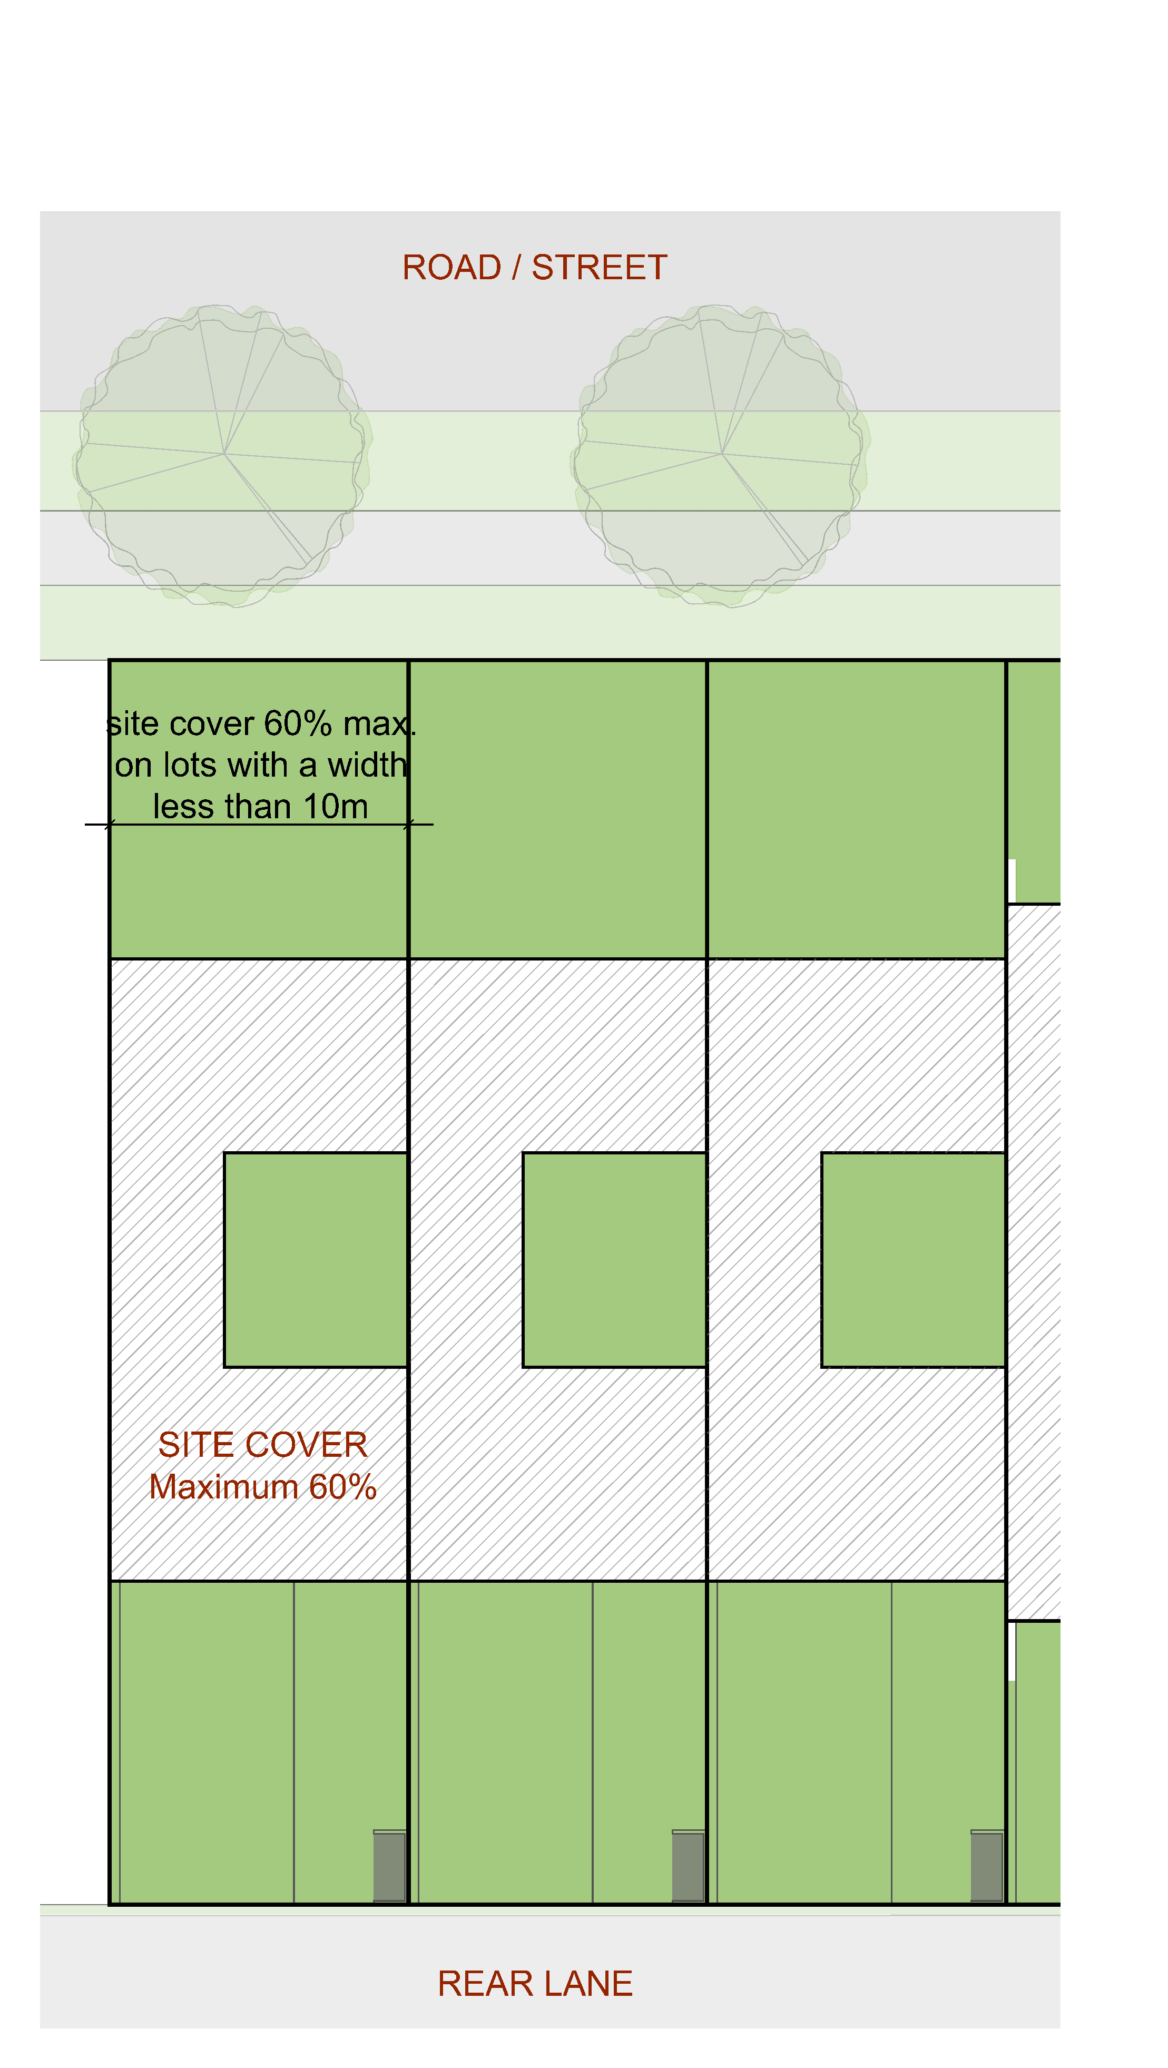
Figure 1
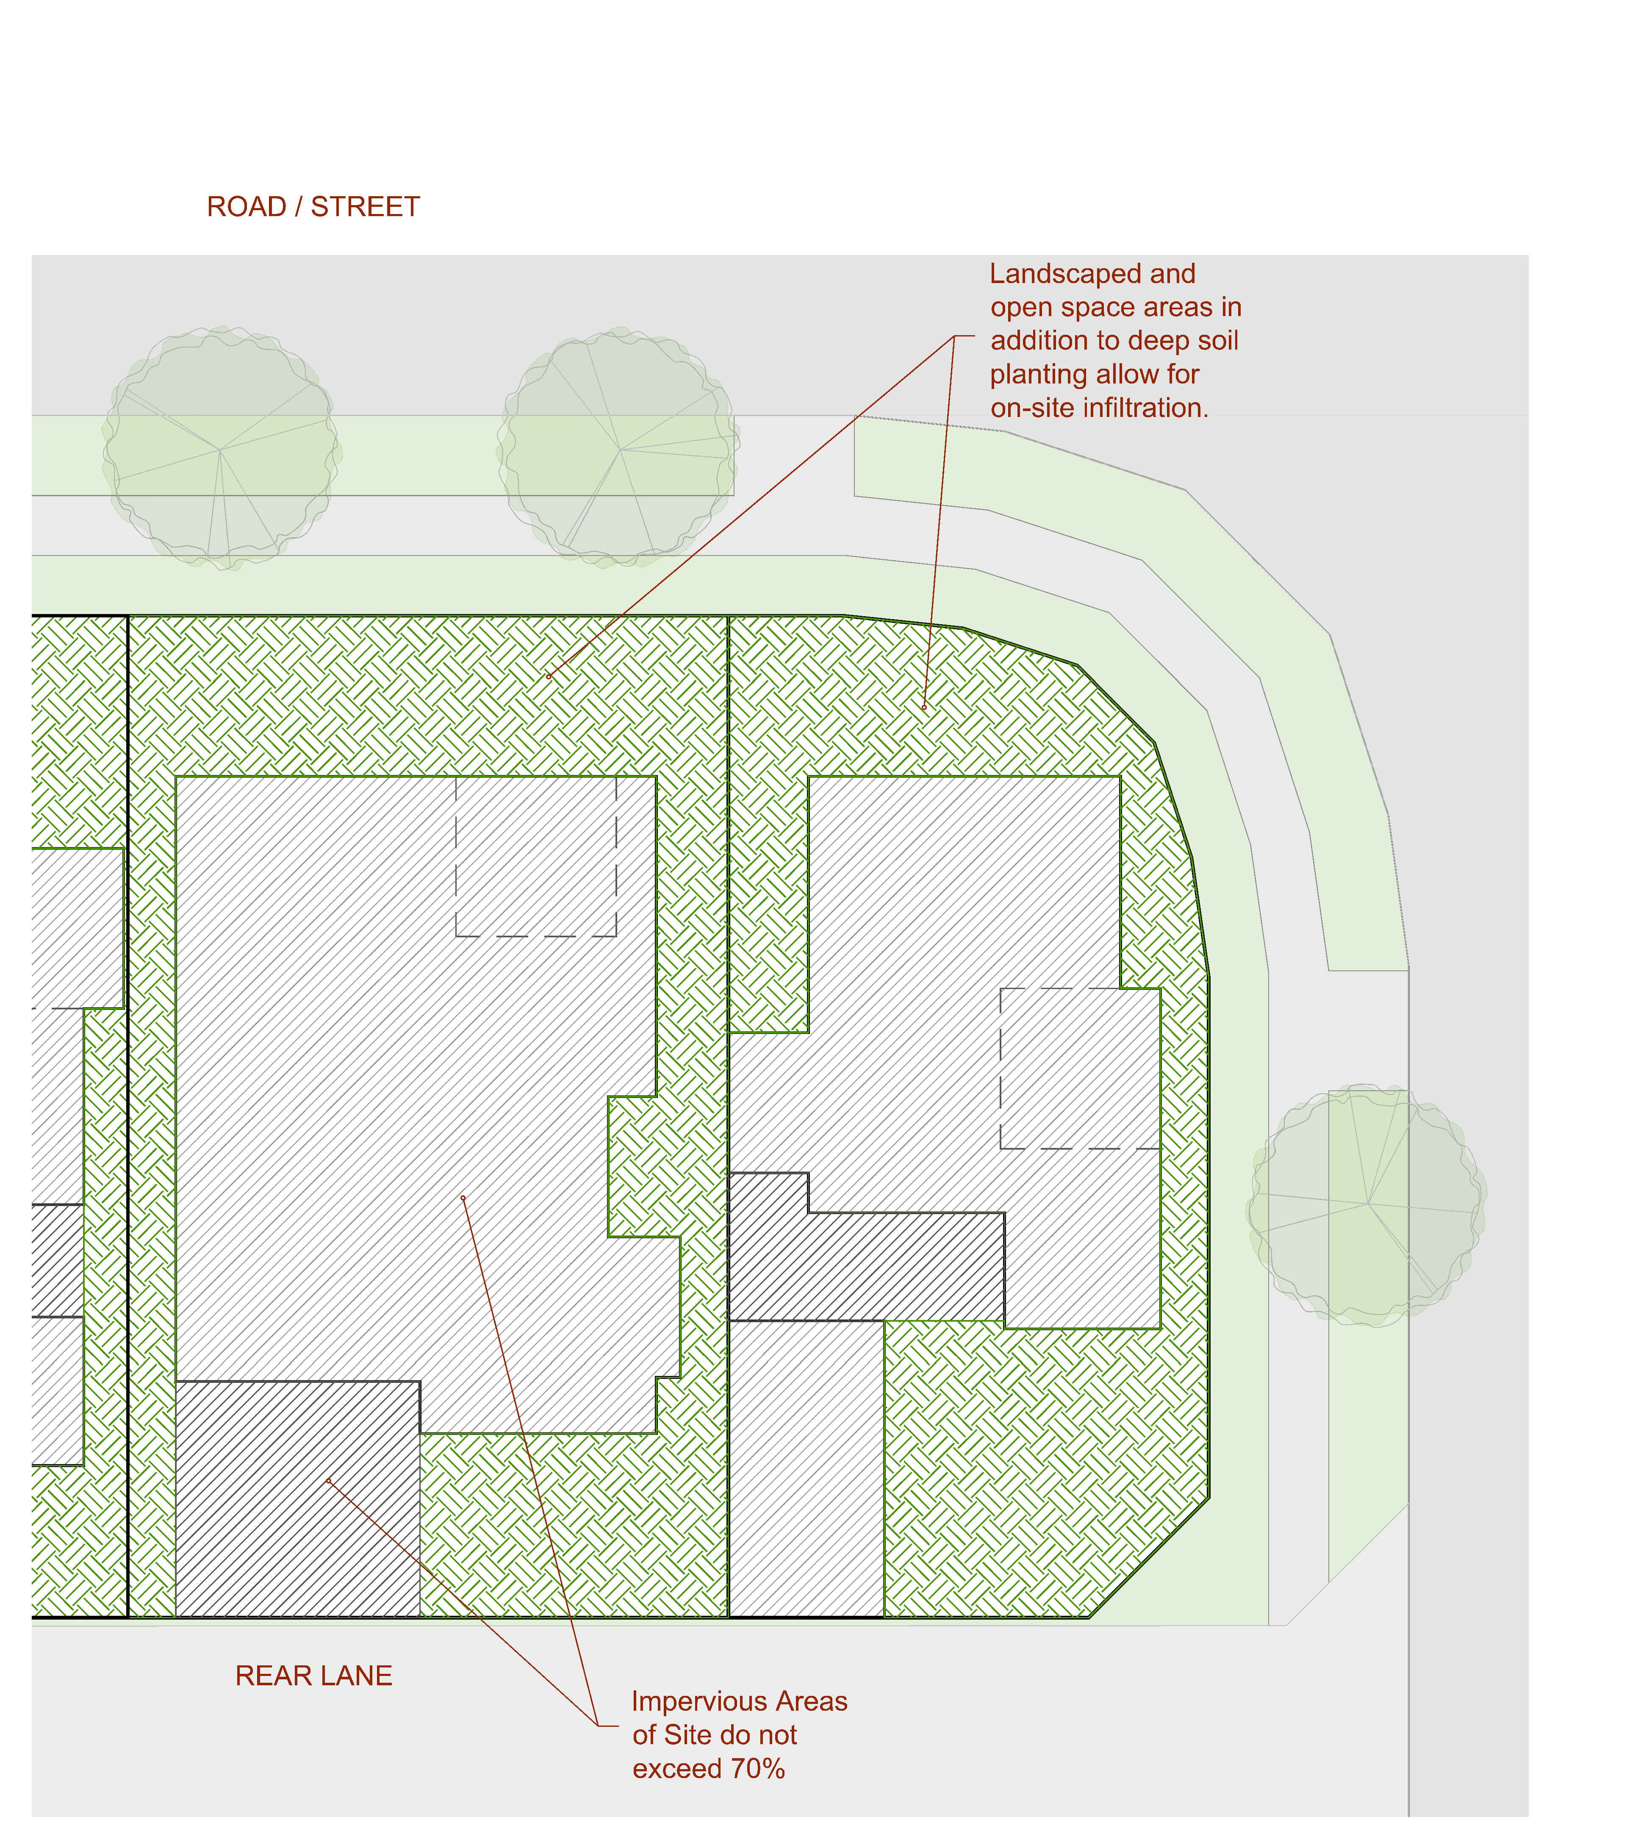
Figure 2
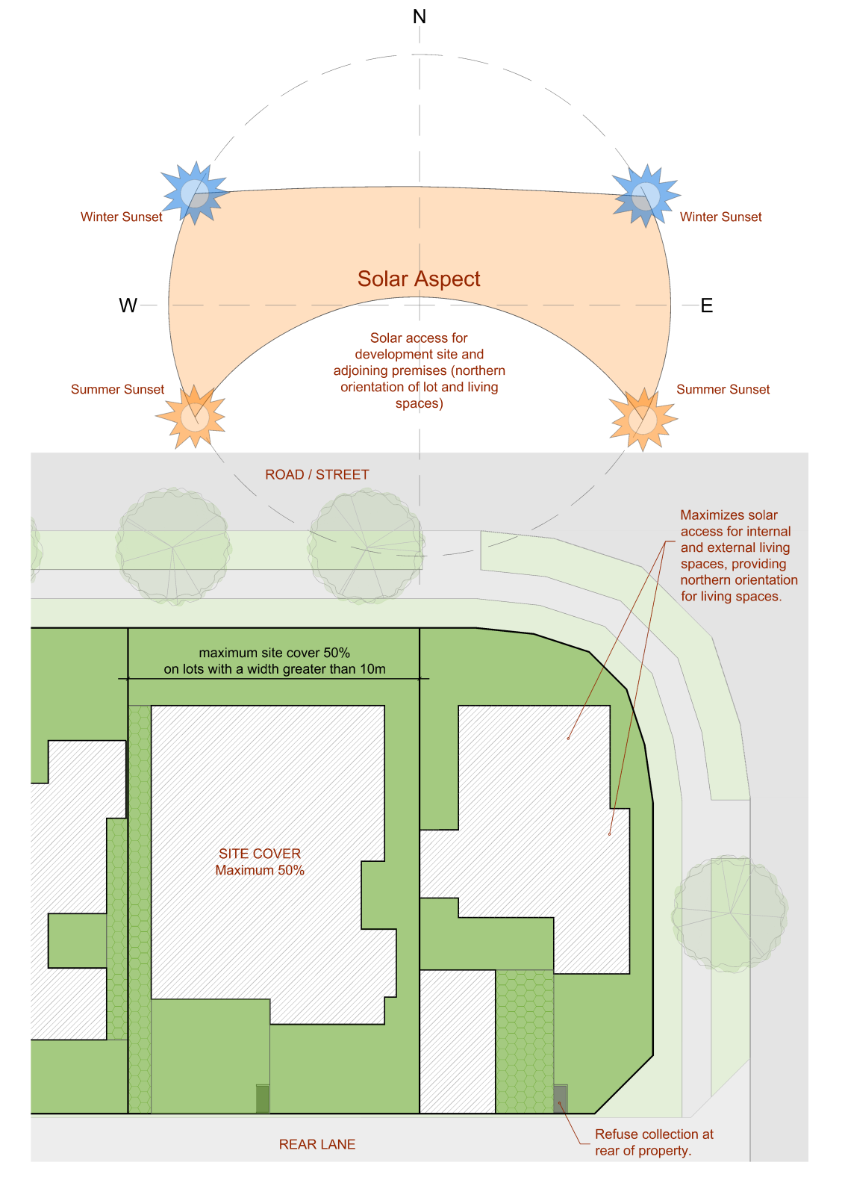
Figure 3
PO₂ Buildings and structures:  - do not lot unduly overshadow adjoining properties; and  - are designed in a manner that minimises the impact on the amenity of residents on adjoining lots;  - comprise a height and bulk which is consistent and compatible with the character of the streetscape and local area;  - maximises solar access for internal and external living spaces; and  - do not compromise solar access for adjoining premises. | AO_{2.1} Buildings have a maximum height of two (2) storeys or 8.5m above ground level.  AO_{2.2} Development ensures that solar access to habitable rooms and private open space on the development site and adjoining premises achieves minimum solar gain of 3 hours between 9am and 3pm July 21.
PO₃ Buildings are setback from the street to:  - complement existing streetscape character, or  - where there is no existing streetscape character, create space for gardens and landscaping, | AO_{3.1} Buildings are setback from the road frontage:  - within 10% of the average front setback of existing residential buildings within 100m of the site; or  - where there is no adjoining buildings the front setback is provided in accordance with Table 4.  Note: Eaves and window hoods (or a portion thereof) may encroach into the above setbacks by a maximum of 600mm.  Note: AO 3.1 is an alternative provision for P1 within QDC Part MP1.1 Design and Siting Standard for Single Detached Houses – On lots under 450m².
  Table 4
  Building element | Minimum setback
  Solid building wall (other than a garage) | 4.0m
  Solid building wall (where for a garage) | 5.5m
  Permeable or non-enclosed elements (e.g. porch, verandah, balcony or carport) | 3.5m (or 3m where secondary road frontage)
PO₄ Buildings are setback from adjacent properties to:  - minimise the impact of development on the amenity and privacy of residents of adjoining lots; and  - facilitate adequate ventilation and access to daylight to habitable rooms within the proposed dwelling house and those of buildings on adjoining lots. | AO_{4.1}. Development is setback from side and rear boundaries by the applicable minimum distance outlined in Table 9.3.10:3.  Note: AO 4.1 is an alternative provision for P2 within QDC Part MP1.1 Design and Siting Standard for Single Detached Houses – On lots under 450m².
PO₅ Built to boundary walls are designed and located:  - in a manner that is consistent and compatible with the character of the local area;  - where they reflect the intended scale and intensity of residential development;  - does not unduly impact on the amenity of an adjoining dwelling;  - considers the existing and future development of adjoining land;  - to allow access to daylight, sunlight and prevailing breezes for residents of the dwelling; and  - to allow for ease of maintenance.  Note: A built to boundary wall is a wall that comprises a 0 metre setback to a property boundary. | AO_{5.1}. Built to boundary walls are not provided on a boundary which is abutted by properties which are located in the Low Density Residential Zone.  AO_{5.2}. Built to boundary walls are not provided on a lot in the Low Density Residential Zone.  AO_{5.3}. Built to boundary walls do not comprise windows or openings and are constructed of low maintenance materials.  AO_{5.4}. Built to boundary walls are not located within 1.0 metre of a habitable room window of an adjoining dwelling house.  AO₅.₅ The maximum length of the built to boundary wall is as nominated in Table 9.3.10:3.  Note: See Figure 4.
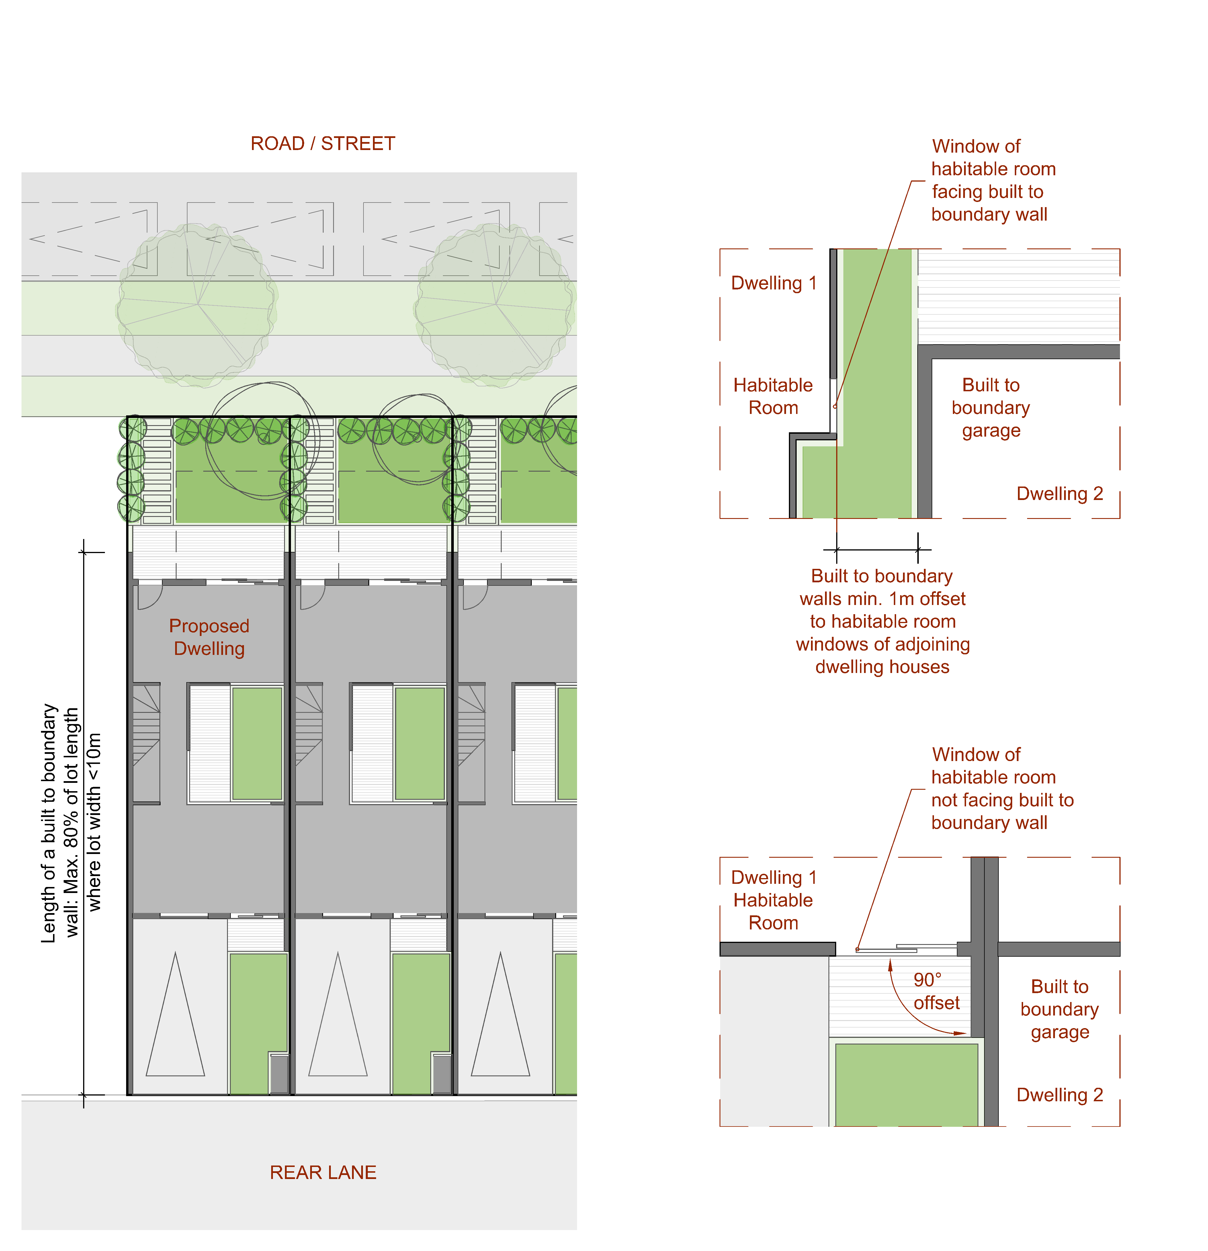
Figure 4
PO₆ Development of built to boundary walls respects the amenity of adjoining premises within the Low Density Residential Zone. | AO_{6.1} Built to boundary walls are not located along a boundary shared with a lot within the Low Density Residential Zone.
PO₇ Garages, carports and driveways do not dominate the street frontage and are designed to be compatible with the main dwelling having regard to:  - height;  - roof form; and  - materials. | AO_{7.1} For lots without rear lane access:  - where two parking spaces are provided they are in a tandem configuration; and  - Covered parking spaces are limited to a garage or carport with a frontage width that is no greater than 3.5m;  - Driveway width is no greater than 3.5m; and  - the garage or carport is setback a minimum of one (1) metre behind the main face of the dwelling.  AO_{7.2} For lots with rear lane access:  - vehicular access to the garage/carport is provided only via the rear lane;  - the site layout must ensure a B85 vehicle (as defined in AS 2890.1:2004 Parking facilities - Off-street car parking) is able to enter a garage/ carport or visitor car park in a single manoeuvre and exit in a single manoeuvre without vehicle turning overhang impinging on walls, posts or landscaping areas).  AO_{7.3} Garage and carport design is compatible with the main dwelling design in terms of:  - height;  - roof form; and  - materials.  Note: See Figure 5.  Note: AO 7.1 and 7.2 are alternative provision for P8 within QDC Part MP1.1 Design and Siting Standard for Single Detached Houses – On lots under 450m².
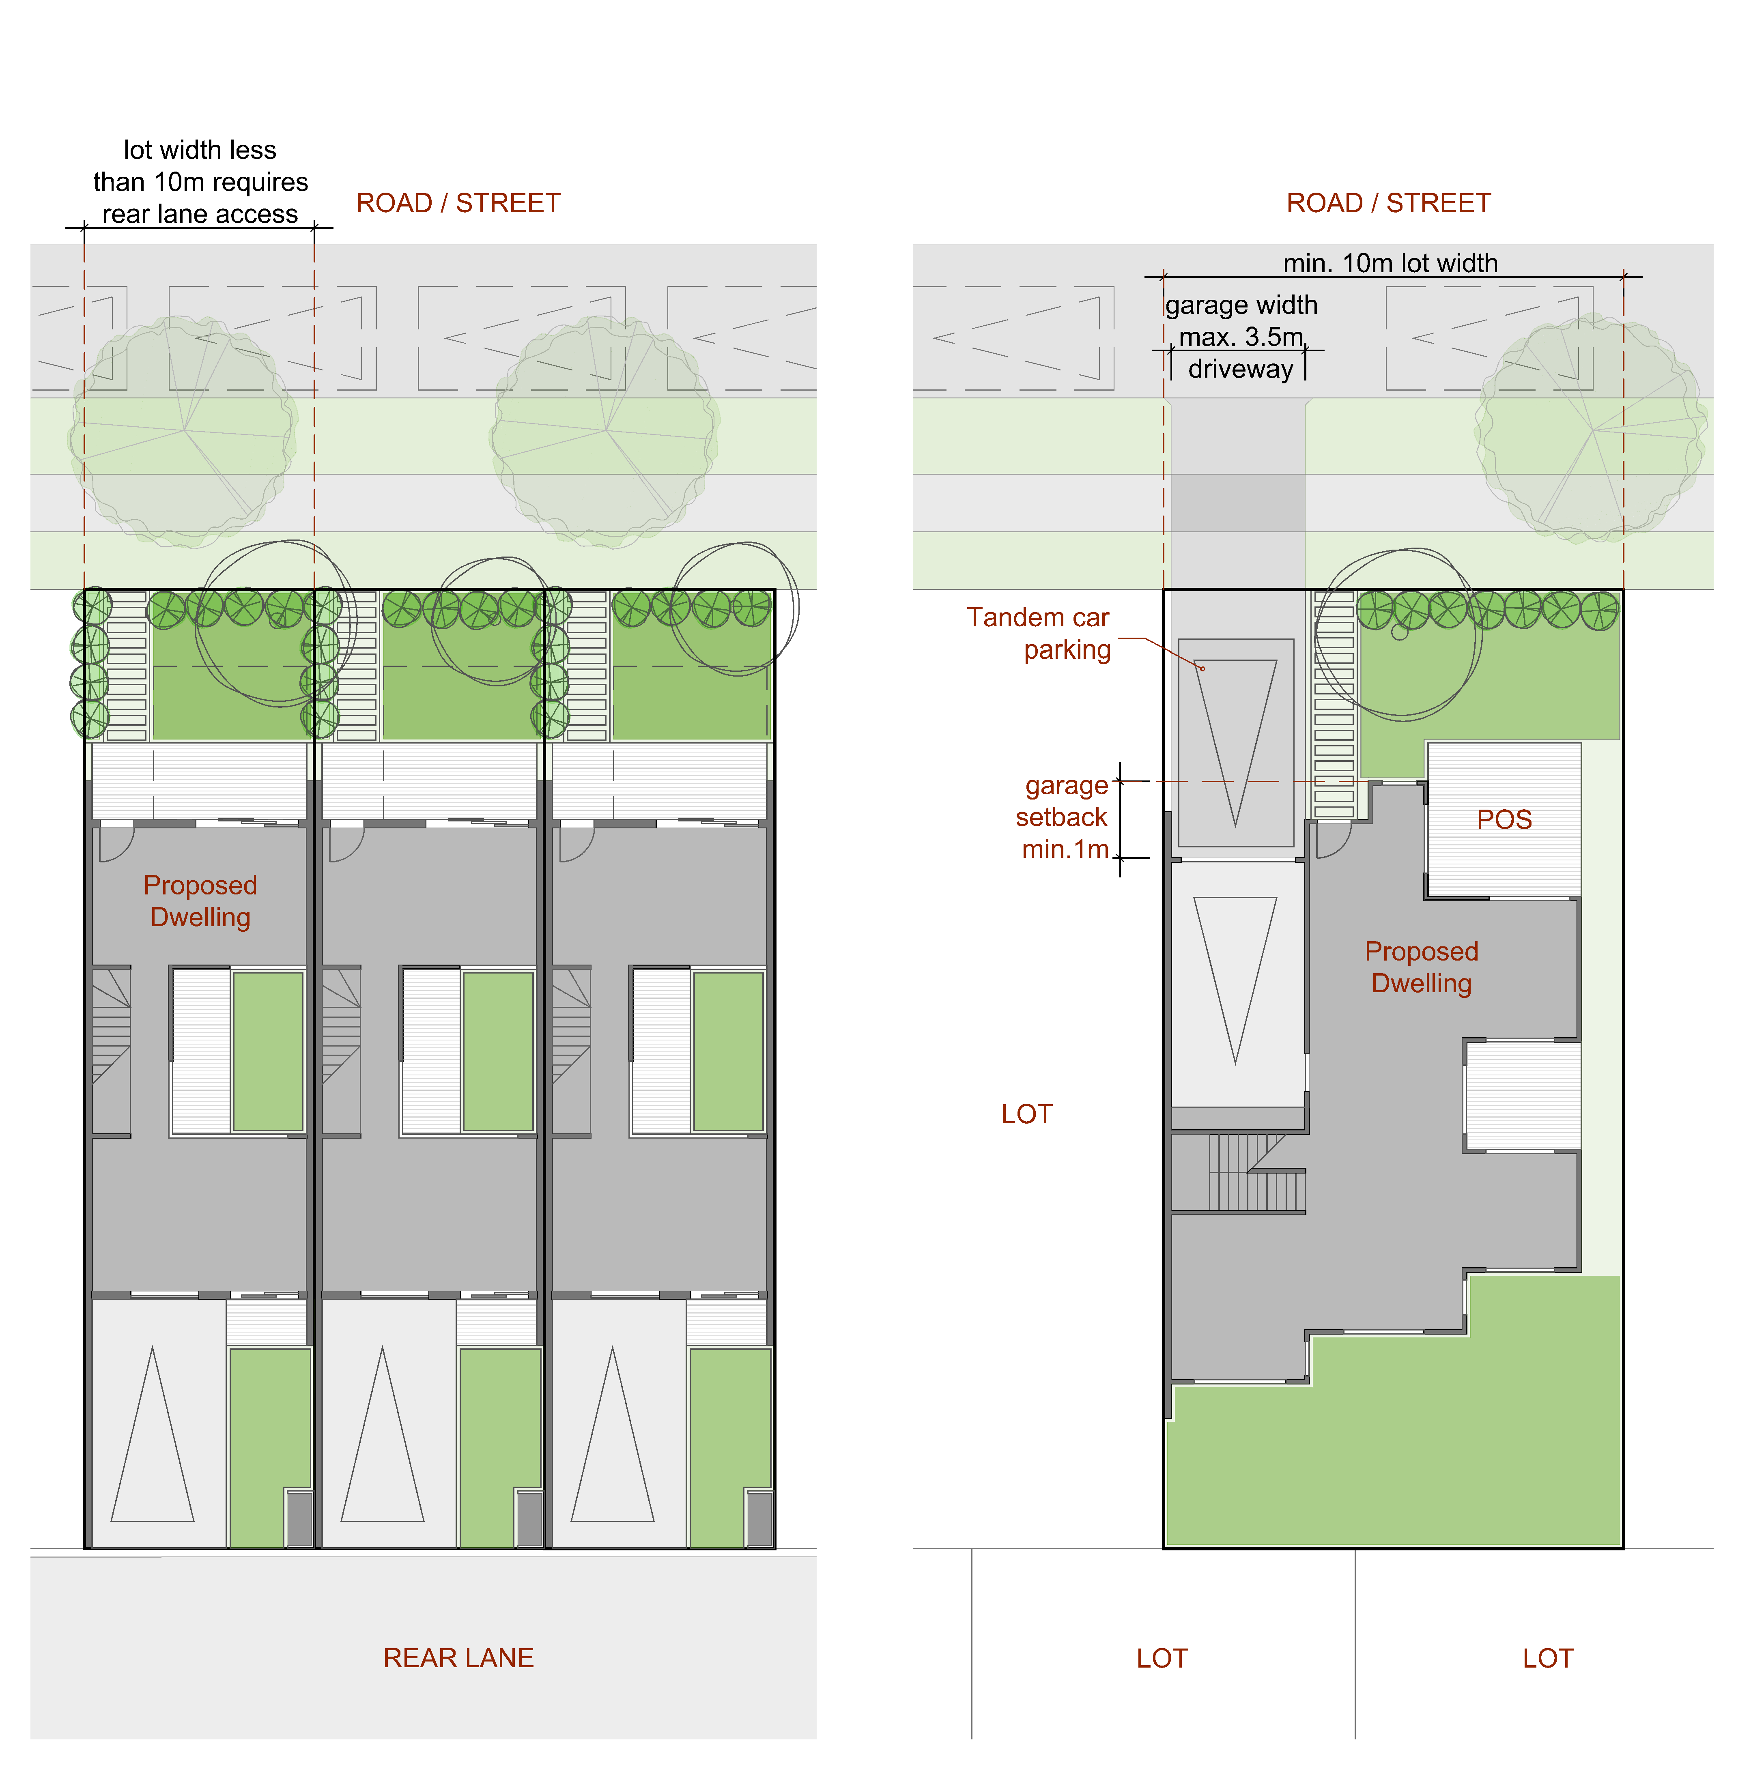
Figure 5
PO₈ Sufficient car parking is provided for the dwelling house that:  - appropriately caters for the anticipated demand generated by residents and visitors;  - ensures the residential amenity of the site and local area is maintained or enhanced;  - does not negatively impact on the character of the streetscape or local area;  - does not unduly burden the passage of pedestrians along the frontage; and  - is of sufficient dimensions to allow ease of access and use for residents and visitors. | AO_{8.1} On-site parking is provided in accordance with the following table:  AO_{8.2} Each parking space has minimum dimensions as per the following table:  Notes: See Figure 6.  Notes: AO 8.1 and 8.2 are alternative provision for P8 within QDC Part MP1.1 Design and Siting Standard for Single Detached Houses – On lots under 450m².  Notes: Double carport, garage or parking space may only be located in conjunction with rear laneway access. All other instances will require tandem car parking solutions.
  Number of bedrooms | Parking Provision (minimum)
  1 or 2 bedrooms | 1 space
  3 or more bedrooms | 2 spaces
  Parking Space | Minimum Dimensions
  Single uncovered parking space  (with at least 400mm clearance between either side of the parking space and the nearest wall.) | 5.4 metres long by 2.6 metres wide
  Single uncovered parking space  (with less than 400mm clearance between either side of the parking space and the nearest wall.) | 5.4 metres long by 3 metres wide
  Single carport | 5.4 metres long by 3 metres wide
  Double carport | 5.4 metres long by 5.8 metres wide
  Single garage | 6.4 metres long by 3 metres wide internally
  Double garage | 6.4 metres long by 6.4 metres wide internally
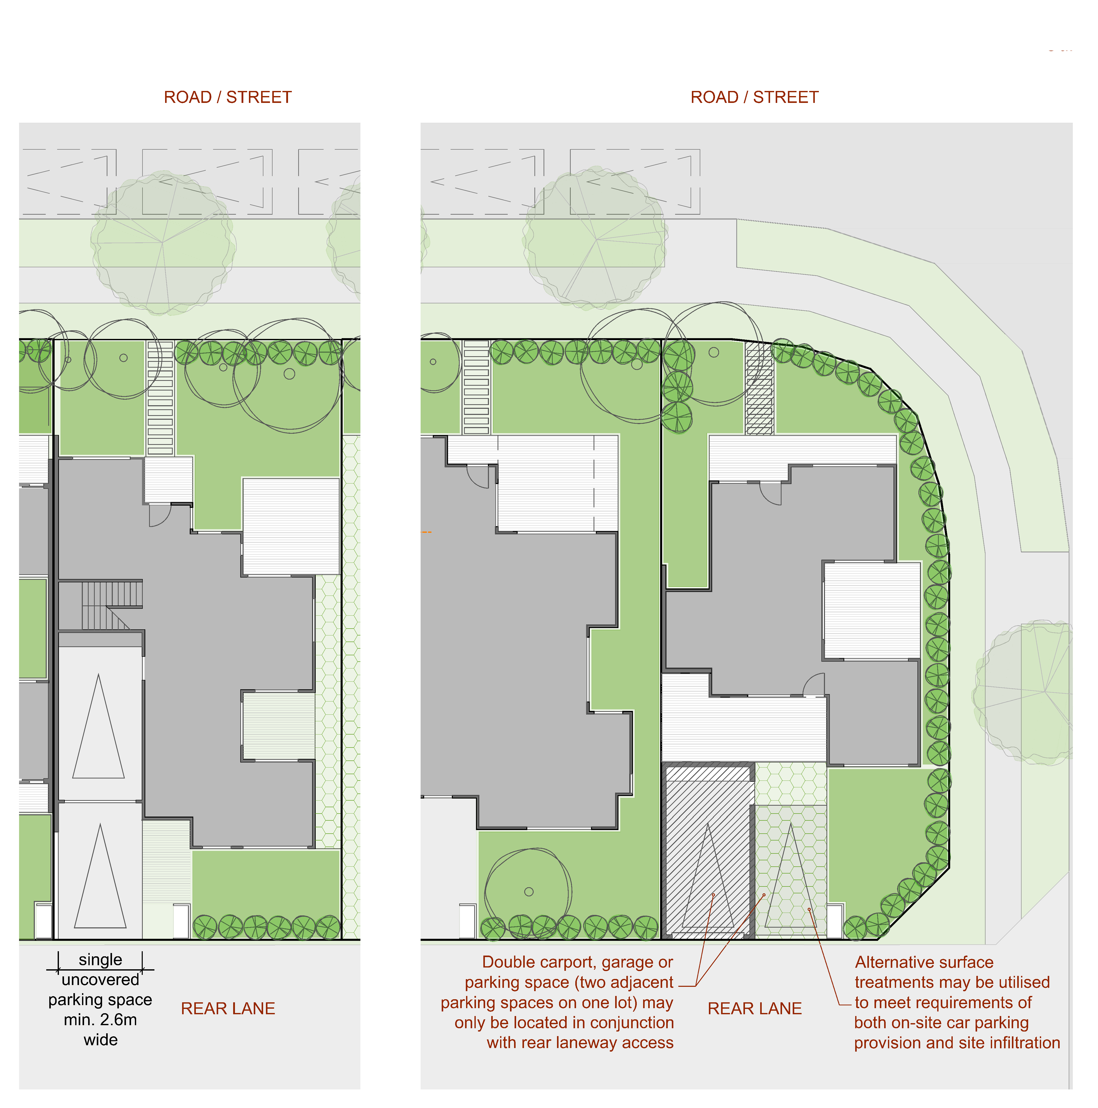
Figure 6
PO₉ Private open space design:  - ensures users have functional, pleasant and private outdoor living spaces;  - meets the needs of the intended users;  - does not detract from the streetscape; and  - does not limit the ability for the dwelling to provide casual surveillance to public spaces. | AO_{9.1} The detached dwelling has a clearly defined area of private open space at ground level that:  - has a minimum area of 16.0m²,  - has minimum dimensions of 4.0m by 4.0m;  - is fenced or landscaped to achieve privacy for occupants;  - is clear of bins, clothes lines, hot water systems, air conditioning units, water tanks and associated infrastructure and other forms of ancillary equipment;  - has access from a living area or kitchen within the dwelling; and  - receives at least three hours of sun between 9am and 5pm on 21 June,  Private open space can include verandas and covered outdoor ground level recreation areas.  AO_{9.2} Private open space is only located within the front setback area:  - where it is the only location where the private open space can be oriented to receive at least three hours of sun between 9am and 5pm on 21 June, and  - there is a 1.5m vegetated buffer between the edge of the POS and the front fence.  Note: See Figure 7.  Note: AO _{9.1} is an alternative provision for P9 within QDC Part MP1.1 Design and Siting Standard for Single Detached Houses – On lots under 450m².
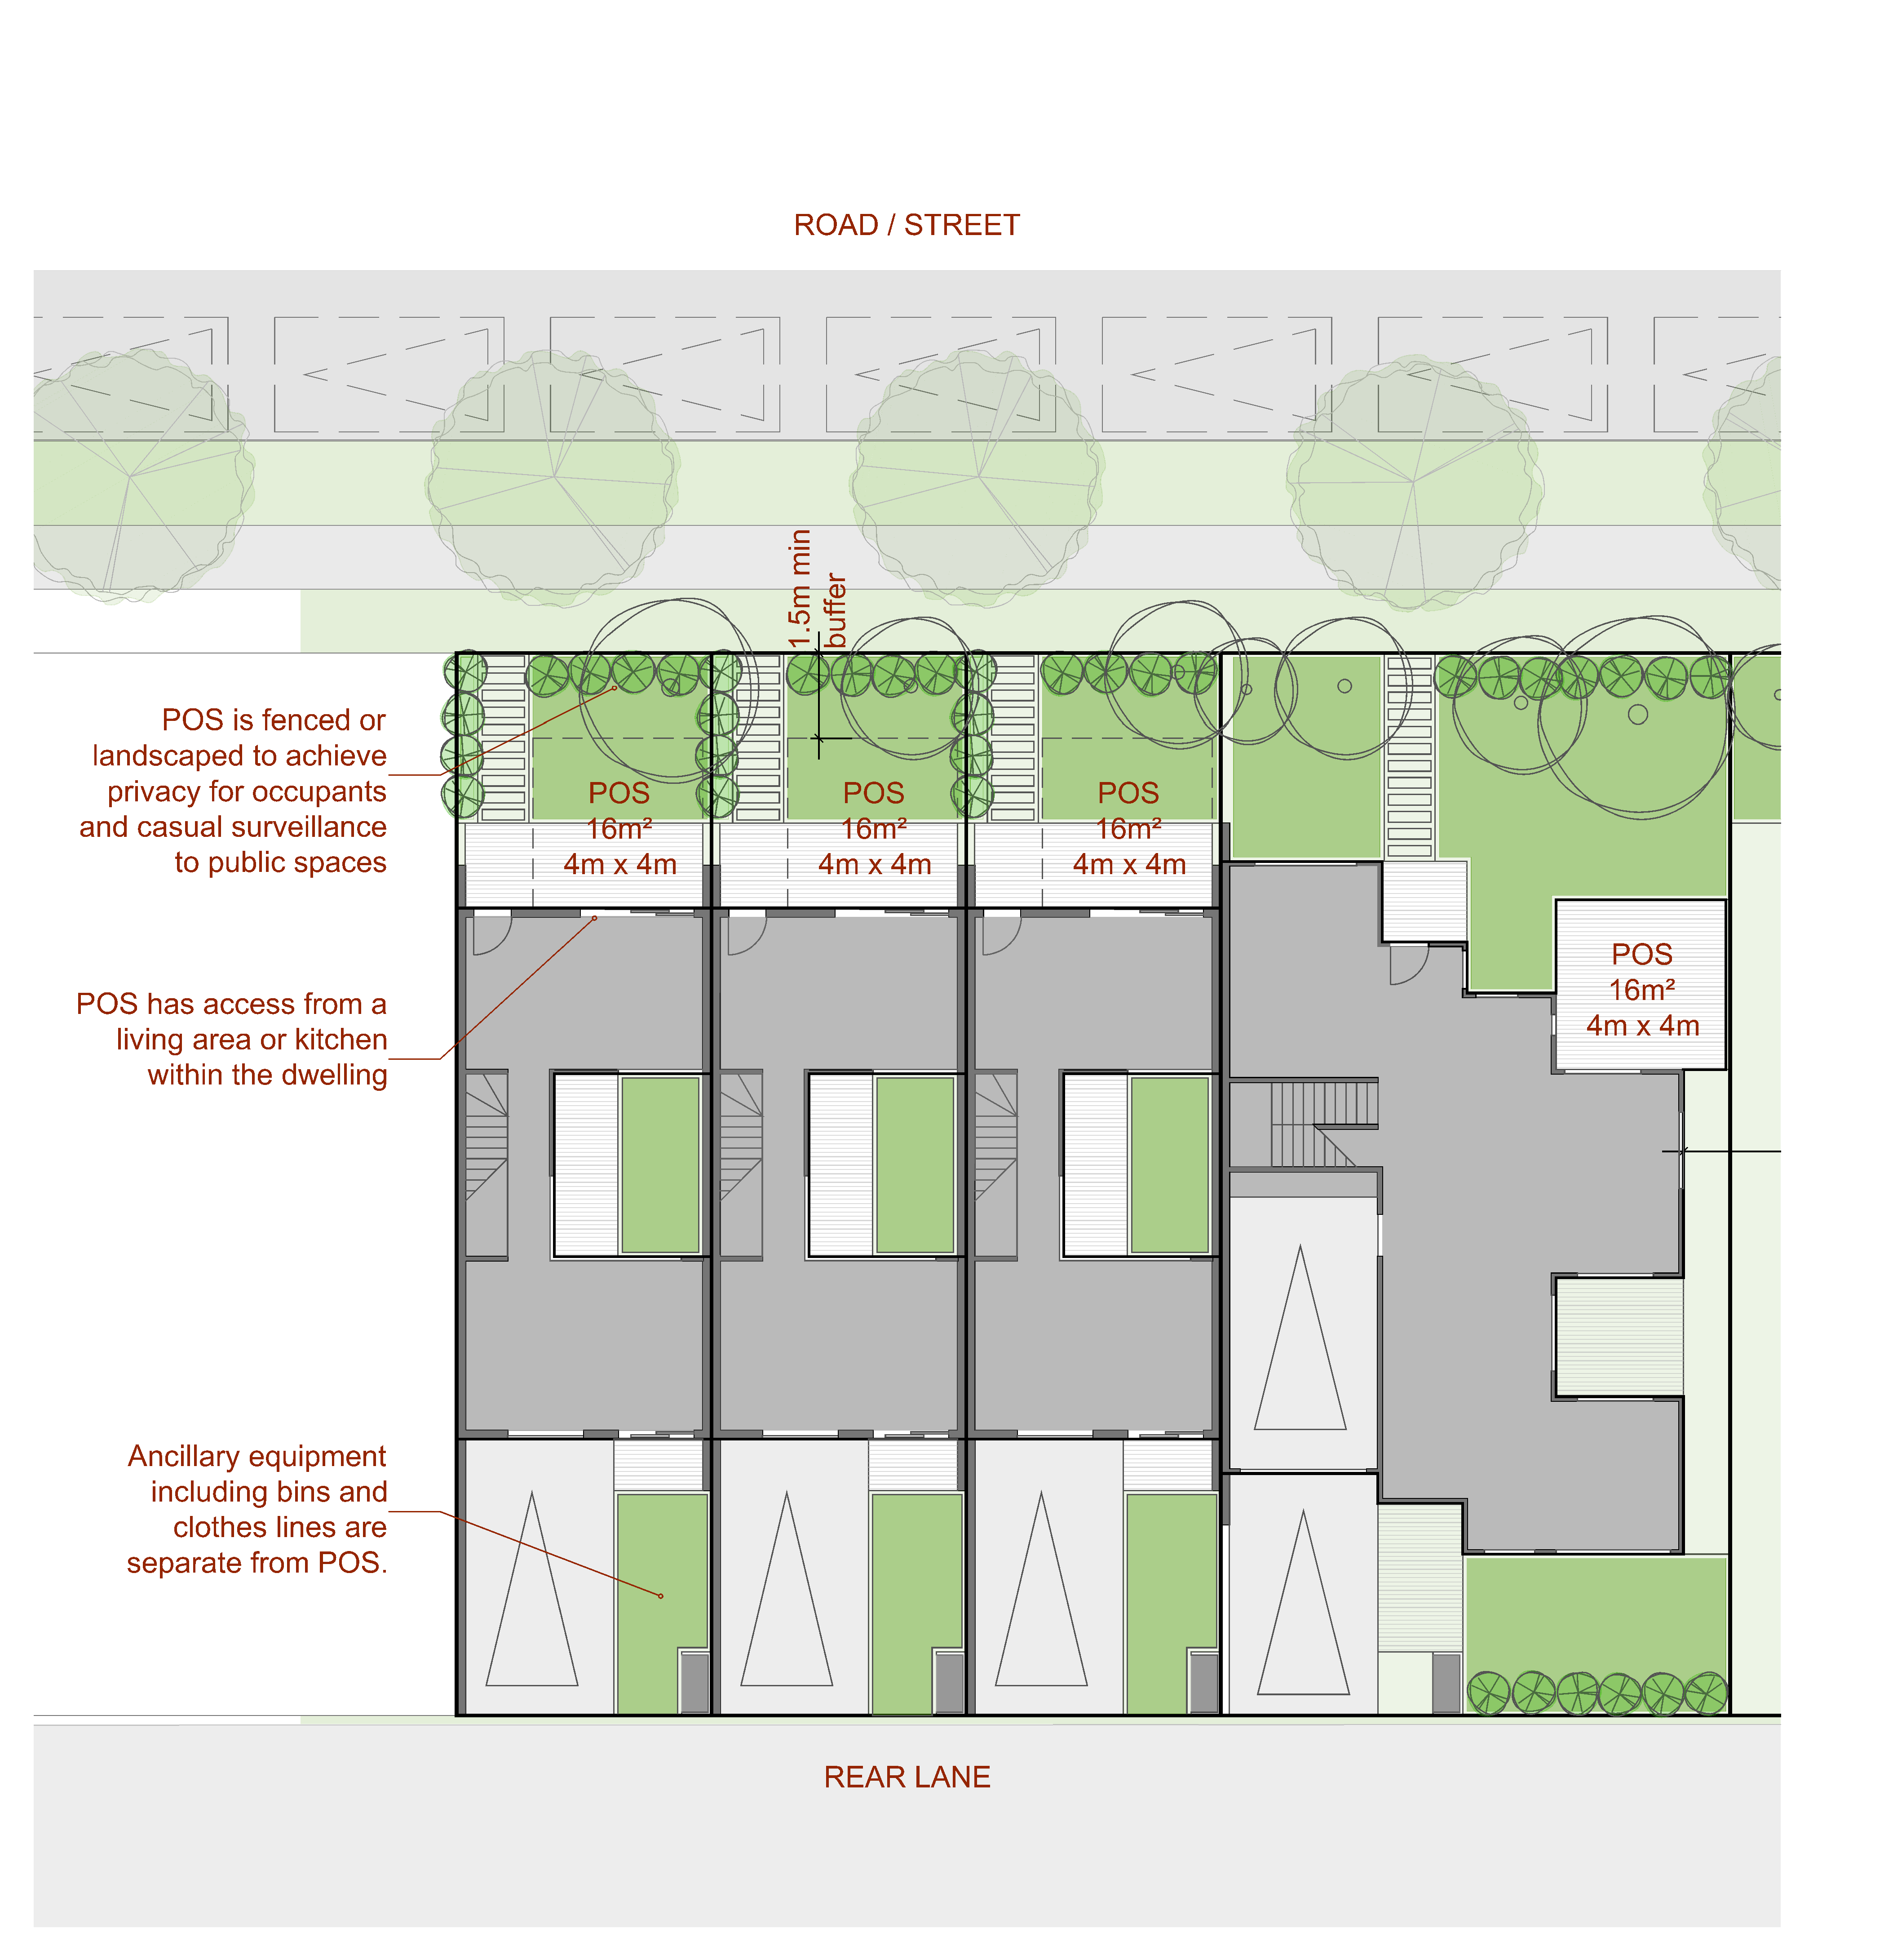
Figure 7
PO₁₀ Development ensures that building design facilitates casual surveillance of the street or adjoining park; | AO_{10.1} Building facades fronting streets or parks include windows, openings, decks or balconies appropriate to permit casual surveillance of these public areas.  AO_{10.2} The front door and at least one habitable room window is visible to the primary street frontage.  Note: See Figure 8.
PO₁₁ Development ensures that fencing and screening associated with a dwelling:  - facilitates casual surveillance of the street or adjoining park;  - provides privacy to the users of private open space; and  - does not negatively impact on the quality of the streetscape. | AO_{11.1} Fences located on a front property boundary or a common boundary with an adjacent park or within the front setback area have:  - a maximum height of1.2 metres; or  - a maximum height of 1.5 metres and a minimum transparency of 30% when viewed from in front of the fence (at 90 degree angle to the fence).  AO_{11.2} Where adjacent to public open space, built form addresses these spaces with:  - a deck, balcony or veranda; or  - overlooking windows to provide casual surveillance; and  - fencing that is no greater in height than 1.2m or at least 30% transparency when viewed from in front of the fence (at 90 degree angle to the fence).  Note: See Figure 8.
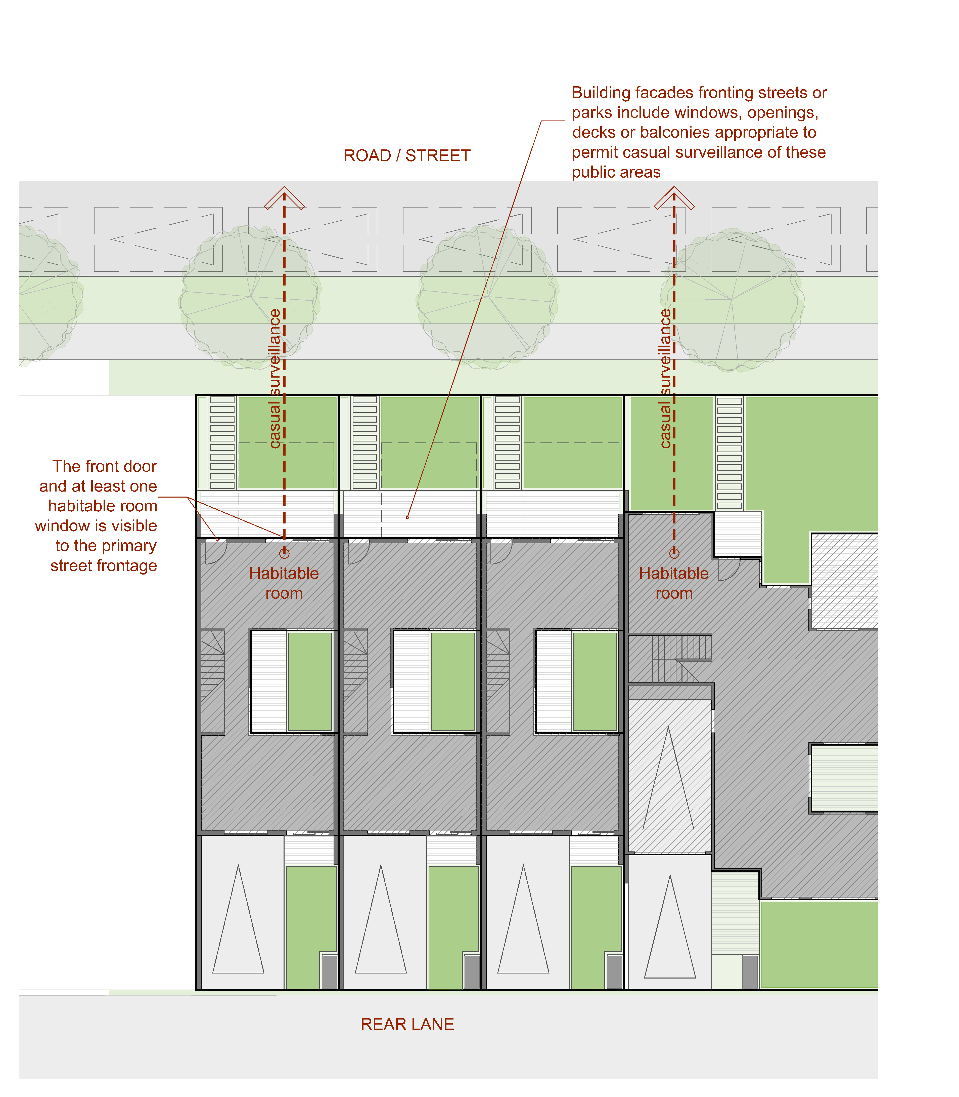
Figure 8
PO₁₂ The privacy of residents of the development or adjoining premises is protected when they are inside a dwelling or in a private open space area. | AO_{12.1} Habitable room windows and balconies do not directly face:  - private open space of an adjoining premises; or  - a habitable room window within 3m on an adjoining premises;  OR  AO_{12.2} Habitable room windows and balconies directly facing private open space or habitable room windows within 3m on an adjoining premises:  - have fixed obscure glazing in that part of the window below 1.5m above floor level; or  - have a sill height or 1.5m or more above floor level; or  - have privacy screens that cover a minimum of 50% window view.  Note: See Figure 9.  Note: AO 12.1 is an alternative provision for P5 within QDC Part MP1.1 Design and Siting Standard for Single Detached Houses – On lots under 450m².
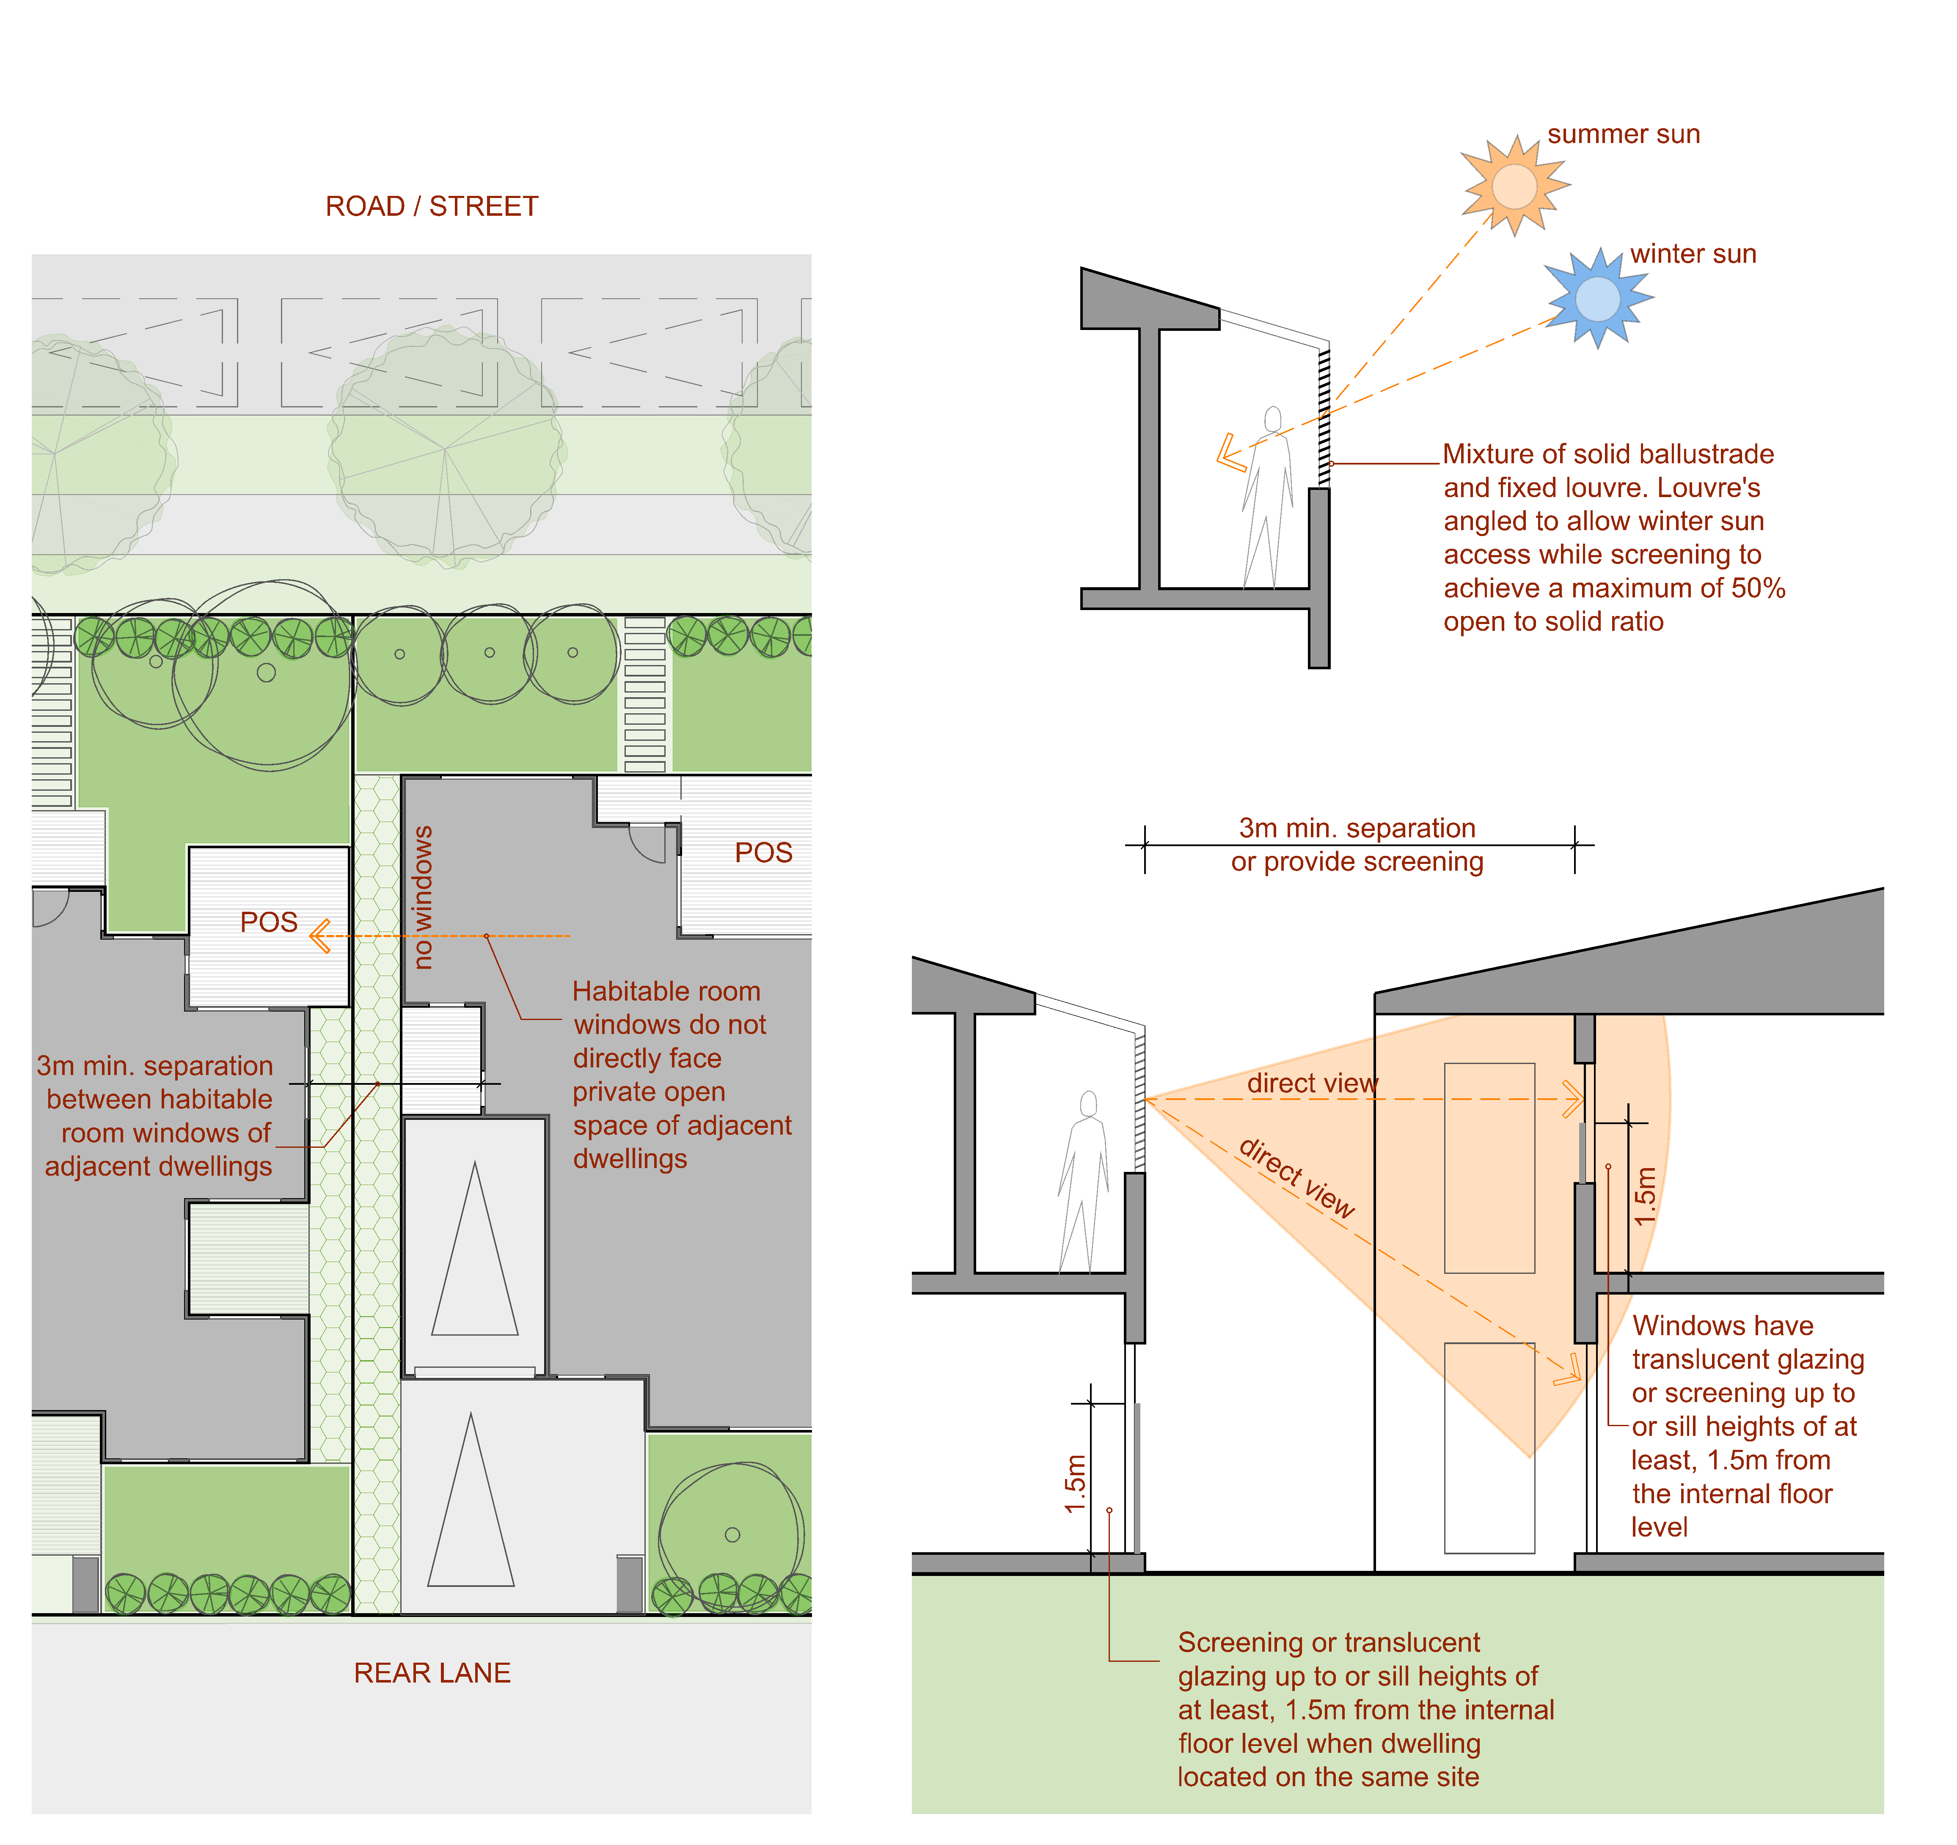
Figure 9
PO₁₃ Stormwater discharge from the site is to a lawful point of discharge as defined in the Queensland Urban Drainage Manual (QUDM), without the use of pumped or charged pipe systems, and not to private land other than to an easement for stormwater purposes befitting the site and allowing discharge to a lawful point of discharge in land over which Council has tenure or control.  Note: Land over which Council has tenure or control does not include Council’s open space network. | AO_{13.1} The site:  (a) has a natural surface with an elevation that is higher than the abutting road and enables stormwater to drain gravitationally to the abutting road via subsurface pipes; or  (b) has a natural surface with an elevation that is higher than Council’s stormwater drainage network in the abutting road and enables stormwater to drain gravitationally to the stormwater drainage network in the abutting road via subsurface pipes; or  (c) has lawful access to an inter allotment drainage network with available capacity to meet the requirements of the development.

Table 9.3.10:2 Minimum Front, Side and Rear Boundary Setbacks
Boundary | Qualification | Lot Width | Minimum Setback
Side | Where the building height is greater than 8.5 metres. | Any | 2 metres plus 0.5 metres for every 3 metres or part thereof exceeding 8.5 metres.
Side | Where the building height is 8.5 metres or less. | ≤ 12.5 metres | 1.2m unless external walls built to boundary (zero lot alignment with no gap to boundary)
Side | Where the building height is 8.5 metres or less. | > 12 metres | 1.2 metre
Rear | Where the building height is greater than 8.5 metres and not associated with a rear lane. | Any | 0 metres (built to boundary) up to 8.5 metres in height;  3 metres for any building element exceeding 8.5 metres in height.
Rear | Where:  - The building height is 8.5 metres or less and  - The site has rear laneway access. | Any | 0 metres
Rear | Where:  - The building height is 8.5 metres or less and  - The side does not have rear laneway access. | ≤ 12.5 metres | 1.2 metres
Rear |  | > 12 metres | 1.2 metre
Secondary frontage | N/A | ≤ 12.5 metres | 0.9 metres
Secondary frontage | N/A | > 12 metres | 1.5 metres

Table 9.3.10:3 Maximum length of a built to boundary wall
 | Lot width  <10m | Lot width  ≥10.0-12.5m | Lot width  >12.5-15m | Lot width  >15.0m
Maximum length (measured as a percentage of lot length) | 80 per cent | 75 per cent | 65 per cent | 60 per cent

Telecommunications Facility Code

Application

This code applies to assessable development identified as requiring assessment against the Telecommunications Facility Code by the categories of development and assessment tables in Part 5 – Tables of Assessment.

Purpose

The purpose of the Telecommunications Facility Code is to ensure that telecommunications facilities are visually integrated with the surrounding natural and built environment and co-located or provide for co-location.

The purpose of the code will be achieved through the following overall outcomes:

development minimises adverse impacts to the community and environment, including impacts of noise and electromagnetic emissions and visual amenity;

development implements best practice with respect to design, environmental management and construction standards;

sufficient all-weather access is provided to the site/facility and is maintained; and

risks to public health and safety are minimised.

Requirements for accepted development and assessment benchmarks for assessable development
Table 9.3.11:1 – Telecommunications Facility Code – Requirements for accepted development and assessment benchmarks for assessable development
Performance outcomes | Acceptable outcomes
Visual Integration
PO₁ Development for a Telecommunications Facility is located and designed to:  provide for the consolidation of Telecommunications Facilities and associated infrastructure and minimise the introduction of adverse impacts on the community associated with new facilities or transmission towers;  (b)_ minimise visual intrusion, having regard to its scale, height, bulk, materials and colour; and  (c) integrate with the character of the area and surrounding land uses. | AO_{1.1} The telecommunications infrastructure is co-located on an existing transmission tower rather than involving the construction of a new separate tower.  OR  AO_{1.2} If the telecommunications facility is either a new freestanding structure or attached to a building, the height does not exceed:  10m above ground level, where located in a road reserve; or  10m above natural ground level, where located in a residential, Community Facilities, Township or Emerging Community Zone; or  30m above ground level where located in the centre zone, Mixed Use Zone, industrial zone, Sport and Recreation, Open Space or rural zone.  AO_{1.3} Where the telecommunications facility is attached to a building, the above height is the combined height of the building and the facility.  AO_{1.4} If a pole, lattice tower or mast, the telecommunications facility provides for the co-location of future infrastructure on the pole, lattice tower or mast.  AO_{1.5} The telecommunications facility is constructed of non-reflective materials and similar colouring to the surrounding land uses.  AO_{1.6} Development does not exceed two telecommunications transmission towers per site.
PO₂ The telecommunications facility is located at distances from the property frontage and the side and rear boundaries to provide clear separation from neighbouring properties and road frontages so that visual obtrusiveness is minimised. | AO_{2.1} Where the telecommunications facility is a freestanding structure (that is, not attached to a building) the following minimum setbacks to property boundaries are achieved:  10m, where the height of the structure is less than 20m;  12m, where the height of the structure is between 20m and 30m; and  20m, where the height of the structure is greater than 30m.
PO₃ Tree and shrub planting provides screening to reduce the visual impacts of the telecommunications facility and to enhance the character of the local area. | AO_{3.1} A minimum 3m wide densely planted landscape strip is provided along all site boundaries.
Environmental Impact
PO₄ Telecommunications facilities do not detract from areas of high scenic amenity. | AO_{4.1} Telecommunications facilities are not located within areas shown on Scenic Amenity Overlay Maps.
PO₅ Telecommunications facilities do not adversely impact on the amenity, health or safety of residential premises, or other sensitive receiving environments. | AO_{5.1} Where the telecommunications facility involves a freestanding tower (that is, not attached to a building) the following minimum clearances to the tower are achieved:  300m to educational establishments, child care centres or retirement facility; and  150m to residential premises.
PO₆ Telecommunications facilities do not cast shadows such that the amenity and character of adjacent premises or a public place is adversely impacted. | AO_{6.1} Buildings or other structures do not result in overshadowing of living room windows or private or communal open space of any residential premises for more than three (3) hours between 9:00 am and 3:00 pm on 21 June, or for more than 20% than existing.
PO₇ Telecommunications facilities prevent or minimise the generation of any noise so that:  nuisance is not caused to adjoining premises or other nearby noise sensitive areas; and  desired ambient noise levels in residential areas are not exceeded. | AO_{7.1} Telecommunications facilities achieve the noise generation levels set out in the Environmental Protection (Noise) Policy 2008.
Public Health and Safety
PO₈ Telecommunications facilities are established, operated and maintained to minimise the risk to public health and safety. | AO_{8.1} Telecommunications facilities are designed and operated to restrict electromagnetic emissions in accordance with:  Radiocommunications (Electromagnetic radiation – Human Exposure) Standard 2003; and  Radio Protection Standard for Maximum Exposure Levels to Radiofrequency Fields – 3KHz to 300GHz.  AO_{8.2} Telecommunications facilities incorporate safety and warning signage to discourage unauthorised access.
PO₉ Fencing encloses the outermost boundaries of the land on which the telecommunications facility is built, in order to prevent unauthorised access. Fencing is designed to:  ensure ease of access to the property for maintenance; and  integrate the telecommunications facility into the local built form character of the surrounding areas. | AO_{9.1} The site is fenced along all boundaries of land identified for telecommunications facility use, including enclosed areas for vehicle parking, storage and landscape works.  AO_{9.2} The materials and coloured finishes used for fencing or walls match those used in the surrounding locality, or where there is no fencing in the surrounding locality the fencing used is green wire mesh to blend with the surrounding natural environment.
PO₁₀ Telecommunications Facilities are to be sited to maximise their efficiency and minimise the number of towers required to service a specific area. | No acceptable outcome is nominated.

Other development codes

Advertising Devices Code

Application

This code applies to assessable development identified as requiring assessment against the Advertising Devices Code by the categories of development and assessment tables in Part 5 – Tables of Assessment.

Purpose

The purpose of the Advertising Devices Code is to facilitate the advertising of businesses, products or services, while ensuring acceptable levels of safety and visual amenity.

The purpose of the code will be achieved through the following overall outcomes:

advertising is aesthetically acceptable and compatible with the character of the local area; and

advertising does not create a hazard to pedestrians, cyclists and vehicular traffic.

High impact advertising devices (billboard, pole, projecting image and 3D signs) are not located in the following areas:

Residential Areas,

Community areas,

Other area, or

Land within the Scenic Amenity Overlay
Where located within or visible from a state-controlled road, advertising devices are designed and constructed in accordance with the Roadside Advertising Guide.
Advertising devices within or adjacent to a State-controlled road corridor require approval by the Department of Transport and Main Roads against the Roadside Advertising Guide.

Requirements for accepted development and assessment benchmarks for assessable development
Table 9.4.1:1 – Advertising Devices Code – Requirements for accepted development and assessment benchmarks for assessable development
Performance outcomes | Acceptable outcomes
Character and Amenity
PO₁ The advertising device:  is attractive and well integrated with the premises;  does not detract from the landscape or streetscape;  does not dominate the landscape or streetscape;  does not contribute to visual cluttering;  is compatible with the character of the locality;  is constructed of quality materials which are able to be maintained in a neat, clean and tidy manner at all times;  is of an appropriate size and shape for the locality in which it is situated;  does not overshadow any adjoining premises; and  where possible, is incorporated within a landscaped environment and/or integrated with the building design. | AO_{1.1} The advertising device complies with the requirements contained in the following:  (a) Table 9.4.1:2—Description and Standards for Advertising Devices; and  (b) Table 9.4.1:3—Maximum face area of all advertising devices.  Note: All dimensions set out in the table include framing or structural components as well as the sign itself.  AO_{1.2} The advertising device does not move, revolve, strobe or flash.  The advertising device promotes products and/or services available from the site on which it is located or contains a message relating to a business or community organisation located on the site.
PO₂ Any advertising device located on premises containing a heritage place listed in SC4 PSP No. 6 – Heritage Places, or a neighbourhood character place listed in SC4 PSP No. 7 – Neighbourhood Character Places complements and respects the heritage values of the listed building and its surrounds. | AO_{2.1} Advertising Devices installed on a heritage or neighbourhood character place are integrated into existing building elements, as illustrated below.
Safety
PO₃ The advertising device:  does not unduly obstruct, or distract, vehicular or pedestrian traffic;  does not, due to height or illumination, interfere with the use, operation or safety of any airport; and  is structurally sound. | AO_{3.1} A minimum of 2.4m high clearance to a public footpath is provided below any advertising device.  AO_{3.2} Advertising devices are structurally sound and securely fastened to prevent accidental damage or injury.  AO_{3.3} Advertising devices are constructed or located such that the view of any traffic sign, traffic signals or street name is maintained, and drivers’ line of sight is not reduced.  AO_{3.4} Advertising devices within 100m of a traffic signal do not move, rotate, flash or strobe and do not incorporate colours and/or shapes that may be mistaken for a traffic signal.  AO_{3.4} Advertising devices do not extend over a roadway or otherwise inhibit vehicular traffic.  AO_{3.5} Advertising devices in areas adjacent to the Toowoomba Airport do not penetrate the Airport Obstacle Limitation Surfaces shown on Airport Environs Overlay Maps.  AO_{3.6} Advertising devices in areas adjacent to the Oakey Army Aviation Centre shown on Airport Environs Overlay Maps do not exceed the following heights:  Area A – 0m;  Area B – 7.5m;  Area C – 15m;  Area D – 45m; and  Area E – 90m.
Illumination of an Advertising Device
PO₄ The level of illumination for an Advertising Device is safe and consistent with the nature of the surrounding area, and ensures that there is no detriment to the amenity of the area in which the Advertising Device is located. | AO_{4.1} The Illuminated Advertising Device does not resemble official traffic signs or signals, and is not located in a position where a traffic hazard or a nuisance is likely to be created.  AO_{4.2} The luminance levels of the Advertising Device are consistent with the following standards:  Industrial areas: 500 cd/ m²;  Commercial areas: 400 cd/ m²;  Residential areas, Community areas,Rural areas and Other areas: 300 cd/ m².  AO_{4.3} The Advertising Device does not flash or strobe.

Performance outcomes | Acceptable outcomes
Advertising devices in a Commercial Area
PO₅ In Commercial Areas, the Advertising Device:  is placed in a manner that does not detract from other signage in the locality having regard to the style, scale, alignment or pattern displayed;  respects the visual rights of neighbouring premises and does not obscure, dominate or overcrowd the view of existing or prospective premises on neighbouring Sites;  clearly identifies the name and street number of the business or activity operating on the premises if it is not already clearly identified; and  respects the amenity of residences in any adjacent Residential Area. | AO_{5.1} For accepted development and accepted development subject to requirements, the Advertising Device meets the standards for the particular type of Advertising Device described in:  Table 9.4.1:2—Description and Standards for Advertising Devices; and  Table 9.4.1:3—Maximum face area of all advertising devices.  AO_{5.2} For code and impact assessable development, no Acceptable Outcome is specified.
Advertising devices in an Industrial Area
PO₆ In Industrial Areas, the Advertising Device:  is located, and is of a scale, colour, type and material, to complement the streetscape and the architecture of the buildings and landscaping on the Site; and  clearly identifies the name and street number of the business or activity undertaken on the premises if it is not already clearly identified; and  respects the amenity of residences in any adjacent Residential Area. | AO_{6.1} For accepted development and accepted development subject to requirements, the Advertising Device meets the standards for the particular type of Advertising Device described in:  Table 9.4.1:2—Description and Standards for Advertising Devices; and  Table 9.4.1:3—Maximum face area of all advertising devices.  AO_{6.2} For code and impact assessable development, no Acceptable Outcome is specified.
Advertising devices in a Residential Area
PO₇ In Residential Areas, the Advertising Device:  comprises a minor component of the overall residential environment;  is discrete and sympathetic to the residential built form and amenity of the locality; and  where in the Residential Conservation Zone, is compatible with, and does not detract from, the heritage and streetscape values of the locality. | AO_{7.1} For accepted development and accepted development subject to requirements, the Advertising Device meets the standards for the particular type of Advertising Device described in:  Table 9.4.1:2—Description and Standards for Advertising Devices; and  Table 9.4.1:3—Maximum face area of all advertising devices.  AO_{7.2} For code and impact assessable development, no Acceptable Outcome is specified.
Advertising devices in Rural Area or Community Area
PO₈ In Rural and Open Space Areas, the Advertising Device:  is a minor and discrete element of the rural and natural landscape and complements that landscape in terms of location, scale, materials, colour and setting;  does not intrude into areas of scenic value or degrade the quality of views from major scenic viewpoints; and  is only for the purposes of displaying property names, tourist information, or details of sporting or other activities undertaken on the Site. | AO_{8.1} For accepted development and accepted development subject to requirements, the Advertising Device meets the standards for the particular type of Advertising Device described in:  Table 9.4.1:2—Description and Standards for Advertising Devices; and  Table 9.4.1:3—Maximum face area of all advertising devices.  AO_{8.2} For code and impact assessable development, no Acceptable Outcome is specified.
Advertising devices in Other Areas and Road Reserves
PO₉ Within Other Areas and Road Reserves, the Advertising Device:  does not cause a nuisance, inconvenience or annoyance to occupiers of adjoining land;  respects the amenity of residences in any adjacent Residential Area; and  accounts for the physical suitability of the Site for that purpose. | AO_{9.1} For accepted development and accepted development subject to requirements, the Advertising Device meets the standards for the particular type of Advertising Device described in:  Table 9.4.1:2—Description and Standards for Advertising Devices; and  Table 9.4.1:3—Maximum face area of all advertising devices.  AO_{9.2} For code and impact assessable development, no Acceptable Outcome is specified.

Table 9.4.1:2 – Signage Information,
Type | Requirements
Above awning sign  An Advertising Device attached to the roof of the awning.  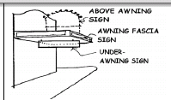 | - Only one ‘above awning’ sign is located on the premises;  - The sign does not exceed a height of 0.5m above the top of the existing awning;  - Where in a Residential Area, Rural Area or Other Area the sign is not illuminated apart from baffled lights; and  - The sign does not extend beyond the sides of the existing awning.
Awning fascia sign  An Advertising Device painted or attached to the front or side face of an awning. | - The sign is located wholly within the outline of a fascia;  - The sign is fixed to the fascia and is projects not more than 0.2m from the fascia; and  - Where in a Residential Area, Rural Area or Other Area the sign is not illuminated apart from baffled lights.
Billboard sign  A billboard is a free-standing structure used primarily to display advertising matter, normally elevated from the ground and supported by one or more vertical supports where the display surface has a width greater than the height.  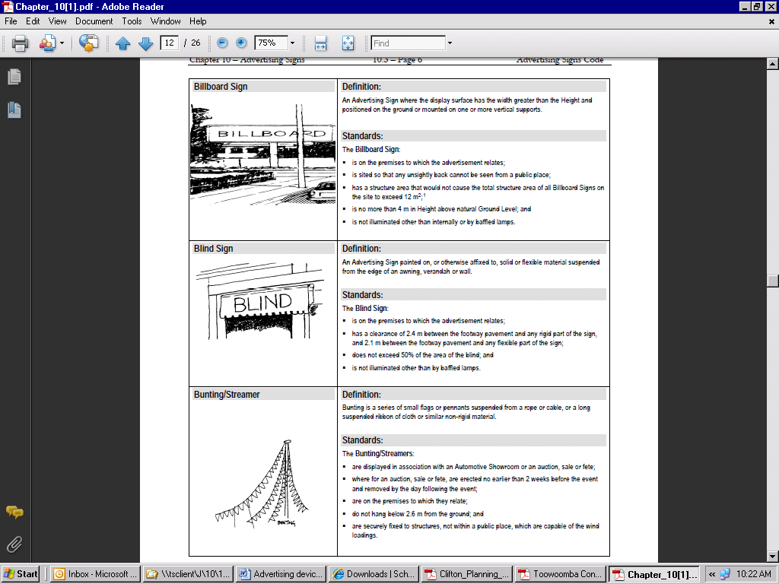 | - Only one billboard is located on the premises;  - The sign does not exceed 20m²;  - The bottom of the sign (excluding the support structure) is no more than 4m above natural ground level;  - The sign is not illuminated other than internally or by baffled lamps;  - The sign is not located in a Residential Area, Community Area, Other Area or on land within the Scenic Amenity Overlay; and  - The sign is not located within 1km of an approved billboard sign.
Blind sign  An Advertising Device painted on, or otherwise affixed to, solid or flexible material suspended from the edge of an awning, verandah or wall. | - The sign does not exceed 50% of the area of the blind.; and  - Where in a Residential Area, Rural Area or Other Area the sign is not illuminated apart from baffled lights.
Bunting/Streamers  A series of small flags or pennants suspended from a rope or cable, or a long suspended ribbon of cloth or similar non-rigid material.  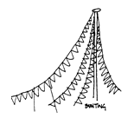 | The bunting/streamers:  - are displayed in association with an Outdoor Sales or an auction or fete;  - where for an auction or fete, are erected no earlier than 2 weeks before the event and removed by the day following the event;  - are on the premises to which they relate;  - do not hang below 2.6 m from the ground; and  - are securely fixed to structures, not within a public place, which are capable of the wind loadings.
Business plate sign  An Advertising Device identifying the name and/or trade or business of the occupant of the premises. | - Only one business plate sign per tenancy is provided;  - The sign does not exceed 0.5m² in a residential zone or 2m² in any other zone;  - The sign is painted or affixed to a wall or fence;  - Where in a Residential Area, Rural Area or Other Area the sign is not illuminated apart from baffled lights; and  - The sign does not project more than 0.1 m from a wall or fence.
Canopy sign  An Advertising Device painted on or otherwise affixed to a canopy, whether the canopy is constructed from flexible or solid material.  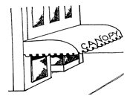 | The canopy sign:  - is on the premises to which the advertisement relates;  - has a maximum clearance of 2.4 m between the footway pavement and any rigid part of the canopy, and 2.1 m between the footway pavement and any flexible part of the canopy;  - does not exceed 50% of the area of the canopy;  - is located in accordance with Schedule B; and  - Where in a Residential Area, Rural Area or Other Area the sign is not illuminated apart from baffled lights..
Changeable message sign  An Advertising Device with an area less than 4 m², usually freestanding, designed to allow the advertising message to be readily changed manually or electronically.  A Changeable message sign does not include a sign used by or on behalf of a public authority, e.g. signage displaying road construction warning/advice related messages.  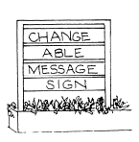  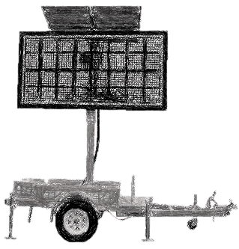 | - Only one double-sided changeable message sign per street frontage is located on the premises;  - The message displayed on electronic advertising devices do not change quicker than every five (5) seconds;  - The sign is not externally illuminated other than by baffled lamps.  - Where the messages change electronically the sign is not located within a Residential Area, Community Area, Rural Area or Other Area.
Fence sign  An Advertising Sign painted or otherwise affixed to a fence along the boundary of a Site.  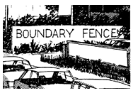 | The fence sign:  - is on the premises to which the advertisement relates;  - is the only Fence Sign on the premises;  - does not exceed 25% of the area of the fence or 10 m², whichever is the lesser;  - is limited to a maximum advertisement Height of 1 m; and  - where in a Residential Area, Rural Area or Other Area, is not illuminated apart from baffled lights.
Flag pole sign  A fabric Advertising Device hung from a pole for the purpose of advertising or identifying a commercial establishment or activity but does not include the flying of the Australian, Queensland or similar flags.   | The flag pole sign:  - is on the premises to which the advertisement relates;  - is limited to one Flag Pole Sign per street frontage except for Automotive Showrooms where it is limited to one for every 30 m of street frontage ;  - has a maximum flag area of 2 m² per flag pole sign; and  - does not exceed 6.5 m in Height.
Ground sign  An Advertising Device that sits on the ground without any poles or framework, usually erected at or near a driveway or entrance to a property and displays a business name or logo.  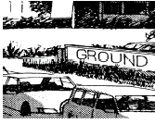 | - The sign does not exceed 4m²;  - The sign has a maximum height of 1.8m;  - The sign has an advertisement area not exceeding 75% of the face of the structure;  - The sign is not closer than 1m to the front boundary of the site; and  - Where in a Residential Area, Rural Area or Other Area the sign is not illuminated apart from baffled lights.
Hamper sign  An Advertising Device painted or otherwise affixed between a door-head and an awning, or similarly above a window and the awning.  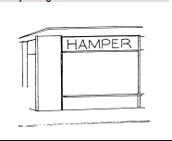 | - The sign does not project more than 0.3m from the wall to which it is attached;  - The sign does not extend beyond the boundaries of the window or door-head to which it is attached; and  - The sign is internally illuminated.
Information sign  An Advertising Device providing information related to the use of facilities or features of an activity undertaken on a site (e.g. a church displaying service times). A menu board for a food outlet is not considered to be an information sign.  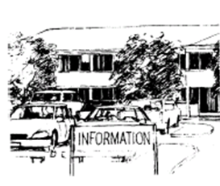 | - The sign is the only information sign on the premises;  - The sign is single sided with the face parallel to the street frontage or where on a corner site the sign may face both of the street frontages;  - The sign does not exceed 2m²;  - Where in a Residential Area, Rural Area or Other Area the sign is not illuminated apart from baffled lights; and  - The sign contains no advertising other than the name or logo of the organisation having tenure of the premises with the name/logo not being more than 30% of the area of the sign.
Mobile Sign  A portable, freestanding, lightweight, Advertising Sign which can be easily moved about a Site.   | The mobile sign:  - is on the premises to which the advertisement relates;  - is the only Mobile Sign on the premises;  - has a maximum Height of 1.5 m and a maximum width of 1.5 m;  - where in a Residential Area, Rural Area or Other Area the sign is not illuminated apart from baffled lights; and  - is secured to prevent danger to pedestrians and traffic in high wind situations.
Pole sign  An Advertising Device which is independent of a building and supported by one (1) or more poles/columns. The display area may consist of multiple panels or slats, which can be replaced. The display surface has a height greater than its width.  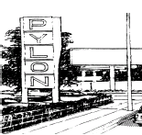 | - The maximum sign dimensions and maximum display areas are:  - Where the sign is located on premises with an area of greater than 1,000m² and not within a residential zone, the sign has a maximum height of 8m, a maximum width of 2.5m and a maximum display area of 10m² per side of a double-sided sign; or  - Where the sign is located in a residential zone, the sign has a maximum height of 3m, a maximum width of 1.5m and a maximum display area of 3m² per side of a double-sided sign; and  - The sign is the only pole sign on the premises; or  - Where the premises has a frontage to an arterial road, sub-arterial road or collector road as shown on road hierarchy map, there is no more than one (1) pole sign for each 100m (or part thereof) of frontage to those roads; and  - The sign is not illuminated other than internally or by baffled lamps; and  - The sign is double-sided or where single sided, is erected so the back of the sign is not visible from a public place; and  - The sign is located a minimum of 3m from a side boundary of a property; and  - Where a site contains more than one business activity and only one pole sign is present on the site, the sign allows for all businesses to be displayed on the one sign;  - The sign is not located in a Residential Area, Community Area, Other Area or on land within the Scenic Amenity Overlay; and  - Pole signs are located as close to the centre of the site frontage as reasonably possible.
Projecting image sign  An illuminated Advertising Sign projected onto a surface as a static or moving image.   | - The sign does not project beyond the surface on which it is projected;  - The sign is not located in a Residential Area, Community Area, Other Area or on land within the Scenic Amenity Overlay,
Projecting wall sign  An Advertising Device projecting at right angles from a wall of a building.  There are two (2) types:  vertical projecting wall sign; and  horizontal projecting wall sign.  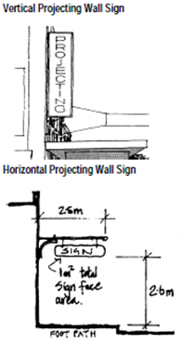 | - The sign is the only projecting wall sign on the premises;  - The sign is on the premises to which the advertisement relates;  - If a vertical projecting wall sign, the sign has a maximum display area of 2m² with a maximum width of 0.5m²;  - If a horizontal projecting wall sign, the sign has a maximum display area of 1m² and has an outermost projection of no more than 2.5m from the wall;  - The sign does not project above the gutter line of the building;  - The sign has a minimum clearance of 2.6m to the footpath;  - The sign is not illuminated other than internally or by baffled lamps; and  - The sign does not cover or hide the architectural features of a building.
Roof sign  An Advertising Device erected on or above a roof or parapet of a building.  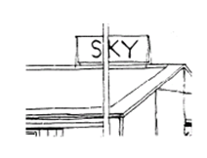  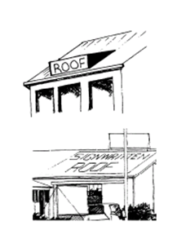 | - The sign is the only roof sign on the premises;  - Where in a Residential Area, Rural Area or Other Area the sign is not illuminated apart from baffled lights;;  - Where painted or located flat on the roof surface, the sign has a maximum area of 25% of the roof; and  - Where protruding vertically from the roof, the sign does not protrude more than 0.5m above any part of the roof line or parapet and does not protrude horizontally more than the length of the roof.
Structure sign  An Advertising Device painted on or otherwise affixed to any structure, such as a storage tank, windmill, tower or similar, that is not a building.  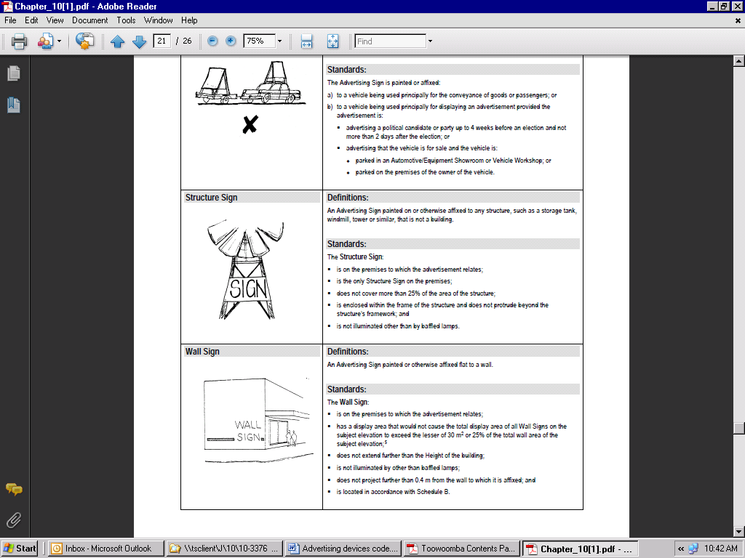 | - The sign is the only structure sign on the premises;  - The sign has a maximum area of 25% of the surface area of the structure;  - The sign is enclosed within the frame of the structure and does not protrude beyond the structure’s framework; and  - Where in a Residential Area, Rural Area or Other Area the sign is not illuminated apart from baffled lights.
Under awning sign  An Advertising Device attached to the underside of an awning.  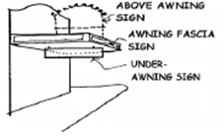 | - The sign is the only under awning sign on the premises;  - The sign has a maximum length of 2.4m and a maximum width of 200mm;  - The sign length is not greater than 75% of the width of the awning to which it is attached;  - The sign is positioned a minimum distance of 1.5m from the end of an awning and/or tenancy;  - The sign is perpendicular to the shopfront; and  - The sign has a minimum vertical clearance of 2.4m from the ground.
Wall sign  An Advertising Device painted or otherwise affixed flat to a wall. | - The sign has a display area that would not cause the total display area of all wall signs on the subject elevation to exceed the lesser of 30m² or 25% of the total wall area of the subject elevation;  - The sign does not extend further than the height of the building;  - Where in a Residential Area, Rural Area or Other Area the sign is not illuminated apart from baffled lights;;  - The sign does not project further than 0.2m from the wall to which it is affixed;  - The sign is integrated into the design of the building; and  - On sites that contain more than one business premises, a single wall sign that provides an equal and consistent advertising opportunity for all tenant/business premises is used.
Window sign  An Advertising Device displayed on a window.  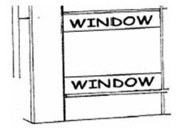 | - The sign does not cover or obscure more than 25% of the window surface;  - Where illuminated window signs are used they are located behind the face of the window (i.e. internal to the building).
3-D sign  An Advertising Device which is designed to replicate or copy an object or shape. The replica may be attached to or constructed as part of a building. The replica may be freestanding or form part of a pole sign.  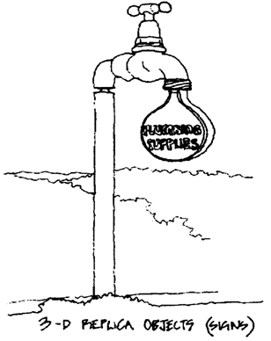 | - The sign is the only 3-D replica sign on the premises;  - The sign is only for a product or service available on the premises on which it is displayed;  - The sign is not located in a Residential Area, Community Area, Other Area or on land within the Scenic Amenity Overlay,  - The sign is not illuminated other than by baffled lamps; and  - The sign has a maximum height of 5m, a maximum width of 2.5m.
Vertical banner freestanding sign  A vertical banner freestanding sign is an advertisement of flexible material normally attached at the top and bottom to brackets extending from a freestanding pole or pole attached to a relocatable base.   | - The maximum area of each face of a Vertical Banner Freestanding Sign is 2.5 m²;  - The maximum width of such as sign is 750 mm;  - The sign is not more than 5 metres high;  - The sign is fully contained within the boundaries of the site;  - The sign is not located within a road reserve;  - No more than one Vertical Banner Freestanding Sign is displayed per 3m of road frontage.

Table 9.4.1:3—Maximum cumulative face area of advertising devices
Column 1  Area | Column 2  Precinct (where applicable) | Maximum total (cumulative) face area of all signs for a premises, being whichever is the lesser of column 3 and column 4
Column 1  Area | Column 2  Precinct (where applicable) | Column 3 | Column 4
Community Area | All | 20m² visible from the road. | No area specified
Residential Area  Rural Area  Other Area | All | 0.25m² per metre of road frontage | 2m²  or  5m² If on the same premises as a lawful non-residential use, other than a home-based business.
Commercial Area  Industrial Area | All  All | No area specified. | No area specified.
Note: Section below provides guidance for calculating sign-face area.
Sign-face area calculation
The information and illustrations below provide guidance for calculating sign face area.

Awning advertising devices
Continuous regular area around advertising device text. | Continuous regular area around an advertising device with a differentiating background.

Fence advertising devices
Continuous regular area around advertising device text. | Continuous regular area around an advertising device with a differentiating background.

Freestanding advertising devices

Continuous area around a freestanding advertising device.

Roof advertising devices
Continuous regular area around advertising device text. | Continuous regular area around an advertising device with a differentiating background.

Wall/Facade advertising devices
Continuous regular area around advertising device text. | Continuous regular area around an advertising device with a differentiating background.

Where the advertising device is three-dimensional

Continuous regular area using the outermost extremities around a three-dimensional advertising device.

Where the advertising device is three-dimensional
For signface area calculation purposes, a single advertising device must have no more than 2 display faces, each of which has an internal angle of no more than 45 degrees to the other display face.
- Advertising devices that include more than 2 display faces must include the additional faces as separate signface area calculations.
- Advertising devices that feature 2 display faces with an internal angle greater than 45 degrees must calculate each display face as a separate signface area (see below).

Signface area calculation for advertising devices with an internal angle greater than 45 degrees.

Environmental Standards Code

Application

This code applies to assessable development identified as requiring assessment against the Environmental Standards Code by the categories of development and assessment tables in Part 5 – Tables of Assessment

Purpose

The purpose of the Environmental Standards Code is to appropriately manage the environmental impacts of development in relation to outdoor lighting, odour, noise, dust, waste management and general air emissions.

The purpose of the code will be achieved through the following overall outcomes:

potential environmental impacts are identified and measures put in place to ensure that those impacts are appropriately managed; and

potential environmental impacts are mitigated to maintain the health and amenity of accommodation activities and other sensitive land uses.

Assessment benchmarks for assessable development
Table 9.4.2:1 – Environmental Standards Code – Assessment benchmarks for assessable development
Performance outcomes | Acceptable outcomes
Outdoor Lighting
PO₁ Development does not unacceptably reduce the amenity and environmental quality of environs, especially of any nearby residential premises or public spaces as a result of light spill. | AO_{1.1} No outdoor lighting is proposed as part of the development.  OR  AO_{1.2} Technical parameters, design, installation, operation and maintenance of outdoor lighting comply with the requirements of Australian Standard ‘AS4282-1997 control of the obtrusive effects of outdoor lighting’.  AO_{1.3} For sporting fields and sporting courts the technical parameters, design, installation, operation and maintenance comply with the requirements of Australian Standard AS4282-1997 – Control of the obtrusive Effects of Outdoor Lighting and a compliance statement by a lighting designer has been provided in accordance with the Australian Standard (Section 4).  AO_{1.4} Where light spillage outside of the property boundary is likely to result in levels above those mentioned in AO_{1.3} the applicant has provided a lighting proposal and impact assessment (environmental and amenity) as part of the application which has demonstrated that the lighting will not create nuisance issues for surrounding sensitive receptors.  AO_{1.5} For private sporting courts the lighting system:  is baffled or shielded to ensure that a light source is not directly visible from a Habitable Room window of an adjoining Dwelling; and  the luminaire does not exceed a height of 8m above the court surface.  AO_{1.6} The alignment of streets, driveways and servicing areas avoid vehicle headlight impacts on adjacent residential dwellings.
PO₂ Outdoor lighting (excluding street lighting, normal residential lighting and low level security lighting) situated in excess of 4m above ground level does not jeopardise the safety or well-being of any pedestrian, cyclist or motorist. Light emissions do not reduce the ability of transport system users to see essential details of the route ahead, including signalling systems and signage. | AO_{2.1} Outdoor lighting situated in excess of 4m above ground level is provided in accordance with Australian Standard AS1158.1.1:2005 – Road Lighting – Vehicular Traffic (Category V) Lighting – Performance and Installation Design Requirements.
PO₃ Outdoor Lighting does not cause unreasonable disturbance or cause detrimental impacts to any significant natural environment. | AO_{3.1} The vertical illumination emanating from the outdoor lighting does not exceed one (1) lx on land within the Environmental Significance Overlay.
PO₄ Proposed sensitive land uses adjoining existing lawful non-residential uses with significant lighting for community purposes, security or safety reasons are designed to proactively address possible obtrusive light nuisance. | AO_{4.1} Proposed sensitive land uses adjoining existing lawful non-residential uses with significant lighting for community purposes, security or safety reasons are designed in a manner to mitigate any light nuisance impacts from the existing lawful use by establishing:  shielding or louvers on windows facing the light source;  orientating buildings and bedrooms so that external lighting does not impact on residents during night time hours; and  utilising earth embankments, landscaping or other physical measures to shield existing light sources.
Odour
PO₅ Development does not unreasonably affect the amenity and environmental quality of environs, especially of any nearby residential premises or public spaces due to odour impacts. | AO_{5.1} The development does not involve activities that create odorous air emissions.  OR  AO_{5.2} The development does not result in air emissions that exceed any of the acceptable levels specified within the Environmental Protection (Air) Policy 2008.  AO_{5.3} The development will not result in the release of noxious or offensive odours beyond the boundary of the site that cause environmental nuisance at any odour sensitive place, i.e. sufficient buffering is available within the development site itself to dissipate odour issues.  Note: An Odour Assessment Report provided with the application may be necessary to demonstrate compliance with AO5.3..
PO₆ Lot reconfigurations for residential or other environmentally sensitive land uses do not encroach upon existing or approved uses that may detrimentally impact upon the amenity of those proposed uses in terms of odour nuisance. | AO_{6.1} Lots for residential or other environmentally sensitive land uses are not located within the distances from specific uses outlined in Table 9.4.2:2 at the end of this code.  AO_{6.2} Where lots for residential or other environmentally sensitive land uses are located within the distances from specific existing uses outlined in Table 9.4.2:2, an Odour Assessment Report has been provided to demonstrate that the development will achieve the following thresholds therefore minimising odour nuisance.
  Existing Use/Activity | Odour Level at Sensitive Receiving Environment.
  All Activities | 2OU/m³ 3 minute average, 99.5th percentile.
  All Activities | 4OU/m³ 3 minute average, 99.9th percentile.
PO₇ Putrescibles waste generated as a result of the development does not cause odour nuisance issues for adjoining land uses. | AO_{7.1} The development ensures that all putrescibles waste will be stored in a manner that prevents odour nuisance and fly breeding and will be disposed of at intervals not exceeding seven (7) days.
Noise
PO₈ The generation of noise from the premises does not cause Environmental Harm or Nuisance to adjoining properties or other noise sensitive land uses.  Development:  is located in an appropriate zone;  proposes best practice design and construction materials (in relation to noise attenuation); and  proposes operational practices that will minimise noise nuisance for adjoining sensitive land uses. | AO_{8.1} The development will achieve the following noise levels (when measured at the nearest sensitive receiver):  Background (L₉₀) + 5dB(A) for variable noise between the hours of 7:00 am to 10:00 pm (measured at the facade of the sensitive land use);  Background (L₉₀) + 3dB(A) for variable noise between the hours of 10:00 pm and 7:00 am (measured within bedrooms assuming open windows);  Background (L₉₀) for continuous noise sources (measured at the facade of the sensitive land use between 7:00 am and 10:00 pm and within bedrooms assuming open windows from 10:00 pm – 7:00 am); and  maximum limit LAmax 45dB(A) inside dwellings; and  The development will achieve the Acoustic Quality Objectives listed within the Environmental Protection (Noise) Policy 2008.  HOWEVER  AO_{8.2} Where a development is unable to meet noise levels specified in AO_{8.1} an acoustic assessment has been undertaken by a suitably qualified and skilled person which demonstrates that the development will not result in environmental nuisance at any existing or likely future residential premises (within a 10 year planning horizon).
PO₉ Development (other than licensed premises operating under a Liquor Licensing Approval) proposing the use of amplified sound equipment is designed, constructed and operated in a manner that is sensitive to the impacts of high and low frequency noise on adjoining sensitive land uses. | AO_{9.1} Where development (other than licensed premises operating under a Liquor Licensing Approval) proposes the use of amplified sound equipment, existing background octave band centre frequencies have been assessed and the development proposes the following maximum sound pressure criterion:
   | Frequency - Hz - "A" Weighted
   | 31 | 63 | 125 | 250 | 500 | 1K | 2K | 4K
  Background Level SPL dB(A) | L₉₀ + 5dB(A) | L₉₀ + 5dB(A) | L₉₀ + 5dB(A) | L₉₀ + 5dB(A) | L₉₀ + 5dB(A) | L₉₀ + 5dB(A) | L₉₀ + 5dB(A) | L₉₀ + 5dB(A)
PO₁₀ Proposed sensitive land uses in close proximity to existing lawful land uses involving significant noise emissions such as entertainment venues, child care centres, industrial zones or other commercial premises are designed and constructed in a manner that achieves acoustic amenity for the users of the development. | AO_{10.1} The development is designed to achieve the internal noise criterion (Acoustic Quality Objectives) for the particular use as specified within the Environmental Protection (Noise) Policy 2008.  AO_{10.2} Where the proposed sensitive land use is not listed in the Environmental Protection (Noise) Policy 2008, the development is designed and constructed to meet the internal sound level design criterion contained in Australian Standard AS2107:2000 Acoustics – Recommended design sound levels and reverberation times for building interiors.  AO_{10.3} Where the sensitive land use is within or adjoining entertainment venues utilising amplified music the applicant has undertaken an acoustic assessment of existing background octave levels and designed the sensitive land use component to mitigate the impacts of low frequency noise (particularly between 31.5Hz and 125Hz).
PO₁₁ Proposed sensitive land uses adjoining Council controlled arterial roads (other than designated ‘Transport Noise Corridors’) are designed and constructed in a manner that provides acoustic amenity for users/residents of the development. | Where development involves a sensitive land use adjoining a Council controlled arterial road (other than designated ‘Transport Noise Corridors’:  AO_{11.1} The development is designed and constructed in a manner that achieves the internal noise Acoustic Quality Objectives listed within the Environmental Protection (Noise) Policy 2008.  AO_{11.2} The siting of buildings and selection of construction materials complies with the specifications of Australian Standard AS3671-1989 Acoustics – Road traffic noise intrusion – Building siting and construction.
PO₁₂ Proposed sensitive land uses adjoining ‘Transport Noise Corridors’ as designated by State or Local Government are designed and constructed in a manner that provides acoustic amenity for users/residents of the development. | AO_{12.1} Proposed sensitive land uses adjoining ‘Transport Noise Corridors’ as designated by State or Local Government comply with the Queensland Development Code Mandatory Part (MP) 4.4 ‘Buildings in a Transport Noise Corridor’ for all habitable rooms adjoining the corridor.
PO₁₃ Air conditioning units, refrigeration units and any other form of mechanical ventilation or extraction systems do not adversely impact on the acoustic amenity of surrounding sensitive land uses. | AO_{13.1} Plant of this nature is not elevated, is acoustically shielded (if necessary) and will not be audible at adjoining sensitive receivers.  AO_{13.2} Roof-top mounted plant and equipment is located away from surrounding sensitive land uses and is acoustically shielded to achieve a nil increase in background noise levels (L₉₀) at the nearest sensitive receiver.
PO₁₄ The construction phase of the development does not cause adverse acoustic impacts on surrounding sensitive receivers. | AO_{14.1} Building work (including excavation and filling) is only conducted between the hours of 6:30 am and 6:30 pm Monday to Saturday (excluding public holidays).  AO_{14.2} Where building work is proposed outside of the acceptable timeframe of 6:30 am to 6:30 pm (Monday – Saturday) the applicant has supplied a ‘construction management plan’ which adequately addresses noise mitigation measures.
PO₁₅ Private sporting courts do not create acoustic amenity issues for surrounding sensitive receivers. | AO_{15.1} Private sporting courts are not used between 10:00 pm and 7:00 am.  AO_{15.2} Mechanical equipment such as ball throwing machines which create audible noise at the nearest sensitive receiver is not used between 7:00 pm and 7:00 am.
PO₁₆ Vibration from the development does not affect the amenity of surrounding sensitive land uses or cause environmental harm or nuisance.. | AO_{16.1} The development does not result in vibration impacts outside of the development site.  AO_{16.2} Where vibration may impact on surrounding sensitive land uses, the proponent has provided a vibration impact assessment or alternatively included vibration within an environmental impact report for the site which demonstrates that the level of vibration will not cause adverse amenity impacts or cause environmental harm or nuisance at any sensitive land use surrounding the development.
Dust
PO₁₇ The construction phase of the development prevents or mitigates (to an acceptable level) the release of dust particles which have potential to cause environmental nuisance to adjoining sensitive receivers (including sensitive receivers along haulage routes during excavation and filling operations). | AO_{17.1} Off-site release of dust particles will be strictly managed to ensure that dust emissions do not travel beyond the property boundary and environmental nuisance does not occur.  AO_{17.2} Areas of exposed fill, excavation and unsealed accesses on the site are watered regularly (particularly during periods of high or constant wind) to reduce dust generation.  AO_{17.3} Areas of fill and excavation are graded, compacted and planted and/or mulched immediately after the dumping operation is complete.  AO_{17.4} Stockpiles of aggregate, sand or other materials brought onto the site are sprayed with water (or treated with an alternative method) to minimise dust nuisance. The frequency of water spraying is increased during hot, dry periods or where wind conditions are such that a dust nuisance is likely to occur. Stockpiles are located away from adjoining sensitive land uses.  Note: Where excavation and filling exceeds 1,000 cubic metres the development has submitted a ‘construction management plan’ which adequately addresses dust mitigation measures. Measures must include strategies such as progressive rehabilitation and complaints processes.
PO₁₈ Haulage activities associated with excavation and filling are managed to prevent environmental nuisance issues. | AO_{18.1} Haulage routes are selected on the basis of using the most suitable road surface to prevent dust generation and minimising the number of dwellings or other sensitive land uses affected by potential dust nuisance.
PO₁₉ Water used for dust suppression activities does not itself create environmental harm. | AO_{19.1} Water approved as a method for controlling dust emissions must not be used in a manner that enables contaminated water to enter any stormwater system or natural drainage corridor outside of the site boundaries.
PO₂₀ The ongoing operation of the development site does not create dust nuisance for adjoining landholders. | AO_{20.1} Areas within the site that are frequently used for vehicular purposes are imperviously sealed.  AO_{20.2} Industry-specific activities undertaken on site that create dust are performed in an enclosed shed or other structure with suitable dust extraction and filtration systems.  AO_{20.3} Grain facilities are equipped with semi enclosed grain receival hoppers fitted with dust extraction and filtration systems. All conveyor belts and bulk grain processing equipment are enclosed to prevent dust emission. Bunker storage without dust extraction is only permitted whereby the release of dust will not impact on surrounding sensitive receivers.  AO_{20.4} All development likely to generate any significant amount of dust must have an adequate water supply available at all times in order to undertake proactive dust reduction measures e.g. watering of access roads.  AO_{20.5} Development that is likely to create ongoing significant dust issues has submitted a ‘site based management plan’ which adequately addresses dust mitigation measures.
PO₂₁ Proposed sensitive land uses are adequately separated from existing lawful land uses likely to generate dust emissions such as landfill sites, quarries, cropping land, motor sport facilities and other similar dust generating activities. | AO_{21.1} Sensitive land uses achieve the separation distances from the nominated uses specified in Table 9.4.2:2.
PO₂₂ Development does not result in dustfall quantities that are likely to impact on the health of surrounding sensitive receivers. | AO_{22.1} Dustfall averaged over an annual period of time does not exceed 133mg/m²/day when measured at the nearest sensitive receiver.
General Emissions
PO₂₃ Air emissions resulting from development do not cause environmental harm (including environmental nuisance). | AO_{23.1} The development does not result in air emissions that exceed any of the acceptable levels specified within the Environmental Protection (Air) Policy 2008.  AO_{23.2} Where a type of air emission is not listed within the Environmental Protection (Air) Policy 2008 the proponent can demonstrate that the level of emission is in compliance with Australian ambient air quality standards; or  If Australian standards do not exist, an ambient air quality standard from another country or organisation may be used with appropriate justification.  AO_{23.3} Where a development is proposing to generate and release air emissions in excess of current air quality emission standards the proponent will provide an ‘air quality impact assessment’ which adequately addresses the impact of the release and provides justification as to why the industry cannot mitigate the levels further.
PO₂₄ Child Care Centres are well located to avoid any harmful impacts from air pollution. | AO_{24.1} Maximum concentrations of air pollutants do not exceed those recommended by the National Health and Medical Research Council.
PO₂₅ Proposed sensitive land uses are adequately separated from existing lawful land uses that produce air emissions. | AO_{25.1} Sensitive land uses in relation to air emissions are not located within the separation distances specified in Table 9.4.2:2.
PO₂₆ Electromagnetic radiation levels from telecommunications and other facilities do not pose health risks to the community. | AO_{26.1} Emission levels from equipment and infrastructure comply with the relevant industry standards as demonstrated through an approved written statement or certification provided by the carrier to council i.e. Electromagnetic Energy report.
PO₂₇ Air emission vents or stacks are sited appropriately to ensure that surrounding land uses are not exposed to concentrated levels of air contaminants. | AO_{27.1} Car park exhaust stacks are located away from adjoining sensitive receivers.  AO_{27.2} Emissions are discharged vertically and have an exit velocity of at least 10m/second.  AO_{27.3} Spray booth exhaust stacks are at least 8m in height or 4m higher than the adjoining ridgeline of a neighbouring building (if the building is within 40m of the emission point), whichever is the greater.  AO_{27.4} Tank venting for hydrocarbon fuel storage and LP Gas is located in accordance with AS1940-2004 The Storage and handling of flammable and combustible liquids (for hydrocarbons) and AS1596:2008 The Storage and Handling of LP Gas.
Waste Management
PO₂₈ The development (excluding high rise buildings in excess of three (3) stories) is designed to ensure that waste storage and collection can be undertaken in a manner that complies with Council’s Technical Guidelines for New Developments Waste Storage and Collection Requirements. | AO_{28.1} For commercial premises and industry activities(other than those premises utilising Council’s wheelie bin waste collection program):  general waste and recycling containers are located within the curtilage of the property in an area that enables the waste collection truck to pick up the containers while entering and leaving the premises in a forward gear;  a container storage area is dedicated that is large enough to cater for the expected volume of general waste and recycling;  storage areas are screened either behind a building or using screening materials or landscaping to a minimum height of 1.5m;  where bulk bins (or alternative combined waste and recycling containers exceeding 2 cubic metres) are proposed the bin storage area is roofed and bunded, contains an impervious surface, is in close proximity to a hose cock and is graded and drained to either a wastewater system connection (requiring a trade waste approval) where sewer is available or in sewered areas, storage areas are drained to an area of significant landscaping, waste water treatment device or water quality improvement system e.g. Bioretention;  where bulk bins (or alternative combined waste and recycling containers exceeding 2 cubic metres) are proposed the bin storage area is designed to enable bins to be washed out within the storage area and drained to a sewer system (requiring trade waste approval) within sewered areas or area of significant landscaping, water treatment device or water quality improvement system e.g. Bioretention in non-sewered areas; and  bin storage areas do not pose amenity issues for surrounding sensitive receivers, including odour during storage periods or noise issues resulting from collection programs.
AO_{28.2} For a Multiple Dwelling of three (3) – six (6) units the development satisfies one of the following criteria:
a minimum road frontage is available within the immediate road reserve adjoining the development in order to place the required number of waste and recycling containers out for collection (2 x 240L wheelie bins per tenement) when calculated at 1m/bin e.g. a development requiring eight (8) bins must have at least 8m of useable road reserve (in terms of bin collection, excluding a 1m clearance around power poles and any area below a street trees canopy where bins cannot be collected);
OR
the complex includes a communal bin storage area, whereby the body corporate will implement internal procedures requiring residents to progressively fill bins and only place full bins out for collection; and
each tenement has an approved bin storage area that will not create amenity issues for surrounding sensitive land uses; and
bin storage areas are screened behind buildings for amenity purposes; and
storage areas are not within dwellings (including garages) and it is not necessary to take the bins through dwellings (including garages) for collection purposes; and
a hose cock is located in close proximity to the storage location to enable bins to be cleaned; and
where a rear storage area is not possible bins are stored in a minimum 1.5m high screened area in the front of the dwelling(s);
OR
screened communal storage areas (to a minimum height of 1.5m) are proposed which contain an impervious floor, hose cock and grading/drainage towards a grassed area or other porous surface.
AO_{28.3} For a Multiple Dwelling above six (6) units the development satisfies one of the following criteria:
The development incorporates ‘internal collection’ of either bulk bins or wheelie bins (in accordance with the waste management guideline that accompanies the environmental standard);
OR
Communal bin storage areas contain a roof, bunding and bin ‘washing’ provisions in the form of either a sewer connection (requiring trade waste approval) or where no sewer is available a connection to a waste water treatment device, drain to an area of significant landscaping or drain to a water quality improvement device e.g. Bioretention system is acceptable;
OR
Where ‘internal collection’ is proposed the internal design complies with the waste management guideline that accompanies this environmental standard and a certification from a registered RPEQ has been provided to demonstrate that manoeuvrability is acceptable for an appropriately sized refuse vehicle.
AO_{28.4} Commercial premises utilising Council’s wheelie bin waste collection service to dispose of commercial waste:
utilise a maximum of four (4) wheelie bins i.e. less than 1 cubic metre;
store bins within the curtilage of the property in a designated area in close proximity to a hose cock, whereby any adjoining sensitive land uses will not experience amenity issues i.e. odour;
store bins on an impervious surface;
place bins on the road reserve for a maximum period of 24 hours during collection programs; and
store bins in an area that is screened from public view either in a building, behind a building or within a purpose built screened storage area within a 1.5m minimum height.
PO₂₉ Development for a Community Residence, Residential Care Facility or Retirement Facility utilising communal bin storage areas ensure that residents have reasonable access to waste containers, where the development is for aged care purposes. | AO_{29.1} For development involving a Community Residence, Residential Care Facility or Retirement Facility, bin storage areas are located within reasonable proximity to all units, in accordance with Council’s Environmental Guideline.
PO₃₀ High rise (in excess of three (3) storeys) residential developments and joint commercial and residential developments are designed to enable best practice waste management principles to be applied. | AO_{30.1} The applicant has provided a waste management plan that as a minimum has addressed the following issues:  likely waste quantity and waste type to be generated on site on a weekly basis;  likely recycling quantities to be generated on a weekly basis;  waste container and recycling container (type and volume) requirements for the residential component (based on 240L of general waste and 240L of recycling per unit) and the commercial component (if applicable);  waste storage area locations;  dual waste chutes for general waste and recycling;  bin room specifications and hygiene practices for waste handling areas, chutes, waste containers and other applicable equipment;  collection arrangements and manoeuvring diagrams (including overhead clearances);  waste minimisation practices;  use of compactors;  an impact assessment of waste management practices on any surrounding sensitive land uses;  air extraction fans, refrigeration or associated devices for refuse storage areas to prevent odour, particularly where putrescibles are stored; and  clinical and related waste storage and collection issues (if applicable).
PO₃₁ Demolition and building activities actively involve waste minimisation and waste avoidance principles including the promotion of recycling and re-use. | AO_{31.1} The development will be carried out in accordance with the waste management hierarchy outlined in the Technical Guideline for New Developments Waste Storage and Collection Requirements and the applicant has nominated the quantity and type of materials that will be disposed of to landfill.
PO₃₂ Development that involves the generation of ‘clinical and related waste’ as per the definition of the Technical Guideline for New Developments Waste Storage and Collection Requirements is designed to adequately cater for legislative storage and collection requirements. | Where involving development that involves the generation of ‘clinical and related waste’ as per the definition of the Technical Guideline for New Developments Waste Storage and Collection Requirements:  AO_{32.1} The storage of ‘clinical and related waste’ is in accordance with the Technical Guideline for New Developments Waste Storage and Collection Requirements with storage locations being demonstrated on submitted site/floor plans.  AO_{32.2} The development has proposed a method of disposing of 'clinical and related waste' and has demonstrated that an applicable waste collection vehicle is able to manoeuvre on site, while entering and leaving the premises in a forward gear.
PO₃₃ Residential development involving ‘internal collection’ of either bulk bins or wheelie bins is designed to a standard that enables heavy vehicle access and manoeuvring whilst providing safety to residents and the protection of infrastructure. | AO_{33.1} The development is designed and certified by a RPEQ and complies with the requirements outlined in Council’s Technical Guidelines for Waste Storage and Collection Requirements for New Developments, including:  appropriate manoeuvring is adequate with vehicles being able to enter and exit the property in a forward gear;  overhead clearance is adequate for the applicable refuse vehicle;  road surface is appropriate for a HRV;  side clearance is appropriate for wheelie bin collection;  collection areas are appropriate for either bulk bins or wheelie bins;  minimum road width of 5.5m; and  internal road networks enable the refuse vehicle to traverse the site without resident safety being jeopardised.
PO₃₄ Development involving refuse storage and collection external to Council’s waste contract utilise waste containers and hygiene practices that prevent odour issues and remove harbourage opportunities for vermin and mosquitoes. | AO_{34.1} The applicant will utilise the following control measures:  putrescibles waste will be removed from the property at intervals not exceeding seven (7) days (putrescibles will be refrigerated where possible and appropriate);  tight fitting lid assemblies will be utilised on all waste containers to prevent the pooling of rainwater, thus minimising mosquito breeding opportunities; and  bins will be secured to ensure that vermin and pest animals do not have access to a potential food source; and  bins will be cleaned on an ‘as needed’ basis if odour is identified as an issue.

Table 9.4.2:2 Separation Distances to Residential and Environmentally Sensitive Land Uses
Existing Use/Activity | Separation Distance
Cropping Land | Minimum 40m vegetated buffer requirement taken from cropping land property boundary.
Landfill | Minimum 1.5km taken from the property boundary of the landfill site.
Transfer Station | Minimum 300m taken from the property boundary of the transfer station site.
Sewerage Works | Minimum 1km taken from the property boundary of the sewerage works.
Poultry Farms | Minimum 1km taken from the closest outside boundary of the shed/conglomeration of sheds (at a 10 year planning horizon).
Extractive Industry | Minimum 1km taken from the outside extremity of the resource boundary (at a 20 year planning horizon).
Piggery | Minimum 1.5km taken from the closest outside boundary of the shed/conglomeration of sheds (at a 10 year planning horizon).
Feedlots | Minimum 1.5km taken from the outside extremity of the closest animal holding yard (at a 10 year planning horizon).
Cattle Dips and Yards | Minimum 200m from the outside extremity of the closest part of the yard or dip (at a 10 year planning horizon).
Kennels | Minimum 1.5km from the nearest outside boundary of the animal holding facility (at a 10 year planning horizon).
Abattoirs | Minimum 500m from the nearest part of the built facility or effluent disposal area.
Dairy Bails and Yards | Minimum 300m from nearest part of the facility (at a 10 year planning horizon).
Motor Sport Facilities | Minimum 1km taken from the nearest part of the facility where vehicles will be utilised for sporting purposes.
Stock Saleyards | Minimum 500m from the nearest part of the facility used for holding animals.
Forestry | Minimum 200m from the nearest part of the plantation designated for commercial harvesting purposes (at a 10 year planning horizon).
NOTE: Buffer may extend beyond Toowoomba Regional Council Local Government boundaries.

Integrated Water Cycle Management Code

Application

This code applies to assessable development identified as requiring assessment against the Integrated Water Cycle Management Code by the categories of development and assessment tables in Part 5 – Tables of Assessment

Purpose

The purpose of the Integrated Water Cycle Management Code is to ensure water and related infrastructure are sustainably managed on a total water cycle basis to maintain the wellbeing of the community and the environment.

The purpose of the code will be achieved through the following overall outcomes:

disturbance to natural land forms, wetlands, water courses and riparian zones is avoided, in order to protect aquatic ecosystems and natural hydrological functions;

the quality of surface and groundwater is protected, consistent with established values and objectives;

development facilitates an efficient use of water resources;

whole of life cycle costs for water and stormwater infrastructure are minimised; and

adverse impacts as a result of flooding and the effects of drainage are avoided.

Assessment benchmarks for assessable development
Table 9.4.3:1 – Integrated Water Cycle Management Code – Assessment benchmarks for assessable development
Performance outcomes | Acceptable outcomes or compliance outcomes if made applicable to compliance  assessable development
Stormwater Management
PO₁ Development does not adversely impact on the quality of receiving waters by avoiding or minimising pollutants entering and being transported with stormwater. | AO_{1.1} Stormwater quality treatment measures are implemented in accordance with SC6.2 PSP No. 2 – Engineering Standards – Roads and Drainage Infrastructure.  AO_{1.2} Pollutant load reductions are achieved in accordance with SC6.2 PSP No. 2 – Engineering Standards – Roads and Drainage Infrastructure.
PO₂ Adverse impacts of construction activities on stormwater quality are avoided or minimised using best practice environmental management for erosion and sediment control. | AO_{2.1} Sediment and erosion control measures are implemented in accordance with SC6.2 PSP No. 2 – Engineering Standards – Roads and Drainage Infrastructure.
PO₃ Stormwater management incorporates water sensitive urban design techniques and avoids adverse impacts from water quantity, flow rates and duration and frequency in receiving waters, having regard to:  channel, bed and bank stability;  aquatic and riparian ecosystems; and  hydrological functions. | AO_{3.1} Stormwater flow control measures are implemented in accordance with SC6.2 PSP No. 2 – Engineering Standards – Roads and Drainage Infrastructure.
Waste Water Management
PO₄ Development does not discharge waste water to a waterway or external to the site unless demonstrated to be best practice environmental management for that site and has appropriate regard for:  cumulative effects;  the applicable water quality objectives for the receiving waters;  adverse impact on ecosystem health of receiving waters; and  in waters mapped as being of high ecological value, the adverse impacts of such releases and their offset. | AO_{4.1} Waste water management measures are implemented in accordance with SC6.2 PSP No. 2 – Engineering Standards – Roads and Drainage Infrastructure.
Artificial Waterways and Water Bodies
PO₅ The waterway or water body is designed to integrate multiple functions, including:  aesthetics, landscaping, and recreation;  flood management;  stormwater management;  water conservation and reuse;  community health; and  pest management. | AO_{5.1} Artificial waterways or water bodies are designed in accordance with SC6.2 PSP No. 2 – Engineering Standards – Roads and Drainage Infrastructure.
PO₆ The waterway is located and designed to be responsive to natural drainage features. | AO_{6.1} Artificial waterways or water bodies are designed in accordance with SC6.2 PSP No. 2 – Engineering Standards – Roads and Drainage Infrastructure.
PO₇ The waterway or body is designed to minimise whole of life cycle costs. | AO_{7.1} Artificial waterways or water bodies are designed in accordance with SC6.2 PSP No. 2 – Engineering Standards – Roads and Drainage Infrastructure.
Flooding and Drainage
PO₈ Flooding and drainage characteristics upstream or downstream of the site are not worsened. | AO_{8.1} Development is undertaken in accordance with SC6.2 PSP No. 2 – Engineering Standards – Roads and Drainage Infrastructure.
PO₉ The drainage network has sufficient capacity to safely convey stormwater run-off from the site. | AO_{9.1} Development is undertaken in accordance with SC6.2 PSP No. 2 – Engineering Standards – Roads and Drainage Infrastructure.
PO₁₀ Stormwater resulting from roofed areas is collected and discharged in a manner that does not adversely affect the stability of buildings or the use of adjacent land. | AO_{10.1} Roof water is collected and discharged in accordance with SC6.2 PSP No. 2 – Engineering Standards – Roads and Drainage Infrastructure.
Water Cycle Management
PO₁₁ The design and management of the development integrates water cycle elements so that:  water is used efficiently and potable water demand is reduced;  wastewater production is minimised;  stormwater peak discharges and runoff volumes are not worsened;  natural drainage lines and hydrological regimes are maintained as far as possible;  large, uninterrupted impervious surfaces are minimised;  reuse of stormwater and grey-water is encouraged where public health and safety will not be compromised; and  water is used efficiently. | AO_{11.1} Integrated water management practices and infrastructure are implemented in accordance with SC6.2 PSP No. 2 – Engineering Standards – Roads and Drainage Infrastructure.

Landscaping Code

Application

This code applies to assessable development identified as requiring assessment against the Landscaping Code by the categories of development and assessment tables in Part 5 – Tables of Assessment

Purpose

The purpose of the Landscaping Code is to facilitate landscaping which is an integral component of urban design, contributing to the creation or enhancement of quality places and spaces.

The purpose of the code will be achieved through the following overall outcomes:

landscaping assists in the creation of aesthetically pleasing, safe, comfortable and functional environments for people to work, live and visit;

landscaping is suitable for its intended function and is responsive to site and environmental conditions;

existing significant vegetation and ecological values are retained and protected, to the extent practicable;

landscaping is integrated with the overall design of a development, and contributes to a coherent streetscape and the desired local character; and

landscaping is established in a manner that ensures the viability of species utilised and cost effective maintenance.
Landscape works within or directly adjacent to a State-controlled road corridor required approval from the Department of Transport and Main Roads in accordance with the Transport Infrastructure Act 1994 and TMR Engineering Policy- Directions and Guides – Policy Number EP143 Road Landscapes.

Assessment benchmarks for assessable development
Table 9.4.4:1 – Landscaping Code – Assessment benchmarks for assessable development
Performance outcomes | Acceptable outcomes
PO₁ Landscape design is developed by a suitably qualified landscape professional and demonstrates an integrated approach to planning/development issues and documents both hard and soft works proposed for the development. | AO_{1.1} Landscape documentation is prepared by the landscape professional identified in Table 9.4.4:2.
PO₂ Landscape construction is undertaken by a suitably qualified landscape professional. | AO_{2.1} Landscape construction is carried out by a member of the Queensland Association of Landscape Industries.
PO₃ Landscape design reflects the local context and incorporates cohesive and desirable aspects of the prevailing landscape character. (Desirable aspects are those considered necessary to maintain and enhance the character, setting and/or ambience, and ecological values of the location.) | AO_{3.1} Where a street or locality has an identifiable character derived from existing vegetation, similar or identical plant species are used.  AO_{3.2} Existing desirable landscape elements and treatments are incorporated into landscaping to integrate the development into the existing character of the area.  AO_{3.3} Existing site trees are integrated into the development.  AO_{3.4} Species selection is reflective of cool temperate species.
PO₄ Where the development involves the creation of a new road street tree planting is undertaken having consideration of:  the hierarchy and function of the street;  selection of appropriate species;  avoidance of conflict between the street tree and utilities and services within the road reserve;  soil conditions;  existing street trees;  solar access; and  driveway access. | Where the development involves the creation of a new road:  AO_{4.1} Street planting is carried out in accordance with the requirements of SC6.2 PSP No. 2 Engineering Services Infrastructure Roads and Drainage.  AO_{4.2} Species and materials are used that minimise the use of potable water.  AO_{4.3} Street tree planting is in accordance with PSP No.8 – Street Trees.
PO₅ Fencing design and acoustic barriers:  are compatible with the existing streetscape and proposed development type; and  provide visual interest and address the street. | AO_{5.1} Front fences longer than 15m and greater than 1,400mm in height are visually fragmented with recesses at least 1.2m deep and 1.2m wide at 15m intervals, planted with at least one tree and groundcovers.  AO_{5.2} All planting and recesses along a fence are located within the property boundary and planting recesses are accessible from within the site.  AO_{5.3} Where acoustic fencing is required by the planning scheme it is designed by an acoustic engineer and incorporates a minimum 3m vegetated buffer on either side of the fence with vegetation having a mature height equal to or above the height of the acoustic fencing.
PO₆ Location, design and provision of planting in carparks and internal roadways achieve a high degree of shade, amenity and safety. | AO_{6.1} Landscaping visually fragments and shades carparking areas with regular tree planting in individual planting bays evenly distributed throughout the car parking area at the rate of one planting bay per eight (8) carparking spaces.  AO_{6.2} Individual planting bays have a minimum dimension of 1,500 x 1,500mm with permeable surface treatments and are flush with the finished surface levels of the car park.  AO_{6.3} No raised kerbing is provided around planting bays. Wheelstops or bollards are used to delineate planting bays where necessary and finished carpark surface levels fall toward planting areas.  AO_{6.4} Planting bays incorporate ground covers less than 1,000mm height that allow unobstructed surveillance.
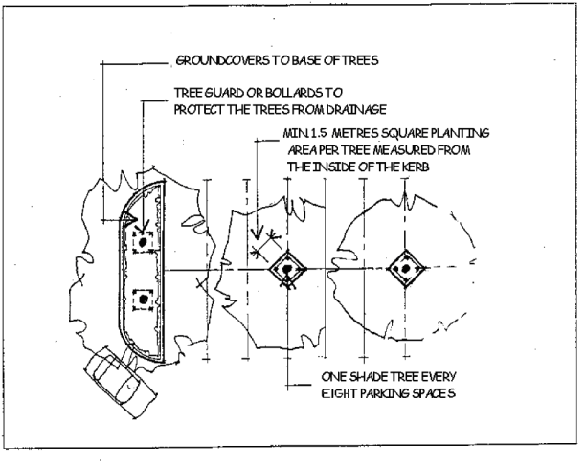
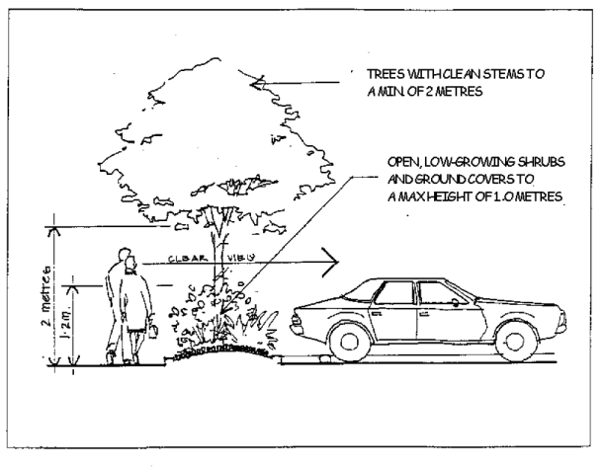
PO₇ Location and habit of tree planting must not interfere with the function and accessibility of any adjacent utility services. | AO_{7.1} Species mature height and siting must not interfere with or compromise overhead and underground utility assets including stormwater inlet pits.  AO_{7.2} Tree planting must be a minimum of 2m from any mains water easements and offset 4m from any sewer main or inspection chamber.
PO₈ Maintenance access points must be considered and accommodated for in the site planning and design process. | AO_{8.1} Access by appropriate maintenance or utility vehicles must be demonstrated with ground surface treatments that are stable and usable in all weather.  AO_{8.2} Functional maintenance vehicle circulation and access gates to be provided.
PO₉ On-site stormwater harvesting is to be maximised for irrigating landscaping in development with reuse measures and amelioration of stormwater impacts provided. | AO_{9.1} Landscape design takes advantage of the flow of water along overland flow paths.  AO_{9.2} Landscaping is used to help maximise opportunities for on-site stormwater infiltration by:  minimising impervious surfaces and incorporating semi-permeable paving products;  falling hard surfaces towards pervious surfaces such as turf or mulched areas;  maximise opportunities for turf and planting areas;  align planting areas parallel to contours to slow the flow of surface water; and  ensure planting palette comprises canopy tree species.  AO_{9.3} Provision for drainage is incorporated through treatments such as subsurface drains, swales, ponds and infiltration cells.  AO_{9.4} Sediment and erosion control measures are provided.  AO_{9.5} Planter boxes on podiums and building forecourts are plumbed to stormwater.
PO₁₀ Landscape design is integrated with any existing urban design theme within the surrounding area and coordinates paving, planting, street furniture, lighting, signage and other elements to reflect that theme and assist in the creation of a sense of place. | No acceptable outcome is nominated.
PO₁₁ Design of pedestrian paths and places reinforces the desired character of the area and/or place and includes features to enhance their use that are of universal design to ensure non-discriminatory access and use. | AO_{11.1} Design complies with AS1428 parts 1, 2, 3, and 4 – Design for Access and Mobility
PO₁₂ Risks to personal safety and the potential for crime, vandalism and fear are reduced through landscape design that has been informed by Crime Prevention Through Environmental Design (CPTED) principles in relation to:  Surveillance.  Access control.  Territorial reinforcement.  Space management. | Landscape design incorporates the following design measures:  AO_{12.1} The attractiveness of crime targets is minimised by providing opportunities for effective surveillance through: clear sight lines from private to public space, reducing concealment or entrapment opportunities, public facilities (toilets, shelters etc) located to promote use, dual access points, avoiding blind corners, and lighting where appropriate.  AO_{12.2} Barriers are used to attract, channel or restrict the movement of people by: clear spatial definition and legibility, optimising opportunity for public interaction, visually permeable screens and fencing, appropriate use of mechanical measures that correspond to actual risk.  AO_{12.3} Reinforcing definition of territory and ownership of private, semi-public and public spaces through: clear design cues for use and activities, transitions and boundaries between public and private, design that encourages public interaction and ownership, legible universal signage.
 | AO_{12.4} Space Management: ensuring that public spaces are appropriately utilised and maintained by the use of vandal- and graffiti-resistant materials, easily accessed and maintained fixtures.

Table 9.4.4:2 – Landscape Design Professionals
Development Type | Category of Landscape Professional Required to  Submit Landscape Documentation
Reconfiguring a lot (RAL)  (Subdivision code) | <5 lots | 5 lots and >5 lots
Reconfiguring a lot (RAL)  (Subdivision code) | Landscape designer | Landscape architect
Material Change of Use (MCU)  Landscape documentation must accompany any built form/architectural and/or civil engineering documentation. | <$500K construction value | >$500K construction value
 | Landscape designer | Landscape architect
Operational Works Applications | <$50K construction value | >$50K construction value
Operational Works Applications | Landscape designer | Landscape architect

Reconfiguring a Lot Code

Application

This code applies to assessable development identified as requiring assessment against the Reconfiguring a Lot Code by the categories of development and assessment tables in Part 5 – Tables of Assessment

Purpose

The purpose of the Reconfiguring a Lot Code is to:

provide for good neighbourhood design, consistent with the character and environmental values of the overlay, zone and precinct, and local plan area in which the land is located;

ensure the creation of a sense of place and distinctive identity;

protect important natural features and values, economic resources and places of cultural heritage significance;

ensure lot reconfiguration provides for an efficient and well integrated urban form, and in rural areas provides for sustainable use of land and agricultural resources;

ensure lot reconfiguration facilitates safe and efficient provision of, and equitable access to, infrastructure and services;

ensure transport networks provide for appropriate levels of accessibility and accommodate a wide range of travel modes including walking, cycling and the use of public transport;

encourage development to be resource efficient; and

. Provide for neighbourhood design that suits safe and practical connectivity with adjoining similar uses in terms of roads, open space and stormwater drainage layout.

The purpose of the code will be achieved through the following overall outcomes:

lot reconfiguration facilitates the creation of safe, convenient, functionally efficient and attractive environments, consistent with the desired character of the zone or precinct in which the site is situated;

lot reconfiguration meets the diverse needs of the community for a range of affordable housing types, accessible commercial and community facilities and local employment opportunities;

Lot reconfigurations facilitate the achievement of dwelling yields in the order of:
(i) 15 dwellings per hectare net in the Low Density Residential Zone; and
(ii) 30 dwellings per hectare net in the Low-medium Density Residential Zone.

lot reconfiguration is responsive to the local environment, including its topography, natural drainage systems, vegetation and habitat, cultural heritage features, streetscape character, landmarks, views and vistas;

lot reconfiguration facilitates the protection and sustainable use of rural land resources;

areas containing important ecological values and cultural values are protected from development and the associated impacts caused by development;

lot reconfiguration facilitates compatible relationships between different land uses and activities;

lot design and sizes are suited to the intended use of the land;

lot orientation facilitates the conservation of non-renewable energy sources and the design of buildings that are appropriate for the local climatic conditions;

infrastructure is supplied to all lots in a safe, efficient, coordinated and sequenced manner which minimises whole of life cycle costs and is sensitive to the environment in which they are provided;

stormwater drainage systems protect people and the built and natural environments in a cost effective manner;

the street system provides identified functions for each street, provides acceptable levels of access, safety and convenience for all users and provides for a high level of connectivity and permeability;

lot reconfiguration increases opportunities for walking, cycling and the use of public transport;

public open space is attractive and accessible and equitably meets user requirements for recreational, social and cultural activities; and

lots facilitate connectivity of roads, open space and stormwater drainage.

Requirements for accepted development and assessment benchmarks for assessable development
Table 9.4.5:1 – Reconfiguring a Lot Code – Requirements for accepted development and assessment benchmarks for assessable development
Performance outcomes | Acceptable outcomes
PO₁ The lots resulting from the rearrangement of boundaries does not contribute to:  the proliferation of lots of rural land fragmentation; or  the potential to introduce uses or activities which conflict with the intent of the applicable zone for all or part of the site. | AO_{1.1} No additional lots are created by the rearrangement of boundaries.  AO_{1.2} The resulting lots from rearranging boundaries are contained entirely within a single zone.
PO₂ Lots resulting from rearrangement of boundaries do not require any new or additional infrastructure connections, or modification of existing connections. | AO_{2.1} All lots resulting from rearrangement of boundaries:  (a) retain all existing connections to water, sewer, electricity and other infrastructure wholly within the lot they serve;  (b) do not require additional infrastructure connections or augmentation of existing connections;  (c) except where in the Rural Zone, have sealed vehicle crossovers;  (d) have stormwater drainage for lots 4000m² or less:  (i) connected to adequately sized inter-allotment drainage; or  (ii) that drains the entirety of each lot independently without fill to the kerb and channel or swale of the road frontage.
PO₃ Where in the rural zone, all lots resulting from rearrangement of boundaries are provided with all weather road access from the driveway crossover to the nearest formed road. | AO_{3.1} Where in the rural zone, all lots resulting from rearrangement of boundaries are provided with a formed gravel road from the driveway crossover to the nearest formed road in accordance with SC6.2 PSP No.2 Engineering Standards – Roads and Drainage Infrastructure.
Lot Sizes and Design
PO₄ All new lots provide sufficient area, frontage and dimensions, and road access that enable their future development to achieve relevant outcomes in applicable Use, Zone, Overlay, and Other Development Codes in relation to:  dwellings, buildings and/or other structures  (b) setbacks ;  (c) landscaping;  (d) on site car parking and vehicle access;  (e) recreation areas (private open space);  (f) cultural heritage and character streetscape values;  (g) other design criteria.  Editors note:  Setback considerations include solar access, privacy and amenity of residents and adjoining neighbours, on-site effluent disposal.  A building envelope may demonstrate suitability to accommodate future development. | AO_{4.1} All lots are rectangular and have minimum width to depth ratios, areas, dimensions and frontages as prescribed in Table 9.4.5:4.  AO_{4.2} Where in the Low Medium Density Residential Zone development for lots 450m² or less in area are capable of accommodating a rectangular building envelope with area and dimensions for:  a dwelling, including ancillary buildings and structures such as garages, covered carports and decks, that comply with the minimum setback requirements of the overlay or zone in which the land is located and building regulations;  (b) private open space and recreation areas;  (c) vehicle access and on-site car parking in accordance with the Transport, Access and Parking Code.

Table 9.4.5:2 – Reconfiguring a Lot Code – assessment benchmarks for assessable development
Performance outcomes | Acceptable outcomes
Master Planning
PO₁ Except where in the Rural Zone (other than where in the Heinemann Road Transport Precinct) Limited Development (Constrained Land) Zone, Community Facilities Zone, Open Space Zone or Recreation Zone, development:  occurs in a logical pattern and sequence;  is of a scale and density that facilitates an efficient land use pattern and facilitates a mix of lot sizes that provide for a range of residential dwelling choices;  is designed to create compact and walkable neighbourhoods that are well connected to employment nodes, centres, open space and recreational areas, community services and educational opportunities;  creates a high quality streetscape and public open space network with connected public spaces and parks;  appropriately responds to constraints and natural values and mitigates any adverse impacts on areas of ecological significance;  is provided with all necessary infrastructure networks and is well serviced by community facilities; and  (g) creates lots which are suitable for their intended use without requiring significant earthworks. | AO_{1.1} A Master Plan is prepared in accordance with SC6.4 PSP No. 4 Master Planning.
General
PO₂ The layout of streets, lots and infrastructure gives the locality a strong and positive identity by:  responding to site characteristics, settings, landmarks, places of cultural heritage significance and views;  creating legible and interconnected movement and open-space networks;  locating community, retail, commercial and public transport facilities at focal points within convenient, safe and direct walking distance for residents/users; and  providing connections to existing facilities, services and movement networks in the surrounding area. | Where included in a local plan:  AO_{2.1} Neighbourhood design and lot layout is consistent with the requirements of any local plan.  All other circumstances:  No acceptable outcome provided.
PO₃ The layout of streets, lots and infrastructure responds appropriately to environmental features of the site or locality by:  following the natural topography;  protecting and promoting views of landscape features, significant ridgelines, mountains, hills, rocky outcrops or other geological formations;  minimising the need for earthworks;  minimising vegetation loss and/or fragmentation;  maintaining natural drainage features and floodways;  maintaining important wildlife corridors and habitat areas;  providing for adequate buffering of (d), (e) and (f);  protecting and maintaining areas of indigenous cultural significance; and  . connecting streets and open space to existing streets and open space on adjoining land as necessary for the orderly development of the precinct. | In partial fulfilment of the performance outcome:  AO_{3.1} A lot with an area of less than 450m² intended to be used for a dwelling house has a natural slope:  across the width of the lot not exceeding 10%; and  along the length of the lot not exceeding 5%.
PO₄ Street blocks and lot types are generally rectilinear and arranged to provide:  an efficient neighbourhood pattern, that supports walking cycling and public transport use;  the highest densities are located around open space, amenity features or other focal points; and  a mix of lot sizes which provide a wide choice in affordable and accessible housing and achieve streetscape variety. | In partial fulfilment of the performance outcome  AO_{4.1} Subdivision involving the creation of lots for residential use ensures lots within the block are arranged so that:  there are between four (4) and six (6) adjoining attached (terrace or row) house lots in a group (to enable group housing construction and integrated streetscape solution);  there are no more than eight (8) narrow frontage (less than 15m) lots in a row;  there are no more than four (4) lots with a width of 7.5m or less in a row unless serviced by a rear lane; and  there are no minor mismatches (e.g. less than 1m) in the rear corner lot boundaries of adjoining lots (to minimise the risk of set out error);  AO_{4.2} Subdivision involving the creation of lots for residential use ensures lots with access to a laneway intended to accommodate more than one dwelling have a:  minimum width of 7.5m; and  minimum depth of 30m.  AO_{4.3} Street blocks fronting local streets do not exceed 100m in length.
PO₅ Reconfiguration avoids risk to human safety and the environment from natural hazards and contaminated land. | In partial fulfilment of the performance outcome  AO_{5.1} Where contamination is suspected (e.g. former dips, industrial sites), provide a preliminary contamination report for Residential or Rural Residential subdivisions.
PO₆ The development is integrated with the surrounding urban or rural environment, having regard to:  the layout and dimensions of streets and lots;  connections to surrounding streets and pedestrian and cycle networks and other infrastructure networks;  provision for shared use of public facilities;  open space networks, retained habitat areas or corridors, landscape features and views and vistas; and  connections to centres. | No acceptable solution is nominated.
PO₇ In a reconfiguration that involves the creation of a new street (other than in a Rural Zone or the Rural Residential Zone) streetscape and landscape treatments are provided that:  create an attractive and legible environment with a clear character and identity;  use and highlight features of the site such as views, vistas, existing vegetation, landmarks and places of cultural heritage significance;  enhance safety and comfort, and meet user needs;  complement the function of the street in which they are located by reinforcing desired traffic speed and behaviour;  assist integration with the surrounding environment;  maximise infiltration of stormwater runoff; and  minimise maintenance costs through:  street pavement, parking bays and speed control devices;  street furniture, shading, lighting and utility installations;  retention of existing vegetation; and  on street planting. | No acceptable solution is nominated.
PO₈ Neighbourhood design and lot mix provides sufficient opportunities for community, retail, commercial and other uses to meet community needs, where this is consistent with the intended character of the zone or precinct in which the land is located and appropriate to the size of development. | No acceptable outcome is nominated.
PO₉ Reconfigurations within the Low-medium Density Residential Zone and the Emerging Community Zone contribute to housing diversity and different levels of affordability to meet community needs by incorporating a mix of residential lot sizes drawing from the following lot types:  Traditional: A traditional lot caters for large dwelling houses, typically on lots with a frontage of up to 20m and depth of 30m to 32m for single storey dwelling houses and 25m for two (2) storey dwelling houses.  Multi-family: A multi-family lot allows for small multiple dwellings (typically four (4) to six (6) dwellings). Multiple dwellings on multi-family lots contribute significantly to diversity within a neighbourhood. Multi-family lots will typically be provided on-street corners to reduce the negative impact of rows of garage doors.  Courtyard: A courtyard lot has an area between 375m² and 480m² and comfortably accommodates a smaller detached dwelling house on a lot with a frontage of approximately 15m.  Villa: A villa lot has an area between 250m² and 320m² and accommodates a smaller dwelling house on a lot with a frontage of approximately 10m. It is suited to the housing needs of an increasing number of one and two person households. A dwelling house on a villa lot is detached but usually built to one side boundary of the lot. | AO_{9.1} Reconfigurations incorporate the lot types identified in the performance outcome as follows:  reconfigurations creating between 10 and 50 additional lots incorporate a mix of at least two (2) different lot types; and  reconfigurations creating more than 50 additional lots incorporate a mix of at least three (3) different lot types.
PO₁₀ Reconfigurations within the Low-medium Density Residential Zone achieve a residential density that makes efficient use of the land and associated physical infrastructure. | AO_{10.1}Reconfigurations in the Low-medium Density Residential Zone facilitate a minimum residential density of 30 dwellings per hectare.
PO₁₁ Reconfigurations within the Principal Centre Zone, Major Centre Zone, District Centre Zone or Local Centre Zone ensure an integrated, orderly and efficient development outcome is achieved across all lots in respect to access to the external road network, pedestrian and vehicle movement within the site and built form and function. | No acceptable outcome is nominated.
Lot Sizes and Design
PO₁₂ Lot size in the Emerging Community Zone does not compromise the future development potential of the area for urban purposes. | AO_{12.1} Lots in the Emerging Community Zone have the minimum area and frontage as shown in Table 9.4.5:4.
PO₁₃ In the Rural Zone, the productive capacity of rural land resources is protected from the reconfiguration of lots that facilitates inappropriate intensification of development in the zone. | AO_{13.1} Lots have a minimum area as shown in Table 9.4.5:4.
Movement network design
PO₁₄ The street and road network has a clear structure, with roads that conform to their function in the network, having regard to:  traffic volumes, vehicle speeds and driver behaviour;  on street parking;  sight distance;  provision for public transport routes and stops;  provision for pedestrian and cyclist movement, prioritising these where appropriate;  provision for waste collection and emergency vehicles;  lot access;  convenience;  public safety;  amenity;  the incorporation of public utilities and drainage; and  landscaping and street furniture. | AO_{14.1} The street and road network is consistent with SC6.2 PSP No. 2 – Engineering Standards – Roads and Drainage Infrastructure.
PO₁₅ The road network provides for convenient and safe movement between local streets and higher order roads. | AO_{15.1} The proposed road network complies with SC6.2 PSP No. 2 – Engineering Standards – Roads and Drainage Infrastructure.
PO₁₆ Local streets do not operate as through traffic routes for externally generated traffic (other than for pedestrians, cyclists and public transport). | No acceptable outcome is nominated.
PO₁₇ Safe, convenient and efficient intersections are provided for vehicles, pedestrians, cyclists and public transport. | AO_{17.1} Intersections and pedestrian and cyclist crossings are provided in accordance with SC6.2 PSP No. 2 – Engineering Standards – Roads and Drainage Infrastructure.
PO₁₈ Access arrangements for lots do not affect the function, vehicle speeds, safety, efficiency and capacity of streets and roads. | AO_{18.1} Access arrangements are consistent with the characteristics intended for the particular type of road or street specified in SC6.2 PSP No. 2 – Engineering Standards – Roads and Drainage Infrastructure.
PO₁₉ On-road car parking is provided according to projected needs taking into account:  total parking demand;  car parking opportunities on lots; and  non-residential and external parking generators. | AO_{19.1} On-street parking is provided in accordance with the Transport, Access and Parking Code.
PO₂₀ The movement network facilitates efficient and cost-effective provision and maintenance of infrastructure. | AO_{20.1} Infrastructure is provided in accordance with SC6.2 PSP No. 2 – Engineering Standards – Roads and Drainage Infrastructure.
PO₂₁ Rear lanes are designed to:  provide enough width to enable safe and efficient vehicle movement, including service vehicles;  have either a straight or T configuration and not be dead ends or cul-de-sacs;  enable easy and safe access into and out of garages without using doors that open into the lane;  not create a more direct through-route alternative for vehicles than the adjoining street network;  ensure rear yards of properties can be fenced for security;  ensure any rear boundary treatment or tree planting does not create concealed recesses or provide uninvited access opportunities into rear yards; and  not provide for visitor parking within the lane unless in specifically designated areas. | AO_{21.1} Rear lanes are designed in accordance with SC6.2 PSP No. 2 – Engineering Standards – Roads and Drainage Infrastructure.
PO₂₂ Development does not compromise the delivery of existing or future public transport routes and encourages a highly connected local street network that enables public transport to efficiently service the area without the need to ‘repeat a part of a route as part of the one trip’. | AO_{22.1} Street networks in new developments are designed to accommodate the movements of a 14.5m long bus.
Road design
PO₂₃ The geometric design features of each type of road:  convey its primary function for all relevant design vehicle types;  have an adequate horizontal and vertical alignment that is not conducive to excessive speeds;  encourage traffic speeds and volumes to levels commensurate with road hierarchy function; and  ensure unhindered access by emergency vehicles. | AO_{23.1} Design of the roads comply with the SC6.2 PSP No. 2 – Engineering Standards – Roads and Drainage Infrastructure.
Pedestrian and cyclist facilities
PO₂₄ A network of pedestrian and cycle ways is provided having regard to:  opportunities to link open space networks, and community facilities, including public transport stops, local activity centres and schools;  likely trip purpose;  topography;  cyclist and pedestrian safety;  cost effectiveness;  likely user volumes and types;  convenience; and  accessibility. | AO_{24.1} In partial fulfilment of the performance criterion, pedestrian and cycle ways are provided in accordance with SC6.2 PSP No. 2 – Engineering Standards – Roads and Drainage Infrastructure.  AO_{24.2} Footpaths and bikeways are provided in accordance with the Austroads Guide to Road Design – Part 6A: Pedestrian and Cyclist Paths (Austroads 2009m).
PO₂₅ The alignment of pedestrian paths and cycleways is designed so that they:  allow for the retention of trees and other significant features;  maximise the visual interest provided by views and landmarks where they exist;  do not compromise the operation of or access to other infrastructure services;  are widened at potential conflict points; and  consider CPTED principles and disability access requirements. | No acceptable outcome is nominated.
PO₂₆ Safe street crossings are provided for pedestrians and cyclists across major roads. | AO_{26.1} Crossings and intersections are provided in accordance with SC6.3 PSP No 2 –Engineering Standards – Roads and Drainage Infrastructure and Austroads Guide to Road Design Part 4: Intersections and Crossings: General.
Public transport
PO₂₇ The movement network caters for the extension of existing or future public transport routes to provide services that are convenient and accessible to the community. | No acceptable outcome is nominated.
PO₂₈ Reconfiguration caters for the extension of public transport routes by locating the highest likely public transport ‘trip generating’ land uses in the vicinity of existing or potential public transport routes, where this is consistent with the intended character of the zone or precinct in which the land is located. | AO_{28.1} Except in the rural zone and the rural residential zone, at least 90% of proposed lots are within 400m safe walking distance from an existing or potential bus route or 500m walking distance of an identified bus stop.
PO₂₉ Residential densities within walking distance of existing and potential public transport stations and routes are at levels that take advantage of the infrastructure where this is consistent with the intended character of the zone or precinct in which the land is located. | No acceptable outcome is nominated.
Open Space Network
PO₃₀ Neighbourhood design and lot layout provides a balanced variety of park types, including:  small local parks, which are designed to:  provide a small open space setting for adjoining dwellings;  incorporate and retain existing natural features;  incorporate landscaping to assist in creating neighbourhood identity and way-finding;  neighbourhood parks, which are designed to:  be centrally located;  support the local community’s recreational needs;  provide opportunities for community and special events;  lineal or corridor parks, which are designed to:  connect with existing or planned open space in the locality;  incorporate pedestrian and cycle paths;  protect significant natural features;  convey stormwater;  provide for other recreational needs when not flooded; and  natural parkland areas which:  retain locally significant wetlands, remnant vegetation and habitat for fauna;  continue ecological corridors and linkages to areas outside of the neighbourhood;  maintain important landscape and visual quality values. | AO_{30.1} The lot reconfiguration makes provisions for the establishment of public parks in accordance with Part 4 Local Government Infrastructure Plan.
PO₃₁ Where provision for a public park is required in Part 4 – Local Government Infrastructure Plan the design and lot layout provides for safe and secure, well distributed and located parkland that:  has passive surveillance by surrounding development;  is of a suitable size, shape and topography for its function;  is located on a suitable road;  is highly accessible to local communities; and  achieves an acceptable standard of flood immunity. | AO_{31.1} The public park meets the requirements of section 4.5.5 of the planning scheme.  AO_{31.1} The public park meets the standards identified in Table 9.4.5:3.
PO₃₂ Neighbourhood design and lot layout provides for safe and secure, well distributed and located parkland that:  provides a clear relationship between the public realm and adjoining land uses through treatment including alignment, fencing and landscaping;  enhances the area’s local identity and landscape amenity;  provides for a range of recreational opportunities to meet community needs;  forms a linkage to existing parkland or habitats;  respects and retains existing natural elements; and  protects biodiversity values and features. | No acceptable outcome is nominated.
Amenity
PO₃₃ Reconfiguration provides for sufficient buffering to minimise impacts on accommodation activities and other sensitive land uses from nearby incompatible uses. | No acceptable outcome is nominated.
PO₃₄ The layout of lots created for industrial or commercial purposes facilitates the siting and design of development in a manner that ensures the amenity of accommodation activities and sensitive land uses is protected. | No acceptable outcome is nominated.
PO₃₅ Where reconfiguring a lot on land in the Low-medium Density Residential Zone, Low Density Residential Zone or Rural Residential Zone that is within 250m of land within the Medium Impact Industry Zone or 500m of land within the High Impact Industry Zone it must not result in future sensitive uses within the site being exposed to industrial air, noise or odour emissions that impact on human health, amenity and wellbeing. | AO_{35.1} Where reconfiguring a lot on land in the Low-medium Density Residential Zone, Low Density Residential Zone or Rural Residential Zone that is within 250m of land within the Medium Impact Industry Zone or 500m of land within the High Impact Industry Zone, it is demonstrated that a future sensitive use on proposed lots can meet:  the indoor noise objectives set out in the Environmental Projection (Noise) Policy 2008 are met; and  the air quality objectives in the Environmental Protection (Air) Policy 2008, are met through the use of measures such as:  landscaping and open space;  setbacks;  the orientation of lots away from the industrial area;  barriers, mounds and fencing; and/or  screening.
Safety and security
PO₃₆ The reconfiguration discourages crime, vandalism and anti-social behaviour and facilitates:  personal and property security;  casual surveillance of footpaths and parkland; and  activity and interaction within public spaces and movement networks. | AO_{36.1} The reconfiguration is designed in accordance with Crime Prevention Through Environmental Design (CPTED) Guidelines for Queensland.
Natural values
PO₃₇ Development is provided with an adequate water supply for firefighting purposes that is safely located and freely accessible. | AO_{37.1} Development within a water supply area involving the creation of new lot/s is connected to council’s reticulated water supply system and a water supply outlet located within a road reserve is within 40M of the following:  (a) all of the land; or  (b) a building envelope designated on each lot; or  (c) the centre of each lot, excluding access handles (where no building envelope is designated); and  (d) all existing or proposed buildings.
PO₃₈ The reconfiguration provides for lot sizes and titling arrangements that ensure areas of ecological significance remain intact as part of common property or within large lots. | No acceptable outcome is nominated.
PO₃₉ The layout of roads, driveways and other infrastructure avoids crossing or otherwise fragmenting waterways, wetlands, habitat areas or ecological corridors. | No acceptable outcome is nominated.
Climatic response
PO₄₀ The street, lot orientation and lot size facilitate buildings that conserve non-renewable energy sources through climate-responsive siting and design. | In partial compliance with the performance outcome:  AO_{40.1} Neighbourhoods are generally designed so that:  the long axis of roads runs east-west;  the number of wide lots (lots with a width greater than 15m) is minimised on streets running north-south; and  lots are generally rectangular in shape and not splayed.  AO_{40.2} Where they are proposed, built-to-boundary walls are located on the west-southwest boundary of lots except where these boundaries are on the higher side of a sloping lot.
Services
PO₄₁ Services, including water supply, stormwater management, sewage disposal, waste disposal, drainage, electricity and telecommunications, are provided in a manner that:  is efficient;  minimises risk of adverse environmental or amenity related impacts;  promotes total water cycle management and the efficient use of water resources; and  minimises whole of life cycle costs for that infrastructure. | No acceptable outcome is nominated.
Noise Impacts
PO₄₂ Lots are of a suitable size and dimensions to facilitate adequate noise management. | AO_{42.1} Lots near a rail corridor or a regional arterial, sub-arterial or distributor roads are of sufficient size and depth to ensure that future dwellings are not exposed to road or rail noise greater than 63dB LA10(18hr).  AO_{42.2} Where it is not practical to achieve the required noise levels through lot layout and design, noise attenuation barriers are utilised to achieve the required noise levels.
PO₄₃ Noise attenuation measures:  are compatible with the local streetscape;  minimise whole of life cycle costs where they are to be located on or adjacent to public land or common property; and  are designed to discourage crime and anti-social behaviour, having regard to:  aesthetic quality and compatibility with streetscape;  physical accessibility;  provision of casual surveillance of public open space and movement networks;  opportunities for concealments or vandalism; and  easy and economic maintenance. | No acceptable outcome is nominated.
Air Quality
PO₄₄ Reconfiguration does not result in lots intended for accommodation activities or sensitive land uses being subject to adverse air quality or impacts. | No acceptable outcome is nominated.
Additional requirements for volumetric subdivision
PO₄₅ The reconfiguration of the space above or below the surface of the land facilitates appropriate development in accordance with the intent of the zone or precinct in which the land is located or is consistent with a lawful approval that has not lapsed. | No acceptable outcome is nominated.
Hatchet Lots
PO₄₆ Lot reconfigurations only create hatchet lots as a means of increasing residential densities in within:  (a) Walking catchments around centres offering a broad range of goods, facilities and services (being 800m around Major and 400m around District centres and designated Local centres within the centre hierarchy);  (b) Land that benefits visually from high quality parkland;  (c) Walking catchments around major non-industrial employment areas (land within 800m walk of 1000 or more non-industrial jobs);  (d) A central transport corridor bounded by Nelson, West, Jellicoe and Hume street, and  (e) An 800m walking catchment of the University of Southern Queensland (Toowoomba campus).  ; | AO_{46.1} Lot reconfigurations only create hatchet lots in the Low-medium Density Residential Zone.
PO₄₇ The location and configuration of the access strip/easement and main body does not compromise:  (a) the streetscape qualities of the area;  (b) the residential amenity of the area; or  (c) the Street System. | AO_{47.1} Only 1 Hatchet Lot is created behind any full frontage lot as shown in Figure 1 below.  Figure 1  AO_{47.2} The access strip/easement to the Hatchet Lot is located on only 1 side of the lot with direct frontage to the street as illustrated in Figure 2 below.  Figure 2
PO₄₈ The configuration of hatchet lots maintain the ability of existing buildings and structures to –  (a) provide adequate daylight and ventilation to habitable rooms;  (b) allow adequate light and ventilation to habitable rooms of buildings on adjoining lots; and  (c) not adversely impact on the amenity and privacy of residents on adjoining lots.  . | AO_{48.1} Where the lot reconfiguration creates a hatchet lots the new lot boundaries create setbacks to existing dwellings that comply with the minimum distances in the Queensland Development Code or relevant planning scheme code.
PO₄₉ The access strip/easement:  (a) has a minimum width of 6 metres for its full length;  (b) is located on the southern or western side of the lot;  (c) has a maximum length of 30 metres;  (d) is located so that there is no more than one driveway serving an adjoining property within 6 metres of the access strip/easement boundary (see figure 3 below). | No acceptable outcome is nominated.
Figure 3
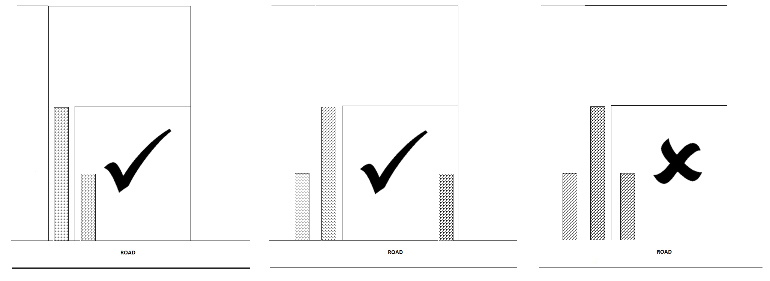
One driveway within 6m One driveway with 6m Two driveways within 6m
of access strip of access strip of access street
PO₅₀ Stormwater is discharged from the site to a lawful point of discharge, as defined in the Queensland Urban Drainage Manual (QUDM), without the use of pumped or charged pipe systems, and not to private land other than to an easement for stormwater purposes befitting the site and allowing discharge to a lawful point of discharge in land over which Council has tenure or control.  Note: Land over which Council has tenure or control does not include Council’s open space network. | AO_{50.1} The site:  (a) has a natural surface with an elevation that is higher than the abutting road and enables stormwater to drain gravitationally to the abutting road via subsurface pipes; or  (b) has a natural surface with an elevation that is higher than Council’s stormwater drainage network in the abutting road and enables stormwater to drain gravitationally to the stormwater drainage network in the abutting road via subsurface pipes; or  (c) has lawful access to an inter allotment drainage network with available capacity to meet the requirements of the development.
Reconfigurations creating lots less than 450m² in area in a residential zone
PO₅₁ Lot reconfigurations creating lots less than 450m² and at least 20 new lots, facilitate the orderly, neighbourly, integrated and timely development of those lots through a Plan of Development.  Note:  Orderly neatly and methodically arranged.  Neighbourly exhibiting the qualities expected in a friendly neighbour.  Integrated combining or coordinating separate elements so as to provide a harmonious, interrelated whole  Timely done or occurring at a favourable or useful time. | AO_{51.1} Lot reconfigurations creating lots less than 450m² incorporate an Approved Plan of Development prepared by a suitably qualified professional(s) that sets development standards that comply with the performance outcomes within the Small Lot Housing Design Code and which includes, but is not limited to, the location of the following:  (a) the lot layout and streets, including lot numbers, lot areas, street reserve widths, street or road carriageways (may include bus stops, taxi ranks, loading zones and similar service areas where proposed), and location and width of footpaths;  (b) land slope and major infrastructure items;  (c) primary and secondary street frontages (if necessary);  (d) public open space areas, including lot number and area;  (e) built-to-boundary wall locations (including mandatory built-to-boundary situations);  (f) where privacy fencing is required at an interface with a street or park; fencing and, if sloping land, retaining wall details;  (g) for lots under 450m²:  (i) location, areas and dimensions of private open space;  (ii) building envelopes indicating minimum setbacks, access points, and heights; and  (iii) driveway crossovers
PO₅₂ The lots are located on a road that is appropriate to accommodate small lots. | AO_{52.1} Small lots are located in accordance with the following table:  Note: Direct access is not typically available to sub-arterial roads and limited to distributer roads (see PSP No.2 Sc6.2.2.2).
  Proposed lot width | Vehicle Access Location
  Lot width <10m | Laneway, Local or collector roads only
  Lot width 10 – 12.4m | Laneway, Local or collector roads only
  Lot width 12.5 – 14.9m | Laneway, Local, collector or distributor roads only
  Lot width >15m | Laneway, Local, collector, distributor or sub-arterial roads only
PO₅₃ Small lots are located so as to minimise the need to cut and fill the land. | AO_{53.1} Small lots are located on land with a pre-development gradient of less than 10%;
PO₅₄ Development provides a frequency of standard and small lots which are varied to facilitate housing variety. | AO_{54.1} There are no more than six (6) contiguous small lots along a street frontage, with groups of two (2) or more small lots separated by at least two (2) standard lots.
Reconfigurations facilitating Dual Occupancy development
PO₅₅ Lot reconfigurations within the Low Density Residential Zone, Low-medium Density Residential Zone, Emerging Community Zone and Township Zone facilitate the integration of Dual Occupancy development into residential neighbourhoods in a manner that is dispersed and does not result in Dual Occupancy becoming the dominant form of housing within a street. | AO_{55.1} Lot reconfigurations designate lots for Dual Occupancy development;  AO_{55.2} No more than 20 percent of the properties within a street block are designated for Dual Occupancy development.  AO_{55.3} No more than three (3) adjoining properties within a street block are designated for Dual Occupancy development.  AO_{55.4} Hatchet lots are not designated as Dual Occupancy lots.  See Figure 4  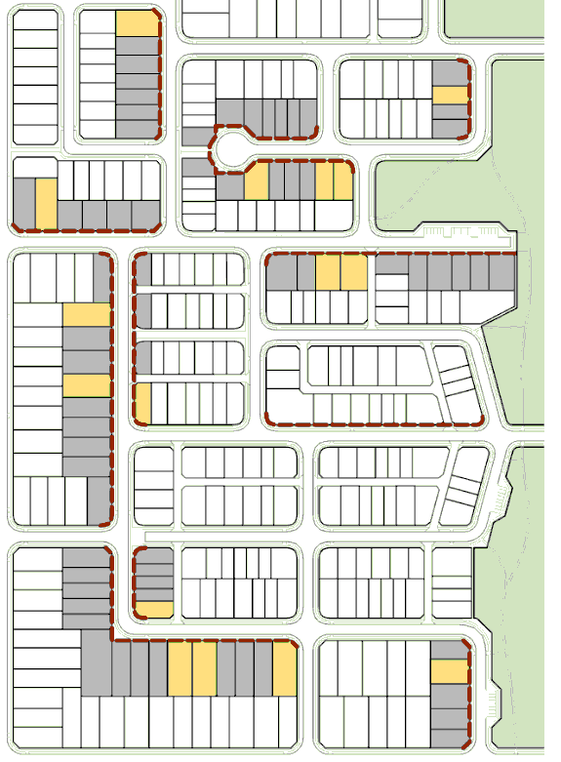  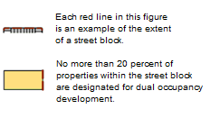  Figure 4
PO₅₆ Lots designated for Dual Occupancy development by lot reconfigurations within the Low Density Residential Zone, Low-medium Density Residential Zone, Emerging Community Zone and Township Zone have an area, shape and dimensions suitable to accommodate their intended use. | AO_{56.1} Lots designated for Dual Occupancy development:  (a) have a minimum area of 500m² where in the Low-medium Density Residential Zone; or  (b) have a minimum area of 700m² where in the Low Density Residential Zone, Emerging Community Zone or Township Zone; and  (c) are rectilinear in shape; and  (d) have a frontage that is consistent with the minimum frontage required for the applicable zone.

Table 9.4.5:3 – Open Space Standards
Land characteristic | Recreation Parks |  |  | Sports Parks
Land characteristic | Local | District | Regional | District | Regional
Shape | Square or rectangular with the sides no greater than 2:1. |  |  | Square or rectangular to maximise the area available for playing fields.
Minimum flood immunity | 15% of the total area above Q100 and free of hazards. | 25% of the total area above Q50 with the main activity area/s above Q100. | 50% of the total area above Q50 with the main activity area/s above Q100 and free of hazards. | Free of hazards with 90% of the land above Q20. All fields/courts above Q50. All facilities above Q100. | Free of hazards with 90% of the land above Q20. All fields/courts above Q50. All built facilities above Q100.
Maximum grade | 1:10 for 80% of the area of the park (i.e. a maximum of 20% of the land may have a greater grade than 1:10). | Average grade of 1:10 for 80% of the area of the park. To facilitate wheelchair access to parks, areas with a grade of 1:14 will also be provided, where possible. Variable topography is satisfactory for the remaining area. | Average grade of 1:20 for main use areas, 1:50 for kick about area, and variable topography for remainder. | 1:50 for all planning surfaces. | 1:50 for all planning surfaces.  Laser levelling to a maximum gradient of planning surface 1:100.
Road frontage and visibility | 50% of the park perimeter to have frontage to a local road. | 50% of the park perimeter to have frontage to a collector road. |  | 50% of the park perimeter to have road frontage.

Table 9.4.5:4 – Lot Sizes and Dimensions – requirements for accepted development and assessment benchmarks for assessable development
Zone(s) | Lot Type | Precinct(s) | Minimum Lot Area/Max Density⁺ |  | Minimum Frontage/  Width | Max Frontage to Depth Ratio*
Low Density Residential | Regular and Corner | Clifford Park Stables Precinct | 1,200 m² |  | 20 m. | 1:3
Low Density Residential | Regular and Corner | Park Residential | 2,250 m² |  | 20 m. | 1:3
Low Density Residential | Regular and Corner | All other circumstances | 500 m² |  | 15 m. | 1:5
Low Density Residential | Hatchet | Hatchet lots do not occur within the Low Density Residential Zone.
Low Density Residential | Community Title Scheme | Clifford Park Stables | 1,200 m² (except for communal lots). |  | 20 m. | No Acceptable Measure Prescribed
Low Density Residential | Community Title Scheme | All other circumstances | 500 m² (except for communal lots). |  | 15 m. | No Acceptable Measure Prescribed
Low – medium Density Residential | Regular and corner | All | 300 m² |  | 20 m. | 1:3
Low – medium Density Residential | Regular and corner | All | Slope# <6% | 300 m² | 10 m. | 1:5
Low – medium Density Residential | Regular and corner | All | Slope# 6-8% | 800 m² | 25 m. | 1:5
Low – medium Density Residential | Regular and corner | All | Slope#  >8% | 1,000 m² | 30 m. | 1:5
Low – medium Density Residential | Hatchet | All | Slope# <6% | 500 m² | 6 m/15 m. | 1:5
Low – medium Density Residential | Hatchet | All | Slope# 6-8% | 800 m² | 6 m/25 m. | 1:5
Low – medium Density Residential | Hatchet | All | Slope# >8% | 1,000 m² | 6 m/30 m. | 1:5
Low – medium Density Residential | Community Title Scheme | All | No minimum lot size |  | 20 m. | 1:3

Zone(s) | Lot Type | Precinct(s) | Minimum Lot Area/Max Density⁺ | Minimum Frontage/  Width | Max Frontage to Depth Ratio*
Principal Centre | Regular and corner | All | No Acceptable Measure Prescribed | No Acceptable Measure Prescribed | No Acceptable Measure Prescribed
Principal Centre | Hatchet | All | No Acceptable Measure Prescribed | No Acceptable Measure Prescribed | No Acceptable Measure Prescribed
Principal Centre | Community Title Scheme | All | No Acceptable Measure Prescribed | No Acceptable Measure Prescribed | No Acceptable Measure Prescribed
Major Centre  District Centre  Local Centre  Mixed Use  Specialised Centre | All | All | No Acceptable Measure Prescribed | No Acceptable Measure Prescribed | No Acceptable Measure Prescribed
Open Space  Sport and Recreation | All | All | No Acceptable Measure Prescribed | No Acceptable Measure Prescribed | No Acceptable Measure Prescribed
Community Facilities | All | All | No Acceptable Measure Prescribed | No Acceptable Measure Prescribed | No Acceptable Measure Prescribed

Zone(s) | Lot Type | Precinct(s) | Minimum Lot Area/Max Density⁺ | Minimum Frontage/  Width | Max Frontage to Depth Ratio*
Low Impact Industry  Medium Impact Industry  High Impact Industry  Extractive Industry | Regular and Corner | Wellcamp Low Impact Industry | 2 ha. | No Acceptable Measure Prescribed | 1:2
 | Regular and Corner | General Industry | 2 ha. | No Acceptable Measure Prescribed | 1:2
 | Regular and Corner | Transport and Warehousing | 5 ha. | No Acceptable Measure Prescribed | 1:2
 | Regular and Corner | Intermodal Facility | 2 ha. | No Acceptable Measure Prescribed | 1:2
 | Regular and Corner | Heavy Industry | 10 ha (except for communal lots). | No Acceptable Measure Prescribed | 1:2
 | Regular and Corner | Quarry / Extractive Industry | 10 ha. | No Acceptable Measure Prescribed | No Acceptable Measure Prescribed
 | Regular and Corner | All other circumstances | No Acceptable Measure Prescribed | No Acceptable Measure Prescribed | No Acceptable Measure Prescribed

Zone(s) | Lot Type | Precinct(s) | Minimum Lot Area/Max Density⁺ |  | Minimum Frontage/  Width |  | Max Frontage to Depth Ratio*
Rural Residential | Regular and Corner | 4000 m² | 4000 m² |  | No Acceptable Measure Prescribed |  | No Acceptable Measure Prescribed
Rural Residential | Regular and Corner | 1 Hectare | 1 ha. |  | No Acceptable Measure Prescribed |  | No Acceptable Measure Prescribed
Rural Residential | Regular and Corner | 2 Hectare | 2 ha. |  | No Acceptable Measure Prescribed |  | No Acceptable Measure Prescribed
Rural Residential | Hatchet | Hatchet lots do not occur within Rural Residential Zone
Rural Residential | Community Title Scheme | 4,000m² |  | 4,000 m² | No Acceptable Measure Prescribed | No Acceptable Measure Prescribed
Rural Residential | Community Title Scheme | 1 hectare |  | 1 ha (except for communal lots). | No Acceptable Measure Prescribed | No Acceptable Measure Prescribed
Rural Residential | Community Title Scheme | 2 hectare |  | 2 ha (except for communal lots). | No Acceptable Measure Prescribed | No Acceptable Measure Prescribed
Rural | Regular and Corner | 100 hectare |  | 100 ha. | 125 m. | No Acceptable Measure Prescribed
Rural | Regular and Corner | 200 hectare |  | 200 ha. | 250 m. | No Acceptable Measure Prescribed
Rural | Hatchet | Hatchet lots do not occur within Rural Zone
Rural | Community Title Scheme | 100 hectare |  | 100 ha (except for communal lots). | 125 m. | No Acceptable Measure Prescribed
Rural | Community Title Scheme | 200 hectare |  | 200 ha (except for communal lots). | 250 m. | No Acceptable Measure Prescribed

Zone(s) | Lot Type | Precinct(s) | Minimum Lot Area/Max Density⁺ |  |  | Minimum Frontage/  Width |  | Max Frontage to Depth Ratio*
Emerging Communities | Regular and Corner | All |  | 10 ha (except for communal lots). |  | 75 m. | No Acceptable Measure Prescribed
Emerging Communities | Hatchet | Hatchet lots do not occur within the Emerging Communities Zone
Emerging Communities | Community Title Scheme | All |  | 10 ha (except for communal lots). |  | 75 m. | No Acceptable Measure Prescribed
Limited Development (Constrained Land) | All | No acceptable measure prescribed
Limited Development (Constrained Land) | Hatchet | Hatchet lots do not occur within the Limited Development (Constrained Land) Zone.
Township | Regular and Corner | All (where reticulated wastewater services are provided) |  | Slope# <6 % | 500 m² | 15 m. | 1:2
Township | Regular and Corner |  |  | Slope# 6-8 % | 800 m² | 25 m. | 1:2
Township | Regular and Corner |  |  | Slope# >8 % | 1,000 m² | 30 m. | 1:2
Township | Regular and Corner | All (otherwise) |  | 2,000 m² |  | No Acceptable Measure Prescribed | No Acceptable Measure Prescribed
Township | Hatchet | Hatchet lots do not occur within the Township Zone.
Township | Community Title Scheme | All (where reticulated wastewater services are provided) |  | 500 m² (except for communal lots). |  | 15 m. | No Acceptable Measure Prescribed
Township | Community Title Scheme | All (otherwise) |  | 2,000 m² (except for communal lots). |  | No Acceptable Measure Prescribed | No Acceptable Measure Prescribed
Table Explanations:
* in the case of Hatchet Lots, the frontage to depth ratio is the width to depth ratio, disregarding the access strip frontage.
# across allotment slope.
⁺ for hatchet shaped lots the minimum lot area does not include the access strip.
Examples of Lot Shapes and Dimensions (PO9)
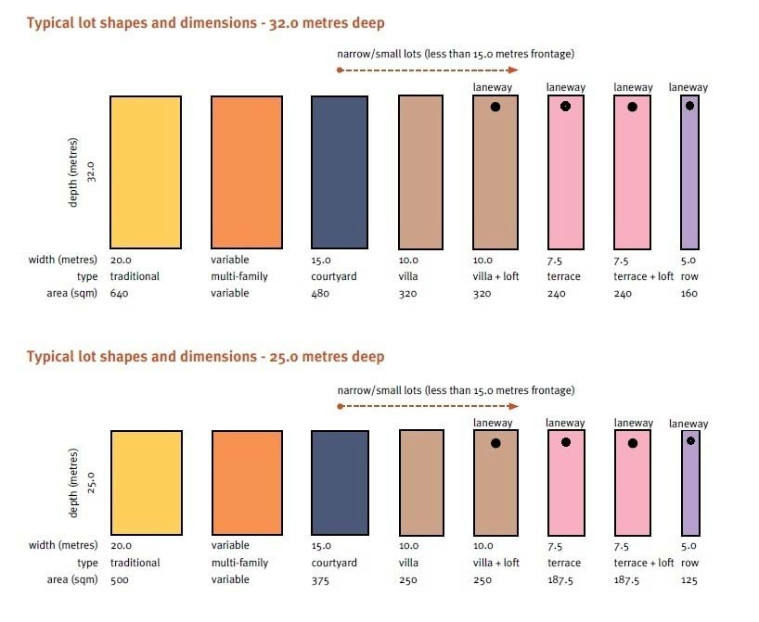
Source: Urban Land Development Authority Guideline No. 1 - Residential 30 (page 15)

Transport, Access and Parking Code

Application

This code applies to assessable development identified as requiring assessment against the Transport, Access and Parking Code by the categories of development and assessment tables in Part 5 – Tables of Assessment

Purpose

The purpose of the Transport, Access and Parking Code is to ensure development makes appropriate provision for transport, access, parking, servicing and end of trip facilities to meet the needs of development and facilitate, as far as practicable, an environmentally sustainable transport network.

The purpose of the code will be achieved through the following overall outcomes:

the function, safety and efficiency of the transport network is protected or improved;

transport network infrastructure is designed for, in order of priority, pedestrians, cyclists, public transport and private vehicles;

pedestrians (including people with a disability) and cyclists are provided with a high level of accessibility, safety and convenience within a development site and on-site facilities are integrated with external walking and cyclist networks and public transport nodes;

the use of public transport is facilitated wherever practicable;

access, parking, servicing and associated manoeuvring areas are designed to be safe, functional and to meet the reasonable demands generated by the development;

access, parking, servicing and associated manoeuvring areas do not detract from streetscape character and are designed to discourage crime and anti-social behaviour;

adverse impacts on the environment and sensitive receptors are avoided; and

.road layout provides for safe and practical connectivity with adjoining land.
Vehicular access points to State-controlled roads require approval under the Transport Infrastructure Act 1994. Access approvals to the State-controlled roads are administered by the Department of Transport and Main Roads in accordance with the Road Planning and Design Manual.

Assessment benchmarks for assessable development
Table 9.4.6:1 – Transport, Access and Parking Code – Requirements for accepted development and assessment benchmarks for assessable development
Performance outcomes | Acceptable outcomes
Driveway Crossovers
PO₁ Vehicular access arrangements, including driveway crossovers:  are appropriate for:  the capacity of the parking area;  the volume, frequency and type of vehicle useage; and  the function and configuration of the access road;  minimise any potentially adverse impact on:  the safety and efficiency of the road and pedestrian/cycle paths;  the safety and efficiency of the road and footpath users;  the integrity of any infrastructure within the road reserve; and  (iv) the safety of access to adjacent properties.  protect the amenity of premises in the vicinity by:  maintaining the predominant vehicular access pattern in the street, including consistent width, grade and location;  preserving the residential amenity of the streetscape, including noise and visual impact, and consideration of existing landscaping by considering:  (A) use of materials which integrate with the streetscape (e.g. existing crossovers and driveways, etc);  (B) minimising the width and grade of the access;  (C) minimising impacts on the appearance of the streetscape by retaining existing vegetation, including approved landscaping; and  (D) locating the access to minimise the impact of vehicle noise on neighbouring/adjoining properties. | AO_{1.1} Vehicular access and driveway crossovers are not:  an additional site/property access;  to a State-controlled Road or a road with bluestone kerbing;  within 25 m of a signalised road intersection;  (d) within 20m of an unsignalised road intersection in a Commercial or Industrial Area;  (e) within 10m of an unsignalised road intersection in a Community, Residential, Rural or Other Area;  (f) within 1m of any infrastructure, including street signage, power poles, street lights, manholes, stormwater gully pits, or other Council/public utility asset;  (g) within theTree Protection Zone, as defined by Australian Standard 4970-2009;  (h) for a lot with a frontage of 10m or less;  (i) greater than 4m in width when for a lot with a frontage / width of more than 10m but less than 20m; and  (j) greater than 6m in width when for a lot with a frontage / width of greater than 20m.  Note: An additional site access is considered to be more than one site access.  AO_{1.2} Except where in a Rural Zone, vehicular access and driveway crossovers:  do not require the modification, relocation, or removal of any existing infrastructure (e.g. street trees, fire hydrants, water meters, manholes or stormwater gully pits);  do not affect or are not adjacent to a traffic island, speed control device, car parking bay, bus stop, or other structure within the roadway;  do not require removal or modification of any existing kerbing, traffic island, speed control device, car parking bay, bus stop, or other structure within the road reserve;
(d) do not require any change to existing footpath/verge profiles, including table drains (where relevant);
(e) do not have access restricted by an access restriction strip or link reserve;
(f) do not access an unformed or unkerbed road;
(g) are constructed from reinforced concrete;
(h) are perpendicular to the road edge; and
(i) are provided in accordance with the Australian Standard AS 2890.1 – Off Street Car Parking and Australian Standard AS 2890.2 (where relevant) and the relevant standard drawing in SC6.2 PSP No. 2 Engineering Standards – Roads and Drainage Infrastructure.
AO_{1.3} Where in a Rural Zone, vehicular access and driveway crossovers:
do not require the modification, relocation, or removal of any existing infrastructure (e.g. street trees, fire hydrants, water meters, manholes or stormwater gully pits);
do not affect or are not adjacent to a a traffic island, speed control device, car parking bay, bus stop, or other structure within the roadway;
do not require removal or modification of any existing kerbing, traffic island, speed control device, car parking bay, loading bay, bus stop, or other structure within the road reserve;
(d) do not require any change to existing footpath/verge profiles, including table drains (where relevant);
(e) do not have access restricted by an access restriction strip or link reserve;
(f) are sealed where accessing a sealed formed road;
(g) are perpendicular to the road edge; and
(h) are provided in accordance with the relevant standard drawing in SC6.2 PSP No. 2 Engineering Standards – Roads and Drainage Infrastructure.
Car Parking Provision
PO₂ Provision is made for on-site vehicle parking to meet the demand likely to be generated by the development and to avoid on-street parking where that would adversely impact on the safety or capacity of the road network or unduly impact on local amenity.  Note: Where the development does not meet the acceptable outcomes, or where no acceptable outcome is specified, a parking demand analysis report prepared by a suitably qualified person may assist in demonstrating compliance with the performance outcome. | AO_{2.1} Where in the Principal Centre Zone or Mixed Use Zone Car parking is provided at the rate of:  Non-Residential Use one (1) parking space per 50m² of GFA; and  Residential Use - one (1) parking space per dwelling.  AO_{2.2} Where not in the Principal Centre Zone or Mixed Use Zone Car parking is provided at the rates set out in Table 9.4.6:3 to this Code.  Note: Where a parking rate for a use is unspecified in Table 9.4.6:3 – no acceptable outcome is provided.  Note: If the number of car parking spaces calculated in accordance with AO_{2.1} and AO_{2.2} is not a whole number, the number of parking spaces to be provided is rounded-up to next highest whole number.  Note: Where application is made for establishment of two or more uses on the same premises, the parking demand is calculated by totalling the requirements for each use.

Table 9.4.6:2 – Transport, Access and Parking Code – assessment benchmarks for assessable development,
Performance outcomes | Acceptable outcomes
Transport Network
PO₁ The development is located on roads that are appropriate for the nature of traffic generated, having regard to the safety and efficiency of the transport network, and the functions and characteristics identified in the transport network hierarchy contained in SC 6.2 PSP No. 2 – Engineering Standards – Roads and Drainage Infrastructure. | No acceptable outcome is nominated.
PO₂ Development does not compromise the orderly provision or upgrading of the transport network. | No acceptable outcome is nominated.
PO₃ Onsite transport network infrastructure (including roads, parking, access and public transport, pedestrian and cyclist facilities) appropriately integrates with surrounding networks and facilitates the orderly development of adjoining land. | No acceptable outcome is nominated.
PO₄ Development is designed to encourage travel by public transport, walking and cycling. This may include integrated access between adjoining sites and/or the provision of mid-block connections which are safe, functional and legible for potential users. | No acceptable outcome is nominated.
PO₅ Car parking areas, pathways and other elements of transport network infrastructure are designed to enhance public safety by discouraging crime and anti-social behaviour, having regard to:  provision of opportunities for casual surveillance;  provision of lighting;  the use of fencing to define public and private spaces, whilst allowing for appropriate sightlines;  minimising potential concealment points and assault locations;  minimising opportunities for graffiti and other vandalism; and  restricting unlawful access to buildings and between buildings. | AO_{5.1} Car parking areas, pathways and other elements of transport network infrastructure are designed in accordance with Crime Prevention Through Environmental Design (CPTED) Guidelines.
PO₆ Directional signage is provided within a development site to assist legibility and way-finding, including for pedestrians and cyclists. | No acceptable outcome is nominated.
Access
PO₇ Vehicle access arrangements and queuing areas are appropriate for:  the capacity of the parking area;  the volume, frequency and type of vehicle usage; and  the function and characteristics of the access road and adjoining road network. | AO_{7.1} Access driveways and queuing areas are located and designed in accordance with the provisions of Australian Standard AS 2890.1 Part 1: Off Street Carparking.
PO₈ Access arrangements minimise any adverse impact on:  the integrity of any infrastructure within the road reserve;  the safety and convenience of pedestrians and cyclists;  the safety and convenience of access to adjacent properties;  the amenity of premises in the vicinity; and  street trees in the road reserve. | No acceptable outcome is nominated.
PO₉ Where the nature of the proposed development creates a demand due to the frequency and volume of vehicle movements for the set-down and pick–up of passengers, provision is made for set-down and pick-up facilities by bus, taxis or private vehicle. | No acceptable outcome is nominated.
PO₁₀ Where set-down and pick-up facilities for bus, taxis or private vehicles are provided as part of development they are:  (a) safe for pedestrians, cyclists and vehicles;  (b) conveniently connected to the main component of the development by pedestrian pathway; and  (c) designed to provide for pedestrian priority and clear sightlines. | AO_{10.1} Bus pick-up/set-down areas:  (a) allow a bus, based on the Long Rigid Bus (12m) in Austroads/Standards Australia HB72 – Design Vehicles and Turning Path Templates, to turn and manoeuvre in and out of the area in an easy and safe manner;  (b) afford maximum safety for passengers boarding or alighting buses;  (c) avoid standing or queuing buses from obstructing access to car parking spaces or circulation within the Site; and  (d) avoid on-street queuing or boarding/alighting of buses that would reduce traffic flow or safety on the road network. One clear traffic lane in each direction should be maintained.  AO_{10.2} Car and taxi pick-up/set-down areas:  allow a car to maneouver in and out of the area in an easy and safe manner;  afford maximum safety for passengers boarding or alighting cars;  avoid standing or queuing cars from obstructing access to car parking spaces or circulation within the site; and  (d) avoid on-street queuing or boarding/alighting of cars that would reduce traffic flow or safety on the road network. One clear traffic lane in each direction should be maintained.
Pedestrian and Cycle Facilities
PO₁₁ Provision is made for the safe and convenient movement of pedestrians on site and external to the site, having regard to desire lines, legibility, weather protection and the needs of people with disabilities. | AO_{11.1} Pedestrian pathways and crossings are provided in accordance with SC6.2 PSP No.2 – Engineering Standards – Roads and Drainage Infrastructure.  AO_{11.2} Access for cyclists and pedestrians is clearly distinguished from vehicle access.  AO_{11.3} Pedestrian paths of a minimum width of 1.5m are provided through each car parking row and connect to the main entrance(s) to the building(s).
PO₁₂ Provision is made for safe and convenient cycle movement to the site and within the site having regard to desire lines, users’ needs and legibility. | AO_{12.1} Shared paths and on-road cycle lane facilities are provided in accordance with SC6.2 PSP No.2 – Engineering Standards Roads and Drainage Infrastructure.
Parking and Circulation
PO₁₃ Car parking areas are designed to be:  clearly defined, marked and signed;  convenient, safe and accessible; and  safe for vehicles, pedestrians and cyclists and minimise vehicle/pedestrian conflicts by providing clear access lines for pedestrians movement within car park areas. | AO_{13.1} The entry to the car park is clearly signposted.  AO_{13.2} Parking spaces are freely available for use by the development’s occupants and visitors during the business hours of the use.  AO_{13.3} Visitor or customer parking spaces are located in the most accessible position to the main entrance of the building and signed as such.  AO_{13.4} Unless otherwise specified in another code relevant to the development, 60% of the parking spaces for non-residential development are clearly visible from the street.  AO_{13.5} Public Safety:  The car park is located where it can be monitored by passers-by or the occupiers of the development.  Where the car park is open to the public at night, lighting is provided throughout the car park and along pedestrian access paths in compliance with Australian Standard AS 1158.3.1 – Road Lighting – Pedestrian Area (Category P) Lighting – Performance and Installation Design Requirements.  Except in the case of residential development:  where the car park is not required at night, entry to the car park is physically restricted; and  where the car park is enclosed, the walls are finished in a light coloured material that reflects light.  Landscaping throughout the car park is provided in a manner, as indicated in the Landscaping Code that allows surveillance and minimises the risk of crime.
PO₁₄ Car parking areas are designed to provide spaces which meet the needs of people with disabilities. | AO_{14.1} Parking spaces for people with disabilities are provided at the rates specified in Appendix C of Australian Standard AS2890.1 Part 1: Off Street Carparking.  AO_{14.2} Car parking spaces for people with disabilities are located as near as possible to the entrance or entrances of the facility or use they serve.  AO_{14.3} Parking spaces for people with disabilities are designed in accordance with the provisions of Australian Standard AS2890.1 Part 1: Off Street Carparking.  AO_{14.4} Pathways and ramps between parking areas and the entrances to buildings are designed in accordance with the provisions of Australian Standard AS1428.1: Design for Access and Mobility.  AO_{14.5} Parking spaces for people with disabilities are identified by a sign incorporating the International Symbol specified in Australian Standard AS1428.1: Design for Access and Mobility.  AO_{14.6} The sign is readily visible from a vehicle at the entrance to the carpark, or guide signs are provided to indicate the direction of the disabled parking spaces.
PO₁₅ Car parking areas for non-residential development on a site in, or adjoining, a residential zone, are designed to minimise any adverse impact on the amenity of premises in the vicinity. | For non-residential development on a site in, or adjoining, a residential zone:  AO_{15.1} Car parking and driveway areas are setback a minimum distance of 3m from a side boundary that is common with a residential use in a residential zone.  AO_{15.2} Landscape planting is used between the car park and driveway areas and the side boundary to soften the visual impacts of car park areas and to provide shade.  AO_{15.3} An acoustic fence of 1.8m height is provided along the property boundary that is common with a residential use in a residential zone.
PO₁₆ Car parking and associated access arrangements are located and designed to avoid dominating the road frontage of the site or otherwise detracting from streetscape character. | AO_{16.1} Car parking is provided either at the rear of the development or beneath buildings.
PO₁₇ Above ground or multi-level car parking areas are designed, articulated and finished to make a positive contribution to the local streetscape character. | AO_{17.1} Above ground or multi-level parking areas are designed, articulated and finished to a quality equal to or better than adjoining buildings.
PO₁₈ Landscaping is provided to soften the visual impact of car parking areas and to provide shading and protection from glare. | AO_{18.1} Aesthetics, glare, heat absorption and re-radiation.  Landscaping is provided throughout the car park in the manner and at the rate indicated in the Landscaping Code; and  Unless otherwise specified in a zone, precinct or use code, where the car park adjoins a street frontage, or a boundary with a Residential or other sensitive land use, a landscaped strip of minimum 3 m width is provided along the frontage/boundary.
PO₁₉ Any parking, access and any other vehicle access/manoeuvring areas incorporate design measures to avoid dust nuisance to surrounding properties. | AO_{19.1} Car parking, access and any other vehicle access/manoeuvring areas vehicle manoeuvring areas are imperviously sealed.
PO₂₀ Noise impacts from vehicle movement areas on any adjoining residential or other sensitive land use are mitigated. | AO_{20.1} A solid, good quality brick, timber or masonry fence of a minimum 1.8m height is constructed between any vehicle movement areas and a boundary to an adjoining residential or other sensitive land use.
PO₂₁ Any part of the parking area designated as a vehicle cleaning or repair area is designed and constructed to avoid adverse impact on water quality or Council’s wastewater or stormwater infrastructure. | AO_{21.1} The development is capable of meeting the requirements of Council’s Trade Waste Policy and the Trade Waste Environmental Management Plan.
Servicing
PO₂₂ Provision is made for the on-site loading, unloading, manoeuvring and access by service vehicles that:  is adequate to meet the demands generated by the development;  is able to accommodate the design service vehicle requirements; and  does not unduly impede vehicular, cyclist and pedestrian safety and convenience within the site. | AO_{22.1} The service bays provided and access to them, can accommodate, at any one time, the types and numbers of service vehicles detailed in Table 9.4.6:3.  AO_{22.2} Service bays provided wholly or partly within a building are physically separated from the rest of the buildings floor space in manner that makes it impractical to use them as storage or work areas.  AO_{22.3} The design and provision of access driveways, manoeuvring areas and loading and unloading facilities for service vehicles complies with Australian Standard AS 2890.2 – 1989 – Off Street Parking – Commercial Vehicle Facilities.  AO_{22.4} Vehicles being loaded or unloaded with goods stand completely on-site and do not impede access to more than 6 parking spaces or 50% of the on-site parking spaces (whichever is the lesser) while doing so.  AO_{22.5} Service vehicles can enter and leave the site in a forward gear.
PO₂₃ Refuse collection vehicles are able to access on-site refuse collection facilities. | AO_{23.1} Where an on-site refuse area is provided, access and manoeuvring areas are designed and provided to enable access by refuse collection vehicle based on the Design Service Vehicle in Austroads/Standards Australia HB72 – Design Vehicles and Turning Path Templates.
PO₂₄ Servicing arrangements minimise any adverse impact the amenity of premises in the vicinity. | No acceptable outcome is nominated.
PO₂₅ Servicing arrangements are located and designed to avoid dominating the road frontage of the site or otherwise detracting from streetscape character. | AO_{25.1} Areas used for servicing are not located at the front of developments, or are otherwise screened to minimise visual intrusion in the streetscape.

Table 9.4.6:3 – Vehicle Provision Rates
For the purpose of interpreting Columns 2 and 3 – Service Vehicle Provision Rate the following definitions apply:

‘No specific rate’ – means the required number of parking spaces (or facilities for service vehicles) will be based on the circumstances of the specific proposal and assessed against the Performance Criteria and information provided with the application.

Where the calculated number of vehicle parking spaces is not a whole number, the required number of vehicle parking spaces to be provided is rounded-up to the next highest whole number;

Where development involves two or more uses on the same premises, vehicle parking demand is calculated by totalling the requirements for each use;

When calculating car parking provision rates, ‘Practitioner’ and ‘Staff’ should be considered separate to each other – with ‘Practitioner’ not being included within the parking provision calculation for ‘Staff’;

SRV - means Small Rigid Vehicle (for vehicle dimensions and manoeuvring requirements see Australian Standard AS 2890.2 – Off Street Parking – Commercial Vehicle Facilities).

HRV - means Heavy Rigid Vehicle (for vehicle dimensions and manoeuvring requirements see Australian Standard AS 2890.2 – Off Street Parking – Commercial Vehicle Facilities).

AV - means Articulated Vehicle (for vehicle dimensions and manoeuvring requirements see Australian Standard AS 2890.2 – Off Street Parking – Commercial Vehicle Facilities).
Development | Parking Rates | Service Vehicle Provision Rate
Adult Store | One (1) space per 25m² GFA. | Less than 500m² GFA – 1 HRV.  500m² – 1,999m² GFA – 1 AV.  2,000m² GFA plus – No specific rate.
Agricultural Supplies Store | One (1) space per 25m² GFA. | 1 AV.
Air Services | Applicant to provide parking report justifying proposed provision of parking. | No specific rate.
Animal Husbandry | No Parking Rate Nominated. | No specific rate.
Animal Keeping | One (1) space per FTE staff plus five (5) spaces. | Nil.
Aquaculture | One (1) space per FTE staff. | No specific rate.
Bar | One (1) space per 25m² GFA. | No specific rate.
Bulk Landscape Supplies | One (1) space per 200m² of total use area with a minimum of four (4) spaces. | 1 AV.
Car Wash | One (1) space per 25m² GFA. | Nil.
Caretaker’s Accommodation | Two (2) parking spaces. | Nil.
Cemetery | 30 spaces plus one (1) space per two (2) FTE staff on the premises at any one time. | Nil.
Child Care Centre | One (1) space per seven (7) children enrolled, plus one (1) space per FTE staff. | Nil.
Club | 0.3 space per patron. | 1 SRV.
Community Care Centre | Applicant to provide parking report justifying proposed provision of parking. | Nil.
Community Residence | Two (2) parking spaces. | Nil.
Community Use | 0.4 space per patron. | No specific rate.
Crematorium | Applicant to provide parking report justifying proposed provision of parking. | No specific rate.
Cropping | No Parking Rate Required. | Nil.
Detention Facility | Applicant to provide parking report justifying proposed provision of parking. | No specific rate.
Dual Occupancy | Two (2) parking spaces per dwelling. | Nil.
Dwelling House | One (1) parking space where the dwelling has one (1) or two (2) bedrooms.  Two (2) parking spaces where the dwelling has three (3) or more bedrooms. | Nil.
Dwelling Unit | One (1), per one (1) and two (2) bedroom unit plus two (2) for each unit of three (3) or more bedrooms. | Nil.
Educational Establishment | Preparatory - One (1) space per seven (7) children enrolled, plus one (1) space per FTE staff.  Primary – One (1) space per ten (10) students plus 1 space per FTE staff. The visitor parking can be provided as a set-down per pick-up area (20% of short term parking);  Secondary – One (1) space per ten (10) year 12 students; plus, a set-down per pick-up area for visitors and one (1) space per FTE staff;  Tertiary – One (1) space per FTE staff; plus, one (1) space per ten (10) students. | 1 SRV.
Emergency Services | Applicant to provide parking report justifying proposed provision of parking. | No specific rate.
Extractive Industry | Applicant to provide parking report justifying proposed provision of parking. | Nil.
Food and Drink Outlet | One (1) space / 20m² GFA; plus queueing area for ten (10) vehicles for any drive-through facility from the collection point. | 1 SRV.
Function Facility | 0.4 space per patron. | No specific rate.
Funeral Parlour | 0.3 space per seat or to each square metre of GFA whichever is greater. | 1 SRV.
Garden Centre | 10% of site area. | 1 HRV.
Hardware And Trade Supplies | One (1) space per 40m² GFA. | Less than 1,000m² GFA – One (1) HRV.  1,000m² – 1,999m² GFA – One (1) AV.  2,000m² GFA plus – No specific rate.
Health Care Services | One (1) space per FTE staff, plus three (3) visitors spaces per FTE practitioner. | One (1) ambulance vehicle pick-up and set-down space if more than two (2) practitioners work from the site at any one time.
High Impact Industry | Two (2) spaces per tenancy plus one (1) space per 100m² GFA. | 0 – 999m² GFA: One (1) HRV.  1,000m² – 2000m² GFA: One (1) AV.  2,000m² GFA: No specific rate.
Home Based Business | One (1) space per non-resident FTE staff. | Nil.
Hospital | Applicant to provide parking report justifying proposed provision of parking. | No specific rate.
Hotel | 0.4 space per patron. | 1 AV.
Indoor Sport And Recreation | Applicant to provide parking report justifying proposed provision of parking. | No specific rate.
Intensive Animal Industries | No Parking Rate Required. | No specific rate.
Intensive Horticulture | One (1) space per staff. | No specific rate.
Landing | No Parking Rate Required. | Nil.
Low Impact Industry | Two (2) spaces per tenancy plus one (1) space per 100m² GFA. | 0 – 999m² GFA: One (1) HRV.  1,000m² – 2,000m² GFA: One (1) AV.  2,000m² GFA: No specific rate.
Major Electricity Infrastructure | No Parking Rate Required. | No specific rate.
Major Sport, Recreation And Entertainment Facility | Applicant to provide parking report justifying proposed provision of parking. | No specific rate.
Market | Eight (8) spaces per 100m² of stall area (excluding access paths). | No specific rate.
Medium Impact Industry | Two (2) spaces per tenancy plus one (1) space per 100m² GFA. | 0 – 999m² GFA: One (1) HRV.  1,000m² – 2,000m² GFA: One (1) AV.  2,000m² GFA: No specific rate.
Motor Sport Facility | Applicant to provide parking report justifying proposed provision of parking. | No specific rate.
Multiple Dwelling | One (1) space per one (1) bedroom dwelling.  Two (2) spaces for each dwelling with two (2) or more bedrooms  One (1) visitor space for every four (4) dwellings. | 1 SRV where more than 10 units.
Nature-based Tourism | No Parking Rate Required. | No specific rate.
Nightclub Entertainment Facility | One (1) space per 5m² GFA; plus 0.5 space per staff FTE. | No specific rate.
Non-resident Workforce Accommodation | No Parking Rate Required. | Nil.
Office | 3.5 spaces per 100m² GFA. | Less than 200m² GFA – Nil.  200m² – 999m² GFA – One (1) AV.  1,000m² GFA plus – No specific rate.
Outdoor Sales | One (1) space per 150m² of total use area. | 1 AV.
Outdoor Sport And Recreation | Applicant to provide parking report justifying proposed provision of parking. | Nil.
Outstation | No Parking Rate Required. | Not Applicable.
Park | No Parking Rate Required. | Nil.
Parking Station | No Parking Rate Required | Not Applicable.
Permanent Plantations | No Parking Rate Required. | Nil.
Place Of Worship | One (1) space per 10m² GFA, OR one (1) space per ten (10) seats (or part thereof), whichever is the greater. | 1 SRV.
Relocatable Home Park | One (1) per dwelling, plus one (1) visitor space for every five (5) dwellings where developments contain five (5) or more dwellings. | No specific rate.
Renewable Energy Facility | No Parking Rate Required. | No specific rate.
Residential Care Facility | 0.3 space per lodging room. | No specific rate.
Resort Complex | One (1) space per unit plus 50% of the requirement for each ancillary use. | 1 SRV.
Retirement Facility | One (1) per dwelling, plus one (1) visitor space for every five (5) dwellings where development contains five (5) or more dwellings. | No specific rate.
Roadside Stalls | No Parking Rate Required. | Nil.
Rooming Accommodation | 0.5 space per Rooming Unit, plus 0.25 visitor space per Rooming Unit, plus one (1) space for an on-site manager (if applicable). | Nil.
Rural Industry | One (1) space per 100m² GFA. | 0 – 999m² GFA: One (1) HRV.  1,000m² – 2,000m² GFA: One (1) AV.  2,000m² GFA: No specific rate.
Rural Worker’s Accommodation | No Parking Rate Required. | Nil.
Sales Office | Two (2) spaces per dwelling. | Nil.
Service Industry | One (1) space per 100m² GFA. | Less than 500m² GFA – One (1) HRV.  500m² – 1,999m² GFA – One (1) AV.  2,000m² GFA plus – No specific rate.
Service Station | One (1) space per 25m² GFA. | 1 AV.
Shop | One (1) space per 20m² GFA. | Less than 500m² GFA – One (1) HRV.  500m² – 1,999m² GFA – One (1) AV.  2,000m² GFA plus – No specific rate.
Shopping Centre | 3.5 spaces per 100m² GFA. | No specific rate.
Short-Term Accommodation | One (1) space per unit plus 50% of the requirement for each ancillary use. | 1 SRV.
Showroom | One (1) spaces per 40m² GFA. | Less than 1,000m² GFA – One (1) HRV.  1,000m² – 1,999m² GFA – One (1) AV.  2,000m² GFA plus – No specific rate.
Substation | No Parking Rate Required. | No specific rate.
Telecommunications Facility | No Parking Rate Required. | No specific rate.
Theatre | 0.4 spaces per patron. | No specific rate.
Tourist Attraction | Applicant to provide parking report justifying proposed provision of parking. | No specific rate.
Tourist Park | One (1) per dwelling, plus one (1) visitor space for every five (5) dwellings where developments contains five (5) or more dwellings. | 1 SRV.
Transport Depot | One (1) car space for every truck space; plus one (1) space per every two (2) non-driver staff. | No specific rate.
Utility Installation | No Parking Rate Required. | No specific rate.
Veterinary Services | One (1) space per FTE staff, plus 3 visitors spaces per FTE practitioner. | 1 SRV.
Warehouse | 1.5 spaces per 100m² GFA. | 0 – 999m² GFA: One (1) HRV.  1,000m² – 2,000m² GFA: One (1) AV.  2,000m² GFA: No specific rate.
Wholesale Nursery | One (1) space per 100m² of total use area. | I HRV.
Winery | One (1) space per 25m² of retail GFA plus three (3) spaces per 100m² of manufacturing GFA. | No specific rate.

Works and Services Code

Application

This code applies to assessable development identified as requiring assessment against the Works and Services Code by the categories of development and assessment tables in Part 5 – Tables of Assessment

Purpose

The purpose of the Works and Services Code is to ensure development is provided with a level of infrastructure which supports the achievement of ecological sustainability and maintains or enhances community health, safety and amenity.

The purpose of the code will be achieved through the following overall outcomes:

premises are provided with an appropriate level of services to meet the demands of development;

the integrity of existing infrastructure is maintained;

access, parking, streets and pedestrian and cycle paths are provided to standards that ensure safe, convenient and efficient operation of movement networks;

risk to life and property is avoided;

development facilitates the efficient provision of infrastructure and use of resources;

whole of life cycle costs for infrastructure are minimised; and

the provision of infrastructure, services and utilities needed to service development does not detract from environmental values or from the desired character and amenity of the locality.

Requirements for accepted development and assessment benchmarks for assessable development
Table 9.4.7:1 – Works and Services Code – Requirements for accepted development and assessment benchmarks for assessable development
Performance outcomes | Acceptable outcomes
Utilities
PO₁ A water supply is provided that is adequate for the current and future needs of the intended use. | AO_{1.1} Where within a water supply area, the development is connected to Council’s reticulated water supply system in accordance with SC6.3 PSP No. 3 Engineering Standards – Water and Wastewater Infrastructure.  OR  AO_{1.2} Where not in a water supply area, the development is provided with an on site water supply in accordance with SC6.3 PSP No. 3 Engineering Standards – Water and Wastewater Infrastructure.  AO_{1.3} Water supply systems and connections are designed and constructed in accordance with SC6.3 PSP No. 3 Engineering Standards – Water and Wastewater Infrastructure.
PO₂ Wastewater treatment and disposal is provided that is appropriate for the level of demand generated, protects public health and avoids environmental harm. | AO_{2.1} Where within a wastewater area, the development is connected to the Council’s reticulated wastewater system in accordance with SC6.3 PSP No. 3 Engineering Standards – Water and Wastewater Infrastructure.  OR  AO_{2.2} Where not within a wastewater area, on-site waster water treatment and disposal is provided which complies with SC6.3 PSP No. 3 Engineering Standards – Water and Wastewater Infrastructure.  AO_{2.3} Waste water systems and connections are designed and constructed in accordance with SC6.3 PSP No. 3 Engineering Standards – Water and Wastewater Infrastructure.
PO₃ The development is equipped with an adequate energy supply approved by and installed in accordance with the standards of the relevant energy regulatory authority. | AO_{3.1} Premises are connected to an electricity supply approved by the relevant energy regulatory authority.
PO₄ Premises are connected to a telecommunications service approved by the relevant telecommunication regulatory authority. | AO_{4.1} The development is connected to telecommunications infrastructure in accordance with the standards of the relevant regulatory authority.
PO₅ Provision is made for future telecommunications services (e.g. fibre optic cable). | AO_{5.1} Conduits are provided in accordance with SC6.2 PSP No.2 Engineering Standards – Roads and Drainage Infrastructure.
PO₆ Development near utility services does not:  adversely affect the function of the service; or  place an additional load on the service; and  protects the infrastructure form physical damage; and  allows ongoing necessary access for maintenance purposes. | AO_{6.1} Setbacks and loadings comply with the Queensland Development Code QDC MP1.4..
PO₇ Infrastructure is integrated with and efficiently extends existing networks. | No acceptable outcome is nominated.
PO₈ Water meter/s are installed and located for easy access by the relevant authority. | AO_{8.1} Water meter/s are installed in accordance with SC6.3 PSP No. 3 Engineering Standards – Water and Wastewater Infrastructure.
Movement Networks
PO₉ Premises are provided with the following works along the full extent of the road frontage and to a standard that is appropriate to the function of the road and the character of the locality:  appropriate roadway treatment;  appropriate pavement edging (including kerb and channel);  safe vehicular access;  safe footpaths and bikeways;  street scaping or street tree planting;  stormwater drainage; and  street lighting systems. | AO_{9.1} Design and construction of external road works are undertaken in accordance with SC6.2 PSP No. 2 Engineering Standards – Roads and Drainage Infrastructure.  AO_{9.2} Footpaths and bikeways are provided in accordance with the Austroads Guide to Road Design – Part 6A: Pedestrian and Cyclist Paths (Austroads 2009m).
PO₁₀ Provision is made in the road reserve for street scaping, pedestrians and cyclists in a manner consistent with:  the current and projected level of usage;  the desired streetscape character; and  activities which are anticipated to occur within the verge. | AO_{10.1} Street scaping works, footpaths and cycle paths are provided in accordance with PSP No. 2 Engineering Standards – Roads and Drainage Infrastructure.  AO_{10.2} Footpaths and bikeways are provided in accordance with the Austroads Guide to Road Design – Part 6A: Pedestrian and Cyclist Paths (Austroads 2009m).
PO₁₁ Parking areas are constructed in a manner that is sufficiently durable for the intended function, maintains all-weather access and ensures the safe passage of vehicles, pedestrians and cyclists. | AO_{11.1} Parking area design and construction is undertaken in accordance with the Transport, Access and Parking Code.
PO₁₂ Movement networks can be easily and efficiently maintained. | AO_{12.1} Infrastructure is provided in accordance with SC6.2 PSP No. 2 Engineering Standards – Roads and Drainage Infrastructure.
Vehicular Access – Non-residential
PO₁₃ Non-residential vehicular access arrangements to a public roadway, including driveway crossovers:  (a) are safe and do not compromise the efficiency, function, convenience of use or capacity of the road network;  (b) are located and designed to:  (i) avoid damage to utility services, pathways, krebs, road pavement and seal and other council/public infrastructure;  (ii) prevent conflict between vehicles and cyclists and pedestrians; and  (iii) avoid damage to existing street trees and retain space for the future planting of street trees within the verge.  (c) minimise the number of vehicular access per site to avoid the loss of on-street carpking spaces, and are appropriately separated from other vehicular accesses and side property boundaries to prevent interference with:  (i) the safety, capacity and operations of the existing or planned road network;  (ii) any existing vehicular accesses;  (iii) adjoining properties; and  (iv) cycleways or pedestrian footpaths and their users.  (d) protect the amenity of premises in the vicinity and surrounding streetscape by:  (i) use of materials which integrate with the streetscape (e.g. existing crossovers and driveways, etc);  (ii) minimising the width and grade of the access; and  (iii) minimising impacts on the appearance of the streetscape by retaining existing vegetation, including approved landscaping. | AO_{13.1} Non-residential vehicular access and driveway crossovers to a public road are not:  an additional site/property access;  to a State-controlled Road or a road with bluestone kerbing;  within 25m of a signalised road intersection;  within 20m of an unsignalised road intersection in a Commercial or Industrial Area;  within 10m of an unsignalised road intersection in a Community, Residential, Rural or Other Area;  for a lot with a frontage of 10m or less;  within 1m of any infrastructure, including street signage, power poles, street lights, manholes, stormwater gully pits, or other Council/public utility asset; and  within the Tree Protection Zone, as defined by Australian Standard 4970-2009.  Note: An additional site access is considered to be more than one site access.  AO_{13.2} Non-residential vehicular access and driveway crossovers:  do not require the modification, relocation, or removal of any existing infrastructure (e.g. street trees, fire hydrants, water meters, manholes or stormwater gully pits);  do not affect or are not adjacent to a traffic island, speed control device, car parking bay, bus stop, or other structure within the road reserve;  do not require removal or modification of any existing kerbing, traffic island, speed control device, car parking bay, loading bay, bus stop, or other structure within the road reserve;  do not require any change to existing footpath/verge profiles, including table drains (where relevant);  do not have access restricted by an access restriction strip or link reserve;  do not access an unformed or unkerbed road;  are constructed from reinforced concrete;  are perpendicular to the road edge;  retain space for the planting of street trees at a minimum rate of one (1) per lot frontage; and
 | are provided in accordance with the Australian Standard AS 2890.1 – Off Street Car Parking and Australian Standard AS 2890.2 (where relevant),the relevant standard drawing in SC6.2 PSP No. 2 Engineering Standards – Roads and Drainage Infrastructure and Australian Standard AS 4970-2009 – Protection of Trees on Development Sites.
Vehicular Access – Residential
PO₁₄ Residential vehicular access arrangements, including driveway crossovers:  are appropriate for:  the capacity of the parking area;  the volume, frequency and type of vehicle useage; and  the function and configuration of the access road.  minimise any potentially adverse impact on:  the safety and efficiency of the road and pedestrian/cycle paths;  the safety and efficiency of the road and footpath users;  the integrity of any infrastructure within the road reserve; and  (iv) the safety of access to adjacent properties.  protect the amenity of premises in the vicinity by:  maintaining the predominant vehicular access pattern in the street, including consistent width, grade and location;  preserving the residential amenity of the streetscape, including noise and visual impact, and consideration of existing landscaping by considering:  (A) use of materials which integrate with the streetscape (e.g. existing crossovers and driveways, etc);  (B) minimising the width and grade of the access;  (C) minimising impacts on the appearance of the streetscape by retaining existing vegetation, including approved landscaping; and  (D) locating the access to minimise the impact of vehicle noise on neighbouring/adjoining properties. | AO_{14.1} Residential vehicular access and driveway crossovers are not:  (a) an additional site/property access;  (b) to a State-controlled Road or a road with bluestone kerbing;  (c) within 25 m of a signalised road intersection;  (d) within 20m of an unsignalised road intersection in a Commercial or Industrial Area;  (e) within 10m of an unsignalised road intersection in a Community, Residential, Rural or Other Area;  (f) within 1m of any infrastructure, including street signage, power poles, street lights, manholes, stormwater gully pits, or other Council/public utility asset;  (g) within the Tree Protection Zone, as defined by Australian Standard 4970-2009;  (h) for a lot with a frontage of 10m or less;  (i) greater than 4m in width when for a lot with a frontage/width of more than 10m but less than 20m; and  (j) greater than 6m in width when for a lot with a frontage/width of greater than 20m.  Note: An additional site access is considered to be more than one site access.  AO_{14.2} Except where in a Rural Zone, residential vehicular access and driveway crossovers:  (a) do not require the modification, relocation, or removal of any existing infrastructure (e.g. street trees, fire hydrants, water meters, manholes or stormwater gully pits);  (b) do not affect or are not adjacent to a traffic island, speed control device, car parking bay, bus stop, or other structure within the roadway;  (c) do not require removal or modification of any existing kerbing, traffic island, speed control device, car parking bay, bus stop, or other structure within the road reserve;  (d) do not require any change to existing footpath/verge profiles, includiing table drains (where relevant);  (e) do not have access restricted by an access restriction strip or link reserve; or  (f) do not access an unformed or unkerbed road;  (g) are constructed from reinforced concrete;  (h) are perpendicular to the road edge; and
(i) are provided in accordance with the Australian Standard AS 2890.1 – Off Street Car Parking and Australian Standard AS 2890.2 (where relevant), the relevant standard drawing in SC6.2 PSP No. 2 Engineering Standards – Roads and Drainage Infrastructure and Australian Standard AS 4970-2009 – Protection of Trees on Development Sites.
AO_{14.3} Where in a Rural Zone, residential vehicular access and driveway crossovers:
(a) do not require the modification, relocation, or removal of any existing infrastructure (e.g. street trees, fire hydrants, water meters, manholes or stormwater gully pits);
(b) do not affect or are not adjacent to a traffic island, speed control device, car parking bay, bus stop, or other structure within the roadway;
(c) do not require removal or modification of any existing kerbing, traffic island, speed control device, car parking bay, loading bay, bus stop, or other structure within the road reserve;
(d) do not require any change to existing footpath/verge profiles, including table drains (where relevant);
(e) do not have access restricted by an access restriction strip or link reserve;
(f) are sealed where accessing a sealed formed road;
(g) are perpendicular to the road edge; and
(h) are provided in accordance with the relevant standard drawing in SC6.2 PSP No. 2 Engineering Standards – Roads and Drainage Infrastructure.

Earthworks and Retaining Walls
PO₁₅ Earthworks result in stable landforms and structures. | AO_{15.1} Earthworks and the construction of retaining walls and batters are undertaken in accordance with SC6.2 PSP No. 2 – Engineering Standards – Roads and Drainage Infrastructure.
PO₁₆ Earthworks do not result in the contamination of land or water and avoid risk to people and property. | AO_{16.1} Earthworks are undertaken in accordance with SC6.2 PSP No. 2 – Engineering Standards – Roads and Drainage Infrastructure.
PO₁₇ Earthworks are undertaken in a manner that:  maintains natural landforms;  minimises height of retaining walls and batter faces;  does not unduly impact on the amenity or privacy for occupants of the site or on adjoining land; and  does not unduly impact on the amenity of the streetscape. | AO_{17.1} Earthworks and the construction of retaining walls and batters are undertaken in accordance with SC6.2 PSP No. 2 – Engineering Standards – Roads and Drainage Infrastructure.
PO₁₈ Earthworks do not create or worsen any flooding or drainage problems on the site or on neighbouring properties. | AO_{18.1} Earthworks and the construction of retaining walls and batters are undertaken in accordance with SC6.2 PSP No. 2 – Engineering Standards – Roads and Drainage Infrastructure.
PO₁₉ Earthworks do not prevent access or create difficult access to the property. | AO_{19.1} Earthworks and the construction of retaining walls and batters ensure driveways can provided in accordance with SC6.2 PSP No. 2 – Engineering Standards – Roads and Drainage Infrastructure.
PO₂₀ Earthworks do not cause a significant impact on the amenity of the locality or along routes taken to transport material as a result of truck volumes, dust or noise. | AO_{20.1} Earthworks are undertaken in accordance with SC6.2 PSP No. 2 – Engineering Standards – Roads and Drainage Infrastructure.
PO₂₁ The transportation of material minimises adverse impact on the road system. | AO_{21.1} Material is transported in accordance with SC6.2 PSP No. 2 – Engineering Standards – Roads and Drainage Infrastructure.
Waste Management
PO₂₂ Where relevant, the development is capable of providing for the storage, collection, treatment and disposal of trade waste such that:  off-site releases of contaminants do not occur;  the health and safety of people and the environment are protected; and  the performance of the wastewater system is not put at risk. | No acceptable outcome is nominated.
PO₂₃ Appropriate refuse container storage areas are provided which are:  in a building or enclosing structure or screened from public view;  of adequate size to accommodate the expected amount of refuse to be generated by the use;  in a position that is conveniently accessible for collection; and  able to be kept in a clean state at all times. | AO_{23.1} Refuse container storage areas are provided which:  are in a building, outbuilding or other enclosed structure, or otherwise screened from public view, by a minimum 1.5 m high solid fence or wall or dense vegetation;  are provided with an imperviously sealed pad, on which to stand the bin(s), that is drained to an approved waste disposal system;  are within normal hose length of a hose cock;  are large enough to accommodate at least one (1) standard sized container per dwelling and, in commercial and industrial premises, one (1) or more industrial bins of a size appropriate to the nature and scale of use; and  are situated not closer than 6m to a road or 2m to any site boundary.  AO_{23.2} On sites greater than 2,000m² in area, provision is made for refuse collection vehicles to access the collection area and to enter and leave the site in a forward direction without having to make more than a 3-point turn.  AO_{23.3} For multiple dwelling and retirement facility, container storage areas are located not more than 50m from any dwelling.
PO₂₄ Where the use is non-residential and generates recyclable waste, provision is made for conveniently located recycling bins on the premises, including in the refuse container storage area. | No acceptable outcome is nominated.
Construction Management
PO₂₅ Work is undertaken in a manner which minimises adverse impacts on vegetation that is to be retained. | AO_{25.1} Works include, at a minimum:  installation of protective fencing around retained vegetation during construction;  erection of advisory signage;  no disturbance, due to earthworks or storage of plant, materials and equipment, of ground level and soils below the canopy of any retained vegetation; and  removal from the site of all declared noxious weeds and environmental weeds.
PO₂₆ Work is undertaken in a manner which does not cause unacceptable impacts on surrounding areas as a result of dust, odour, noise or lighting. | AO_{26.1} Construction is undertaken in accordance with the Environmental Standards Code.
PO₂₇ While undertaking development works, the site and adjoining road are maintained in a tidy, safe and hygienic manner. | AO_{27.1} Construction is undertaken in accordance with the Environmental Standards Code.
PO₂₈ Traffic, parking and delivery of construction materials generated during construction are managed to minimise impact on the amenity of the surrounding area and to manage the safety of pedestrians, cyclists and motorists. | AO_{28.1} Construction is undertaken in accordance with the Environmental Standards Code.
PO₂₉ Council and state infrastructure is not damaged by construction activities. | AO_{29.1} Construction, alterations and any repairs to infrastructure is undertaken in accordance with the SC6.2 PSP No.2 Engineering Standards – Roads and Drainage Infrastructure, Queensland Development Code QDC MP1.4, and, where applicable, in consultation with the relevant service authority.  AO_{29.2} Construction, alterations and any repairs to State-controlled roads and rail corridors are undertaken in accordance with the Transport Infrastructure Act 1994.

Amended on 3 July 2017
Amended on 4 August 2014
Amended on 27 April 2018
Council may request a shadow analysis be prepared to demonstrate compliance with the performance outcome.
Crime Prevention Through Environmental Design (CPTED) Guidelines for Queensland will provide relevant guidance to which applicants should have regard in demonstrating compliance with this performance outcome.
‘Sensitive land use’ is defined in the Planning Regulation 2017
In order to demonstrate compliance with the performance criterion, Council may request the preparation of a report, prepared by a suitably qualified person, detailing compliance.
The Landscaping Code sets out additional requirements for the provision of landscaping.
Council may request that a commercial impact assessment be prepared to demonstrate compliance with the performance outcome. A commercial impact assessment includes a review of the need for commercial development in the proposed location and the impact of the proposed commercial development on other centres.
Vehicular access points to State-controlled roads require approval under the Transport Infrastructure Act 1994. Access approvals to the State-controlled roads are administered by the Department of Transport and Main Roads in accordance with the Road Planning and Design Manual.
‘Sensitive land use’ is defined in the Planning Regulation 2017.
Vehicular access points to State-controlled roads require approval under the Transport Infrastructure Act 1994. Access approvals to the State-controlled roads are administered by the Department of Transport and Main Roads in accordance with the Road Planning and Design Manual.
Please note that shops are separately defined and may attract a different level of assessment to the service station component.
Parking requirements are set out in the Transport Access and Parking Code.
‘Sensitive land use’ is defined in the Planning Regulation 2017.
Landscaping is to be provided to a standard specified in the Landscape Code.
‘Sensitive land use’ is defined in the Planning Regulation 2017.
This term is used in the manner explained in the State Planning Policy 2/07, Protection of Extractive Resources, as the area that indicates the extent of the extractive resource and any existing or future processing operations. In the context of this code, it applies whether or not the extractive industry is in a Key Resource Area to which the SPP applies.
This term is also used in the manner explained in the State Planning Policy 2/07, Protection of Extractive Resources, as the area surrounding the resource/processing area needed to maintain separation of people from undesirable levels of noise, dust, ground vibration, or air blast overpressure that may be produced as residual impacts from existing or future extraction or processing of the extractive resource. In the context of this code, it applies whether or not the extractive industry is in a Key Resource Area to which the SPP applies.
Demonstration of compliance with PO₁₀ is likely to also require the submission of a report, prepared by a suitably qualified person, that describes and evaluates all relevant public safety issues associated with the development, including: (a) blasting; (b) pedestrian movement and safety; (c) subsidence; and (d) perimeter fencing.
Demonstration of compliance with PO₁₂ is likely to require the submission of a management plan, approved by Council prior to commencement of use that addresses all issues relevant to PO₁₂.
The term employee includes full-time, part-time or casual staff, sub-contractors and other person actively involved in the operation of the business whether or not receiving remuneration from the operator of the business.
Amended on 3 November 2014
Amended on 27 April 2018
Amended on 27 April 2018
‘Sensitive land use’ is defined in the Planning Regulation 2017.
Landscaping is to be provided to a standard specified in the Landscape Code.
Amended on 27 April 2018
Odour reports, when required, address the draft Environmental Protection Agency guideline ‘A procedure to assess the risk of odour nuisance from proposed developments’.
Applicants should also have regard to the Works Code, the Integrated Water Management Code and other relevant legislative, industry and licensing requirements.
Proposals may also need to comply with any requirements of applicable local laws or of the Department of Primary Industries and the Department of Environment and Resource Management.
Amended on 27 April 2018
Amended on 27 April 2018
Amended on 3 November 2014
Amended on 29 November 2019
The ‘main face’ of the dwelling is the closest non-garage/carport dwelling element to the front boundary (such as the main building façade, or a first-floor balcony that faces the street (if provided).
For intensive horticulture, applicants should have regard to the Section 3 of the SPP1/92 – Planning Guidelines – Separating agricultural and residential land uses. For other uses Council may require a study that, amongst other matters, identifies how the development is in accordance with Environmental Protection (Air) Policy 1997 or Environmental Protection (Noise) Policy 1997.
Council recommends that applicants seeking approval for intensive animal industries refer to the ‘Reference Manual for the Establishment and Operation or Beef Cattle Feedlots in Queensland’, ‘Queensland Dairy Farming Environmental Code of Practice’ and ‘Environmental Code of Practice for Queensland Piggeries’ and that applicants consult with Primary Industries and Fisheries prior to the lodgement of a development application. For intensive horticulture, applicants should have regard to the Section 3 of the SPP1/92 – Planning Guidelines – Separating agricultural and residential land uses. For other uses Council may require a study that, amongst other matters, identifies how the development is in accordance with Environmental Protection (Air) Policy 1997 or Environmental Protection (Noise) Policy 1997.
Amended on 29 November 2019
The ‘main face’ of the dwelling is the closest non-garage/carport dwelling element to the front boundary (such as the main building façade, or a first-floor balcony that faces the street (if provided).
As determined by Toowoomba Regional Council or shown on an approved Plan of Development.
⁵¹ ‘directly face’ means an angle within 45° either horizontally or vertically.
Amended on 3 November 2014
Amended on 27 April 2018
Amended on 27 April 2018
Amended on 3 November 2014
Amended on 27 April 2018
Amended on 27 April 2018
‘Sensitive land uses’ are defined in the Planning Regulation 2017.
Amended 27 April 2018
Amended on 27 April 2018
Amended on 27 April 2018
Amended on 27 April 2018
Amended on 27 April 2018
State Planning Policy (July 2017) Appendix 2 – Stormwater management design objectives (Amended on 29 November 2019 as part of Amendment No.16) – amended on 29 November 2019
Amended on 19 August 2016
State Planning Policy (July 2017) Appendix 2 – Stormwater management design objectives (Amended on 29 November 2019 as part of Amendment No.16) – amended on 29 November 2019
Amended on 18 March 2016
Amended on 3 Novemer 2014
Amended on 9 August 2019
Amended on 27 April 2018
Amended on 29 November 2019
Amended on 27 April 2018
Amended on 9 August 2019
Amended on 9 August 2019
Amended on 29 November 2019
Amended on 27 April 2018
Amended on 27 April 2018
Amended on 29 November 2019
Applicants should also note that the provisions of the various overlays in the planning scheme may also affect neighbourhood design.
Amended on 29 November 2019
Amended on 27 April 2018
Amended on 27 April 2018
Amended on 29 November 2019
The Access, Parking and Servicing Code sets out other requirements relating to movement network design.
The Access, Parking and Servicing Code sets out other requirements relating to road design.
Amended on 9 June 2017
Amended on 9 June 2017
A report by a suitably qualified person may be required to allow an assessment to be made of the potential environmental impacts of or affecting the proposed reconfiguration. Council recommends that applicants seeking approval for lots potentially affected by intensive animal industries refer to the ‘Reference Manual for the Establishment and Operation or Beef Cattle Feedlots in Queensland’, ‘Queensland Dairy Farming Environmental Coe of Practice’ and ‘Environmental Code of Practice for Queensland Piggeries’ and that applicants consult with Primary Industries and Fisheries prior to the lodgement of a development application. For agricultural uses and agricultural land generally, applicants should have regard to the Section 3 of the SPP1/92 – Planning Guidelines – Separating agricultural and residential land uses. For other uses Council may require a study that, amongst other matters, identifies how the development is in accordance with Environmental Protection (Air) Policy 1997 or Environmental Protection (Noise) Policy 1997.
The subdivision layout will be expected to address the elements of crime prevention through environmental design described in the Crime Prevention Through Environmental Design (CPTED) Guidelines for Queensland.
Amended on 27 April 2018
Amended on 27 April 2018
The Wetlands and Waterways Overlay Code sets out additional requirements that may apply to a development proposal.
The Integrated Water Cycle Management Code and the Works Code sets out additional requirements that may apply to a development proposal.
A report by a suitably qualified person may be required to allow an assessment to be made of the potential noise impacts.
A report by a suitably qualified person may be required to allow an assessment to be made of the air quality or impacts. SC6.1 PSP No. 1 - Development Application Requirements provides guidance on assessing air quality impacts.
Amended on 29 November 2019
Amended on 27 April 2018
Amended on 29 November 2019
Amended on 29 November 2019
Amended on 29 November 2019
Amended 27 April 2018
Amended on 9 August 2019
Amended on 30 April 2021
Amended on 3 November 2014
Amended on 9 August 2019
Applicants should note that the Department of Transport and Main Roads may have additional requirements.
Applicants should note that the Department of Transport and Main Roads may have additional requirements.
Amended on 27 April 2018
Crime Prevention Through Environmental Design Guidelines for Queensland prepared by the State Government may provide applicants with guidance on these matters.
Amended on 9 August 2019
Amended on 29 November 2019
Amended on 29 November 2019
Amended on 3 November 2014
Amended on 27 April 2018
Amended on 27 April 2018
Applicants should also have regard to the metering requirements of other relevant authorities.
Amended on 30 April 2021
Amended on 30 April 2021
Applicants should note that Council may request the submission of an engineering report undertaken by suitably qualified professionals to demonstrate compliance with the performance outcomes, particularly where alternative solutions are proposed.
For the purposes of this code trade waste is defined as water-borne waste from business, trade or manufacturing premises, other than human waste or stormwater.
Refer to the Parking, Transport and Servicing Code for refuse vehicle turning requirements.
Amended on 27 April 2018

