Contents
Part 7 Local plans 3
7.1 Preliminary 3
7.2 Local plans codes 4
7.2.1 Highfields, Meringandan and Meringandan West Local Plan Code, 4
7.2.1.1 Application 4
7.2.1.2 Context and setting 4
7.2.1.3 Assessment benchmarks for assessable development 8
7.2.2 Glenvale Local Plan Code 23
7.2.2.1 Application 23
7.2.2.2 Context and setting 23
7.2.2.3 Assessment benchmarks for assessable development 24
7.2.3 Charlton Wellcamp Enterprise Area Local Plan Code 27
7.2.3.1 Application 27
7.2.3.2 Context and setting 27
7.2.3.3 Assessment benchmarks for assessable development 32

Local plans,

Preliminary

Local plans address matters at the local or district level and may provide more detailed planning for the zones.

Local plans are mapped and included in Schedule 2.

A precinct may be identified for part of a local plan.

The categories of development for development in a local plan are in Part 5.

Assessment benchmarks for local plans are contained in a local plan code.

Each local plan code identifies the following:

the purpose of the local plan;

the overall outcomes that achieve the purpose of the local plan;

the performance outcomes that achieve the purpose of the local plan;

the acceptable outcomes that achieve the performance outcomes and the purpose of the local plan; and

the performance and acceptable outcomes of a precinct.

The following are the local plan codes for the planning scheme:

Highfields, Meringandan and Meringandan West Local Plan:

Highfields Town Centre Core Precinct.

Highfields Town Centre Frame Precinct.

Medium Density Residential Precinct.

Glenvale Local Plan;

Charlton Wellcamp Enterprise Area Local Plan:

Intermodal Facility Precinct.

Transport and Warehousing Precinct.

Wellcamp Low Impact Industry Precinct

General Industry Precinct.

Heavy Industry Precinct.

Quarry Precinct.

Conservation Precinct.

Commercial Centre Precinct.

Local plans codes

Highfields, Meringandan and Meringandan West Local Plan Code,

Application
This code applies to assessable development:-

within the Highfields, Meringandan and Meringandan West Local Plan area as shown within Schedule 2 (Mapping); and

identified as requiring assessment against the Highfields, Meringandan and Meringandan West Local Plan Code by the tables of assessment in Part 5 (Tables of assessment).

Context and setting
        - The purpose of the Highfields, Meringandan and Meringandan West Local Plan Code is to provide additional local planning requirements for the Highfields, Meringandan and Meringandan West area. The Highfields, Meringandan and Meringandan West Local Plan Code encourages incremental growth of the existing residential community of Highfields, focussed on the Highfields town centre and contained to defined boundaries that ensure that Highfields remains a physically discrete settlement from Toowoomba.. The Highfields, Meringandan and Meringandan West Local Plan Code also encourages minor expansion and consolidation of the township of Meringandan and the rural residential community of Meringandan West. The local plan sets out new road and pathway linkages to improve public transport, pedestrian and cycle, and private vehicle movements.

The provisions of this local plan prevail over the provisions of any applicable zones, to the extent of any inconsistency. Development complies with this Code where it complies with the purpose of the Code. The purpose of the Code will be achieved through the Overall Outcomes. The Performance Outcomes express the Overall Outcomes in more detail. The Acceptable Outcomes represent the preferred way of complying with the Performance Outcomes, and there may be other ways of complying with the Performance Outcomes while still meeting the purpose of the Code.

The purpose of the code will be achieved through the following Overall Outcomes:

Highfields
          - an inter-urban break ensures that Highfields remains a physically discrete settlement from Toowoomba City;
          - development reinforces a local character for Highfields that is unique from the character of Toowoomba City and surrounding townships. Established areas of Highfields are characterised by predominantly low density housing. Newer neighbourhoods in northern Highfields will increasingly comprise greater housing diversity and at higher densities. Neighbourhoods are focussed around a town centre comprising development of greater density and mix of uses than surrounding areas, and established within a variety of urban layouts;
          - development consolidates the Highfields town centre as the focal point of the Highfields District;
          - development of the Highfields town centre is well planned, vibrant, active and integrated with surrounding neighbourhoods;
          - substantial additional retail development is provided in the Highfields town centre and not at Highfields Plaza;
          - residential expansion predominantly occurs to the north and north-west of the Highfields town centre;
          - residential developments are formed as part of neighbourhoods or create new neighbourhoods with identifiable and vibrant centres;
          - housing of a higher density than other residential areas are encouraged within a walkable catchment of centres, generally a five minute walk or 400 - 500 metres;
          - development is predominantly located on the western side of the New England Highway to avoid fragmentation. New commercial and retail development is concentrated in the Highfields town centre or identified centres that service local catchment needs. Tourist related activities that do not adversely affect residential amenity or undermine the centres policy may be considered where adjacent to existing non-residential uses;
          - an integrated public transport system provides convenient connections throughout Highfields with good, efficient connections to Toowoomba City, Oakey and other key destinations in the Region. Development provides efficient and convenient access to public transport stops;
          - the major road network for Highfields is based on the key corridors of New England Highway, Highfields Road, Woolmer Road, Cawdor Road and Meringandan Road.
          - the minor road network distributes local traffic and provides good connections to reinforce the higher level function of New England Highway, Highfields Road, Woolmer Drive, Cawdor Road and Meringandan Road;
          - future road links proposed in the local plan code will improve internal connectivity and complement the existing road network, and establish a road link to the west of Toowoomba; and
          - development within the Cooby Creek Reservoir catchment does not have an adverse impact on the quantity or quality of inflows.
Meringandan
          - development occurs within the existing township zone to reinforce the desire for this community to remain distinct and physically separate from Highfields;
          - the identified Meringandan township extension area (Emerging Community Zone) conserves land that may be suitable for urban development in the future, most likely beyond the life of the planning scheme. The timing of future development within this area is dependent on availability of infrastructure and demand;
          - a local centre provides for local retail, commercial and community needs, and incorporates community and open spaces;
          - development strengthens Meringandan township by recognising the local centre as the central part of this community; and
          - public realm improvements to connecting streets and provision of entry statements further strengthen the character and identity of Meringandan township.

Meringandan West
          - Meringandan West is a physically separate rural residential community;
          - development is consistent with the existing community character and urban form; and
          - a small local centre provides for local convenience needs and serves as a focal point for the community.

Highfields Town Centre

The Highfields town centre, which encompasses the Highfields Town Centre Core Precinct, Highfields Town Centre Frame Precinct and Medium Density Residential Precinct, provides the focal point for the Highfields, Meringandan and Meringandan West, and comprises a diverse range of facilities and services including higher level retail, business, mixed use, residential, tourism and entertainment, educational, cultural, government and community facilities.

The form of development in the Highfields town centre focuses on the establishment of a ‘Main Street’ with ‘sleeved’ anchor stores provided in key locations, active street frontages along key streets, and a ‘Town Square’ which will function as a key civic node for Highfields.

Highfields Town Centre Core Precinct provides a focus for the primary retailing, commercial, administrative, and civic-based activities for the Highfields town centre.
          - The Precinct is protected and consolidated as a major centre and the preferred dominant centre for Highfields. Development is arranged and undertaken to give emphasis to the establishment of the ‘Town Square’ and ‘Main Street’ elements as primary focal points and community gathering places.
          - A range of specialty retail, office, dining, residential and other land uses that generate significant numbers of pedestrian movements and other activities are established in this Precinct.
          - Land uses that require high levels of exposure to vehicular traffic and easily accessible and highly visible on-site parking areas are not established in this Precinct.
          - There is a priority for pedestrian movement and a preference for the establishment of premises that generate a vibrant and active street-front at ground floor level, and with premises designed and orientated to address the street.
          - Strong pedestrian linkages from building to building are facilitated by the provision of continuous active frontages along pedestrian routes with ample shade and street furnishings provided in appropriate locations along these routes.
          - Buildings are generally, but not exclusively, limited to 4 storeys in height with a 2 storey podium level to maintain a traditional town centre scale for pedestrians. Opportunities for higher buildings and higher podium levels are possible along the ‘Main Street’ and on intersections with the ‘Main Street’, where the design of the building warrants meritorious consideration.
          - Roof lines and building form are articulated and incorporate appropriate architectural elements and features such as colonnades, recesses, shade awnings and glass window shop fronts at ground level to provide visual interest to pedestrians. Entries are at grade or ramped to allow for equitable access.
          - Mixed use development encourages activation of street life and a safe public environment. Accommodation premises or components thereof are only provided above ground and first floor levels.
          - Entertainment and other non-residential uses that do not require a ground floor shop front presence are also placed behind premises providing an active street frontage, or above ground level.
          - Ceiling heights for ground and first floor levels are of a height to allow commercial, retail or other preferred non-residential land use activities that have a pedestrian orientated purpose to establish.

Highfields Town Centre Frame Precinct provides complementary support facilities and services to the Highfields Town Centre Core Precinct including retail, commercial and civic services and facilities.
          - Land uses that require high levels of exposure to vehicular traffic and easily accessible and highly visible on-site parking areas are established in this Precinct.
          - The predominant uses are retail showrooms and service industries. Other commercial, community and indoor recreation uses may also be acceptable. New buildings are designed for equitable access and are robust in form and ceiling heights to allow ease of adaptation for a wide range of uses especially showroom types of development. Residential uses are not established within this Precinct.
          - Development in the Highfields Town Centre Frame Precinct protects the role and function of the Highfields Town Centre Core Precinct in the retail hierarchy. Anchor stores including department stores, discount department stores, discount variety stores and supermarkets are not established within the Highfields Town Centre Frame Precinct. Retail uses complement rather than detract from those established in the Highfields Town Centre Core Precinct.

Medium Density Residential Precinct provides for a range of medium density residential forms of development close to the facilities and services in the Highfields Town Centre Core Precinct. Detached and other forms of housing at densities of below 15 dwellings per hectare are not established in the Precinct so that the land supply, residential capacity and infrastructure for Highfields district are optimised.
          - This Precinct is located on land that has good access to the Highfields Town Centre Core Precinct, transport services, recreation facilities and employment opportunities.
          - Non-residential development within this precinct is restricted to the ground floor level.

Meringandan Township Expansion Area

The township expansion area is consistent with the existing Meringandan community character and urban form. Highfields and Meringandan are physically separate due to the natural landform and features of the locality, this maintains the distinct identity of each of these communities;

Future development strengthens and consolidates the existing Meringandan community;

This area contains primarily residential development and is supported by commercial and community activities.

Assessment benchmarks for assessable development
Table 7.2.1:1 – Highfields, Meringandan and Meringandan West Local Plan Code – assessment benchmarks for assessable development
Performance outcomes | Acceptable outcomes
General (applies to all land within the Local Plan area)
PO₁ Higher order retailing or commercial development activities only occur within the Highfields Town Centre. | AO_{1.1} Business activities with a Gross Floor Area greater than 1,000m² only occur within the Highfields Town Centre.
Road Network
PO₂ Development maintains and reinforces the integrity of the main road structure formed by the New England Highway, Highfields Road, Woolmer Road, Cawdor Road, Reis Road, Kratzke Road, O’Brien Road, Kleinton Road and Meringandan Road. | AO_{2.1} New roads associated with new development do not assume a greater importance in the road hierarchy for Highfields than the New England Highway, Highfields Road, Woolmer Road, Cawdor Road, Reis Road, Kratzke Road, O’Brien Road, Kleinton Road and Meringandan Road.
PO₃ Development facilitates the establishment of a road connection (distributor or higher) from the intersection of Highfields Road and Polzin Road to Woolmer Road. | No acceptable outcome is nominated.
PO₄ Development facilitates the establishment of a western road link (distributor or higher) from the northern section of Highfields Road into Toowoomba. | No acceptable outcome is nominated.
Where in the Low-medium Density Residential Zone
PO₅ Local centres form a community focal point for new neighbourhoods and comprise a compatible mix of retail, commercial and community uses which provide for daily needs, and may include urban open spaces | No acceptable outcome is nominated.
PO₆ New local centres are located and distributed to provide a centre within a 400-500m walk for most residents. Centres should be highly accessible to the community it is intended to serve, be located on a higher order road and have appropriate amenity for the successful operation of the centre. | AO₆.₁ Centres are generally located in areas indicated on Highfields Local Plan Map (Figure 2);  AO₆.₂ Alternative locations for centres meet the following criteria:  - located at an intersection with a distributor road (as indicated on ‘road hierarchy mapping – Schedule 2); and  - located a minimum of 800m from the nearest existing centre and/or future centre as indicated on Highfields Local Plan Map (Figure 2).
PO₇ Housing forms of a higher density than other residential areas are encouraged within the walkable catchment of a centre so as to maximise the number of people living within the catchment. | AO₇.₁ Development within 400m of a centre achieves a minimum density of 40 dwellings per hectare (nett).
PO₈ An interconnected street network focuses on local centres and has strong links between local centres and the Highfields Town Centre.  Figure 1: Diagram of the neighbourhood unit which is based on a 400m radius, five-minute walk to local centre.  Source: Liveable Neighbourhoods – a Western Australian Government sustainable cities initiative | No acceptable outcome is nominated.
Structure and Built Form – Where in the Highfields Town Centre
PO₉ Developments that include higher density residential development are located within a convenient and accessible walking distance from the Highfields Town Centre Core Precinct, except where the residential component would conflict with the efficient operation of vehicle-oriented uses such as community facilities, bulky goods retailing and service industries in the Highfields Town Centre Frame Precinct. | AO_{9.1} Residential development within the Highfields Town Centre (excluding the Highfields Town Centre Frame Precinct) achieves densities of up to 40 dwellings units per hectare (nett).  AO_{9.2} Residential development does not occur in the Highfields Town Centre Frame Precinct.
PO₁₀ Development is of a density, scale and form that accentuates the dominance of the Highfields town centre. | AO_{10.1} Development has a maximum height of:  Four (4) storeys in the Highfields Town Centre Core Precinct;  Three (3) storeys in the Highfields Town Centre Frame Precinct; and  Four (4) storeys in the Highfields Medium Density Residential Precinct.  AO_{10.2} Development has a maximum density of 40 dwellings per hectare (nett) in the Highfields Medium Density Residential Precinct.
PO₁₁ Development in the Highfields town centre supports the creation of ‘main street’ environments generating pedestrian activity and facilitating active pedestrian focussed street frontages. | AO_{11.1} For sites in the Highfields Town Centre Core Precinct:  residential accommodation is limited to the floors above the first two (2) levels of a building; and  commercial and retail premises are provided in shopfront tenancies at ground level or in upper floors.  AO_{11.2} For sites in the Highfields Town Centre Medium Density Residential Precinct non-residential uses occur in shopfront tenancies at ground level only and are associated with residential accommodation at levels above the ground floor.
PO₁₂ Development is designed to accommodate a mix of activities that:  can be interchanged between tenancies without substantial design alterations;  are mutually compatible;  allow for a range of densities and housing types; and  provide for the daily convenience needs of customers. | AO_{12.1} Buildings have floor to ceiling heights generally in accordance with the following:  ground level: 3.3m minimum to allow for commercial and/or retail uses; and  all other floors: 3m minimum.
PO₁₃ Buildings are designed to:  achieve distinction between various elements and levels;  relate to the human scale, particularly at interfaces to public streets and communal/semi-public spaces; and  screen carparking, service areas, building plant and other components and activities that have the potential to adversely impact on amenity. | AO_{13.1} Buildings over two (2) storeys have distinct street level and upper level elements with distinctions between elements achieved through varied setbacks and/or variations in building materials, colours, and textures at the threshold between the elements.  AO_{13.2} Development in the Highfields Town Centre Core Precinct fronting a ‘Main Street’ are built to the front boundary at street level and set back at upper level.  AO_{13.3} Development in the Highfields Town Centre Core Precinct integrates car parking areas within or beneath buildings so that carparking areas are screened from view from pedestrian thoroughfares.  AO_{13.4} Development in the Highfields Town Centre Frame Precinct integrates carparking areas and structures so that:  car parking areas are located within, behind or beneath buildings so that they are screened from view from pedestrian thoroughfares; and  carparking areas are consolidated and accessed from shared driveways.  AO_{13.5} Services, structures and mechanical plant (including individual air conditioning equipment for dwelling units) are visually integrated into the design and finish of the building or effectively screened from view.  AO_{13.6} Roofs include pitches, gables, skillions or other articulated styles, and include other articulated features such as parapets, where in the Highfields Town Centre Core Precinct and Highfields Town Centre Frame Precinct.
PO₁₄ Ground storeys with frontages to public open spaces incorporate open and active uses that are likely to foster casual, social and business interaction for extended periods (such as shopfronts, indoor/outdoor cafes and restaurants). | AO_{14.1} Development in locations identified as having ‘Active Frontages’ on Figure 2d – Highfields Town Centre Precinct - Pedestrian/Cyclist Network, incorporate one or more of the following uses at ground floor level:  community use;  educational establishment;  food and drink outlet;  health care services;  service industry;  shop;  showroom; and  veterinary services.  AO_{14.2} Entrances to buildings address the street or public space to which the building has frontage.
AO_{14.3} Where buildings are located on a corner site, the main entrance faces the principal street or the corner.
AO_{14.4} Clear windows are provided at ground storey and grille or translucent security screens (where provided) are used rather than solid shutters, screens or roller-doors.
AO_{14.5} Buildings which front a street or public open space incorporate shops or food and drink outlets.
PO₁₅ Patterns of lots, urban spaces, buildings and uses:  facilitate convenient pedestrian and vehicular access;  provide clear, safe and convenient connections to existing streets, public transport routes and paths for pedestrians and cyclists;  provide for the location of buildings close to frontages of streets and other urban spaces in order to facilitate navigation, access and casual surveillance of public and semi-public spaces;  maintain visual links to important views or key features of the Highfields town centre (indicated as placemaking features on Figure 2a – Highfields Town Centre Precinct - Key Features); and  provide for buildings facing streets and public open spaces that have their entries visible, clearly recognisable and accessible from the street or public space. | No acceptable outcome is nominated.
Major Design Features – Where in the Highfields Town Centre
PO₁₆ The ‘Town Square’ is:  the pre-eminent civic space and community focal point for the Highfields District. It is generally located central to the Highfields Town Centre Core Precinct and fronting part of O’Brien Road (the ‘Main Street’);  an urban open space that provides an appropriate balance of urban outdoor spaces and green space areas within the Highfields Town Centre Core Precinct. It is flanked by buildings with uses such as restaurants and cafes and positioned between the anchor stores and associated commercial tenancies located on either side of the ‘Main Street’; | AO_{16.1} The area of the Town Square is at least 7,500m² with a frontage of at least 80m to the ‘Main Street’. Refer to Figure 2b – Highfields Town Centre Precinct - Key Features for indicative location of the ‘Town Square’.  AO_{16.2} The land required for the Town Square is surveyed and transferred to Council as part of the first development approval for any assessable development (material change of use or reconfiguring a lot) that includes the land identified as containing the Town Square on Figure 2b – Highfields Town Centre Precinct - Key Features.
a functional public space provided with landscape treatments and passive recreational opportunities such as street furniture, shade trees, ground covers, shade structures, water features and other physical embellishments. It is available for managed use by the community for social functions, informal gatherings and other passive usage of the civic space. In this regard, the area for the ‘Town Square’ is dedicated to Council for public ownership; and
convenient pedestrian and cycle access connections enable movement of people to and from the ‘Town Square’ and ‘Main Street’, to other parts of the Highfields Town Centre Core Precinct and beyond.
PO₁₇ The ‘Main Street’ is the main retail, business and entertainment spine of the Local Plan area. It comprises a diverse mix of business activities to service the higher order retail and commercial needs of the community, with significant developments provided in appropriate locations so as not to be visually dominant and to reinforce the intent and function of the Highfields Town Centre Core Precinct. | AO_{17.1} Buildings fronting the ‘Main Street’ have articulated and textured façades. The design incorporates a low proportion of solid massing and an open appearance by using two or more elements such as:  colonnades;  awnings;  balconies;  eaves;  recesses; and/or  windows.  AO_{17.2} Blank, unarticulated walls longer than 10m are not provided on the ‘Main Street’. Articulation of frontages can be achieved through the use of:  variations in plan shape, such as curves, steps, recesses, projections or splays;  variations in the treatment and patterning of windows, sun protection devices, or other elements of a façade;  elements of a finer scale than the main structural framing; and  murals or artworks.
PO₁₈ The ‘Main Street’ is a shared, low vehicle speed street for pedestrians, cyclists and vehicles. It has generous footpath widths, a high standard of soft and hard landscape treatments. Footpaths are covered by street tree canopies and building awnings providing shade for pedestrians. A vibrant and active street-front is displayed. | AO_{18.1} Development that fronts the ‘Main Street’, located as shown on Figure 2b – Highfields Town Centre Precinct - Key Features, is constructed to Council development standards including:  30m wide ultimate road reserve;  single carriageway lane in each direction;  5m road reserve dedication (per fronting lot );  5m wide paved footpath;  2m on road cycle lanes in each direction;  minimum 3m width, over footpath awning;  kerbside perpendicular or angled parking;  street tree plantings in footpath and/or parking spaces;  street furniture;  low speed environment;  intersection and streetscape treatments that act as gateway/‘Main Street’ entry points; and  minimise through traffic.  Note: Refer to Figures 3(a) to (3)e for Illustrations of the Highfields Main Street.
PO₁₉ Anchor stores or large shopping centre developments are not visually prominent in terms of building bulk or developed on standalone sites surrounded by extensive areas of bitumen carparking. | AO_{19.1} Anchor stores and large shopping centre developments are located generally in accordance with Figure 2b – Highfields Town Centre Precinct - Key Features.  AO_{19.2} Anchor stores and other higher order developments are ‘sleeved’ behind smaller shop front premises.
PO₂₀ Public spaces, including the Town Square and Main Street, and major activity generators, such as anchor stores, are effectively integrated into the movement system and provide for the needs of intended users. | AO_{20.1} Pedestrian connections provide direct pedestrian thoroughfares linking anchor stores and other significant facilities and destination points (as identified as placemaking features on Figure 2b).  AO_{20.2} In the Highfields Town Centre Core Precinct, pedestrian arcades or other thoroughfares are provided, are a minimum of 6m wide, provide a direct line of sight to a major pedestrian destination (including anchor stores and the Town Square), and are not indirect or terminate in dead ends.  AO_{20.3} Public spaces associated with development incorporate seating and other street furniture.
PO₂₁ Pedestrian pathways are:  comfortable and safe to use;  adequately sheltered from excessive sunlight and inclement weather; and  provided to give convenient and legible access to car parking areas. | AO_{21.1} Awnings are provided on street frontages and/or above pedestrian thoroughfares to a minimum width of 3m (or to match the width of the adjoining footpath or pedestrian thoroughfare) within the Highfields Town Centre Core and Highfields Town Centre Frame Precincts.  AO_{21.2} Hard landscape and paving treatments are durable, low maintenance, avoid glare and reflection, and are non-slip.  AO_{21.3} Specific pedestrian routes are provided and are clearly marked in accordance with Figure 2d – Highfields Town Centre Precinct - Pedestrian/Cyclist Network.
PO₂₂ The ‘public realm’ – outdoor spaces both on public and private property in which the public frequent – are well defined and are designed and managed to encourage regular and casual usage with unrestricted access. | AO_{22.1} Development in the Highfields Town Centre Core Precinct incorporates:  open space areas and small informal spaces adjacent to the street, where pedestrian thoroughfares meet and where there are opportunities for rest stops, meeting places and other vantage points; and  outdoor pedestrian orientated commercial areas that are integrated with pedestrian thoroughfares and open spaces such as street corner cafes, al-fresco restaurants, market style shops.
Landscaping – Where in the Highfields Town Centre
PO₂₃ Landscaping enhances the quality of buildings, urban spaces and significant pedestrian and cycle pathways without unduly restricting opportunities for casual surveillance. | AO_{23.1} Trees and other vegetation provide shade and visual interest yet do not impede casual surveillance of the street, by providing trees and other vegetation along footpaths and other open spaces where between a building and the street, at heights of between 0.6m and 2m above ground level at maturity.
PO₂₄ Street furniture is provided and meets the needs of likely users and contributes to the desired character and landscaping theme of the centre and includes, but is not limited to, seating, drinking fountains, shade structures and shelters, litter bins, bicycle parking facilities, signs, bollards and lighting. | AO_{24.1} Development in the Highfields Town Centre Core Precinct incorporates the provision of street furniture and landscape works where the scale of the development exceeds:  for mixed use development including residential uses: 25 dwellings/hectare (nett);  for Shops and Shopping Centres, over 1,000m² GFA;  offices over 500m² GFA;  short-term accommodation over 1,000m² GFA.  AO_{24.2} Street furniture, including seats, bollards, grates, grilles, screens and fences, bicycle racks, flag poles, banners, litter bins, telephone booths and drinking fountains are co-ordinated with other elements of the streetscape.  AO_{24.3} Incorporation of street furniture and landscape works is provided in accordance with a streetscape planting design manual, relevant planning scheme policy or in the absence of these as per an agreement between the Council and the developer of the land use for the reasonable provision of streetscape works that enable the intent of the Precinct to be achieved.  AO_{24.4} Bicycle parking facilities are provided in accordance with the Austroads Guide to Traffic Management – Part 11: Parking (Section 7.8.5), and are designed to meet AS 2890.3-1993.
PO₂₅ Street trees and landscaping treatment contribute to the character, amenity, utility and safety of public and semi-public thoroughfares and spaces. Premises are attractively landscaped to fulfil the function, location, use and setting relevant to the premises.  Landscaping is integrated with the built form to create focal points in appropriate locations. | AO_{25.1} Street trees are provided along footpaths, in public open spaces and in carparks, consistent with the requirements of the Landscaping Code.  AO_{25.2} Lighting is located consistent with the Works Code.  AO_{25.3} Soft landscaping (vegetation, planting and the like) and hard landscaping (paving, retaining walls and the like) is provided on premises, in the following forms:  trees, low planting and hard landscaping are provided along street frontages or access ways, for a minimum width of 3m;
shade trees are provided in car parks at a rate of one (1) tree per six (6) spaces;
a landscaped buffer strip is provided between the business and commercial use and any adjacent residential uses at ground level, which:
has a minimum width of 3m;
is planted with a variety of screening trees and shrubs (species selected appropriate to the task and scale of development to be screened from view); and
incorporates solid fencing or walls of at least 1.8m in height where acoustic attenuation is required;
roof-top planting is to soften the appearance of buildings and provide visual amenity, especially for residential mixed use buildings; and
planting is integrated with the design of any multi-level car parking structures.
AO_{25.4} For mixed use development incorporating residential uses and/or office uses, the provision of landscaped area(s) at ground level is not less than 10% of the site area.
Parking and Servicing
PO₂₆ Refuse disposal areas are located in convenient and unobtrusive positions and are capable of being serviced by refuse collection vehicles. | AO_{26.1} Centralised refuse storage areas are:  located at least 5m from any street frontage or any other boundary;  of hardstand construction; and  convenient to access.
PO₂₇ Parking areas, servicing and access are designed and located:  to ensure no parking, servicing and access area, or structures are a dominant visual element on the site on which it is developed, or the streetscape;  to allow multiple developments to utilise common carparking areas;  to service the needs of all users of the development; and  to avoid pedestrian, cyclist and vehicular conflict.  Note: Vehicle movement networks are indicated in Figure 2c – Highfields Town Centre Precinct - Vehicle Movement. | AO_{27.1} Car parking areas, service areas and access driveways are located where they will not unduly intrude upon pedestrian use of footpaths and will not dominate the streetscape through:  the use of rear access lanes;  parking and service areas situated at the rear of the site or below ground level; or  shared driveways where reciprocal access and shared carparking and access arrangements are in place, as relevant.
PO₂₈ Access driveways are located where they will not detract from the active frontages of the Precinct, impact on the overall streetscape appearance or the character and amenity of public spaces and will not unduly intrude upon pedestrian use of footpaths. | AO_{28.1} Vehicular driveway access for carparks, refuse service and loading dock facilities of the development is not provided to developments from the 'Main Street' or other streets identified in Figure 2d– Highfields Town Centre Precinct - Pedestrian/Cyclist Network as having an active street frontage.  AO_{28.2} Loading and service bays are located at the rear of the premises or where appropriate below ground level and accessed by streets that are not identified in Figure 2d– Highfields Town Centre Precinct - Pedestrian/Cyclist Network as having an active street frontage.
Residential Amenity
PO₂₉ Development involving a residential component provides residents of the site and surrounding land with a high level of privacy whilst providing residents with a reasonable outlook. | AO_{29.1} Development is to ensure that:  Habitable rooms or private open space of a dwelling are separated by at least 9m; or  Outlook from windows, balconies, and terraces is screened where a direct view is available into a habitable room or private open space of a dwelling; or  Windows have translucent glazing or sill heights of at least 1.7m where within 9m of a habitable room or private open space of a dwelling.  AO_{29.2} Where screening is used, it:  is a solid translucent screen or perforated panels or trellises which have a maximum of 50% openings; and  is permanent and fixed, and designed to blend in with the development.
PO₃₀ Mixed use development incorporating residential uses provides reasonable standards of identity, privacy and security for residents and their visitors. | AO_{30.1} Pedestrian entries are prominent when viewed from the street, are clearly defined, signposted, and well lit for safety.  AO_{30.2} Entries to the residential component of a mixed use development are clearly separated from non-residential entrances.  AO_{30.3} Safe and secure parking areas are provided for residential uses that are clearly marked, easily accessible and separate from non-residential building users.  AO_{30.4} Development fronting streets, open space areas and dwellings:  provides vehicle loading/unloading and refuse storage/collection facilities within enclosed service yards or courtyards;  locates site service facilities and refuse storage/collection areas away from residential dwelling units, and away from the frontage to a public street or park in a manner that would result in bins being directly visible from those public spaces;  limits service vehicle loading/unloading to between 7:00 am and 6:00 pm; and  designs and locates ventilation and mechanical plant that does not direct noise and odours toward nearby dwelling units.
PO₃₁ Development that includes a residential component is provided with private open space which:  facilitates active use by residents;  has adequate privacy;  has access to direct sunlight; and  has convenient access from a main living area. | AO_{31.1} Landscape design allows for shading and sunlight to communal areas, privacy buffers between dwelling units and assists in providing microclimatic control.  AO_{31.2} A minimum of 20% of the site is provided as landscape and recreation spaces each with a minimum dimension of 3m.  AO_{31.3} Development includes a screened area within or outside of the building envelope for storing refuse bins.

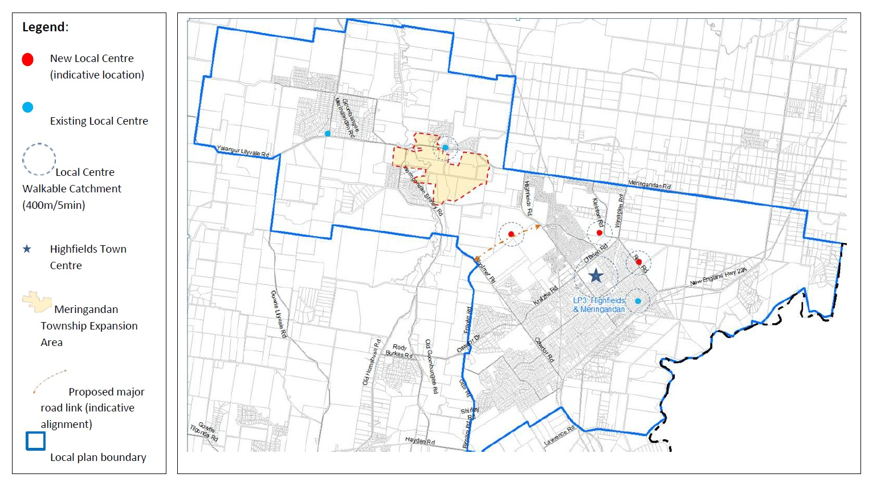
Figure 2: Map of Highfields Local Plan
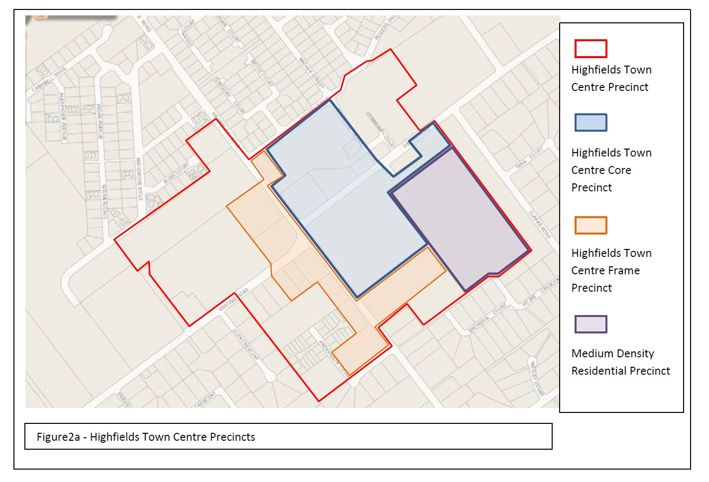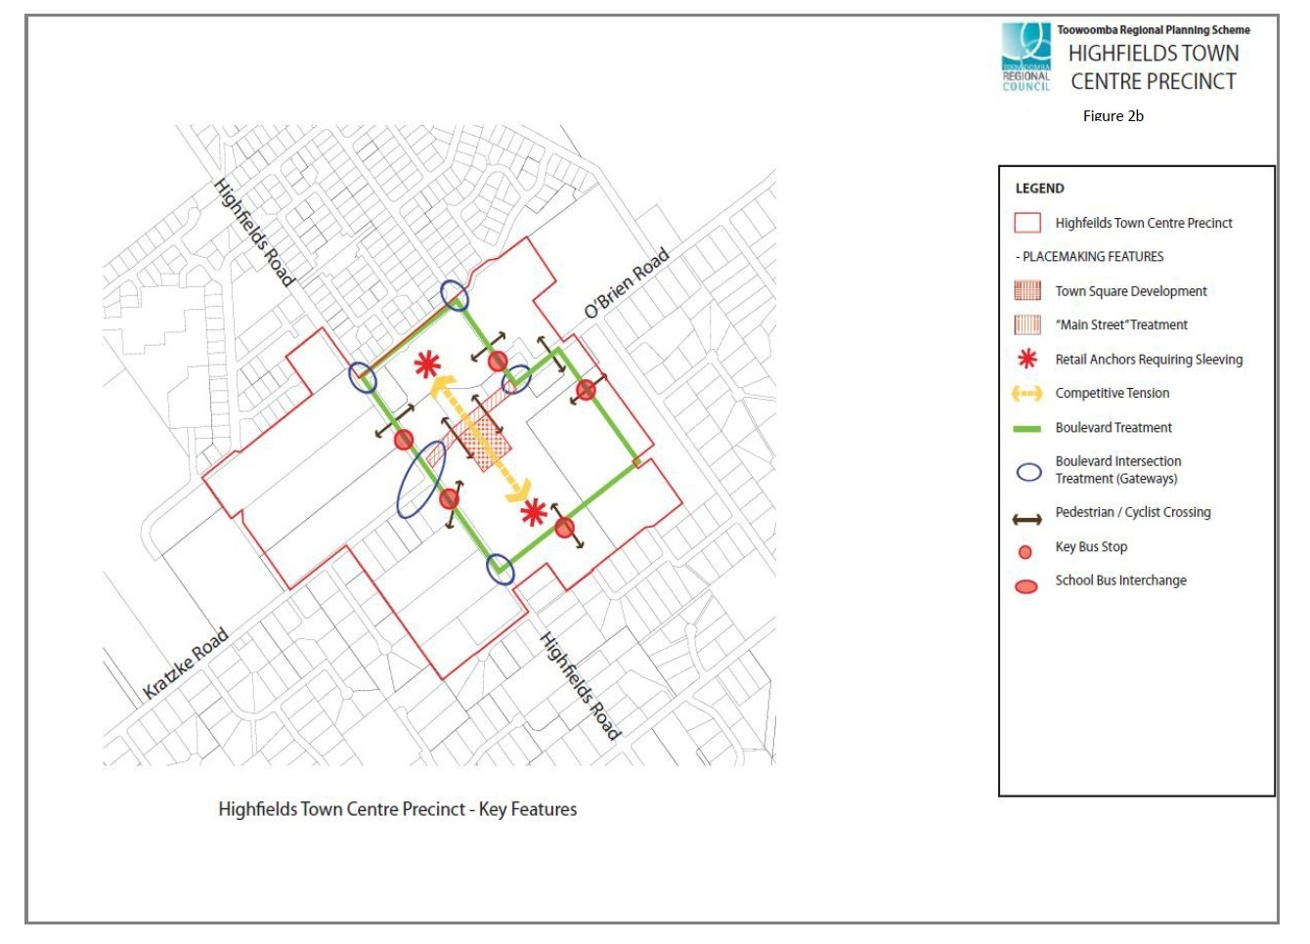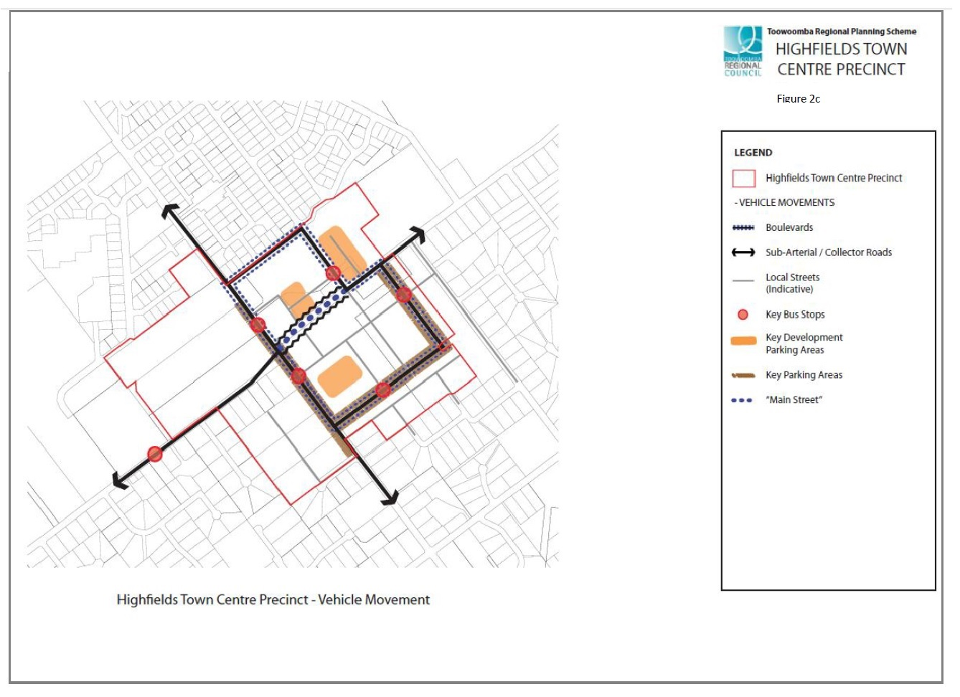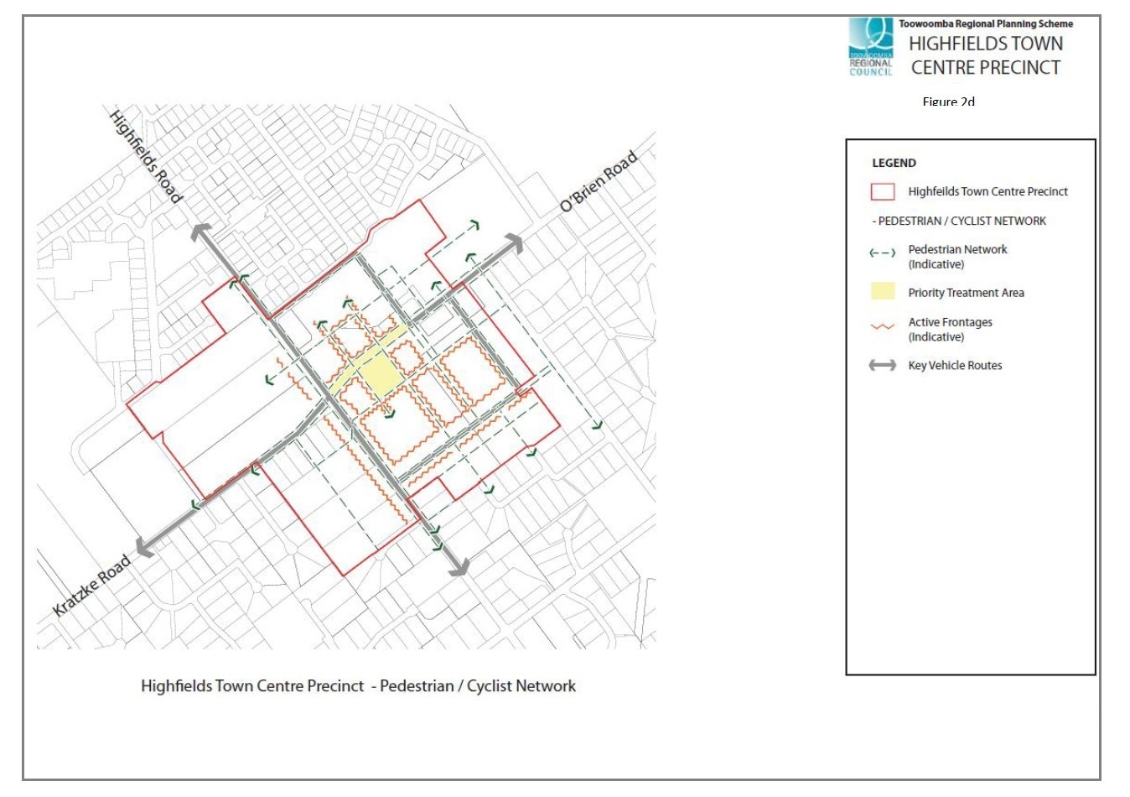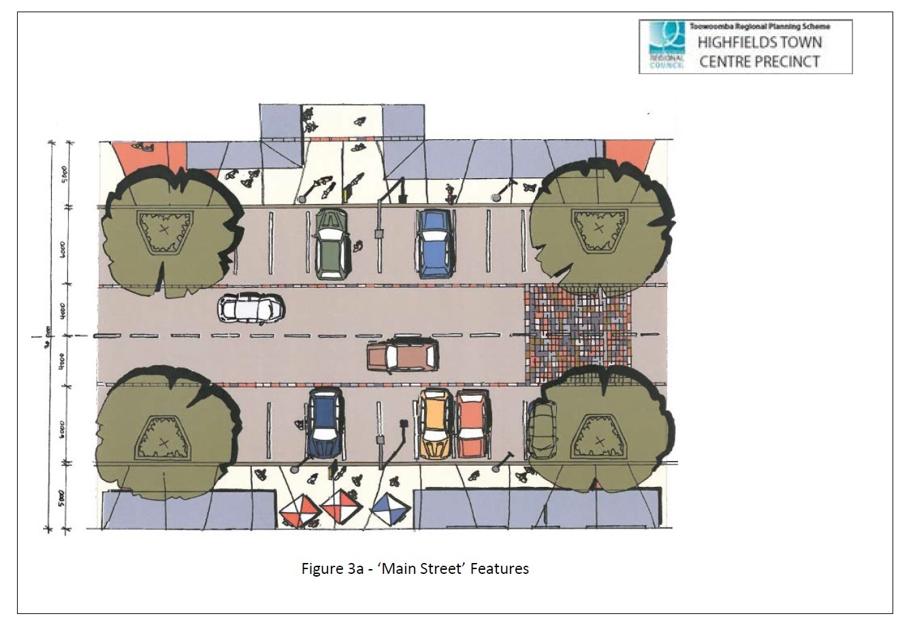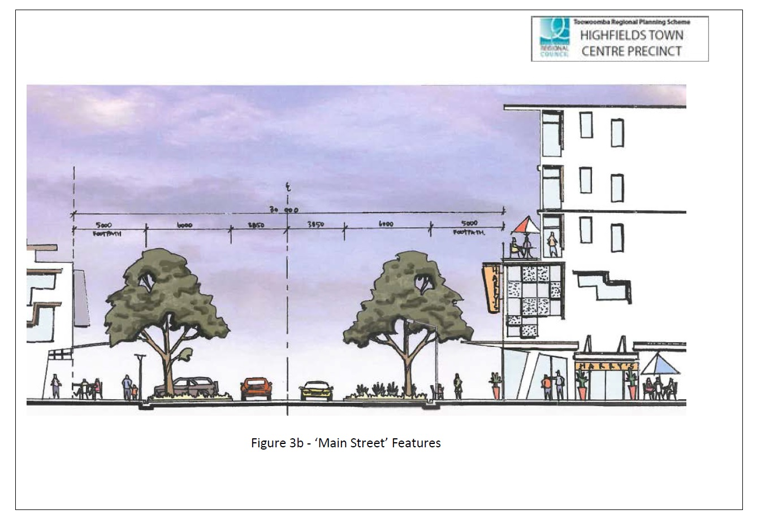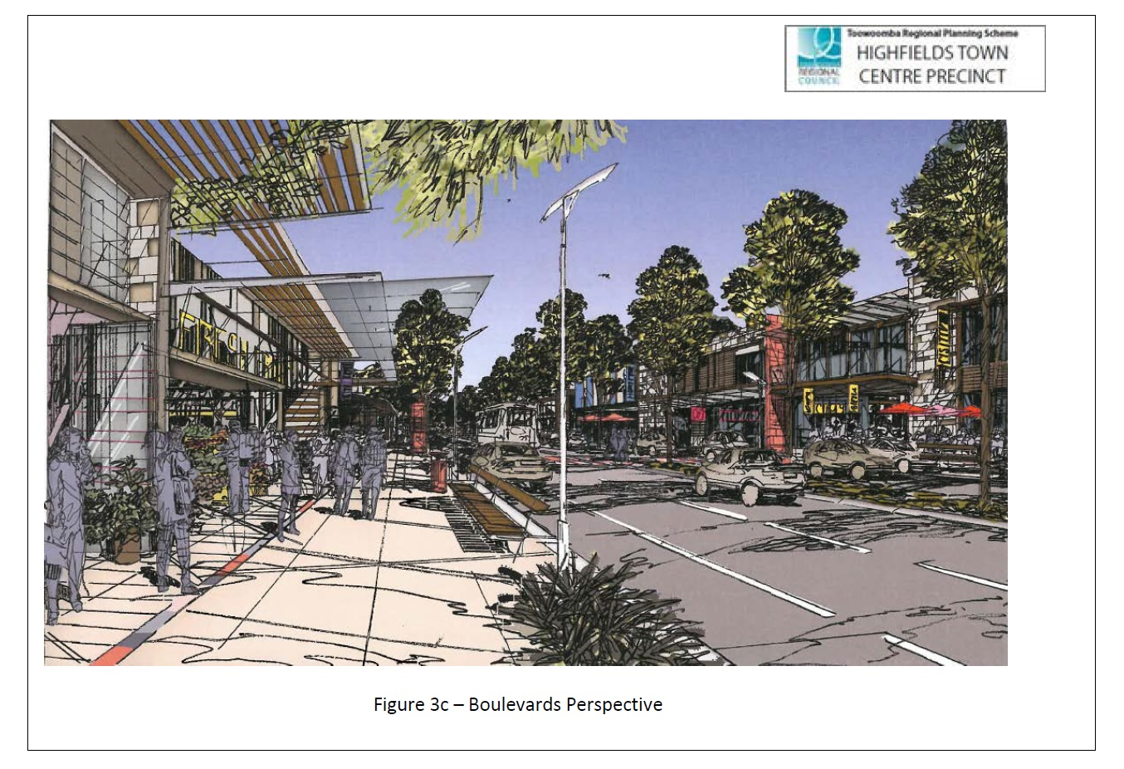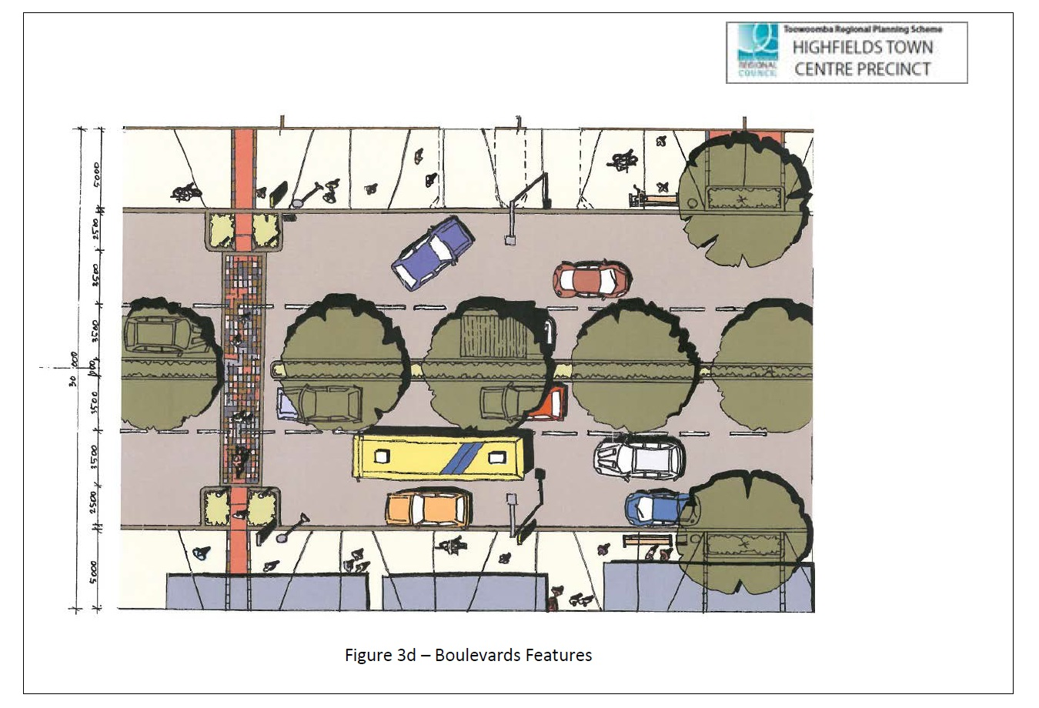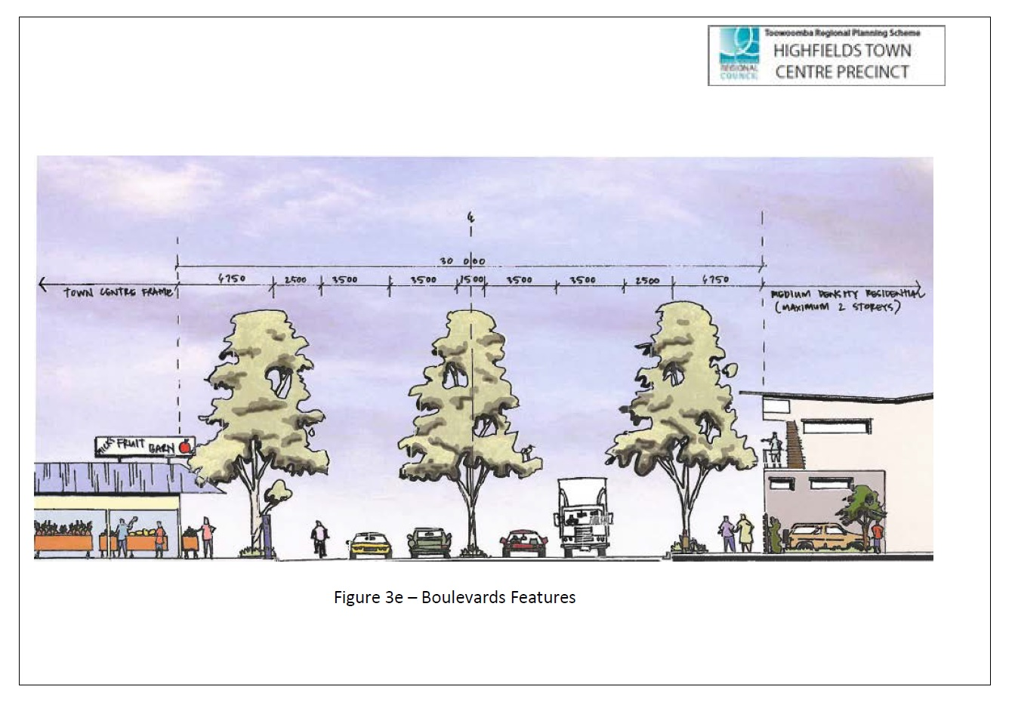

Glenvale Local Plan Code

Application
This code applies to assessable development:-

within the Glenvale Local Plan area as shown within Schedule 2 (Mapping); and

identified as requiring assessment against the Glenvale Local Plan Code by the tables of assessment in Part 5 (Tables of assessment).

Context and setting

The purpose of the Glenvale Local Plan Code is to provide for the establishment of an open space and transport network within the Glenvale Local Plan area that contributes to the establishment of a highly accessible residential area with a high quality character and amenity within the Glenvale Local Plan area.

The purpose of the code will be achieved through the following Overall Outcomes:

the Glenvale Local Plan area is to accommodate residential development and a range of densities which contribute to a residential character and maintain high levels of residential amenity;

land use activities, transport networks and key infrastructure within the Glenvale Local Plan area contribute to the amenity of the Glenvale area and cater for future population growth in the area;

development contributes to or enables the provision of an integrated open space network throughout the Glenvale area. The open space network is centred on the Spring Creek riparian corridor and extends to incorporate major landscape features such as vegetated knolls, pockets of remnant vegetation and permanent lake features;

a network of boulevards is established throughout the Local Plan area to define the main movement corridors, link key open space and landscape features, preserve the amenity of residential areas and to promote a consistent ‘garden city’ landscape theme;

a series of permanent lakes is provided as a key landscape feature within the Local Plan area. The larger of the proposed permanent lakes is a primary landmark feature of the Glenvale area and is developed to create a key focal point for community and recreational activity;

the Local Plan area is developed in a manner which is well connected and permeable, including for pedestrians and cyclists. High levels of connectivity are achieved through development providing for the development of an internal circulation route linking development areas and central, shared pathways within the open space network. Subdivision layouts involving cul-de-sacs and other barriers to connectivity are avoided; and

development provides for and supports public transport services.

Assessment benchmarks for assessable development
Table 7.2.2:1 – Glenvale Local Plan Code – assessment benchmarks for assessable development
Performance outcomes | Acceptable outcomes
General (applies to all land within the Local Plan area)
Open Space Network
PO₁ Additional public open space is provided in association with new development, to meet the expanding demand for new recreation parks and sport parks generated by new residents.  Public open space is highly accessible to all residents and visitors. | AO_{1.1} New open space and recreation parks are provided consistent with Glenvale Local Plan Map No.1.
Where located on or adjacent to land mapped as Open Space on Map 2 – Elements
PO₂ Residential development activates open space areas and creates high levels of amenity, visual access and opportunities for casual surveillance. | AO_{2.1} Dwellings are oriented towards open space elements and do not provide backyards or rear fences to designated open space.  AND  AO_{2.2} Dwellings are orientated to front open space and provide a local access road that runs along and separates the house from the designated open space.  OR  AO_{2.3} A rear lane of sufficient width for vehicle access and services is provided at the rear of any new allotment. Dwellings located on at least one side of a rear lane are oriented to address the rear lane and provide casual surveillance.  AND  AO_{2.4} A pedestrian pathway is provided to the front of the dwelling with an open style construction of fence to delineate the private land from the public open space.
PO₃ The ecological values of land within the open space network are protected and enhanced. | AO_{3.1} Existing remnant vegetation is retained and protected in any riparian corridor within the open space network.  AO_{3.2} Existing remnant vegetation is enhanced with additional planting in compliance with the Landscape Code.
PO₄ The character and amenity of the Glenvale area is enhanced by the establishment of a network of key open space, landscape and placemaking features. | AO_{4.1} A series of key open space nodes are developed in the locations identified on Map 2 – Elements and provides formal gathering areas and facilities such as barbeques, play equipment and amenities for the use of families and visitors.  AO_{4.2} A series of permanent lakes and detention basins are constructed in locations identified for water-bodies on Glenvale Local Plan Map No.1 and in accordance with the recommendations of the Spring Creek Catchment Management Strategy.  AO_{4.3} Landscape treatments that complement the vegetation in the natural riparian corridor are implemented around the permanent lakes and water-bodies identified on the Glenvale Local Plan Map No.1.
PO₅ A high level of connectivity for pedestrians and cyclists is provided throughout the Local Plan area. | AO_{5.1} The shared pedestrian/cycle connections identified on Glenvale Local Plan Map No.1 are provided.
Road Network and Boulevards
PO₆ Development does not comprise the safe and efficient operation of the road network. | AO_{6.1} The number of new intersections or access points provided on Glenvale Road and Greenwattle Street is minimised.
PO₇ The location and construction of new roads does not fragment or sever open space corridors and linkages. | AO_{7.1} The location and alignment of new roads is consistent with the transport network illustrated on Glenvale Local Plan Map No.1.

Note: Sight Distance – Minimum sight distance is achieved in accordance with the Department of Transport and Main Roads Planning and Design Manual and the Road Landscape Manual.

Charlton Wellcamp Enterprise Area Local Plan Code

Application
This code applies to assessable development:-

within the Charlton Wellcamp Enterprise Area Local Plan area as shown within Schedule 2 (Mapping); and

identified as requiring assessment against the Charlton Wellcamp Enterprise Area Local Plan Code by the tables of assessment in Part 5 (Tables of assessment).

Context and setting

The purpose of the Charlton Wellcamp Enterprise Area Local Plan Code is to provide additional local planning requirements for the Charlton Wellcamp Enterprise Area. The Charlton Wellcamp Enterprise Area is a regionally significant employment hub, accommodating a mix of business and industry activities that capitalises on the area’s strategic location and competitive strengths.

The provisions of this local plan prevail over the provisions of any applicable zones, to the extent of any inconsistency. Development complies with this Code where it complies with the purpose of the Code. The purpose of the Code will be achieved through the Overall Outcomes. The Performance Outcomes express the Overall Outcomes in more detail. The Acceptable Outcomes represent the preferred way of complying with the Performance Outcomes, while there may be other ways of complying with the Performance Outcomes while still meeting the purpose of the Code.

The purpose of the code will be achieved through the following overall outcomes:

Charlton Wellcamp Enterprise Area is a regionally significant employment hub, serving as a major business and employment area for the Toowoomba, Surat Basin Energy Province and broader Darling Downs Region. Intended to accommodate more than 10,000 employees, it is recognised as an important asset to the broader South-East Queensland and Queensland economies.

Charlton Wellcamp Enterprise Area accommodates a mix of regionally significant business and industry activities that capitalises on the area’s strategic location and competitive strengths, particularly proximity to regional transport networks and surrounding agricultural, energy and extractive industry activity. Accordingly, Charlton Wellcamp Enterprise Area will provide for transport and logistics and innovative major, high-impact and special industries providing high value-adding uses and employment opportunities.

The Area contains a number of precincts:
Intermodal Facility Precinct

The Intermodal Facility Precinct is located at the north of the Charlton Wellcamp Enterprise Area and incorporates approximately 359ha of developable land.

The Intermodal Facility Precinct caters for enterprises that require the delivery of goods via rail or the interchange of freight between rail and road transport modes. It is envisaged that a number of businesses and facilities will be located in this precinct, including:

road/rail freight interchange facilities;

major road freight terminal buildings and depots;

major rail freight terminals and depots; and

associated storage and operational facilities.

Uses that are incompatible with the above facilities and activities not associated with the operation of intermodal activities are discouraged from establishing in the Intermodal Facility Precinct.

The intermodal facility is linked to the Surat Basin and the Port of Brisbane via a spur from the Western Railway line. In the longer term, the Melbourne to Brisbane inland rail line may be constructed, providing a link between Toowoomba and Moree and, ultimately, a connection to Melbourne.

The Precinct will be serviced by a spur line and sidings that connect to the Western Railway line. Two siding options have been explored - an east west orientation and a north south orientation. Each has the potential to satisfy current national rail design standards. Further investigation is required to identify the most suitable orientation in collaboration with Department of Transport and Main Roads and Queensland Rail.

The precinct will enjoy efficient access to the Warrego Highway and the proposed Toowoomba Bypass. Access to the Warrego Highway will be via a signalised intersection at O’Maras Road/Stegers Road. The Warrego Highway will have a future interchange with the Toowoomba Bypass.

Further subdivision and development of the precinct will not occur until a suitable rail siding alignment, with agreement from stakeholders, and the confirmation of a set alignment has been determined for the Melbourne to Brisbane inland rail line. Subdivision and development does not occur in the Precinct prior to relevant decisions being made about rail infrastructure, so as not to prejudice development of or limit siting and design flexibility for an intermodal facility.

The design and layout of the Intermodal Facility Precinct does not negatively impact upon the current or future operation of the Warrego Highway, Western Railway, the Proposed Toowoomba Bypass, or the Melbourne to Brisbane inland rail line.
Transport and Warehousing Precinct

The Transport and Warehousing Precinct is located to the north of the Warrego Highway, adjacent to the Intermodal Facility Precinct. The Transport and Warehousing Precinct covers a developable area of approximately 154ha.

The Transport and Warehousing Precinct provides land for road-based freight, transport, warehouse and distribution uses and facilities. The following uses are envisaged:

road freight interchange facilities;

major road freight terminal buildings and depots; and

associated storage and operational facilities.

Uses considered incompatible with and activities not associated with the operation of the transport and warehouse uses are not supported in this precinct. Uses that do not take advantage of the high quality freight access opportunities are likewise not supported in this precinct.

Businesses within the Transport and Warehousing Precinct have synergies with the neighbouring Intermodal Facility Precinct.

The precinct will enjoy efficient links to the Intermodal Facility Precinct, Warrego Highway, and proposed Toowoomba Bypass Corridor. The design and layout of the Precinct does not negatively impact the current or future operation of the Warrego Highway, Western Railway, or the Proposed Toowoomba Bypass or Moree to Toowoomba section of the Melbourne to Brisbane inland rail line.

Wellcamp Low Impact Industry Precinct

The Wellcamp Low Impact Precinct is located to the southern side of the Toowoomba Cecil Plain Road, to the west of the quarry. The Wellcamp Low Industry Precinct covers a developable area of approximately 125ha.

The Wellcamp Low Industry Precinct provides for the establishment of low impact industry and separates potentially heavier forms of industry to the south from sensitive land uses to the north.

Development in the Wellcamp Low Industry Precinct is for low impact industry uses and compatible uses, such as warehousing, that are regionally significant, support or have direct nexus with other development in the Charlton Wellcamp Enterprise Area Local Plan.

General Industry Precinct

The General Industry Precinct is located to the south of the Warrego Highway and includes approximately 315ha of developable land.

The General Industry Precinct provides land for medium and large scale general industry enterprises that service a regional market (or greater) and are linked to other activities in the Region, particularly in the Surat Basin and greater Darling Downs area.

The following uses build upon the competitive strengths of the Region and are envisaged in the General Industry Precinct:

food product manufacturing;

metal and metallic product manufacturing;

building & construction material manufacturing;

machinery & equipment manufacturing;

other chemical product manufacturing; and

leather and leather product manufacturing (e.g., specialised saddle and harness manufacture).

Initial development in the precinct is accommodated in the area immediately to the south of Warrego Highway, with longer term development in the area abutting the northern edge of Toowoomba Cecil Plains Road.
Heavy Industry Precinct

The Heavy Industry Precinct is located in the southernmost part of the Local Plan area. Developable land included within the Heavy Industry Precinct totals approximately 520ha.

The Heavy Industry Precinct provides land for high-impact industries of regional, state or national significance, with specific industry types and requirements developed in consultation with the State Government.

Servicing within the Precinct is not reliant on the development of services elsewhere in the Charlton Wellcamp Enterprise Area and will conform to best practice environmentally sustainable development and industrial efficiency standards.

The activities of the Heavy Industry Precinct do not adversely impact on the amenity or viability of the other industries within the Charlton Wellcamp Enterprise Area Local Plan.
Commercial Centre Precinct

The Commercial Centre Precinct meets the commercial, retail and service needs of the employee population in the Charlton Wellcamp Enterprise Area and passing traffic along the Warrego Highway.

Centres have high visual exposure to major arterials and sub-arterials and are also conveniently located and easily accessible to employment areas throughout the Charlton Wellcamp Enterprise Area Local Plan.

The nature of the retail activity is focused on servicing the needs of workers and businesses within the Charlton Wellcamp Enterprise Area. The ultimate mix of services accommodated in the Commercial Centre Precinct comprise a limited mix of business activities that service the day-to-day needs of workers and businesses including food and drink outlet, hotel, sales office, service station, and shop uses.

Two new commercial centres are anticipated in the precinct:

Charlton North commercial centre - provides for an expansion of the existing commercial centre at Charlton at the intersection of the Warrego Highway, O’Maras Road and Steger Road. This commercial centre will primarily service the north portion of the Local Plan area as well as passing traffic on the Warrego Highway;

Charlton South commercial centre - is located along O’Maras Road to the south of Dry Creek. The centre services the southern portion of the Local Plan area.
Conservation Precinct

The purpose of the Conservation Precinct is to protect environmental values whilst managing stormwater and flooding.

The Charlton Wellcamp Enterprise Area landscape is characterised by predominantly cleared rural land. There are few known ecological values within the Charlton Wellcamp Enterprise Area Local Plan due to clearing for agricultural production and extractive industry.

Mapped areas of significant vegetation within the Charlton Wellcamp Enterprise Area Local Plan are areas identified on the Regional Ecosystem mapping as Not of Concern. Where practical this vegetation will be retained.

There is a significant possibility of isolated areas of significant vegetation and/or threatened species occurring across the area including nationally significant grassland and woodland communities.

Notwithstanding the low ecological values present in the Local Plan area, there are opportunities to rehabilitate ecosystem function in the Open Space Precinct and along riparian corridors. The Charlton Wellcamp Enterprise Area contains two (2) significant waterways (Westbrook Creek and Dry Creek), with Gowrie Creek located to the north of the Western Rail Line, just outside the Charlton Wellcamp Enterprise Area. There are also a number of smaller waterways and drainage lines throughout the site. Buffering of 140m (70m on either side from the centreline of a waterway) is provided along the major waterway line, providing for flood mitigation and riparian conservation and rehabilitation.

Low impact recreational uses are suitable within riparian corridors. Such uses are generally compatible with environmental values. Linear open spaces present opportunities to provide trails that link into the broader pedestrian and cycle network.
Quarry Precinct

The existing quarrying activities in this precinct continue, and expand in an environmentally responsible way.

Progressive rehabilitation and landscaping of land in the precinct during and at the conclusion of the working life of the quarry occurs and an effective buffer area between quarrying activities and surrounding land is maintained within the precinct.

Development within the Charlton Wellcamp Enterprise Area provides for the timely, efficient and effective provision of infrastructure in a form that meets the needs of the type of industry encouraged within the area.

Charlton Wellcamp Enterprise Area is suitable as a regionally significant enterprise area due to its access to regional transport networks. The following existing and proposed major transport routes are essential to the successful delivery of the Charlton Wellcamp Enterprise Area and their implementation and operational efficiency is not to be prejudiced:

Warrego Highway.

Gore/Newell Highway.

Proposed Toowoomba Bypass.

Western Railway.

Proposed link to the Port of Gladstone.

Proposed Melbourne to Brisbane Inland Rail.

The functional layout of development in the Local Plan area capitalises on its location at the junction of regionally significant road and rail links, providing unparalleled access to regional and interstate freight transport and industrial enterprise hubs.

The Local Plan area has a well integrated internal transport network with efficient links to the regional and interstate road and rail freight routes. The internal transport network is focussed on Stegers Road, O’Maras Road and Toowoomba Cecil Plains Road.

All elements of the transport network are designed and constructed to maximise efficiency in transport and minimise potential for conflicts.

An integrated public transport system provides convenient services throughout Charlton Wellcamp Enterprise Area and provides frequent, efficient connections to the Toowoomba urban area and key destinations in the Region.

Pedestrian pathways and bicycle connections are provided throughout the Local Plan area.

Infrastructure will be provided that contributes to the competitive strengths of the Local Plan area, and that supports the planned development of the area.

All infrastructure networks are provided to the Local Plan area at the level capable of servicing the proposed development and which considers the needs of future development.

The development and use of land within the zones for transport and industry purposes is dependent on the availability of adequate infrastructure. Until such time as infrastructure becomes available, the continued rural use of such lands is supported.

Development minimises land use conflicts and impacts on amenity through good design and appropriate siting of lots and buildings.

The industrial activities located in the Local Plan area are able to operate 24 hours a day, providing an active enterprise location.

New development and ongoing business operations exemplify best practice sustainable design principles and technologies.

Charlton Wellcamp Enterprise Area is aesthetically appealing, well-connected, functional, economically viable and environmentally sustainable, thereby setting the benchmark for best practice industrial and enterprise development of this type.

New development is located, designed, sited and used in ways that avoids environmental harm and does not present unacceptable environmental, health or safety risks.

Development is sited to minimise land use conflicts between industrial activities and surrounding sensitive land uses.

Assessment benchmarks for assessable development
Table 7.2.3:1 – Charlton Wellcamp Enterprise Area Local Plan Code – assessment benchmarks for assessable development
Performance outcomes | Acceptable outcomes
General - applies to the whole of the Local Plan area
Regional Significance
PO₁ Businesses that locate in Charlton Wellcamp contribute facilities of regional significance that capitalise on the area’s strategic location and competitive strengths. | AO_{1.1} Businesses that locate in Charlton Wellcamp:  provide goods and services to resource and energy businesses in the Surat Basin;  take advantage of the Warrego Highway and Gore Highway for the transport of freight and goods;  take advantage of existing and proposed east/west and north/south rail connections within the area; or  have links to other major employment nodes/markets/distribution networks for imports and exports, including the Port of Brisbane, Surat Basin and existing industrial areas at Ebenezer, Bromelton, Toowoomba or Brisbane.
Major Access Network
PO₂ Charlton Wellcamp is suitable as a regionally significant enterprise area due to its high level of access to regional transport networks.  The following existing and proposed major transport routes are essential to the successful delivery of the Charlton Wellcamp Enterprise Area and their operational efficiency is not prejudiced:  Warrego Highway;  Gore Highway;  proposed Toowoomba Bypass;  Western Railway, which provides access to the Darling Downs and Western Queensland, Surat Basin Energy Province and the Port of Brisbane;  proposed link to the Port of Gladstone; and  proposed Melbourne to Brisbane Inland Rail. | No acceptable outcome is nominated.
Staging
PO₃ Development has access to all infrastructure networks at the level capable of servicing the proposed development and which considers the needs of future development. | AO_{3.1} Development occurs on land that adjoins land where transport, water, wastewater, drainage and telecommunications infrastructure is already in place.
Subdivision Layout/Reconfiguring a Lot
PO₄ Subdivision creates lots that have appropriate areas and dimensions for the siting and construction of required buildings and other structures, the provision of safe access and adequate on-site vehicle parking, required landscaping and buffering, other user needs and environmental considerations, having particular regard to the other Performance Outcomes and Acceptable Outcomes of this Code.  Note: Figure 1- Indicative Industrial Subdivision Layout demonstrates how an appropriate subdivision layout may be achieved.  Lot size and dimensions take into account the slope of the land, topography, and the desirability of minimising earthworks/retaining walls associated with building construction.  Lot size and dimensions enable buildings, structures and use areas are sited and managed to:  protect natural or cultural features;  respect site constraints including soil conditions, bushfire risk, flooding, erosion, drainage and buffers to incompatible land uses; | AO_{4.1} Subdivision creates regular shaped lots with minimum areas and average widths of not less than the following:
  Precinct | Minimum Area | Minimum Average Width
  Intermodal Facility | 2ha | Ratio of 1:2 width to depth
  Transport and Warehousing | 5ha | 100m
  Wellcamp Low Impact Industry Precinct | 2ha | Ratio of 1:2 width to depth
  General Industry | 2ha | Ratio of 1:2 width to depth
  Heavy Industry | 10ha | 100m
  Quarry Precinct | 10ha | 100m
  Commercial Centre | Not Applicable | Not Applicable
  Conservation | Subdivision not permitted | Subdivision not permitted
allow for special features such as important vegetation, landforms, waterways and views are protected or enhanced; and  if applicable, protect the on-going or future viability of adjoining agricultural land for viable commercial rural production. | AO_{4.2} Lot areas and dimensions allow for site development to incorporate open space as follows:  in a minimum 70m wide corridor on either side of the centreline of a waterway or in a corridor the width of flood prone land, established and maintained as a vegetated area along each side of the waterway;  on areas with a slope in excess of 7.5%;  in accordance with the Conservation and Recreation Precincts of the Local Plan; and  on areas adjoining agricultural land external to the Local Plan area, by providing minimum 40m wide buffer areas designed in accordance with Section 3 of the State Planning Guidelines: Separating Agricultural and Residential Land Uses.  Note: Figure 2 Open Space and Constrained Areas demonstrates how land required for open space may be provided.
PO₅ The reconfiguration gives the location a strong and positive identity by responding to site characteristics, setting, landmarks, places of cultural heritage significance, views, and by establishing clearly legible road hierarchy and streetscaping themes.  The design facilitates the staged development of the precinct in an orderly, integrated and cost-effective way, and the integration of business and industry premises into their surroundings, ensuring minimal impact on the amenity of adjacent or nearby areas. | No acceptable Outcome is nominated.  Note: One way to demonstrate compliance with the Performance Outcome is to prepare a ‘Detailed Concept Plan’ for the site and its surrounds. A Detailed Concept Plan would be expected to determine and indicate:  major land use areas;  any areas with significant environmental value or physical constraints;  preferred movement corridors;  major drainage paths and detention areas, and other open spaces;  the relationship of the sites to the surrounding locality; and  staging for development.  A development proponent may also prepare an alternative Concept Plan for approval by Council to replace an existing Concept Plan.  Any such proponent prepared Concept Plan will be assessed and decided by Council at the time of lot reconfiguration, or material change of use (if no lot is to be reconfigured).
PO₆ The street system and road hierarchy has capacity to safely and efficiently accommodate projected vehicle movements, and allows adequate and safe connectivity to the external road network in a way that does not compromise the operating conditions of that network, particularly the Warrego Highway, the Toowoomba Cecil Plains Road and the Toowoomba Bypass (when constructed).  The street system provides a high level of internal accessibility and safe external connections for vehicles (including heavy vehicles) which includes minimising the use of cul-de- sacs.  The road and street system has a clear structure, with component streets designed and constructed to operate to their intended function and hierarchy.  The street system takes proper account of the topography and natural drainage systems.  The layout provides a network of streets, paths and cycle ways which allow for a high degree of local accessibility and connectivity and achieve a high standard of comfort and safety, through the use of trees and lighting, surveillance from buildings along street frontages and the design of roads that discourage higher traffic speeds.  The density and layout of the development, including the reconfiguration of lots for industrial purposes, is responsive to the promotion of public transport and non-vehicular transport modes.  The following roads are designed to limit any site access:  Warrego Highway (between Leeson Road and Troys Road);  Toowoomba Cecil Plains Road;  O’Maras Road; and  Steger Road. | AO_{6.1} The street system reflects the characteristics specified in Table 7.2.3:2 and Table 7.2.3:3 and as represented in Figures 3a, 3b and 3c Industrial Roads Cross Sections.  AO_{6.2} An internal road network is established consistent with Table 7.2.3:2, and which is focussed on Stegers Road, O’Maras Road and Toowoomba Cecil Plains Road.  AO_{6.3} All streets link with other streets that are no more than one level higher or lower in the hierarchy, as defined in Table 7.2.3:2 and Table 7.2.3:3.  AO_{6.4} Development complies with the current version of ‘Complete Streets: Guidelines for Urban Street Design 2010 (the new Queensland Streets)’.  AO_{6.5} Direct vehicular access is not provided to:  Warrego Highway (between Leeson Road and Troys Road);  Toowoomba Cecil Plains Road;  O’Maras Road; or  Steger Road.
PO₇ The layout of development contributes to the character of the precinct, provide for the desirable range of uses and activities, be cost-effective to maintain, and contribute to stormwater management and environmental sustainability.  The layout incorporates natural and cultural features, allows for the control of soil erosion and sedimentation, and avoids inappropriate development on flood-prone land. | No Acceptable outcome is nominated.  Note: One way to demonstrate compliance with the Performance Outcome is to prepare a ‘Concept Plan’. A Concept Plan would be expected to determine and indicate:  major land use areas;  any areas with significant environmental value or physical constraints;
The layout integrates with its surrounding urban and/or natural environment, allows for orderly and cost-effective staged provision of infrastructure, and provides for buffers between any existing or potential incompatible land uses.  Public or communal open space and landscaping provides for:  the creation of attractive streetscape environments with distinctive character and identity;  a range and equitable distribution and connectivity of recreation areas, paths, and attractive settings and focal points;  the opportunities and constraints presented by the physical characteristics of the land;  opportunities for the incorporation of existing trees, rocks, streams and other sites of natural or cultural value, and linkage of habitats and wildlife corridors;  opportunities to link public open spaces into an effective network;  public safety and reasonable amenity of adjoining land uses in the design of facilities and associated engineering works;  effective visual buffering, and separation of industrial activities from surrounding incompatible sensitive land uses; and  a clear relationship between public open space and adjoining land uses established by appropriate treatment including alignment, fencing, landscaping, and issues of security and surveillance. | (c) preferred movement corridors;  (d) major drainage paths and other open spaces;  (e) the relationship of the site/s to the surrounding locality; and  (f) staging for development.  A development proponent may also prepare an alternative Concept Plan for approval by Council to replace an existing plan.  Any such proponent prepared plan will be assessed and decided upon by Council at the time of lot reconfiguration, or material change of use (if no lot is to be reconfigured).
Site Layout
PO₈ The site layout takes into account on-site and surrounding topography, drainage patterns, utility services, access, vegetation, and adjoining land use. | No acceptable outcome is nominated.
PO₉ The site layout, building form and landscaping assists in minimising noise generation and spill lighting and screening unsightly open storage and other outdoor areas from public view. | AO_{9.1} The site layout and building form maximises protection of surrounding sensitive land uses from adverse impacts by providing:  all or most building openings facing away from residential and community uses;  external lighting oriented away from residential and community uses; and  landscaping which complies with the Landscaping Code.
PO₁₀ The site layout contributes as much as possible to energy efficiency (in terms of heating, cooling, lighting and natural ventilation). | AO_{10.1} The building is sited to maximise the exposure of occupants to cooling summer breezes, and to minimise their exposure to the western summer sun and to cold winter winds.  Note: Figure 4 Climatically Responsive Design Site Layout and Figure 5 Climatically Responsive Design Natural Light and Ventilation demonstrate how AO_{10.1} may be achieved.
PO₁₁ Where the site is not being fully developed at one time, the layout allows for later development to be carried out in an orderly and efficient manner. | No acceptable outcome is nominated.
PO₁₂ Hard stand areas are sited at the rear of buildings to ensure that such ancillary uses do not dominate streetscapes. | No acceptable outcome is nominated.
Building Setbacks and Envelope Siting
PO₁₃ Buildings are setback from the road frontage in such a way that:  allowance is made for efficient use of the site and the desired road character and operation;  future identified road corridors and existing highway/road interchange upgrades are not compromised;  significant landscaping is provided at the front of the site;  on-site visitor carparking is provided in an easily visible location at or near the front of the site;  buildings contribute to an attractive streetscape character;  buildings help to screen any unsightly outdoor service, storage or other use area; and  the location of utility services and drainage paths are taken into account. | AO_{13.1} All buildings are setback from the primary road frontage not less than:  40m from the Toowoomba Bypass corridor;  20m from the Warrego Highway (other than in the Commercial/Centre Precinct) or the Toowoomba Cecil Plains Road; or  10m otherwise.
PO₁₄ Buildings are sited in relation to side and rear boundaries such that:  allowance is made for efficient use of the site;  the requirements of the Building Code of Australia can be satisfied;  the location of utility services and drainage paths are taken into account;  buildings help to screen any unsightly outdoor service, storage or other use areas;  existing or likely future use of adjoining land is not significantly adversely affected; and  effective buffer areas are provided to creeks and to agricultural land adjoining the Charlton Wellcamp Enterprise Area Local Plan area. | AO_{14.1} Buildings are setback:  not less than 40m from any boundary adjoining land outside the Charlton Wellcamp Enterprise Area Local Plan area used for rural purposes; and  not less than 70m from Dry Creek, Westbrook Creek or Spring Creek;  or otherwise, where not for (a) or (b):  a minimum of 5m from any side or rear boundary.
Building Scale and Appearance
PO₁₅ The building has a height and bulk that allows for the building to be set into the landscape/ streetscape without becoming visually intrusive. | AO_{15.1} Development provides a site cover of not more than:  50% in the Heavy Industry Precinct; or  65% in all other Precincts.  AO_{15.2} Building height is not greater than 12m where on land within 100m of the Warrego Highway, Toowoomba Bypass or Toowoomba Cecil Plains Road. A building may have a height greater than 12m where it can be demonstrated that it will not have a significant impact on the visual amenity of the precinct.
PO₁₆ Building bulk and form responds to local character, climatic conditions and contributes to an attractive streetscape. | AO_{16.1} The unarticulated length of external walls does not exceed 15m where:  facing a road frontage; or  visible from a residential area or public open spaces.  Development achieves articulation through the use of variation in textures, colours, finishes and landscaping.  Note: Figure 6 Building Appearance demonstrates how AO_{16.1} may be achieved.  AO_{16.2} Variation of building form and elevation is appropriate to the building’s internal function.  Note: Figure 7 Definition of Entries, and Reinforcement of Site Building Functions demonstrates how AO_{16.2} may be achieved.
PO₁₇ Buildings and signage located at important intersections are distinctive and act as gateway markers to identify entry points into the local plan area. | AO_{17.1} Gateway signage is constructed at:  Toowoomba Bypass/Warrego Highway interchange;  Toowoomba Bypass/Toowoomba Cecil Plains Road interchange;  Warrego Highway on the western entrance;  Toowoomba Cecil Plains Road western entrance; and  O’Maras Road Overpass.  AO_{17.2} Signage at the locations in AO_{17.1} is:  consistent with the Advertising Devices Code;  provides a single sign with capacity to advertise numerous major businesses located in the Charlton Wellcamp Enterprise Area; and  has a theme consistent with other gateway signage established in the Charlton Wellcamp Enterprise Area.  Note: Figure 7 Definition of Entries, and Reinforcement of Site Building Functions demonstrates how AO_{17.1} and AO_{17.2} may be achieved.  Note: If no other gateway signage has been established in the Charlton Wellcamp Enterprise Area then the first gateway signage is prepared with the assistance of Council officers.
PO₁₈ Ensure that the front of the building addresses the street. Areas within the buildings requiring public access are orientated towards the street frontage or well connected to it both physically and visually by:  ensuring the building has a definite hierarchy of functions; and  areas within the buildings requiring private or more secure access are configured so as to hinder passive visual or physical intrusion. | AO_{18.1} Important design considerations are incorporated into new buildings and include:  all elevations of buildings which address any street frontage have openings that allow for visual and/or physical connection to the street, regardless of whether it is the main entry street;  the function of different parts of the building is easily recognisable from the external appearance e.g., administration/entrances/offices appear different from warehouse areas and have different levels of accessibility; and  private spaces or areas requiring secure containment are appropriately integrated into the building form and located in less public spaces.  Note: Figure 6 Building Appearance; Figure 7 Definition of Entries, and Reinforcement of Site Building Functions; and Figure 8 Gateway features demonstrate how AO_{18.1} may be achieved.
PO₁₉ Building Entrances are:  clearly identified by singular entrances and defined pathways; and  defined through shelter and human scale architectural design. | AO_{19.1} Entrances to buildings are identifiable from public areas including car parks, roads and footpaths. Important design considerations in achieving this include but are not limited to:  the design and scale of building entrances are appropriate for their function;  Note: Figure 6 Building Appearance and Figure 7 Definition of Entries, and Reinforcement of Site Building Functions demonstrate how AO_{19.1} (a) may be achieved.  separate entrances are provided for vehicles and for pedestrians;  Note: Figure 9 Industrial Site Layout Principles demonstrates how AO_{19.1} (b) may be achieved.  the main entry to the building is at the front of the building or otherwise easily identifiable from the street;  Note: Figure 6 Building Appearance; Figure 7 Definition of Entries, and Reinforcement of Site Building Functions; and Figure 9 Industrial Site Layout Principles demonstrate how AO_{19.1} (c) may be achieved.  the office space for each building is located along the principal road frontage of the site;  Note: Figure 9 Industrial Site Layout Principles demonstrates how AO_{19.1} (d) may be achieved.
building entries are defined by distinctive architectural elements that contrast against the building façade. This can be achieved through glazing, colour, architectural features (i.e. awnings) etc;
pedestrian entries incorporate sun and rain shelter;
pedestrian entries are defined by human scale design elements;
Note: Figure 6 Building Appearance demonstrates how AO_{19.1} (e), (f) and (g) may be achieved.
landscaping at the front of buildings reinforces the prominence of building entries; and
defined pathways provide a direct line of travel to building entrances.
Note: Figure 7 Definition of Entries, and Reinforcement of Site Building Functions demonstrates how AO_{19.1} (h) and (i) may be achieved.
PO₂₀ Thresholds and fenestrations:  allow for adequate access, and egress, ventilation and light for the required function of their location; and  are designed to ensure the integrity of the building’s weather protection and security. | AO_{20.1} Thresholds and fenestrations allow for:  fenestration placement and design to overlook public and communal areas;  identification of the building/s functional components e.g. larger windows to public areas with appropriate orientation and awnings, smaller windows to more private areas and where the orientation means that solar and breeze access is limited.
PO₂₁ Roof design:  achieves variety in roof shape and colour to compliment the building design and contribute towards the character;  keeps within the scale of the building envelope;  conceals plant rooms and equipment;  allows for water collection, ventilation, shade and shelter;  provides large overhangs on pitched roofs to shade external walls and surrounding grounds (especially hardscape areas that may act as heat sinks); and  provides appropriately scaled and integrated guttering, downpipes and water tanks. | AO_{21.1} Overhangs or awnings over pedestrian entrances are a minimum of 900mm from the external building face to the outermost projection.
PO₂₂ Development:  has a high quality appearance when viewed from the street, adjoining properties and public open space; and  minimises air quality, noise and odour impacts on the amenity of adjoining land. | No acceptable outcome is nominated.
PO₂₃ The building is designed and finished to have a high quality, modern appearance that helps integrate the building into the environment in which it is set. | AO_{23.1} A building has materials, colours and architectural details of a high standard, and in accordance with the following:  materials - brick, masonry, glass, colourbond; and  colours – ‘earth tones’ comprising greens, blues, greys.
PO₂₄ Suitable building materials are used that provide:  durability - materials are applied as fit for their design. Considered material selection according to its vandal resistance and maintenance regimes will assist in the development maintaining a quality appearance for longer; and  liveability - selection and configuration of materials to minimise noise and air-borne pollutant transmission. | No acceptable outcome is nominated.
Landscaping
PO₂₅ Landscaping is designed, established and maintained in a manner to:  be an appropriate scale relative both to the street reserve width and to the size and nature of the development;  incorporate significant existing vegetation, where possible;  be sensitive to site attributes, such as streetscape character, natural landform, existing vegetation, views and drainage; and  allow adequate lighting and pedestrian and vehicular safety. | AO_{25.1} On-site landscaping is provided:  along the full length of the road frontage of the site, apart from vehicle access points, with a minimum width of:  10m along the Toowoomba Bypass Corridor, and where opposite rural land outside the Charlton Wellcamp Enterprise Area Local Plan area;  6m along the Warrego Highway;  6m along Toowoomba Cecil Plains Road;  2m along the Warrego Highway within the Commercial Centre Precinct;  3m along any other road frontage; and  10m, densely planted, along the rear of buildings adjoining non-access roads;  along any adjoining waterway for a minimum width of 70m (measured from the edge of the defined waterway channel and applicable to each side of the waterway); and  elsewhere on the site to screen outdoor storage areas and other unsightly open areas from public view where such screen planting has a minimum width and height of 2m.
AO_{25.2} Landscaping near electric lines or substations, whether for commercial or private purposes, is designed and developed so that:
on land beneath, or within 5m of land beneath, an electric line , or within 5m of a substation boundary, any vegetation at maturity or landscaping structures or works do not exceed 4m in height;
otherwise, vegetation is planted in a position that is further from the nearest edge of the land beneath electric line or substation boundary than the expected maximum height at maturity of the vegetation;
on land adjoining an electricity substation boundary, the vegetation foliage at maturity is not within 3m of the substation boundary. However, where a substation has a solid wall along any part of its boundary, foliage may extend to, but not above or beyond, that solid wall; and
there is personnel and vehicular access available to the electricity works.
Note: Figure 10 Electricity Infrastructure Buffers demonstrates how AO_{25.2} may be achieved.
PO₂₆ Landscape placement and orientation achieves the following outcomes:  soften the appearance of building walls;  soften the view of large areas of hard paving when viewed from adjoining streets;  soften or screen the view in to work or storage areas;  incorporate shade planting to parking areas;  provide visual buffering along the rear of buildings on non-access roads;  planting to not excessively reduce solar access and ventilation; and  maintain sightlines.  Plant selection achieves the following outcomes:  species that have low water requirements and are drought resistant;  durable plant species that are able to withstand placement in an industrial environment;  species that do not create an excessive amount of litter or shed limbs; and  species with non-invasive root systems or shallow root systems that have the potential to damage underground services or paved services. | AO_{26.1} Landscape treatment is used to frame pathways and building entries, adding to site legibility.  Note: Figure 7 Definition of Entries, and Reinforcement of Site Building Functions demonstrates how AO_{26.1} may be achieved.  AO_{26.2} Landscape areas do not impact on the safe operation of vehicles. Sightlines are maintained by avoiding the location of dense planting at corners of carpark aisles or at car park entries.  AO_{26.3} Development retains existing large mature trees where possible.  AO_{26.4} Plant selection occurs consistent with the Acceptable Outcomes of the Landscaping Code.  AO_{26.5} Planted landscape areas within the carpark areas generally consist of:  ground cover;  bare stem (between 1.2m - 2m in height) tree species, provided every three car spaces; and  tree species that have low water requirements and are non-limb shedding and do not create excessive litter.
Ancillary Use Areas
PO₂₇ Waste storage and collection areas, loading/unloading areas and any outdoor storage facilities of premises are:  suitably located for convenient use; and  designed to be visually attractive or screened. | AO_{27.1} Waste storage and loading/unloading areas are located for convenient use and collection, screened from public view and are behind the main building line or in a building or enclosure.  AO_{27.2} Outdoor storage areas are sited so as to be visually unobtrusive from the street or any nearby residential or other incompatible use, or screened from view.  Note: Figure 9 Industrial Site Layout Principles and Figure 11 Landscape Screening demonstrate how AO_{27.1} and AO_{27.2} may be achieved.
Fences and Walls
PO₂₈ Fences and walls:  are finished and maintained to be visually attractive and to contribute to or blend with the site's landscaping;  where appropriate, are designed and detailed to provide visual interest to the streetscape;  are constructed of materials which are compatible with the buildings on the site;  can provide effective screening from any adjoining incompatible use; and  where appropriate, assist in highlighting entrances and paths. | AO_{28.1} Retaining walls do not exceed a height of 2m and are landscaped or otherwise detailed so as not to appear to be a solid expanse or mass.  AO_{28.2} Solid fencing or walls or landscaped earth mounds are provided to screen views and/or buffer noise to any adjoining non-industrial use.  Note: Figure 12 Fencing for Industrial Areas provides examples of preferred and undesirable fencing in industrial areas.
Environmental Performance - Environmental Management
PO₂₉ Development minimises potential conflicts with, or impacts on, other uses having regard to vibration, odour, dust or other emissions. | AO_{29.1} Development achieves the air quality design objectives set out in the Environmental Protection (Air) Policy 2008.  AO_{29.2} Development that involves the storage of materials on site that are capable of generating air contaminants either by wind or when disturbed are managed by:  being wholly enclosed in storage bins; or  a watering program so material cannot become airborne.
PO₃₀ Development prevents or minimises the generation of any noise so that:  nuisance is not caused to adjoining premises or other nearby sensitive land uses; and  desired ambient noise levels in residential areas are not exceeded. | AO_{30.1} Development achieves the noise generation levels set out in the Environmental Protection (Noise) Policy 2008.
Environmental Performance – Hazard and risk
PO₃₁ The industry proposed contributes to public safety by:  minimising the potential for harm to development by natural events; and  minimising the potential for harm to the surrounding community. | No acceptable outcome is nominated.  Note: Council may require as part of an information request, a hazard and risk assessment that demonstrates that potential hazards have been controlled through physical design, material handling and storage, adopted site procedures and safety management systems.
Environmental Performance – Rainwater Tanks
PO₃₂ All new buildings are to capture, retain and reuse a substantial amount of rainwater. | AO_{32.1} All new buildings are to incorporate rainwater tanks with a capacity of 3kl per 100m² of roof area.
Where in the Intermodal Facility Precinct
PO₃₃ Development requires the delivery of goods via rail or the interchange of freight between rail and road transport modes or is directly associated with rail or road transport activities. | AO_{33.1} Development is for:  road/rail freight interchange facilities;  major road freight terminal buildings and depots;  major rail freight terminals and depots; or  associated storage and operational facilities.
PO₃₄ Development within the Intermodal Facility Precinct does not compromise the ability of the intermodal facility to take full advantage of the Melbourne to Brisbane inland rail line or negatively impact on ability to provide a rail siding that integrates with the inland rail line. | AO_{34.1} Development does not occur until a set alignment for the Melbourne to Brisbane inland rail line has been confirmed in writing and a suitable alignment for the rail siding in the precinct has been identified. The preferred alignment is agreed in writing with Queensland Transport (DTMR), Queensland Rail and all other relevant stakeholders.  AO_{34.2} The design and layout of the precinct does not negatively impact upon the opportunity to establish the Melbourne to Brisbane inland rail line and associated infrastructure.
PO₃₅ The design of the rail siding within the Intermodal Precinct provides for the efficient operation of rail services and the intermodal facility, provides for the safe and efficient movement of trains and minimises conflict with the road network. | AO_{35.1} The design of the rail siding within the Intermodal Precinct achieves the following:  high level layout design for trains up to 1,800m in length with double stacked containers. This is achieved without having to break down trains prior to entering the site;  enable efficient connections for services in all directions. This enables the operation of the intermodal facility without significantly impacting on the operation of the Western Rail line;
minimal conflict with the road network. This final alignment necessitates the construction of the least number of bridges and other highly engineered road infrastructure that would otherwise be required to facilitate the efficient operation of the Warrego, proposed Toowoomba Bypass and internal road network;
minimum length of siding road (between turnouts) corresponds with length of trains to be serviced;
grade separation for major and minor arterial roads;
straight alignment and 5m centres for yard tracks and 6.5m minimum between track centres of main line and siding;
corridor (right of way) width for main lines as per ‘QR standard drawing 2571 track formation’;
horizontal curve radii are limited to 200m (40kph) for main lines and 100m (25kph) for the terminal;
turnouts to be located on a straight; and
allowances to be made for locomotive provisioning, maintenance, safe vehicular access and possible overhead gantry crane.
PO₃₆ Reconfiguration does not prejudice development of or limit siting and design flexibility for an intermodal facility | AO_{36.1} Lots are consistent with an approved master plan prepared in accordance with SC6.4 PSP No. 4 Master Planning.
Where in the Transport and Warehousing Precinct
PO₃₇ Development is for road based freight, transport, warehouse and distribution uses and facilities. | AO_{37.1} Development is for:  road freight interchange facilities;  major road freight terminal buildings and depots; or  associated storage and operational facilities.
Where in the Heavy Industry Precinct
PO₃₈ New development comprises uses of regional, state or national significance, as determined through ongoing negotiations with Toowoomba Regional Council, the Department of Infrastructure and Planning and the Department of Employment, Economic Development and Innovation. | No acceptable outcome is nominated.
Where in the Quarry Precinct
PO₃₉ The existing hard rock quarry continues to operate. | No acceptable outcome is nominated.
PO₄₀ Development is for a purpose that is compatible with the existing quarry and does not have a detrimental impact on the ongoing operation and future expansion of the quarry. | No acceptable outcome is nominated.
Where in the Commercial Centre Precinct
PO₄₁ The preferred land uses in the Commercial Centre Precinct are focussed on servicing the needs of workers and businesses in the Charlton Wellcamp Enterprise Area Local Plan area. | AO_{41.1} The built form is appropriate to the function of the Commercial Centre Precinct as a local service centre, incorporating uses such as:  food and drink outlet;  hotel (where in the Charlton North Commercial Centre Sub-Precinct);  sales office;  service station (where in the Charlton North commercial centre);  short-term accommodation (where in the Charlton North commercial centre); and  shop.
PO₄₂ Built form within the Commercial Centre Precinct contributes to the character of the area by creating a pedestrian scale village atmosphere. This is achieved through high quality building design which presents a human scale and addresses public areas.  Buildings in the Commercial Centre Precinct reflect the human-oriented nature of the precinct as compared to the industrial areas of the Charlton Wellcamp Enterprise Area Local Plan area, through distinctions in building design, form and scale.  All buildings and structures are designed to reflect the desired image of the Charlton Wellcamp Enterprise Area Local Plan area as a contemporary enterprise area. | AO_{42.1} All buildings and structures are designed to reflect the desired image of the Charlton Wellcamp Enterprise Area Local Plan area as a contemporary enterprise area.  AO_{42.2} The Charlton North Commercial Centre functions as a gateway marker to the Local Plan area. To reinforce this role, the architectural design is distinctive and promotes the image of Charlton Wellcamp as a regionally significant enterprise area.  AO_{42.3} Buildings address outdoor public areas including footpaths, open space and car parks.  AO_{42.4} Pedestrian routes are covered by protective awnings and shade trees over footpaths.  AO_{42.5} Vistas are created by street trees along the edges of footpaths and road pavement, road alignment, topography and overall built form.  AO_{42.6} Building design addresses main roads, public areas and adjoining open space, to create an integrated, urban built form.  AO_{42.7} Buildings are designed with flexible layouts and building heights to enable occupancy by different uses over time. This is achieved through buildings with floor to ceiling heights of:  ground level: 3.3m minimum to allow for commercial and/or retail uses; and  all other floors: 3m minimum.  AO_{42.8} Dominant uses such as the service station and the hotel are integrated with the overall design and architectural style for the site, making a positive contribution to the image of the centre.
PO₄₃ The public realm within centres contributes to a human scale village atmosphere with high levels of user amenity. | AO_{43.2} Development oriented to street frontages incorporates feature points such as pedestrian thoroughfares (arcades), entries, corners and congregation areas.
Table 7.2.3:2 – Industrial Streets Summary of Acceptable Outcomes
Road Classification | Minimum Reserve Width | Carriageway Width  (Traffic Lane) | Median Width | Minimum Verge Width Each Side | Recommended Nominal Reserve Width
Highway | 60 – 100m | 14m – 14.8m  (4 x 3.5–3.7) | 5m | 9 – 13m | 100m
Industrial  Sub-arterial  (4 lanes) | 36m | 14m (4 x 3.5) | 5m | 8.5m | 36m
Industrial Distributor  (2 lanes) | 31m | 14m (2 x 7) | - | 8.5m | 31m
Industrial Collector/Local Access  (2 lanes) | 31m | 14m (2 x 7) | - | 7m | 28m
Note: All details as per TRC Preliminary Road Design Report
Table 7.2.3:3 – Preferred Road Types
Road Name | Road Type | Road Reserve Width
Warrego Highway (between Leeson Road and Troys Road) | 4 lane divided highway plus potential provision of service roads | 100m
Toowoomba Cecil Plains Road (between Brimblecombe Road and Troys Road) | 4 lane divided regional arterial | 60m
O’Maras Road | 4 lane divided industrial sub-arterial | 36m
Steger Road | 4 lane divided industrial sub-arterial | 36m
Witmack Road | 2 lane industrial distributor | 31m
Wirths Road | 2 lane industrial distributor | 31m
Nass Road | 2 lane industrial distributor | 31m
Meehans Road | 2 lane industrial collector | 28m
Leeson Road | 2 lane industrial collector | 28m
Note: All details as per TRC Preliminary Road Design Report

Figure 1 – Indicative industrial Subdivision Layout
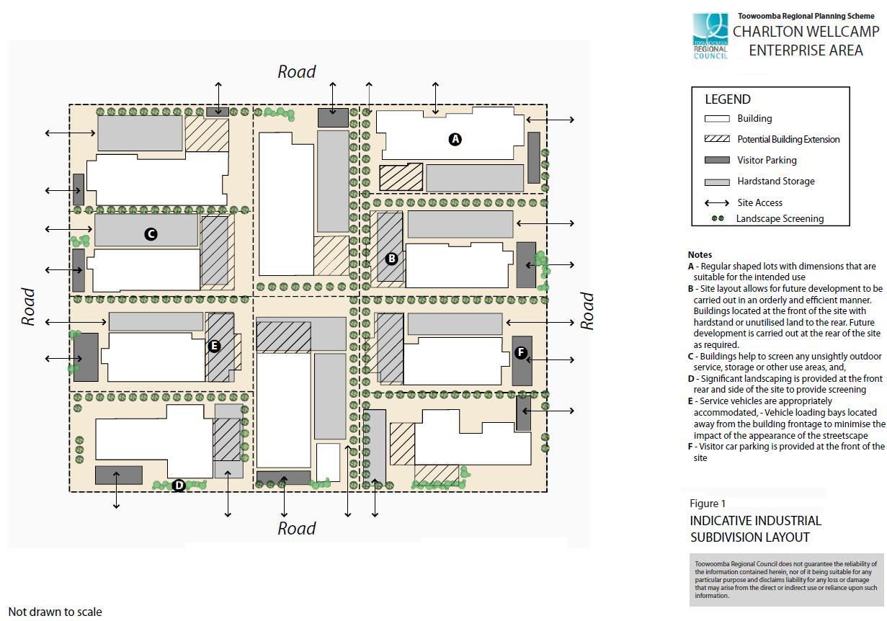

Figure 2 Open Space and Constrained Areas
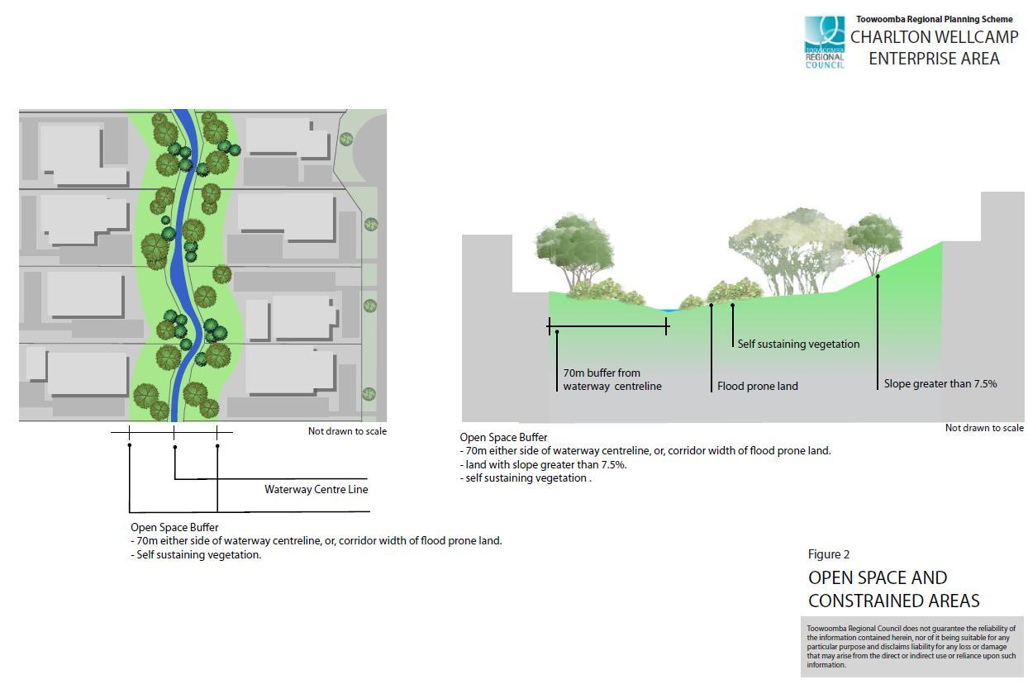

Figure 3 Industrial Roads and Cross Sections
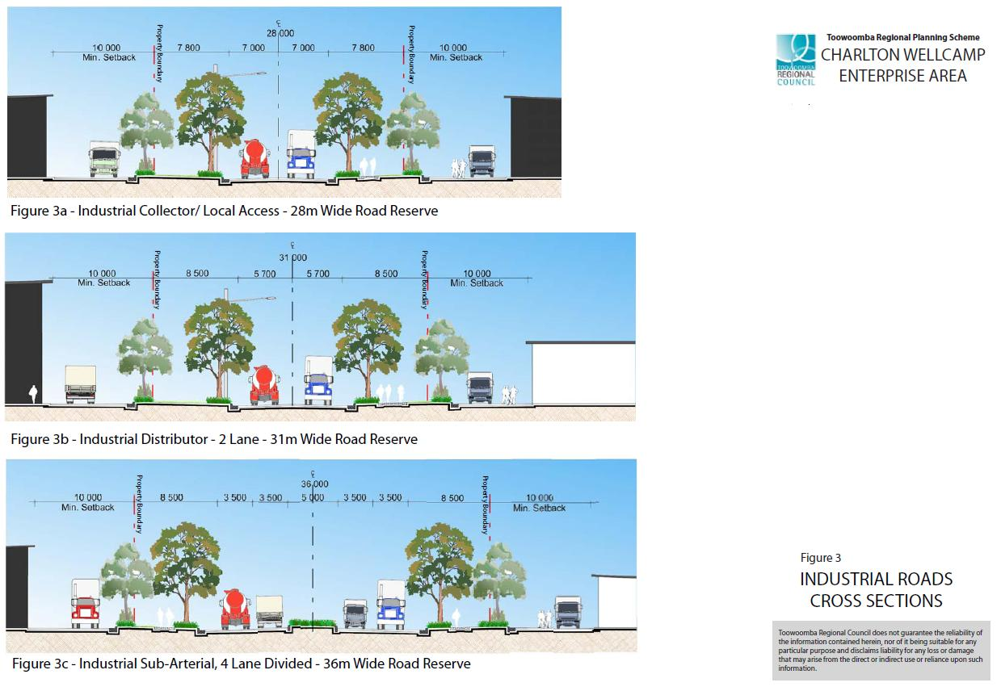

Figure 4 Climatically Responsive Design Site Layout
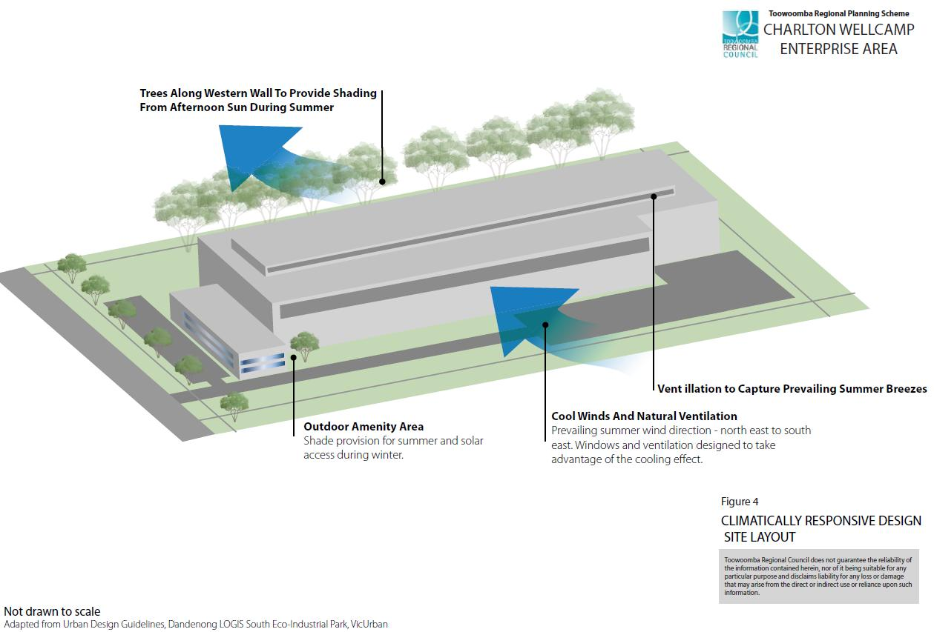

Figure 5 Climatically Responsive Design Natural Light and Ventilation
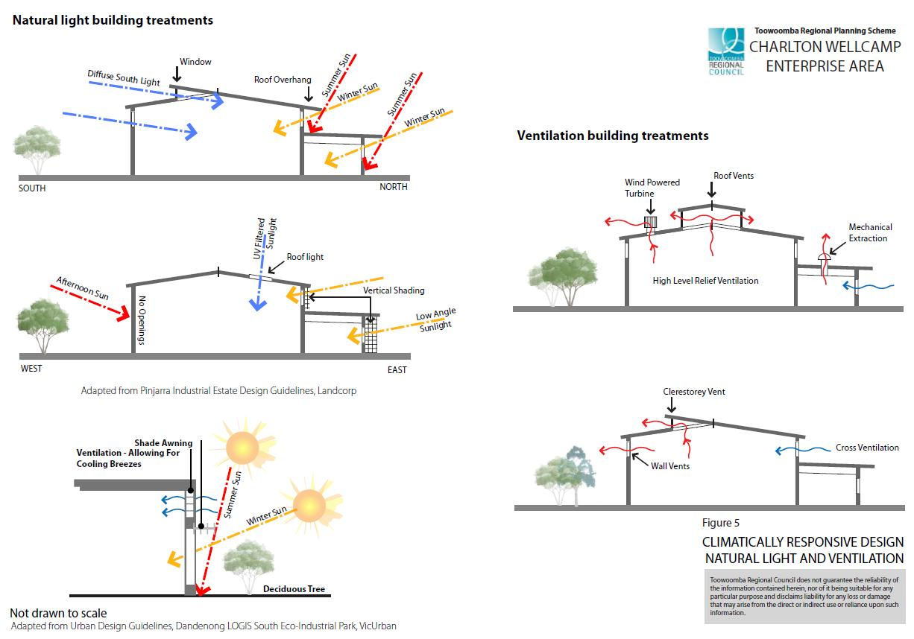

Figure 6 Building Appearance
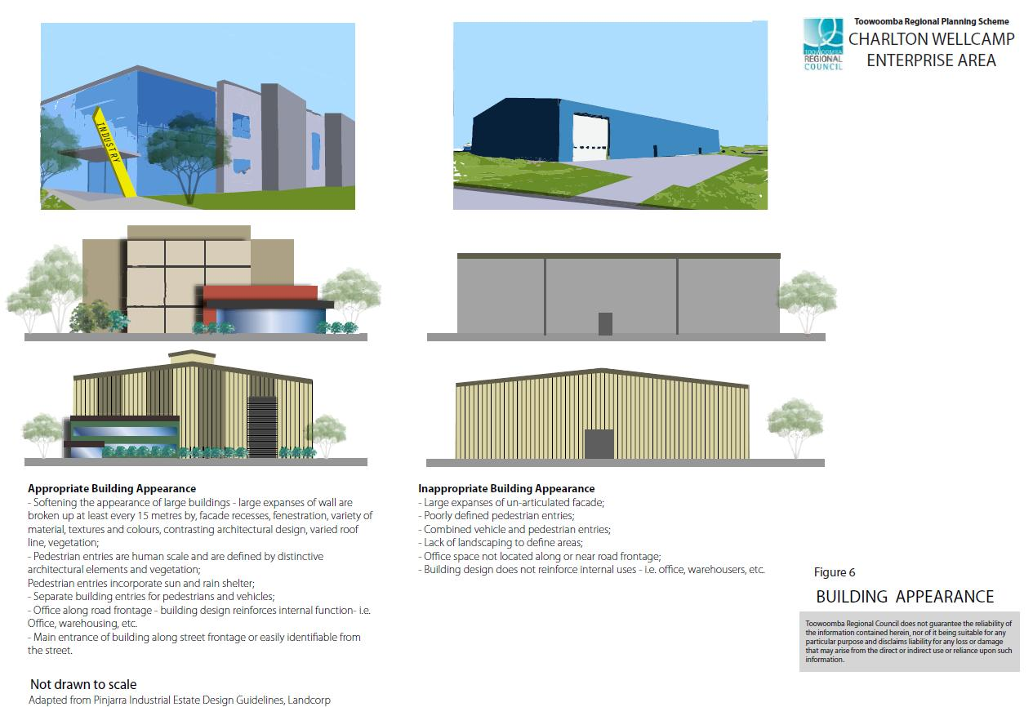

Figure 7 Definition of Entries, and Reinforcement of Site Building Functions

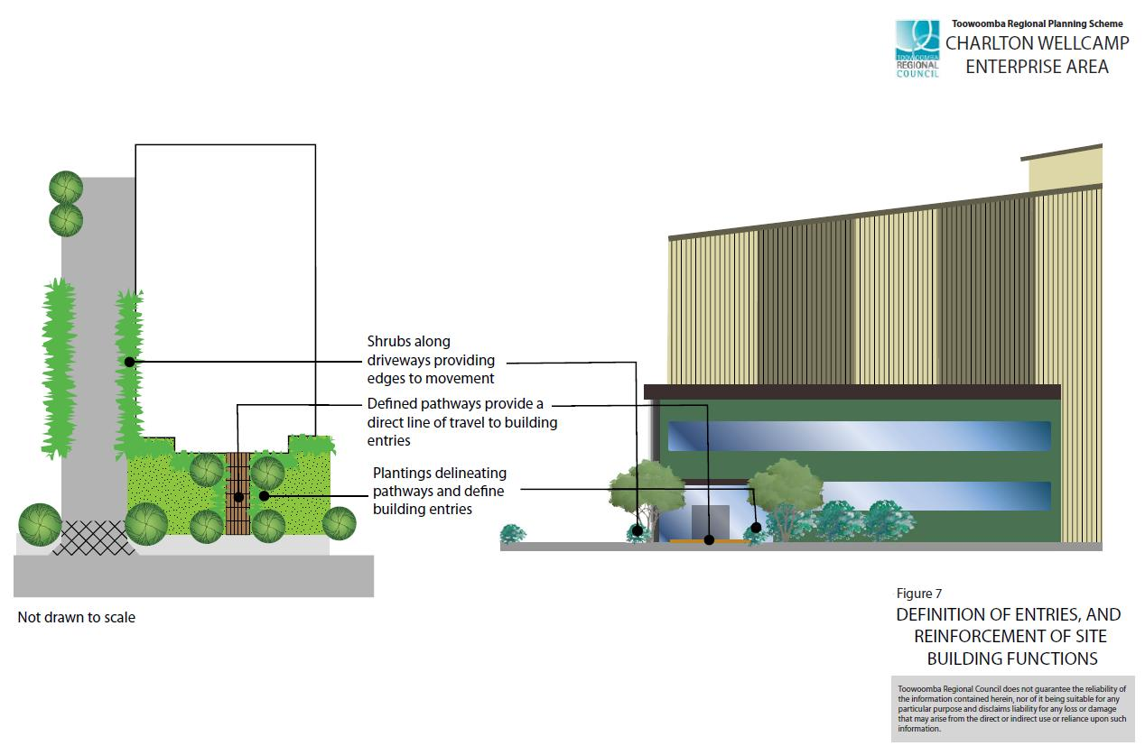

Figure 8 Gateway Features

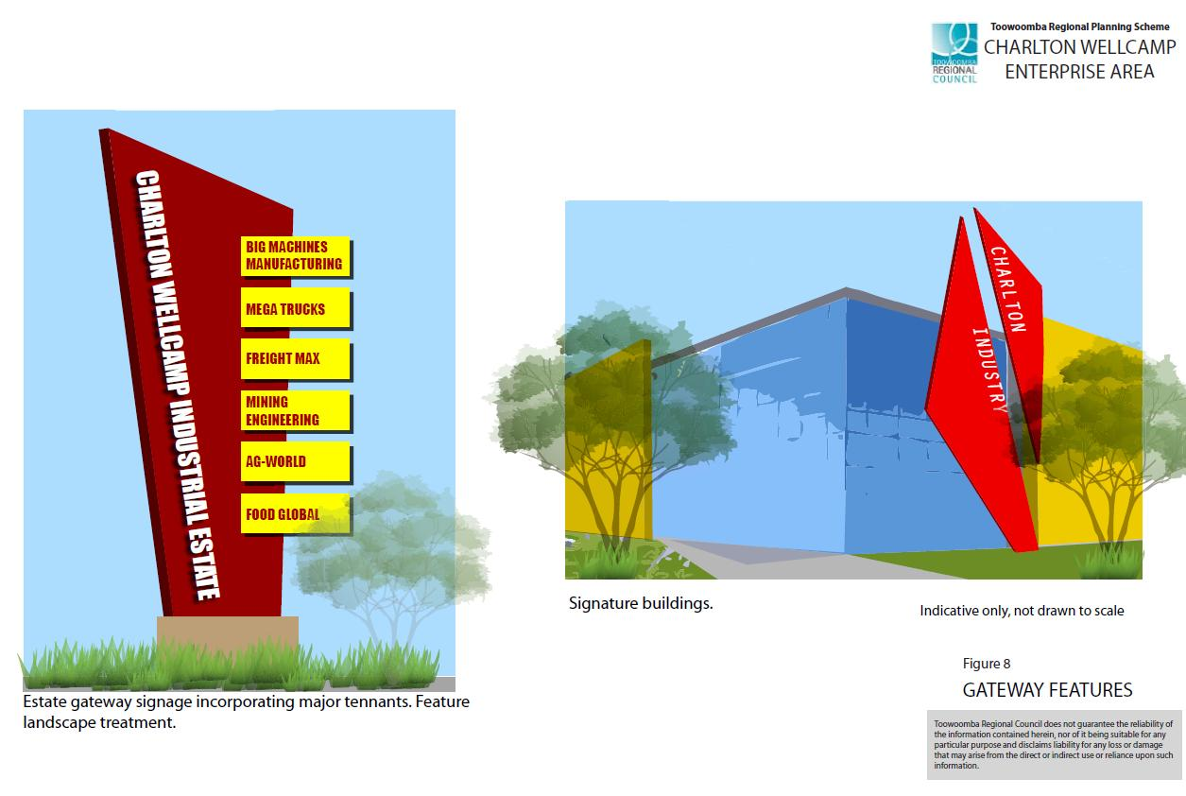

Figure 9 Industrial Site Layout Principles
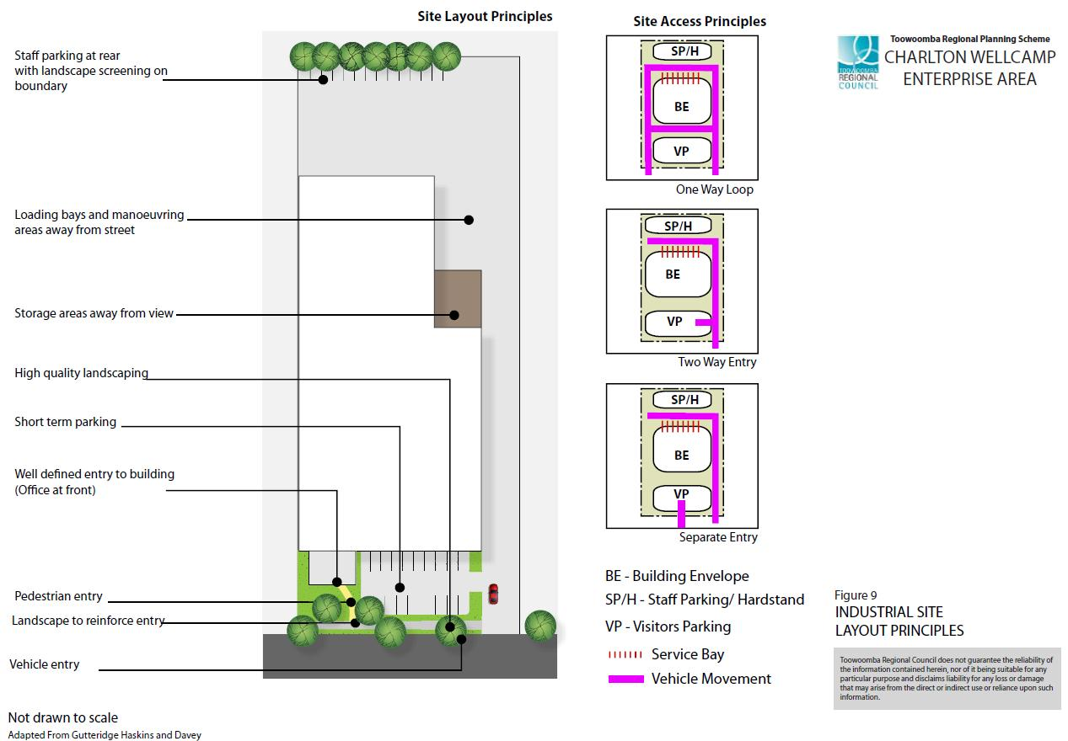

Figure 10 Electricity Infrastructure Buffers
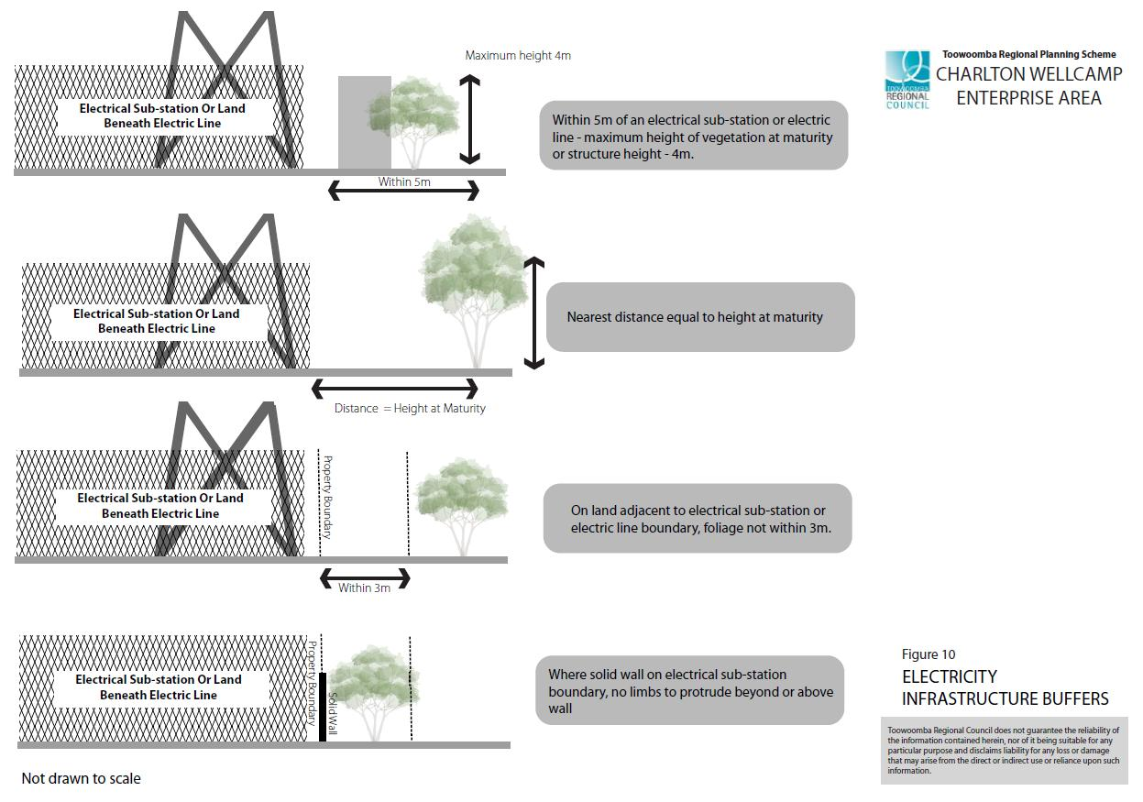

Figure 11 Landscape Screening
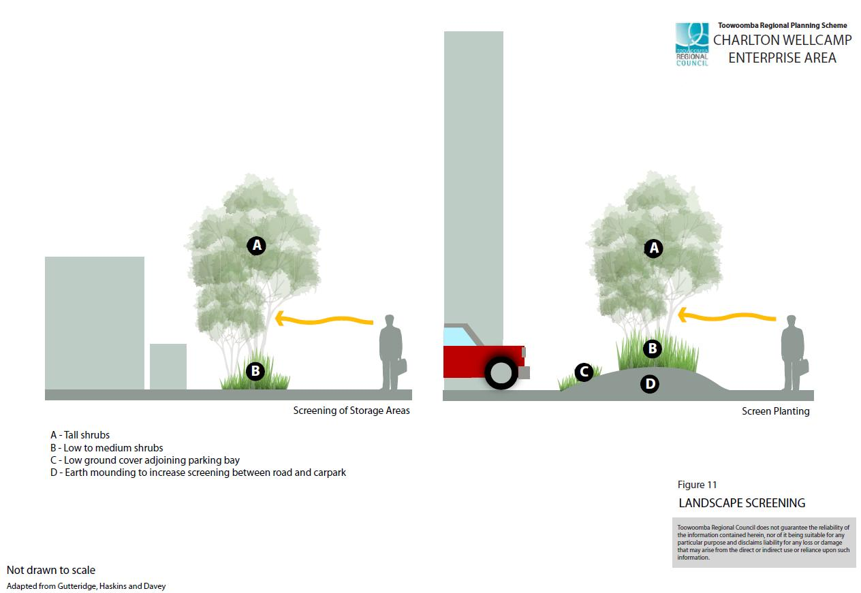

Figure 12 Fencing for Industrial Areas

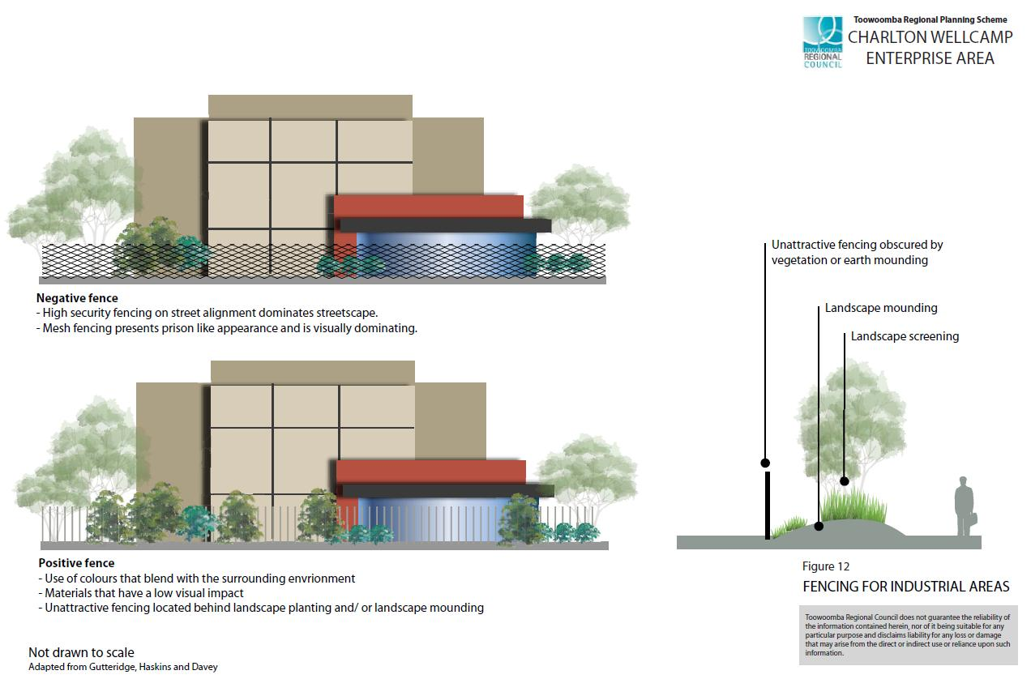

Amended on 3 July 2017
Amended on 4 August 2014
Amended on 29 July 2016
Amended on 3 November 2014
Amended on 18 March 2016
Amended on 29 July 2016
Amended on 3 November 2014
Amended on 27 April 2018
Odour reports, when required, address the draft Environmental Protection Agency guideline ‘A procedure to assess the risk of odour nuisance from proposed developments’.
Amended on 27 April 2018

